Supplementary figures

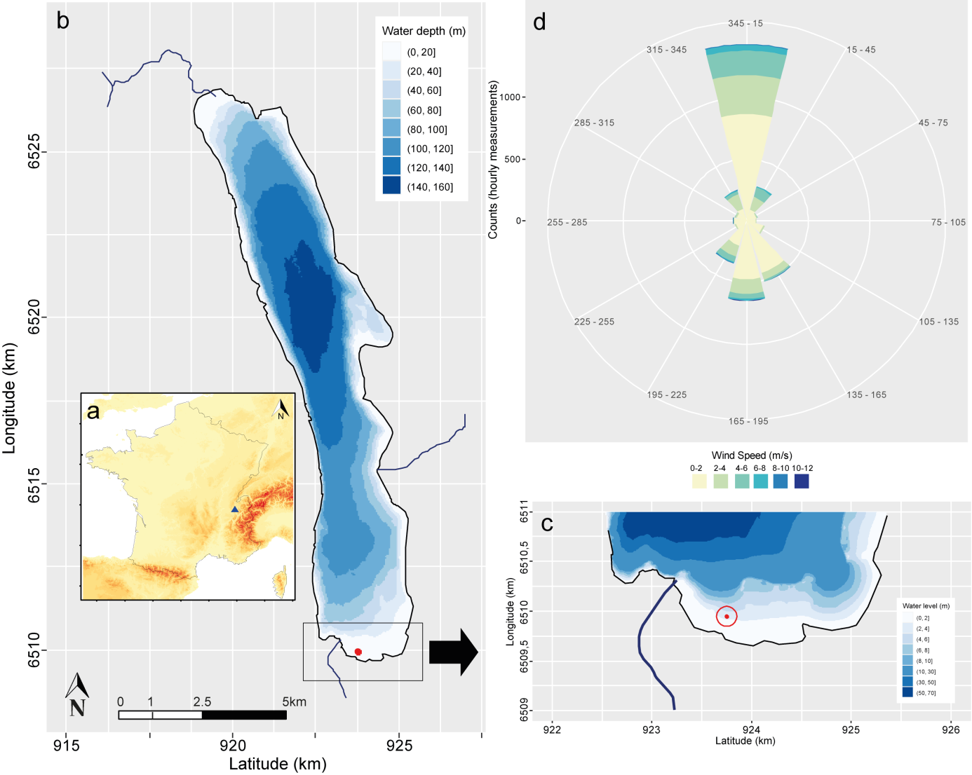
Fig. S1: Location of Lake Bourget in the East of France (blue triangle) (a). Map of Lake Bourget showing the sampling site location in littoral area at the South of the lake (red dot) (b) and (c) a focus on the studied area showing the buffer (red circle) considered for inferring wave energy. (d) Wind rose highlighting wind directions over the studied period.

Fig. S2: Environmental variables over time. Temporal dynamics of (a) water oxygen, (b) organic matter content, (c) sediment organic carbon and (d) nitrogen. Gray dots on graphs represent sampling dates over the studied period.

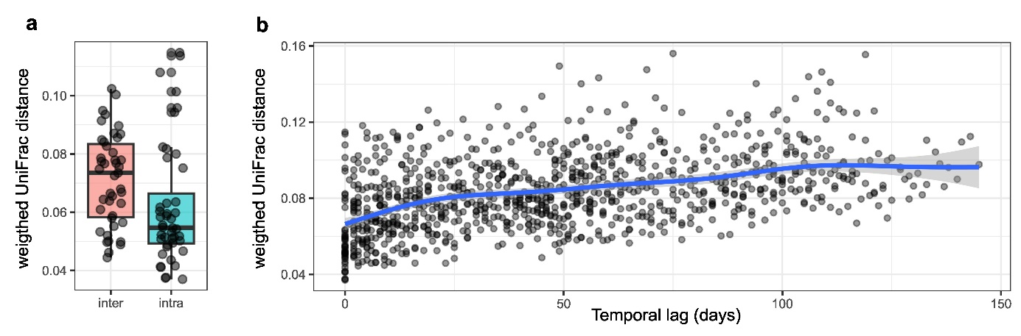
Fig. S3. Temporal variability in weighted UniFrac distances.
(a) Comparison between intra-replicate distances (within sampling dates) and inter-timepoint distances (between successive sampling dates) across the time series. Inter-timepoint distances were significantly higher than intra-replicate distances (Wilcoxon rank-sum test: W = 1293, p = 0.003), indicating that temporal turnover in microbial community composition exceeded replicate-level variability. (b) Relationship between inter-timepoint weighted UniFrac distances and temporal lag (days between sampling dates). A significant positive correlation was observed (linear regression: R² = 0.18, p < 0.001), showing that community dissimilarity increased with time elapsed between sampling events.

Fig. S4: Sediment microbial co-occurrence network. Nodes (circles) represent OTU colored according to phyla group. Minor phyla represent groups with a relative abundance <1% and Proteobacteria phylum is represented by the most dominant class. Size of each node is proportional to their relative degree. Edges represent positives (gray curves) and negatives (orange curves) correlations between OTU. Only significant and strong correlations are shown (Pearson R ≥ 0.6, P<0.01).

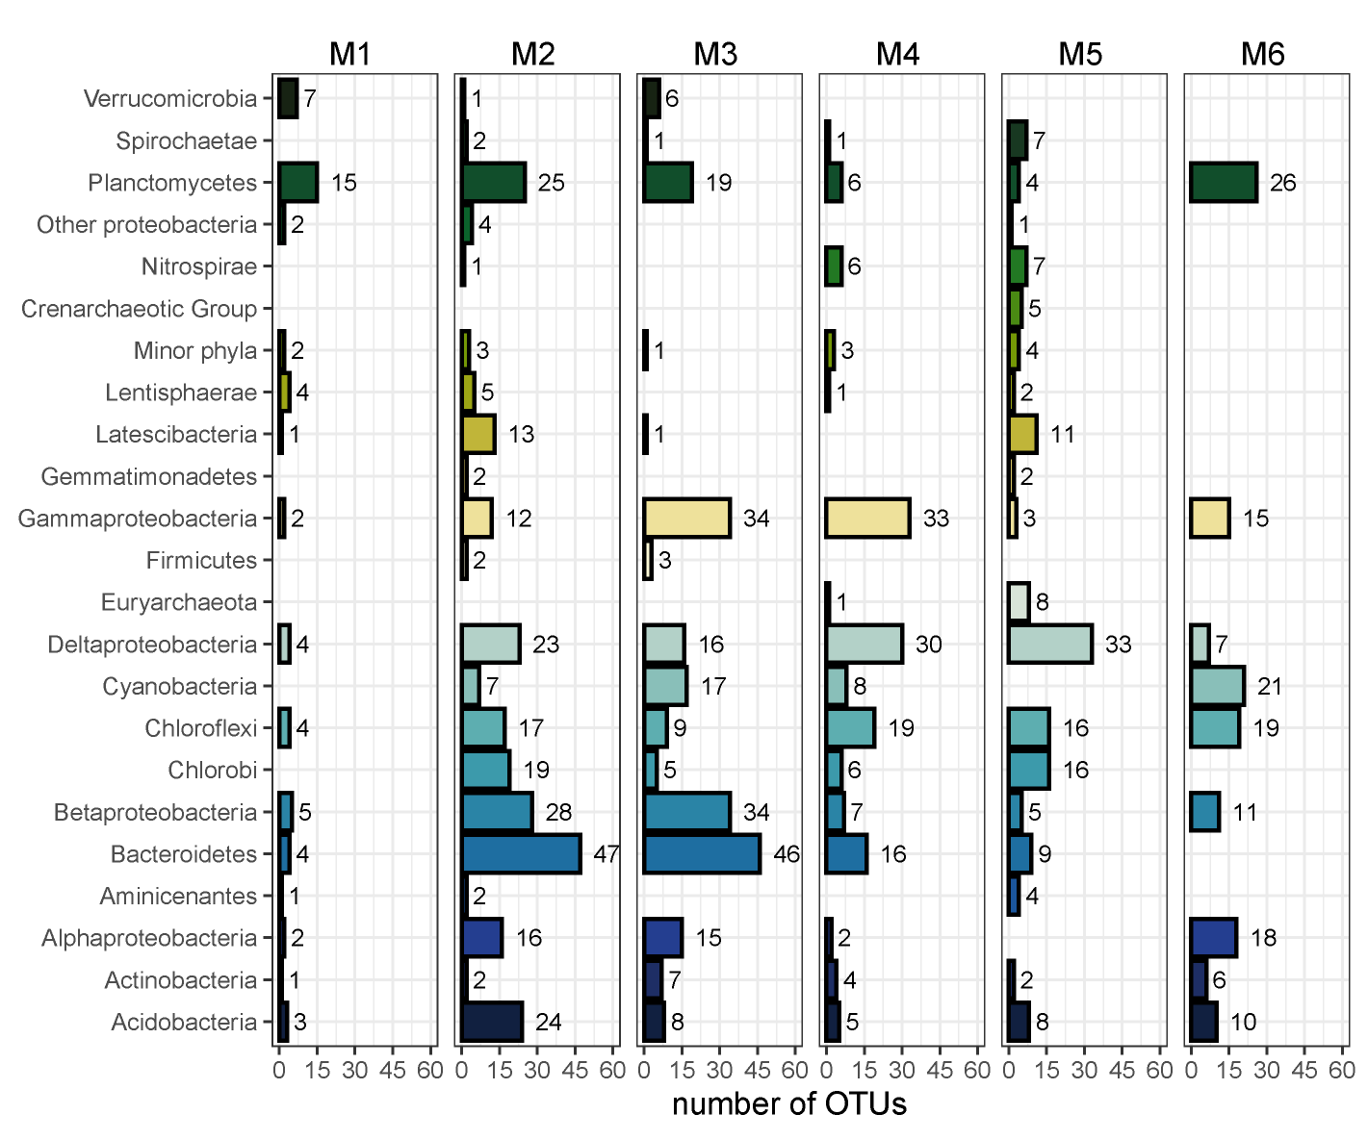
Fig. S5: Modules size according to taxonomic composition. Minor phyla represent groups with a relative abundance <1% and Proteobacteria phylum is represented by the most dominant classes for the different modules (M1 to M6)

