Characterization and Genome Analysis of Jumbo Escherichia Phage UE-S1 and the Antibacterial Potential of its Lysozyme Against Uropathogenic E. coli
Hira Niaz¹, Anza Abbas¹, Aqsa Ayub^{1,} Abdur Rahman¹ and Fazal Adnan¹*
¹ Atta ur Rahman School of Applied Biosciences, National University of Sciences and Technology, Islamabad, Pakistan
*Corresponding author: adnanfazal@asab.nust.edu.pk

SUPPLEMENTARY INFORMATION
Table S1: Details of phage genomes used for the intergenomic similarity analysis via VIRDIC
Table S2: List of phages with homologs of the terminase large subunit protein of phages UE-S1 identified by BlastP search
Table S3: Detail of selected 13 phages used in ViPTree for proteomic tree construction
Table S4: List of open reading frames (ORFs) in phage UE-S1 genome encoding proteins with identifiable sequence similarity to other proteins. Hypothetical proteins, represented by 487 ORFs, are excluded from this list.
Table S5: Physicochemical properties of predicted amphipathic helices in the LysUE1
Figure S1: The circular genomic map of UE-S1 phage created using CGView. Various colour represents putative proteins grouped into distinct categories including structural, lysis, DNA packaging, nucleotide metabolism, replication and repair and hypothetical proteins.
Figure S2: Helical wheel projections (A) N- terminal amphipathic helices, (B) C-terminal amphipathic helices in the LysUE1 generated using HeliQuest. Hydrophobic residues are shown in yellow/grey, and polar/charged residues blue/purple. The arrows indicate the hydrophobic moment vector (μH), which reflects the degree of amphipathicity.

Table S1: Details of phage genomes used for the intergenomic similarity analysis via VIRDIC
TaxID | Name | Accessions | Length | Number of HSPs | Total Aligned Length | Dice Score
2502408 | Escherichia phage vB_EcoM_G17 | MK327931 | 370817 | 465 | 351133 | 0.9635
2588085 | Escherichia phage vB_EcoM_phAPEC6, | MK817115 | 352598 | 360 | 328950 | 0.9257
2495557 | Escherichia phage SP27 | LC494302 | 347152 | 327 | 325012 | 0.9217
1874688 | Escherichia phage vB_Eco_slurp01 | LT603033 | 348043 | 319 | 323017 | 0.9149
1555202 | Escherichia phage 121Q | KM507819 | 348532 | 315 | 322698 | 0.9134
1273738 | Escherichia phage PBECO 4 | KC295538 | 348113 | 311 | 320943 | 0.9089
2268588 | Escherichia phage UB | MH383160 | 353081 | 313 | 321754 | 0.9049
2267248 | Escherichia phage CMSTMSU, | MH494197 | 386442 | 338 | 319885 | 0.8593
1439894 | Klebsiella phage K64-1 DNA, | AB897757 | 346602 | 151 | 114219 | 0.3242
1147094 | Enterobacteria phage vB_KleM-RaK2 | JQ513383 | 345809 | 144 | 113003 | 0.3211
2502408 | Escherichia phage vB_EcoM_G17 | MK327931 | 370817 | 465 | 351133 | 0.9635

Table S2: List of phages with homologs of the terminase large subunit protein of phages UE-S1 identified by BlastP search
Scientific Name | Query Cover | E value | Per. ident | Acc. Len | Accession | Taxonmy
Escherichia phage vB_EcoM_JNE01 | 100% | 0 | 87.47 | 886 | WOL22807.1 | Asteriusvirus
Escherichia phage ph0011 | 88% | 0 | 97.7 | 781 | WAE77214.1 | Asteriusvirus
Klebsiella phage vB_KleM_RaK2 | 98% | 0 | 75.4 | 889 | YP_007007266.1 | Alcyoneusvirus
Klebsiella phage K64-1 | 98% | 0 | 74.14 | 889 | YP_010843026.1 | Alcyoneusvirus
Klebsiella phage Muenster | 98% | 0 | 74.03 | 889 | QOE32521.1 | Alcyoneusvirus
Klebsiella phage KP13-7 | 98% | 0 | 73.91 | 889 | UYL04997.1 | Alcyoneusvirus
Klebsiella phage phiKp_21 | 98% | 0 | 73.91 | 889 | BEH88165.1 | Alcyoneusvirus
Escherichia phage EJP2 | 99% | 0 | 68.25 | 878 | WEM33334.1 | Asteriusvirus
Klebsiella phage  fENko-Kae01 | 98% | 0 | 67.62 | 872 | WNV47407.1 | unclassified Caudoviricetes
Escherichia phage 121Q | 62% | 0 | 100 | 545 | YP_009101598.1 | Asteriusvirus
Escherichia phage Sharanji | 62% | 0 | 100 | 546 | WNN14618.1 | Asteriusvirus
Escherichia phage A4 | 50% | 0 | 93.71 | 445 | USL83697.1 | Asteriusvirus
Escherichia phage Ecwhy_1 | 50% | 0 | 94.61 | 445 | QAY00436.1 | Asteriusvirus
Salmonella phage PHA46 | 61% | 0 | 75.93 | 543 | WVO01624.1 | unclassified Caudoviricetes
Salmonella phage Munch | 61% | 0 | 75.71 | 543 | AZU98245.1 | unclassified Caudoviricetes
Yersinia phage fHe-Yen9-04 | 62% | 0 | 74.62 | 546 | YP_009623878.1 | Eneladusvirus
Yersinia phage fHe-Yen9-03 | 62% | 0 | 74.62 | 546 | SOK59080.1 | Eneladusvirus
Serratia phage BF | 61% | 0 | 71.22 | 548 | YP_009599769.1 | Eneladusvirus
Xanthomonas phage XbC2 | 62% | 0 | 71.25 | 549 | UYE98700.1 | Mimasvirus
Cronobacter phage vB_CsaM_GAP32 | 62% | 0 | 71.04 | 549 | YP_006987374.1 | Mimasvirus
Pectobacterium phage vB_PcaM_CBB | 62% | 0 | 70 | 549 | YP_009594815.1 | Mimasvirus
Xanthomonas phage XaC1 | 60% | 0 | 67.33 | 535 | WNA15997.1 | unclassified Caudoviricetes
Salmonella phage SD-6_S16 | 33% | 0 | 100 | 296 | WPK19426.1 | Asteriusvirus
Vibrio phage 2.275.O._10N.286.54.E11 | 61% | 9e-166 | 52.94 | 537 | AUS02583.1 | unclassified Caudoviricetes
Agrobacterium phage Atu_ph07 | 53% | 5e-127 | 44.61 | 602 | YP_009611774.1 | Polybotosvirus
Pseudomonas phage  sp. 30-2 | 66% | 6e-118 | 43.52 | 531 | BDR25843.1 | Wroclawvirus
Pseudomonas phage  vB_Pa-PAC2 | 66% | 2e-117 | 43.3 | 522 | XAI94062.1 | Wroclawvirus
Pseudomonas phage vB_PaeM_PA5oct | 66% | 2e-117 | 43.3 | 531 | YP_010678934.1 | Wroclawvirus

Table S3: Detail of selected 13 phages used in ViPTree for proteomic tree construction
ID | length | name | Nucleus type | V.family | H group | S_{G} to UE-S1
NC_023693 | 148612 | Escherichia phage phi92 | dsDNA | - | Pseudomonadota | 0.0189
JN849462 | 246421 | Vibrio phage phi-pp2 | dsDNA | Straboviridae | Pseudomonadota | 0.0189
NC_055733 | 221116 | Aeromonas phage Ah1 | dsDNA | Straboviridae | Pseudomonadota | 0.0196
NC_071039 | 286783 | Pseudomonas phage vB_PaeM_PA5oct | dsDNA | - | Pseudomonadota | 0.0578
NC_042013 | 490380 | Agrobacterium phage Atu_ph07 | dsDNA | - | Pseudomonadota | 0.0495
NC_042116 | 354378 | Yersinia phage fHe-Yen9-04 | dsDNA | - | Pseudomonadota | 0.2826
NC_041917 | 357154 | Serratia phage BF | dsDNA | - | Pseudomonadota | 0.2845
NC_041878 | 378379 | Pectobacterium phage vB_PcaM_CBB | dsDNA | - | Pseudomonadota | 0.2866
NC_019401 | 358663 | Cronobacter phage vB_CsaM_GAP32 | dsDNA | - | Pseudomonadota | 0.2868
NC_019526 | 345809 | Klebsiella phage vB_KleM_RaK2 | dsDNA | - | Pseudomonadota | 0.3397
NC_027399 | 346602 | Klebsiella phage K64-1 | dsDNA | - | Pseudomonadota | 0.3411
NC_027364 | 348113 | Escherichia phage PBECO4 | dsDNA | - | Pseudomonadota | 0.802
NC_025447 | 348532 | Escherichia phage 121Q | dsDNA | - | Pseudomonadota | 0.8008

Table S4: List of open reading frames (ORFs) in phage UE-S1 genome encoding proteins with identifiable sequence similarity to other proteins. Hypothetical proteins, represented by 487 ORFs, are excluded from this list.
Locus tag | strand | start | stop | function
UES1_02 | + | 1099 | 2154 | DNA primase subunit
UES1_03 | + | 2177 | 3697 | helicase
UES1_10 | + | 6419 | 8170 | HNH homing endonuclease
UES1_14 | + | 9172 | 9891 | exonuclease
UES1_17 | + | 11108 | 13426 | Ribonucleoside-diphosphate reductase subunit alpha
UES1_19 | + | 14265 | 15389 | Ribonucleoside-diphosphate reductase subunit beta
UES1_23 | + | 16312 | 17043 | nucleoside triphosphate pyrophosphohydrolase
UES1_28 | + | 18923 | 19444 | Dihydrofolate reductase
UES1_29 | + | 19441 | 19869 | Ribonuclease HI
UES1_30 | + | 19900 | 21240 | DNA helicase
UES1_33 | + | 22178 | 22681 | translation initiation factor IF-3
UES1_34 | + | 22695 | 23240 | ATP-dependent protease
UES1_35 | + | 23311 | 23856 | KTSC domain-containing protein
UES1_38 | + | 26307 | 28271 | DNA gyrase subunit B
UES1_39 | + | 28322 | 29734 | topoisomerase II medium subunit
UES1_42 | + | 32487 | 33005 | DNA polymerase III
UES1_44 | + | 33425 | 33751 | head morphogenesis
UES1_46 | + | 34102 | 35055 | clamp loader subunit
UES1_52 | + | 39150 | 40286 | toxic anion resistance protein
UES1_53 | + | 40368 | 41057 | 3'-5' exoribonuclease
UES1_76 | + | 50728 | 52608 | cytosine specific methyltransferase
UES1_114 | + | 66331 | 66855 | HNH endonuclease
UES1_148 | + | 79733 | 80686 | sigma-70 family RNA polymerase sigma factor
UES1_151 | + | 81787 | 82575 | HNH endonuclease
UES1_179 | + | 93359 | 94000 | protein kinase
UES1_191 | + | 97856 | 98371 | endonuclease
UES1_204 | - | 104626 | 103481 | regulator of chromosome condensation
UES1_205 | - | 105880 | 104705 | regulator of chromosome condensation RCC1
UES1_208 | - | 109167 | 108025 | regulator of chromosome condensation-like protein
UES1_209 | - | 110350 | 109241 | putative DNA condensation protein
UES1_211 | - | 112802 | 111681 | regulator of chromosome condensation-like protein
UES1_212 | - | 114024 | 112876 | regulator of chromosome condensation RCC1
UES1_253 | + | 129716 | 130072 | acetyltransferase
UES1_370 | + | 175699 | 176220 | DNA N-6-adenine-methyltransferase
UES1_371 | + | 176217 | 176750 | putative cytitidyltransferase
UES1_389 | + | 183503 | 184645 | T4 RnlA family RNA ligase
UES1_394 | + | 185742 | 186674 | 3'-phosphatase, 5'-polynucleotide kinase, phage-associated
UES1_406 | + | 190115 | 190858 | putative serine/threonine protein phosphatase
UES1_411 | + | 192992 | 194413 | DNA ligase
UES1_412 | + | 194425 | 195495 | endonuclease
UES1_413 | + | 195508 | 196299 | metallophosphoesterase
UES1_416 | + | 197166 | 197861 | ATP-dependent Clp protease proteolytic subunit
UES1_420 | + | 199247 | 199726 | dCMP deaminase
UES1_422 | - | 202183 | 200282 | major tail protein
UES1_427 | + | 204305 | 205057 | putative Sir2-like protein
UES1_428 | + | 205054 | 205605 | NUDIX hydrolase
UES1_431 | + | 206295 | 207734 | PhoH-like protein
UES1_435 | + | 209981 | 210952 | WGR domain containing protein
UES1_445 | + | 214405 | 216210 | anaerobic ribonucleoside-triphosphate reductase
UES1_446 | + | 216385 | 216744 | Pyruvate formate-lyase
UES1_448 | + | 217096 | 217518 | anaerobic ribonucleoside-triphosphate reductase activating protein
UES1_456 | + | 225713 | 226945 | nucleotidyltransferase
UES1_458 | + | 227535 | 227909 | Rz-like spanin
UES1_460 | + | 228216 | 228827 | HNH endonuclease
UES1_465 | + | 230786 | 231226 | starvation-inducible transcriptional regulator
UES1_472 | + | 233688 | 234272 | thymidine kinase
UES1_480 | + | 236674 | 237600 | LysM peptidoglycan-binding domain-containing protein
UES1_481 | + | 237618 | 237950 | HPF/RaiA family ribosome-associated protein
UES1_487 | + | 239550 | 240662 | CCA tRNA nucleotidyltransferase
UES1_488 | + | 240774 | 241172 | NUDIX hydrolase
UES1_495 | + | 243465 | 244256 | head-tail adaptor Ad2
UES1_496 | + | 244285 | 246279 | homing endonuclease
UES1_498 | + | 246642 | 247268 | putative deoxynucleoside monophosphate kinase
UES1_499 | + | 247366 | 250029 | tail sheath protein
UES1_501 | + | 250419 | 251105 | tail tube protein
UES1_502 | + | 251198 | 251974 | tail tube protein
UES1_503 | + | 251986 | 253080 | tail tube protein
UES1_504 | + | 253153 | 253572 | head completion protein
UES1_512 | + | 258893 | 260218 | ATPase
UES1_513 | + | 260293 | 261717 | HNH endonuclease
UES1_516 | + | 262737 | 263330 | DprA-like DNA recombination-mediator protein
UES1_517 | + | 263330 | 264883 | thymidylate synthase
UES1_520 | - | 273601 | 268118 | tail fiber protein
UES1_522 | - | 276775 | 274634 | putative colanic acid biosynthesis protein
UES1_523 | - | 277916 | 276789 | tail protein
UES1_527 | - | 280746 | 280282 | NUDIX hydrolase
UES1_528 | - | 282102 | 280759 | tail sheath stabilizer and completion protein
UES1_530 | + | 283704 | 285992 | putative ATP-dependent Clp protease ATP-binding subunit
UES1_533 | - | 300037 | 299642 | GPW/gp25 family protein
UES1_534 | - | 300539 | 300051 | lysozyme
UES1_535 | - | 303239 | 300576 | putative baseplate hub subunit and tail lysozyme
UES1_536 | - | 305502 | 303253 | structural protein
UES1_537 | - | 305828 | 305514 | baseplate wedge protein 53
UES1_538 | - | 306559 | 305828 | structural protein
UES1_539 | + | 306591 | 307529 | putative RNA polymerase sigma factor
UES1_540 | + | 307516 | 308547 | recombination endonuclease subunit
UES1_541 | + | 308556 | 310703 | recombination endonuclease subunit
UES1_542 | - | 311214 | 310723 | DNA endonuclease VII
UES1_544 | - | 313112 | 312276 | baseplate hub
UES1_546 | + | 315460 | 317199 | portal vertex protein
UES1_549 | + | 318453 | 319076 | prohead core scaffolding protein and protease
UES1_551 | + | 320350 | 321525 | major capsid protein
UES1_552 | + | 321680 | 323275 | homing endonuclease
UES1_555 | + | 324032 | 325642 | tail fiber protein
UES1_556 | + | 325653 | 326162 | tail fiber assembly protein
UES1_558 | + | 326642 | 329647 | DNA polymerase
UES1_563 | + | 331207 | 331506 | co-chaperone GroES
UES1_569 | + | 333789 | 334775 | RNase H-like 5'-3' exonuclease
UES1_570 | + | 335968 | 338625 | large terminase protein
UES1_572 | + | 340137 | 341189 | single strand DNA binding protein
UES1_573 | + | 341259 | 342377 | recombination protein
UES1_575 | + | 342898 | 343617 | HNH endonuclease
UES1_576 | + | 343658 | 344476 | exodeoxyribonuclease X
UES1_577 | + | 344492 | 345976 | DEAD/DEAH box helicase family protein
UES1_583 | + | 348809 | 349447 | DNA polymerase
UES1_586 | + | 350877 | 351932 | DNA primase subunit
UES1_587 | + | 351955 | 353475 | DNA helicase
UES1_594 | + | 356197 | 357948 | putative homing endonuclease

Table S5: Physicochemical properties of predicted amphipathic helices in the LysUE1
 | Hydrophobicity  <H> | Hydrophobic moment <µH> | Net charge z | Freq polar residues | Freq nonpolar residues
N-terminal helix  (11-20 aa) | 0.305 | 0.754 | -1 | 0.600 | 0.400
C-terminal helix  (149-160 aa) | 0.067 | 0.393 | 1 | 0.583 | 0.417

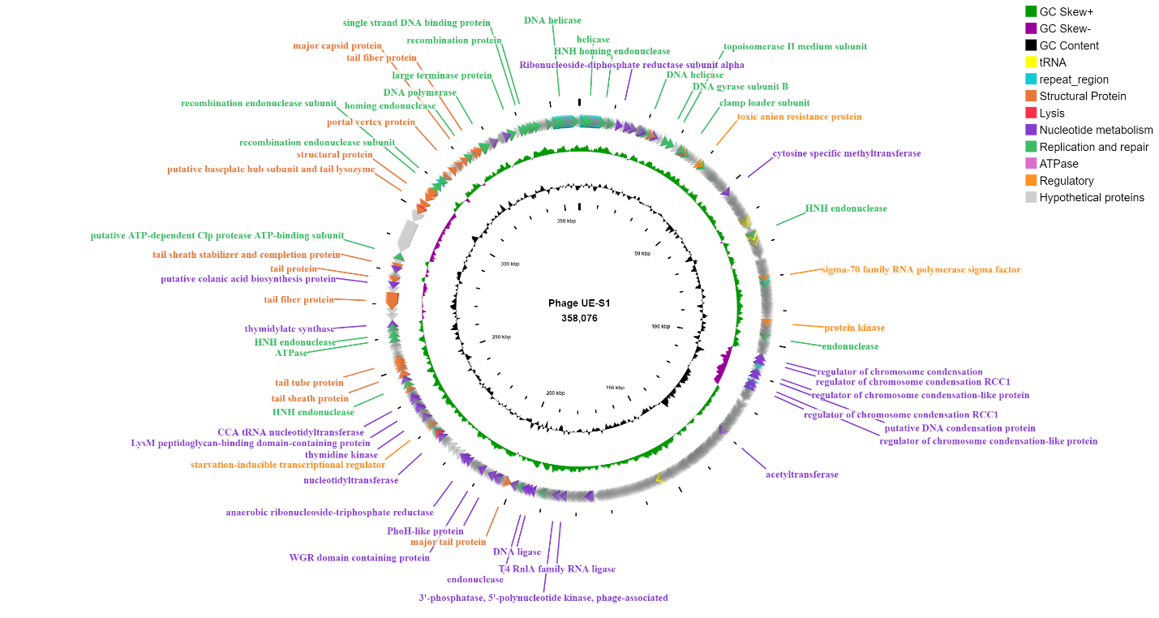

Figure S1: The circular genomic map of UE-S1 phage created using CGView. Various colour represents putative proteins grouped into distinct categories including structural, lysis, DNA packaging, nucleotide metabolism, replication and repair and hypothetical proteins.

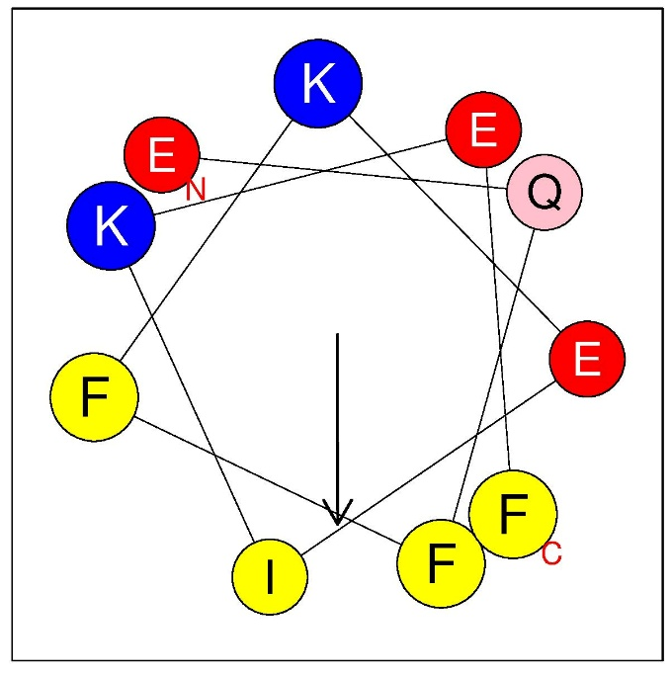

B.
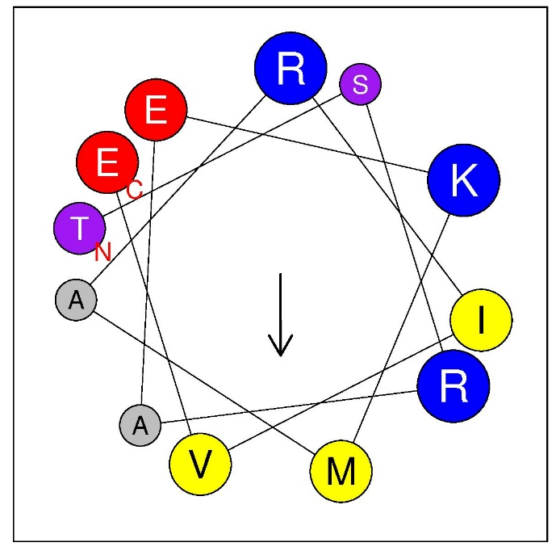

Figure S2: Helical wheel projections (A) N- terminal amphipathic helices, (B) C-terminal amphipathic helices in the LysUE1 generated using HeliQuest. Hydrophobic residues are shown in yellow/grey, and polar/charged residues blue/purple. The arrows indicate the hydrophobic moment vector (μH), which reflects the degree of amphipathicity.

