Raw figures

Supplementary Figure 1: Raw image associated with Figures 1 and 3A from the original paper. The image corresponds to a two-dimensional electrophoresis of 100 µg of intracellular proteins from M. bovis BCG Moreau cultured in 7H9 medium. Proteins were resolved on 7 cm IPG strips across a pH gradient of 4-7 and separated in the second dimension on 14% SDS-PAGE gels. Protein spots were visualized by colloidal Coomassie Brilliant Blue G-250 staining.
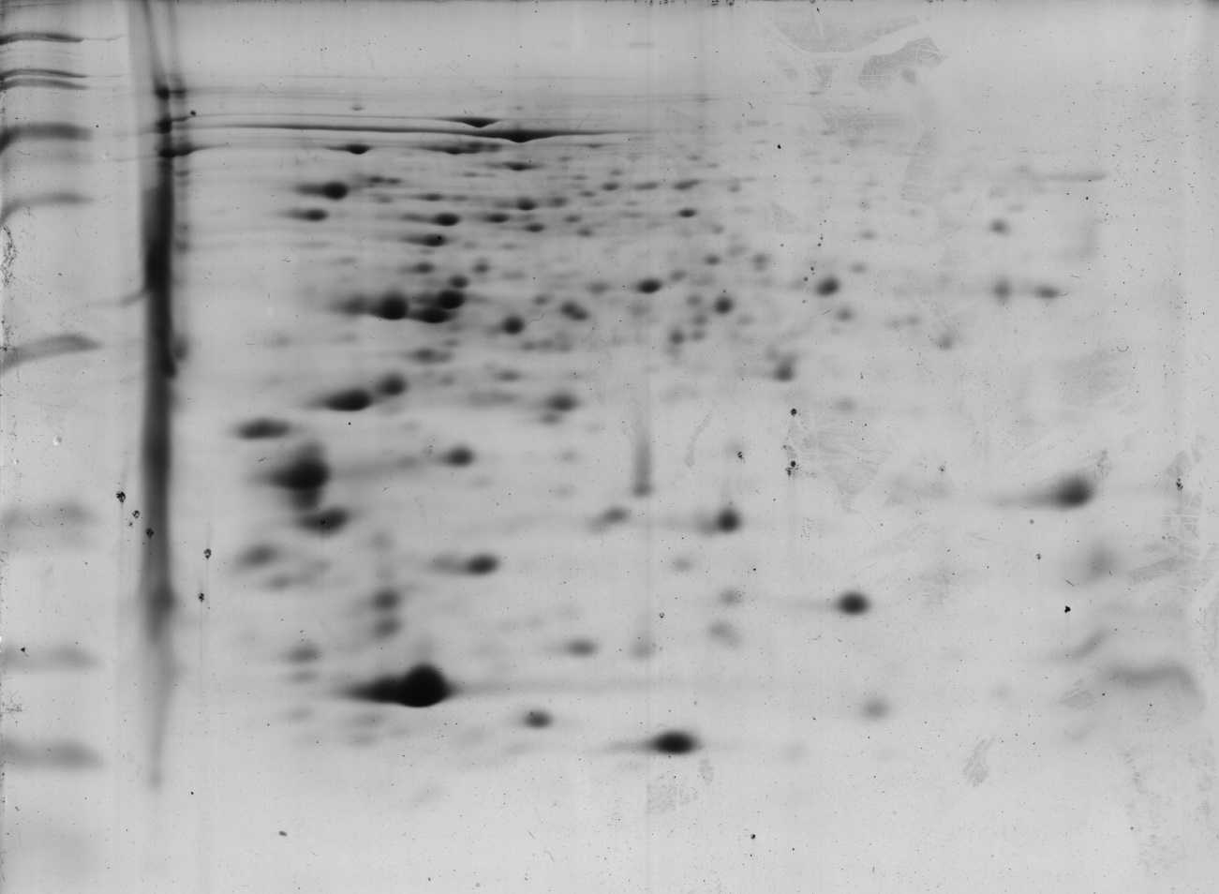

Supplementary Figure 2: Raw image associated with Figure 3B from the original paper. The image corresponds to a two-dimensional electrophoresis of 100 µg of intracellular proteins from M. bovis BCG Pasteur cultured in 7H9 medium. Proteins were resolved on 7 cm IPG strips across a pH gradient of 4-7 and separated in the second dimension on 14% SDS-PAGE gels. Protein spots were visualized by colloidal Coomassie Brilliant Blue G-250 staining.
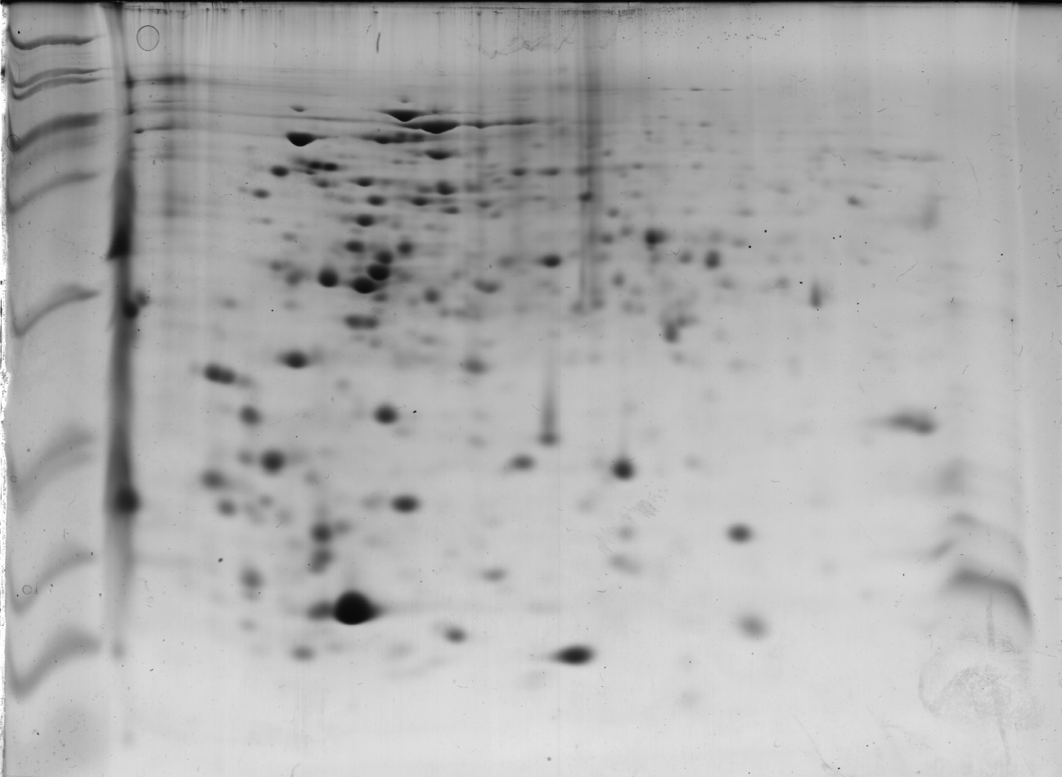

Supplementary Figure 3: Raw image associated with Figure 3C from the original paper. The image corresponds to a two-dimensional electrophoresis of 100 µg of intracellular proteins from M. bovis BCG Moreau cultured in Sauton medium. Proteins were resolved on 7 cm IPG strips across a pH gradient of 4-7 and separated in the second dimension on 14% SDS-PAGE gels. Protein spots were visualized by colloidal Coomassie Brilliant Blue G-250 staining.
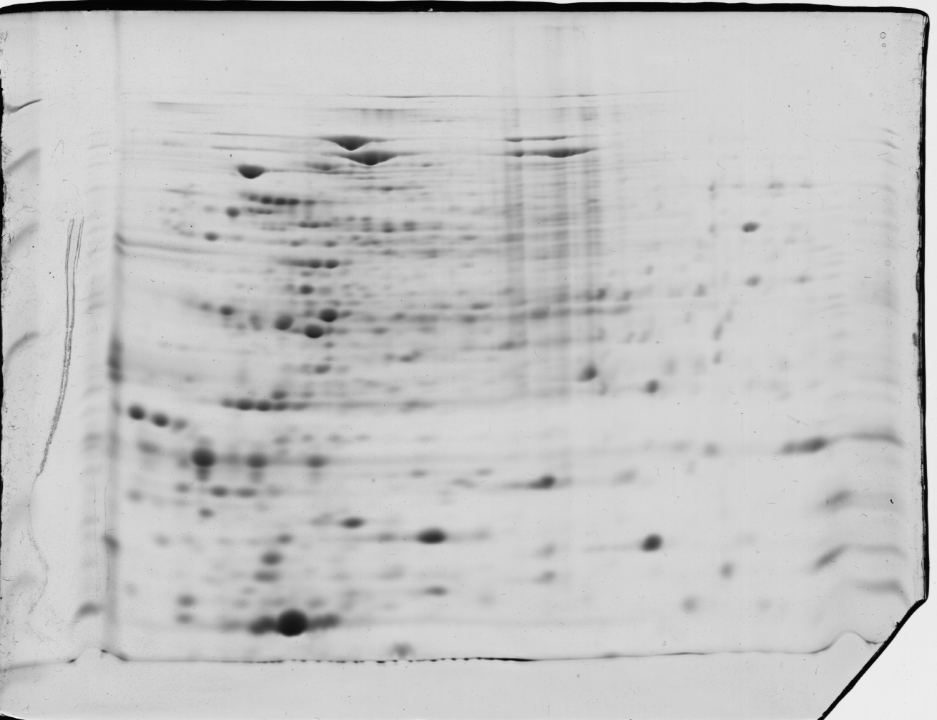

Supplementary Figure 4: Raw image associated with Figure 3D from the original paper. The image corresponds to a two-dimensional electrophoresis of 100 µg of intracellular proteins from M. bovis BCG Pasteur cultured in Sauton medium. Proteins were resolved on 7 cm IPG strips across a pH gradient of 4-7 and separated in the second dimension on 14% SDS-PAGE gels. Protein spots were visualized by colloidal Coomassie Brilliant Blue G-250 staining.
