Supplementary date
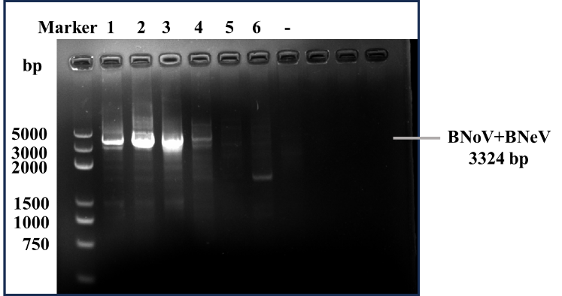
1. Uncropped images for figure 1C: Construction and identification of rAd5-BNoV+BNeV_VP1.
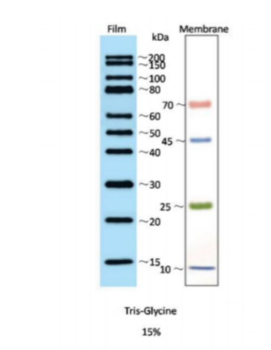
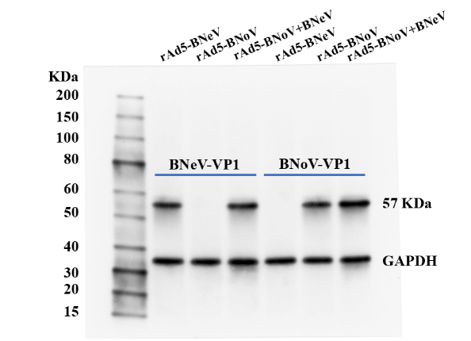
2. Uncropped image for figure 1E: Western blotting analysis of BNoV-VP1 and BNeV-VP1 proteins expressed by rAd5-BNoV+BNeV_VP1 in HEK-293 cells. The protein marker used in this experiment is from GenStar, Beijing, China.

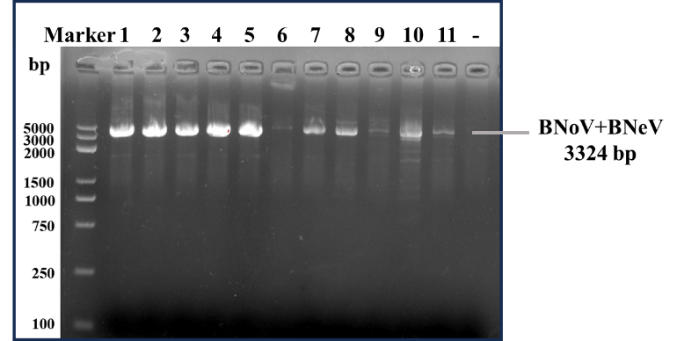
3. Uncropped image for figure 2A: rAd5-BNoV+BNeV_VP1 purified by chromatography.

