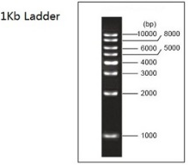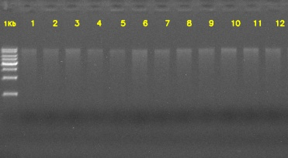

Figure S1 Extracted DNA from the treated-wastewater (W1, W2 and W3) and Tap water checked using 1% agarose gel electrophoresis. 1-3: three replicates of W1, 4-6: three replicates of W2, 7-9: three replicates of W3, and 10-12: three replicates of Tap water.

