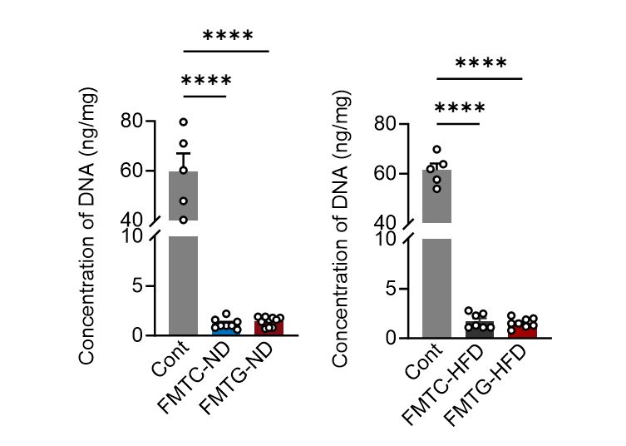
Supplementary Figure 1. Fecal DNA concentration in control (Cont) and antibiotic-treated groups. (A) Comparison of fecal DNA concentration between the Cont group, which did not receive antibiotics, and the FMTC-ND and FMTG-ND groups, which underwent two weeks of antibiotic treatment. (B) Comparison of fecal DNA concentration between the Cont group, which did not receive antibiotics, and the FMTC-HFD and FMTG-HFD groups after two weeks of antibiotic treatment. n: Cont (n=5); FMTC-ND (n=8); FMTG-ND (n=10); FMTC-HFD (n=7); FMTG-HFD (n=8). Data are presented as mean ± SEM, and statistical significance was determined using one-way ANOVA followed by Bonferroni's multiple comparisons test. ***p＜0.001.
Abbreviation: FMTC-ND, fecal microbiota transplant from offspring of mothers without gestational diabetes mellitus under normal diet; FMTG-ND, fecal microbiota transplant from offspring of mothers without gestational diabetes mellitus under normal diet; FMTC-HFD, fecal microbiota transplant from offspring of mothers without gestational diabetes mellitus under high-fat diet; FMTG-ND, fecal microbiota transplant from offspring of mothers without gestational diabetes mellitus under high-fat diet.

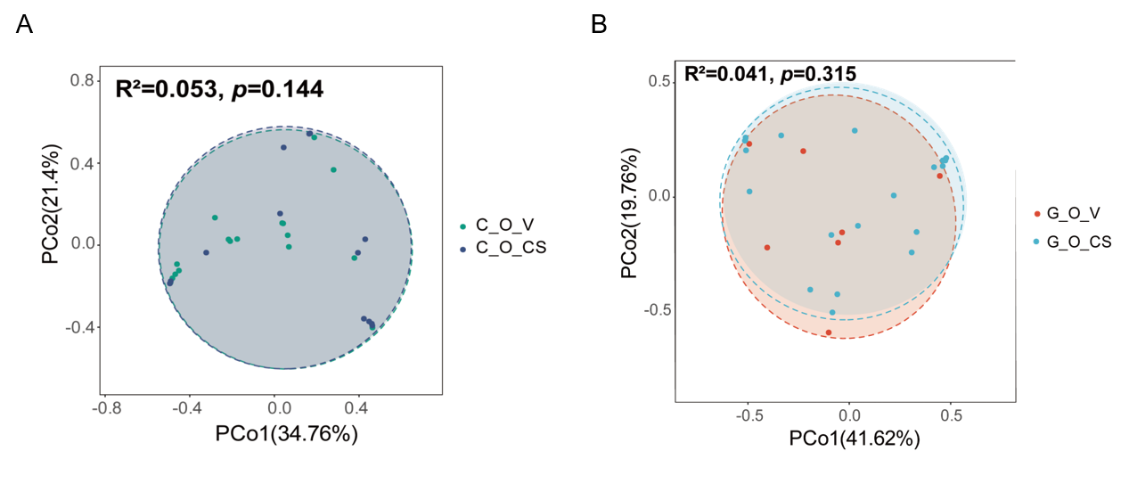
Supplementary Figure 2. The impact of different delivery modes on infant fecal microbiota composition. Principal coordinate analysis (PCoA) based on Bray–Curtis distances illustrating the microbial community differences between offspring of non-GDM mothers delivered via vaginal birth (C-O-V) and offspring of non-GDM mothers delivered via cesarean section (C-O-CS) (A), as well as between offspring of GDM mothers delivered via vaginal birth (G-O-V) and offspring of GDM mothers delivered via cesarean section (G-O-CS) (B). PERMANOVA was used to assess statistical significance, with R² and p-values indicated in each panel.
Abbreviation: GDM, gestational diabetes mellitus.

