Supplementary figure 1. Phylogenetic tree of major capsid protein. Image elaboration by Geneious Prime 2020 (https://www.geneious.com).

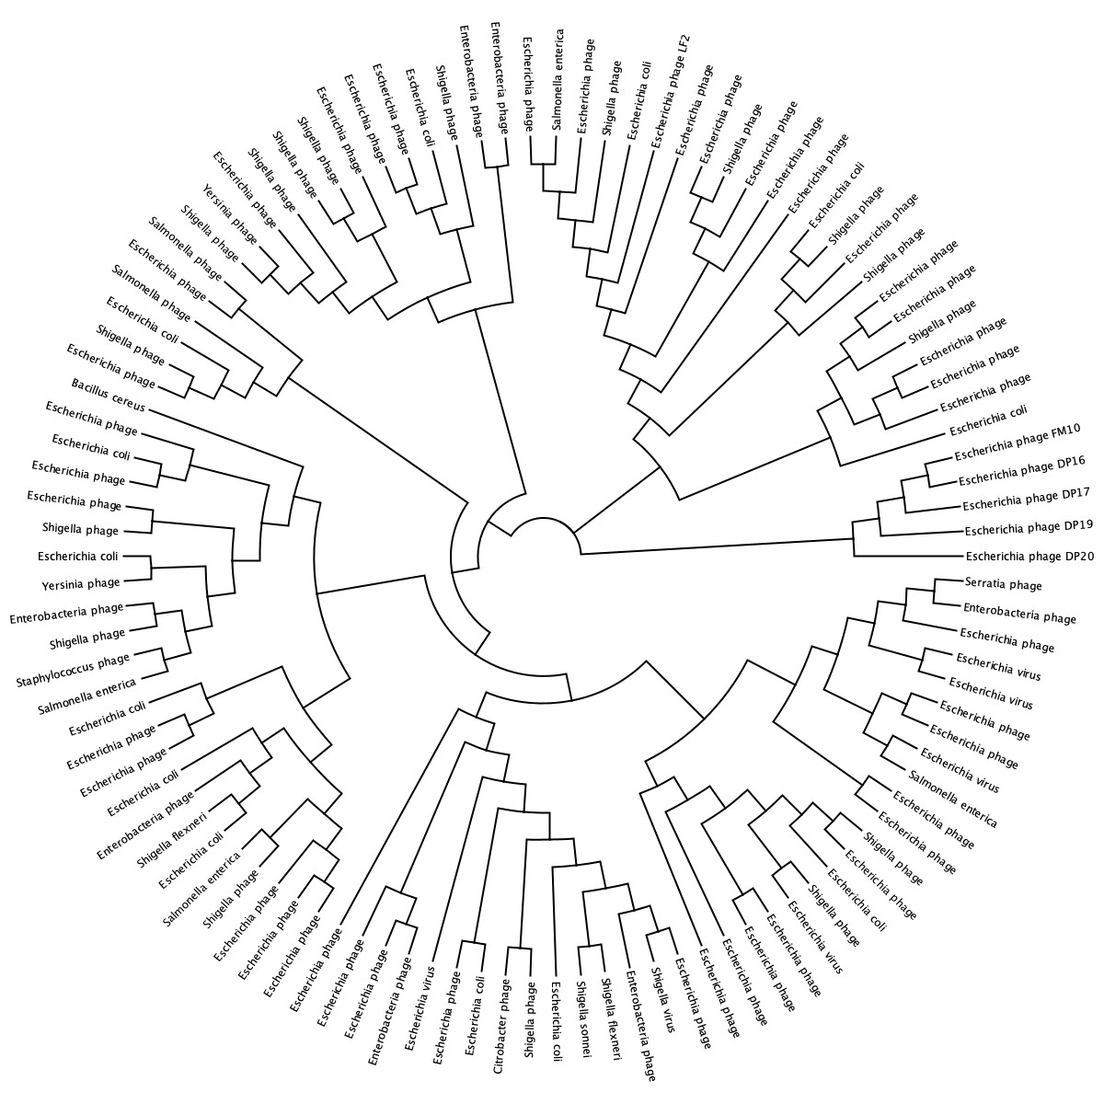

Supplementary figure 2. Phylogenetic tree of neck protein. Image elaboration by Geneious Prime 2020 (https://www.geneious.com).
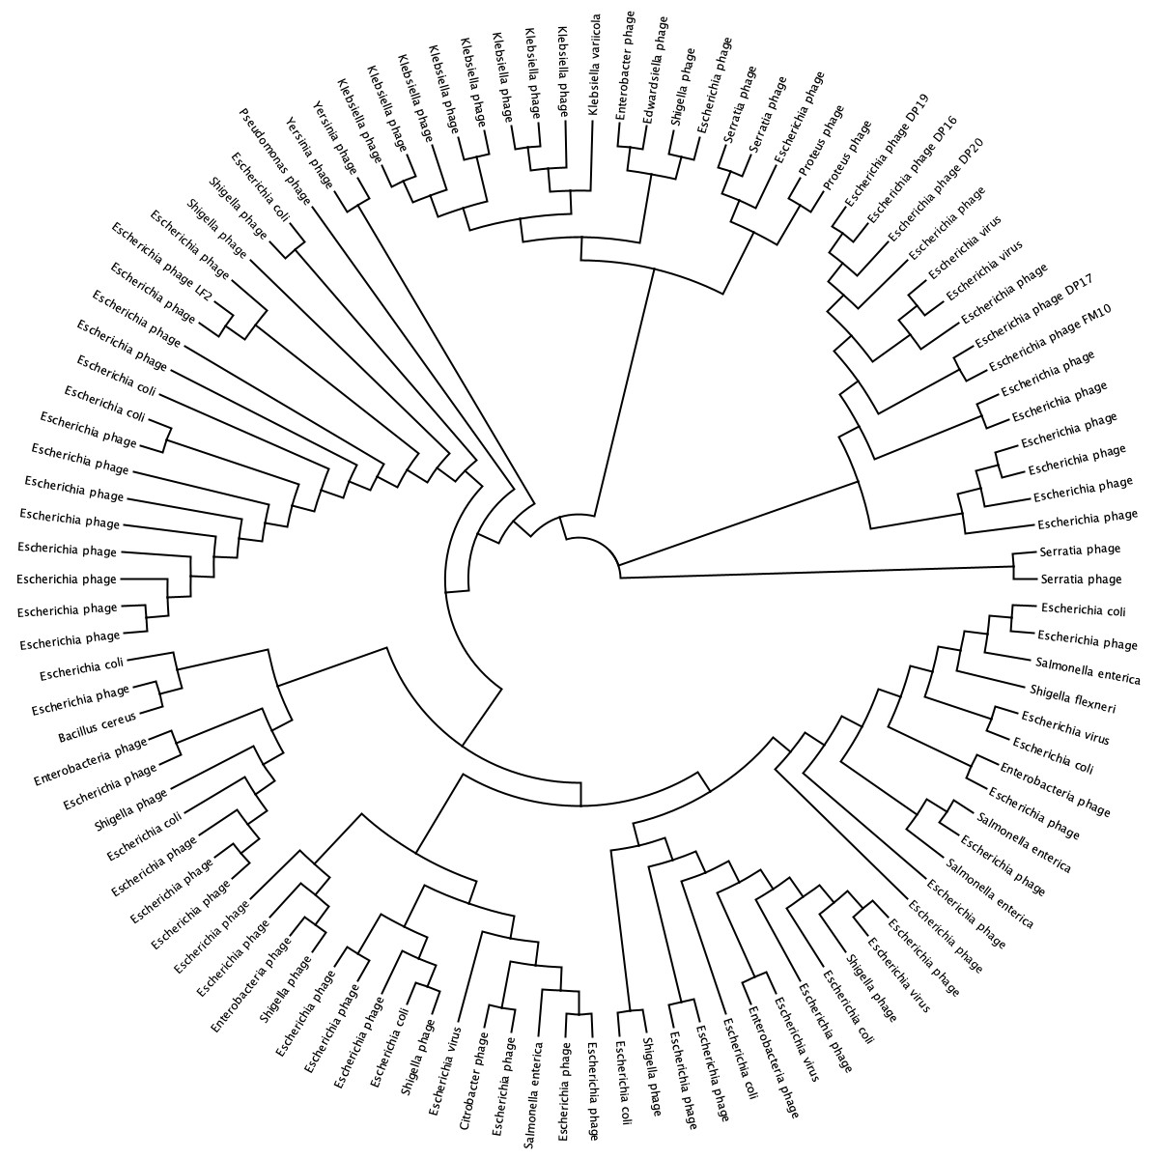

Supplementary figure 3. Phylogenetic tree of large terminase subunit. Image elaboration by Geneious Prime 2020 (https://www.geneious.com).

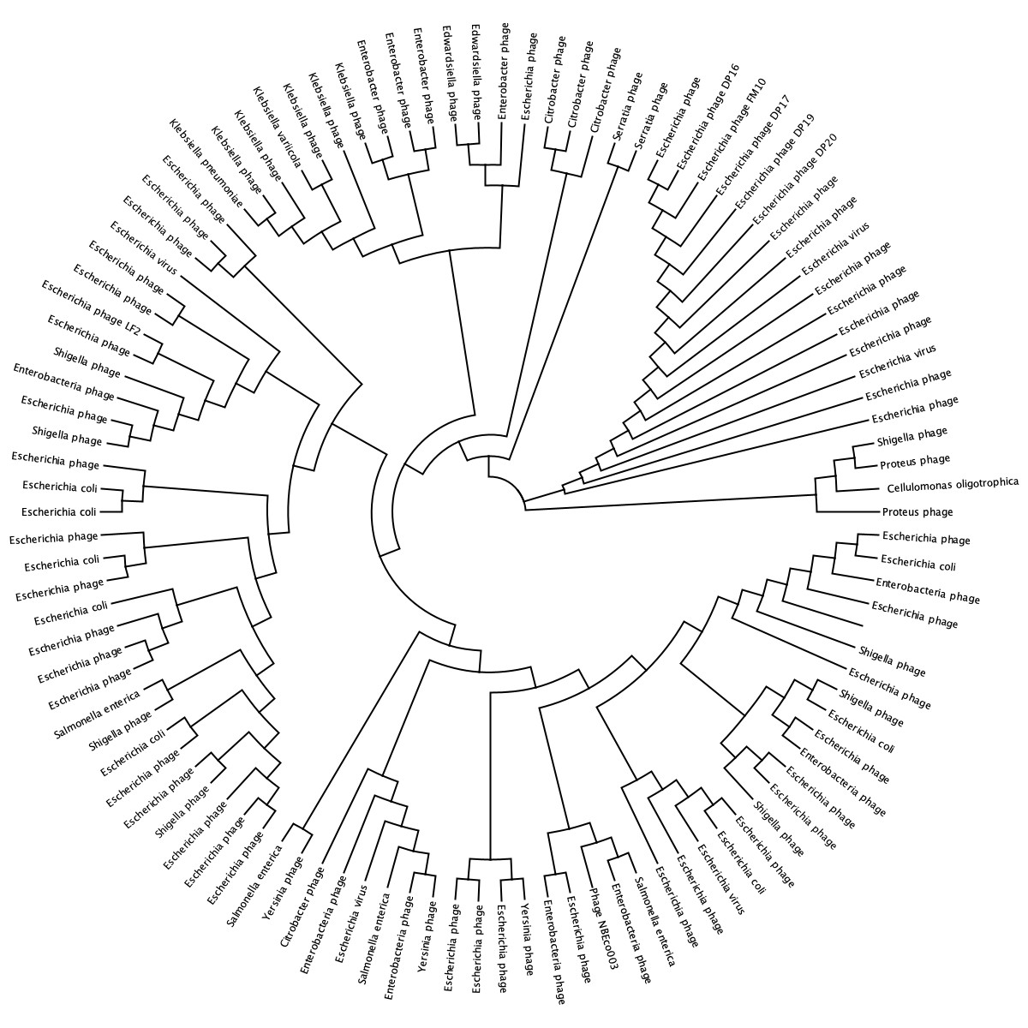

Supplementary table 1. Characteristics of E. coli used in this work. In prophage column, x: absence of prophage; v: presence of prophage; NP= information not available.
E. coli Strain | Pro-phage | Antibiotic Resistance | Source
EC01 | x | Ceftazidime, Ciprofloxacin, Ceftriaxone, Cefazolin, Cefepime, Cefoxitin, Ampicillin/Sulbactam, Piperacillin/Tazobactam | Body tissue, left middle finger tissue
EC06 | x | ampicillin | urine
EC07 | x | none | urine
EC08 | x | ampicilline, Trimethoprim/Sulfamethoxazole | urine
EC11 | v | none | urine
EC12 | x | ciprofloxacin, cefoxitin, gentamicin, tobramycin | urine
EC13 | x | none | urine
EC14 | x | none | urine
EC15 | x | none | urine
EC16 | x | Trimethoprim/Sulfamethoxazole | urine
EC17 | x | ampicillin, cefazolin | body tissue, right breast
EC18 | x | ciprofloxacin, ampicillin, trimethoprim/sulfamethoxazole | sputum
EC24 | x | Ampicillin, Ciprofloxacin, Trimethoprim/Sulfamethoxazole | urine
EC26 | x | Ampicillin, Trimethoprim/Sulfamethoxazole | urine
EC27 | x | Ampicillin, Trimethoprim/Sulfamethoxazole | urine
EC28 | x | Ampicillin | urine
EC35 | x | ampicillin | urine
EC38 | x | none | urine
EC39 | x | none | urine
EC41 | v | none | urine
EC42 | x | intermediate resistance to ampicillin | blood
EC43 | x | ampicillin | blood
EC48 | v | Ampicillin, Ciprofloxacin, Gentamicin, Tobramycin, Trimethoprim/sulfamethoxazole | urine
EC49 | v | Ampicillin, Ciprofloxacin, Trimethoprim/sulfamethoxazole | urine
EC51 | x | ampicillin, trimethoprim/sulfamethoxazole | urine
EC52 | x | ampicillin | urine
EC54 | x | ampicillin, sulbactam, trimethoprim/sulfamethoxazole | urine
EC55 | x | none | urine
EC56 | x | ampicillin, trimethoprim/sulfamethoxazole | urine
EC59 | x | none | peritoneal fluid abdomen
EC61 | x | ampicillin, trimethoprim/sulfamethoxazole | bone sacrum
EC62 | x | none | sputum
EC63 | v | ampicillin | urine
EC67 | x | ciprofloxacin, gentamicin, tobramycin | urine
EC68 | x
EC70 | x | none | urine
EC71 | x | ampicillin, ciprofloxacin, ampicillin/sulbactam, trimethoprim/sulfamethoxazole | urine
EC72 | x | none | urine
EC74 | x | trimethoprim/sulfamethoxazole | urine
EC75 | x | none | urine
EC76 | x | none | urine
EC77 | v | none | urine
EC82 | x | ampicillin, ceftriaxone, cefazolin, cefoxitin, ampicillin/sulbactam | urine
EC83 | x | none | urine
EC84 | x | ampicillin, trimethoprim/sulfamethoxazole | urine
EC86 | x | none | urine
EC87 | x | none | urine
EC88 | x | none | urine
EC89 | x | ampicillin, trimethoprim/sulfamethoxazole | urine
EC90 | x | nitrofurantoin | urine
EC91 | x | ampicillin, cefazolin, ampicillin/sulbactam, trimethoprim/sulfamethoxazole | urine
EC96 | v | ampicillin, ampicillin/sulbactam, trimethoprim/sulfamethoxazole | blood
EC97 | x | ampicillin, ampicillin/sulbactam, trimethoprim/sulfamethoxazole | blood
EC99 | x | none | urine
EC100 | x | none | urine
EC103 | v | none | urine
EC104 | x | none | urine
EC105 | x | ceftriaxone, certazidime, cefazolin, cefepime, cefoxitin, ampicillin/sulbactam, piperacillin/tazobactam, ampicillin | urine
EC106 | x | none | urine
EC107 | v | none | urine
EC110 | v | ampicillin | urine
EC111 | v | ampicillin, cefazolin, cefoxitin, ampicillin/sulbactam, trimethoprim/sulfamethoxazole, piperacillin/tazobactam | blood
EC112 | v | ampicillin | urine
EC113 | x | ampicillin, ciprofloxacin, ampicillin/sulbactam, trimethoprim/sulfamethoxazole | blood
EC114 | x | ceftazidime, ceftriaxone, cefazolin, cefepime, cefoxitin, ampicillin/sulbactam, piperacillin/tazobactam, ampicillin | urine
EC115 | x | trimethoprim/sulfamethoxazole | urine
EC117 | x | ampicillin, ceftazidime, ceftriaxone, cefazolin, cefepime, cefoxitin, ampicillin/sulbactam, piperacillin/tazobactam | blood
EC120 | x | none | urine
EC123 | x | none | urine
EC124 | x | ampicillin, cipro, cefox, gentamicin, tobramycin, ampicillin/sulbactam, trimethoprim/sulfamethoxazole | urine
EC125 | x | none | urine
EC126 | v | none | urine
EC130 | x | none | urine
EC131 | x | ampicillin, ampicillin/sulbactam | urine
EC132 | x | ampicillin, ampicillin/sulbactam | urine
EC133 | x | none | urine
EC134 | x | meropenem | urine
EC139 | x | none | urine
EC140 | x | none | urine
EC142 | x | none | urine
EC143 | x | ampicillin, ampicillin/sulbactam | urine
EC144 | x | ceftazidime, ceftriaxone, cefazolin, cefepime, cefoxitin, ampicillin/sulbactam, piperacillin/tazobactam, ampicillin | urine
EC145 | x | ertapenem | urine
EC146 | x | ampicillin, gentamicin, tobramycin, ampicillin.sulbactam | urine
EC149 | v | none | urine
EC151 | x | none | urine
EC152 | v | ampicillin, ampicillin/sulbactam | urine
EC154 | x | ampicillin, cefazolin, cefoxitin, ampicillin/sulbactam | body site breast, right post anitbiotics
EC157 | x | ampicillin, cefazolin, cefoxitin, ampicillin/sulbactam | body site esophagus
EC165 | x | none | urine
EC166 | x | none | urine
EC168 | x | none | expectorated sputum
EC172 | x | ampicillin | urine
EC173 | v | ampicillin, cipro, ampicillin/sulbactam | urine
EC176 | x | ampicillin, gentamicin, tobramycin, ampicillin/sulbactam | urine
EC177 | x | ampicillin, cipro, cefazolin, gentamicin, tobramycin, ampicillin/sulbactam, trimethoprim/sulfamethoxazole | urine
EC178 | x | ampicillin, ampicillin/sulbactam, trimethoprim/sulfamethoxazole | urine
EC180 | x | none | expectorated sputum
EC183 | x | none | urine
EC186 | x | none | urine
EC187 | x | none | urine
EC188 | x | none | urine
EC189 | x | none | urine
EC190 | v | none | urine
EC193 | x | gentamicin, tobramycin | blood
EC194 | x | ampicillin, cipro, gentamicin, tobramycin, trimethoprim/sulfamethoxazole | blood
EC195 | x | ampicillin, cipro, ceftazolin, cefoxitin, ampicillin/sulbactam, trimethoprim/sulfamethoxazole, piperacillin/tazobactam | blood
EC196 | v | ampicillin, ceftazidime, cipro, ceftriaxone, cefazolin, cefepime, cefoxitin, ampicillin/sulbactam, trimethoprim/sulfamethoxazole, piperacillin/tazobactam | sputum
EC197 | x | ampicillin, cefazolin, cefoxitin, ampicillin/sulbactam | body tissue breast, right
EC201 | x | none | urine
EC202 | x | none | urine
EC203 | x | ceftazidime, cipro, ceftriaxone, cefazolin, cefepime, cefoxitin, gentamicin, tobramycin, ampicllin/sulbactam, trimethoprim/sulfamethoxazole, piperacillin/tazobactam | urine
EC204 | x | ampicllin, gentamicin | urine
EC205 | v | none | urine
EC206 | x | none | urine
EC207 | x | none | urine
EC208 | x | none | urine
EC210 | x | ampicillin, ampicillin/sulbactam, trimethoprim/sulfamethoxazole | urine
EC218 | x | none | urine
EC222 | x | cipro, cefox, | urine
EC227 | x | none | urine
EC228 | x | none | urine
EC229 | v | none | urine
EC232 | x | none | urine
EC234 | x | none | urine
EC235 | x | none | urine
EC237 | x | none | urine
EC238 | x | none | urine
EC242 | v | none | urine
EC245 | x | none | body site knee, left
EC246 | x | amp, apm/sulbact, trimeth/sulfa | urine
EC247 | v | amp, amp/sulbact, cefazolin, cefox, trimeth/sulfa, cefepime, ceftazidime, cipro | urine
EC248 | x | amp, cefazolin, amp/sulbact | urine
EC249 | x | amp, cefazolin, cefox, amp/sulbact | urine
EC250 | v | amp, cefox, amp/sulbact | urine
EC254 | x | none | urine
EC257 | v | none | urine
EC258 | x | amp, amp/sulbact | urine
EC259 | x | none | urine
EC260 | v | none | urine
EC265 | x | none | expectorated sputum
EC266 | x | amp, ceftazidime, cipro, ceftriaxone, cefaz, cefepime, cefox, genta, tobra, amp/sulbat, trimeth/sulfa, piper/tazo | body tissue right, deep wound tissue femur
EC267 | x | none | aspirate axilla, left
EC269 | x | ceftazidime, cipro, ceftriax, cefaz, cefepime, cefox, genta, tobra, amp/sulbact, trimeth/sulfa, piper/tazo | expectorated sputum - cystic fibrosis
EC270 | x | amp, amp/sulbact, trimeth/sulfa | body site cervix
EC271 | x | amp, genta, tobray, trimeth/sulfa | urine
EC272 | x | none | urine
EC275 | x | N/A | urine
EC277 | x | amp, ceftazidime, cipro, ceftriax, cefaz, cefepime, cefox, genta, tobra, amp/sulbac, trimeth/sulfa, piper/tazo | sputum ling, right
EC282 | x | none | urine
EC283 | x | none | urine
EC284 | x | nitrofurantoin | urine
EC285 | x | amp, cipro, genta, tobra, amp/sulbact | urine
EC288 | x | none | urine
EC289 | x | none | urine
EC290 | x | amp, amp./sulbact | urine
EC291 | x | amp, genta, amp/sulbact | urine
EC292 | x | amp, amp/sulbact | urine
EC293 | x | amp, amp/sulbact | urine
EC294 | x | amp, amp/sulbact | urine
EC295 | x | none | urine
EC300 | x | ampicillin, cipro, genta, tobra, amp/sulbact, trimeth/sulfa | lesion leg
EC301 | x | none | abscess anal skin e-swab
EC302 | x | amp, cipro, amp/sulbact | urine
EC303 | x | none | urine
EC306 | x |  | urine
EC308 | x | amp, cgenta, tobra, amp/sulbact, trimeth/sulfa | urine
EC309 | x | none | urine
EC310 | x | none | urine
EC311 | x | cipro, genta, tobra | urine
EC314 | x | none | blood
EC315 | x | amp, cipro, ceftriax, cefaz, nitro, ceftaz | urine
EC319 | x | none | urine
EC320 | x | amp, amp/sulbact, trimeth/sulfa | urine
EC321 | x | amp, cipro, cefaz, genta, tobra, amp.sulbact, trimeth/sulfa | urine
EC326 | x | cipro, trimeth/sulfa | urine
EC327 | x | none | urine
EC328 | x | amp, amp/sulbact | urine
EC329 | x | amp, trimeth/sulfa | urine
EC330 | x | none | urine
EC331 | x | none | urine
EC332 | x | none | urine
EC334 | x | none | urine
EC335 | x | amp, amp/sulbact, trimeth/sulfa | urine
EC339 | x | cipro, cefox | urine
EC340 | x | amp, amp/sulbact | urine
EC341 | v | cipro, | urine
EC344 | x | none | urine
EC346 | x | amp, amp/sulbact, trimeth/sulfa | urine
EC347 | x | amp, amp/sulbact | urine
EC349 | v | none | urine
EC352 | x | none | urine
EC353 | v | amp, ceftaz, cipro, ceftriax, cefaz, cefepime, cefox, amp/sulbact, piper/tazo | urine
EC356 | x | none | urine
EC357 | v | none | urine
EC358 | x | amp, amp/sulbact | urine
EC359 | x | none | urine
EC360 | x | amp, amp/sulbact | urine
EC361 | x | none | urine
EC362 | x | none | aspirate breast
EC363 | x | amp, amp/sulbact | sputum bronchus
EC364 | x | amp, cipro, cefaz, cefox, amp/sulbact, trimeth/sulfa, piper/tazo | tracheal aspirate
EC366 | x | amp, ceftaz, ceftriax, cefaz, cefox, amp/sulbact | urine
EC367 | x | none | urine
EC370 | x | amp, cipro, genta, tobra, trimeth/sulfa | urine
EC371 | x | cipro, trimeth/sulfa | urine
EC374 | v | none | urine
EC375 | v | none | urine
EC379 | x | amp, tobra, amp/sulbact, trimeth/sulfa, piper/tazo | urine
EC389 | x | none | urine
EC391 | x | none | urine
EC397 | x | amp, amp/sulbact | urine
EC398 | x | none | urine
EC401 | x | none | urine
EC404 | x | none | urine
EC405 | v | none | urine
EC406 | v | amp, amp/sulbact, trimeth/sulfa | urine
EC410 | v | none | urine
EC415 | v | amp, ceftaz, ceftriax, cefaz, cefox, amp/sulbact, trimeth/sulfa, piper/tazo | urine
EC416 | x | none | urine
EC418 | v | amp, amp/sulbact | urine
EC425 | x | amp, cefaz, cefox, amp/sulbact | urine
EC426 | x | amp, cipro, amp/sulbact, trimeth/sulfa | urine
EC427 | x | cipro. trimeth/sulfa | urine
EC429 | x | amp, amp./sulbact, trimeth/sulfa | urine
EC433 | x | none | urine
EC435 | x | amp, amp/sulbact, trimeth/sulfa | urine
EC436 | x | amp, genta, tobra, amp/sulbact, trimeth/sulfa | urine
EC438 | x | none | urine
EC442 | x | ceftaz, cipro, ceftriax, cefaz, cefepime, cefox, genta, amp/sulbact, piper/tazo, amp | urine
EC443 | v | none | urine
EC445 | x | cipr, amp/sulbact, trimeth/sulfa, amp | sputum - cystic fibrosis
EC447 | x | amp, amp/sulbact | blood
EC448 | x | none | blood
EC452 | x | none | placenta
EC456 | x | amp, amp/sulbact | urine
EC460 | x |  | expectorated sputum
EC465 | x | amp, cipro, cefaz, genta, tobra, amp.sulbact, trimeth/sulfa | urine
EC466 | x | none | urine
EC467 | x | none | urine
EC468 | x | none | urine
EC478 | x | none | urine
EC482 | v | trimeth/sulfa | urine
EC483 | x | none | urine
EC484 | x | none | urine
EC485 | v | amp, amp/sulbact | urine
EC486 | x | amp, trimeth/sulfa | urine
EC487 | x | amp, amp/sulbact, piper/tazo | urine
EC488 | x | none | urine
EC489 | x | none | urine
EC492 | x | amp, amp/sulbact | urine
EC493 | v | amp, amp/sulbact | urine
EC494 | x | none | urine
EC495 | x | none | urine
EC498 | x | none | urine
EC499 | x | amp, amp/sulbact | urine
EC500 | v | amp, ceftaz, ceftrix, cefaz, cefox, amp./sulbact | urine
EC501 | v | amp, genta, amp/sulbact, trimeth/sulfa | urine
EC502 | x | amp, amp/sulbact, trimeth/sulfa | urine
EC503 | x | none | urine
EC504 | x | none | urine
EC505 | v | none | urine
EC506 | x | amp, amp/sulbact | urine
EC507 | x | amp, amp/sulbact | urine
EC508 | x | none | urine
EC509 | v | none | urine
ELI3 | v | NP | urine
ELI5 | x | NP | urine
ELI6 | x | NP | urine
ELI7 | x | NP | urine
ELI18 | x | NP | urine
ELI19 | v | NP | urine
ELI25 | x | NP | urine
ELI26 | x | NP | urine
ELI29 | x | NP | urine
ELI30 | x | NP | urine
ELI33 | x | NP | urine
ELI34 | x | NP | urine
ELI35 | x | NP | urine
ELI36 | x | NP | urine
ELI37 | v | NP | urine
ELI41 | x | NP | urine
ELI42 | x | NP | urine
ELI43 | v | NP | urine
ELI44 | v | NP | urine
ELI45 | v | NP | urine
ELI46 | x | NP | urine
ELI47 | x | NP | urine
ELI48 | x | NP | urine
ELI49 | x | NP | urine
ELI50 | x | NP | urine
ELI51 | x | NP | urine
ELI57 | x | NP | urine
ELI58 | v | NP | urine
ELI63 | x | NP | urine
ELI73 | x | NP | urine
ELI74 | x | NP | urine
ELI75 | x | NP | urine
ELI103 | x | NP | urine
ELI106 | x | NP | urine
ELI108 | x | NP | urine
ELI110 | x | NP | urine
ELI111 | v | NP | urine
ELI112 | x | NP | urine
ELI113 | x | NP | urine
ELI123 | x | NP | urine
ELI129 | x | NP | urine
ELI130 | v | NP | urine
ELI131 | x | NP | urine
ELI132 | x | NP | urine
ELI137 | x | NP | urine
ELI138 | x | NP | urine
ELI145 | x | NP | urine
ELI146 | x | NP | urine
ELI147 | v | NP | urine
ELI148 | x | NP | urine
ELI151 | v | NP | urine
ELI154 | x | NP | urine
ELI158 | x | NP | urine
ELI159 | v | NP | urine
ELI161 | x | NP | urine
ELI167 | x | NP | urine
ELI168 | x | NP | urine
ELI176 | x | NP | urine
ELI177 | v | NP | urine
ELI178 | x | NP | urine
ELI181 | x | NP | urine
ELI188 | x | NP | urine
Shigella spp. Strain | Pro-phage | Antibiotic Resistance | Source
SH01 | x | Amp, sulfamethoxazole/trimethoprim., Cipro, Azithro | faeces
SH10 | x | Amp, Cipro, sulfamethoxazole/trimethoprim, azithro | faeces
SH11 | x | Amp, sulfamethoxazole/trimethoprim, Azithro | faeces
SH12 | x | amp, cipro, sulfamethoxazole/trimethoprim | faeces
SH13 | x | Amp, Cipro, TMP/SMX | faeces
SH14 | x | Amp, Cipro, Tmp-smx | faeces
SH15 | x | Amp, Tmp-smx | faeces
SH16 | x | Tmp-Smx | faeces
SH17 | x | Amp-R, Tmp-Smx | faeces
SH18 | v | none | faeces
SH19 | x | none | faeces
SH20 | x | Amp, Amik, Cipro, Cefri, Cefo, Genta, Tobra, Tmp-smx, Cefza,  Cefe | faeces
SH21 | x | none | faeces
SH22 | x | none | faeces
SH23 | x | none | faeces
SH24 | x | none | faeces
SH25 | x | none | faeces
SH26 | x | none | faeces
SH27 | x | none | faeces
SH28 | x | none | faeces
SH29 | x | none | faeces
SH30 | x | none | faeces
SH31 | x | none | faeces
SH32 | x | none | faeces
SH33 | x | none | faeces
SH34 | x | none | faeces

Supplementary Table 2. Comparison of the area under the growth curves (AUC) between bacterial cultures with and without phage addition. AUC values are expressed as mean ± standard deviation (SD). The AUC of each replicate is calculated using the Growthcurver package in R (version 4.5.1, R Core Team), and differences between conditions are evaluated using the t-test (p < 0.05).

SH12 | LF2MOI1* | LF2MOI5* | LF2MOI10* | DP16MOI1* | DP16MOI5* | DP16MOI10* | Control
Average | 14,152 | 9,879 | 1,383 | 1,623 | 0,970 | 0,679 | 51,829
St. dev. | 0,224 | 0,460 | 1,201 | 1,838 | 0,842 | 0,651 | 1,094
SH22 | LF2MOI1 | LF2MOI5 | LF2MOI10 | DP16MOI1* | DP16MOI5* | DP16MOI10* | Control
Average | 21,494 | 21,018 | 22,342 | 1,557 | 0,439 | 0,409 | 15,360
St. dev. | 1,264 | 3,211 | 1,594 | 2,697 | 0,390 | 0,708 | 0,301
SH10 | LF2MOI1* | LF2MOI5* | LF2MOI10* | DP16MOI1* | DP16MOI5* | DP16MOI10* | Control
Average | 10,856 | 12,009 | 14,590 | 0,215 | 0,318 | 1,184 | 43,309
St. dev. | 0,400 | 1,382 | 2,450 | 0,373 | 0,552 | 0,911 | 1,100
SH21 | LF2MOI1* | LF2MOI5* | LF2MOI10* | DP16MOI1* | DP16MOI5* | DP16MOI10* | LF2MOI1+DP16MOI1* | LF2MOI1+DP16MOI5* | LF2MOI1+DP16MOI10* | Control
Average | 12,433 | 12,382 | 7,241 | 24,484 | 20,768 | 13,441 | 14,797 | 13,302 | 12,103 | 31,210
St. dev. | 2,585 | 2,148 | 2,698 | 2,964 | 3,166 | 2,217 | 0,537 | 1,391 | 1,207 | 2,044

Supplementary table 3.
Correlation coefficients with rho values for each antibiotic–phage pair. Pairwise associations were evaluated using tetrachoric correlations for binary resistance variables.
★: represents statistically significant associations (p < 0.05, chi-square test or Fisher’s exact test).
 | LF2 | FM10 | DP16 | DP16 | DP19 | DP19
ceftazidime | -0.02 | -0.07 | 0.08 | 0.07 | -0.11 | 0.11
ciprofloxacin | 0.04 | 0.03 | 0.09 | 0.01 | 0.02 | 0.1
ceftriaxone | 0.02 | -0.07 | 0.08 | 0.07 | -0.07 | 0.11
cefazolin | -0.09 | -0.12 | 0.08 | -0.07 | -0.11 | 0.13*
cefepime | -0.02 | 0.01 | 0.03 | 0.02 | -0.11 | 0.08
cefoxitin | -0.1 | -0.09 | 0.06 | -0.06 | -0.14* | 0.05
ampicillin/sulbactam | -0.08 | -0.12 | 0.02 | -0.09 | -0.07 | 0.04
piperacillin/tazobactam | -0.08 | 0.03 | 0.03 | -0.05 | -0.13* | 0.06
ampicillin | -0.02 | -0.11 | 0.08 | 0 | -0.03 | 0.05
trimethoprim/sulfamethoxazole | 0.08 | 0.01 | 0.14* | 0.08 | 0.08 | 0.1
tobramycin | -0.06 | 0.07 | 0 | 0.05 | -0.09 | 0.03
gentamicin | -0.03 | 0.03 | -0.01 | 0.07 | -0.04 | 0.04
sulbactam | 0 | 0.03 | -0.04 | -0.02 | -0.02 | -0.04
nitrofurantoin | 0.04 | -0.07 | -0.09 | 0.01 | 0.01 | -0.09
meropenem | -0.06 | 0.02 | -0.1 | -0.08 | 0.05 | 0.04
ertapenem | 0.06 | 0.02 | 0.04 | 0.05 | -0.08 | 0.04
azithromycin | 0.11 | 0.04 | 0.07 | 0.09 | 0.09 | 0.07

Supplementary table 4. Coding sequence (CDS) of bacteriophage FM2. Minimum and maximum indicates the star and stop codon.
Name | Type | Minimum | Maximum | Length | Direction
hypothetical protein CDS | CDS | 168854 | 169429 | 576 | reverse
Phage protein CDS | CDS | 168202 | 168804 | 603 | reverse
Phage protein CDS | CDS | 167838 | 168212 | 375 | reverse
Phage protein CDS | CDS | 167500 | 167859 | 360 | reverse
Phage protein (ACLAME 1472) CDS | CDS | 167198 | 167503 | 306 | reverse
Phage protein CDS | CDS | 166916 | 167188 | 273 | reverse
Phage protein CDS | CDS | 166709 | 166906 | 198 | reverse
Phage protein CDS | CDS | 166407 | 166646 | 240 | reverse
hypothetical protein CDS | CDS | 165422 | 166378 | 957 | reverse
hypothetical protein CDS | CDS | 165141 | 165341 | 201 | reverse
Phage protein CDS | CDS | 164777 | 165082 | 306 | reverse
Phage protein CDS | CDS | 164089 | 164775 | 687 | reverse
Phage protein CDS | CDS | 163598 | 164089 | 492 | reverse
Phage protein CDS | CDS | 163365 | 163601 | 237 | reverse
Phage Nudix hydrolase (ACLAME 1506) CDS | CDS | 162917 | 163375 | 459 | reverse
Phage lysozyme R (EC 3.2.1.17) CDS | CDS | 162394 | 162882 | 489 | reverse
Phage protein CDS | CDS | 162116 | 162397 | 282 | reverse
Phage endonuclease CDS | CDS | 161644 | 162057 | 414 | reverse
Phage protein CDS | CDS | 161376 | 161630 | 255 | reverse
Phage protein CDS | CDS | 160997 | 161311 | 315 | reverse
Phage protein CDS | CDS | 160642 | 160971 | 330 | reverse
Phage protein CDS | CDS | 159930 | 160469 | 540 | reverse
Phage protein CDS | CDS | 159625 | 159933 | 309 | reverse
Autonomous glycyl radical cofactor CDS | CDS | 159256 | 159618 | 363 | reverse
Phage protein CDS | CDS | 159032 | 159256 | 225 | reverse
Phage protein CDS | CDS | 158776 | 159042 | 267 | reverse
Phage protein CDS | CDS | 158561 | 158776 | 216 | reverse
Phage endonuclease CDS | CDS | 158041 | 158499 | 459 | reverse
hypothetical protein CDS | CDS | 157490 | 158032 | 543 | reverse
Valyl-tRNA synthetase CDS | CDS | 157146 | 157493 | 348 | reverse
Phage protein CDS | CDS | 156686 | 157153 | 468 | reverse
Phage protein CDS | CDS | 156477 | 156689 | 213 | reverse
Phage protein CDS | CDS | 156274 | 156480 | 207 | reverse
Phage protein CDS | CDS | 156095 | 156277 | 183 | reverse
Thymidine kinase CDS | CDS | 155504 | 156085 | 582 | reverse
Phage protein CDS | CDS | 155264 | 155476 | 213 | reverse
Phage rI lysis inhibition regulator (ACLAME 1105) CDS | CDS | 154949 | 155251 | 303 | reverse
Phage protein CDS | CDS | 154668 | 154847 | 180 | reverse
Phage protein CDS | CDS | 154454 | 154660 | 207 | reverse
Phage protein CDS | CDS | 154286 | 154396 | 111 | reverse
Phage protein CDS | CDS | 154110 | 154289 | 180 | reverse
Phage protein CDS | CDS | 153578 | 154108 | 531 | reverse
Phage protein CDS | CDS | 153095 | 153568 | 474 | reverse
Thioredoxin, phage-associated CDS | CDS | 152109 | 153095 | 987 | reverse
hypothetical protein CDS | CDS | 151815 | 152081 | 267 | reverse
Thioredoxin, phage-associated CDS | CDS | 150716 | 151696 | 981 | reverse
Thioredoxin, phage-associated CDS | CDS | 150291 | 150578 | 288 | reverse
Thioredoxin, phage-associated CDS | CDS | 149705 | 150232 | 528 | reverse
Thioredoxin, phage-associated CDS | CDS | 148647 | 149642 | 996 | reverse
Thioredoxin, phage-associated CDS | CDS | 147632 | 148591 | 960 | reverse
Thioredoxin, phage-associated CDS | CDS | 146619 | 147569 | 951 | reverse
Thioredoxin, phage-associated CDS | CDS | 146314 | 146619 | 306 | reverse
hypothetical protein CDS | CDS | 145901 | 146314 | 414 | reverse
thioredoxin CDS | CDS | 145645 | 145908 | 264 | reverse
hypothetical protein CDS | CDS | 145352 | 145648 | 297 | reverse
hypothetical protein CDS | CDS | 144977 | 145333 | 357 | reverse
Phage protein CDS | CDS | 144678 | 144848 | 171 | reverse
Pin protease inhibitor CDS | CDS | 144263 | 144676 | 414 | reverse
Phage protein CDS | CDS | 144074 | 144253 | 180 | reverse
recombination endonuclease VII CDS | CDS | 143562 | 144035 | 474 | reverse
Ribonucleotide reductase of class III (anaerobic), large subunit (EC 1.17.4.2) CDS | CDS | 141748 | 143565 | 1818 | reverse
Ribonucleotide reductase of class III (anaerobic), activating protein (EC 1.97.1.4) CDS | CDS | 141281 | 141751 | 471 | reverse
Phage protein CDS | CDS | 141187 | 141303 | 117 | reverse
Phage protein CDS | CDS | 140955 | 141170 | 216 | reverse
Glutaredoxin CDS | CDS | 140345 | 140668 | 324 | reverse
Phage protein CDS | CDS | 139996 | 140178 | 183 | reverse
Phage protein CDS | CDS | 139751 | 139999 | 249 | reverse
Phage protein CDS | CDS | 139450 | 139743 | 294 | reverse
Phage protein CDS | CDS | 139308 | 139442 | 135 | reverse
Phage protein CDS | CDS | 139111 | 139311 | 201 | reverse
Phage protein CDS | CDS | 138808 | 139047 | 240 | reverse
Phage protein CDS | CDS | 138409 | 138741 | 333 | reverse
Phage protein CDS | CDS | 138185 | 138412 | 228 | reverse
Phage protein CDS | CDS | 137919 | 138188 | 270 | reverse
T4-like phage RNA polymerase sigma factor for late transcription CDS | CDS | 137289 | 137846 | 558 | reverse
Phage protein (ACLAME 855) CDS | CDS | 137090 | 137299 | 210 | reverse
Phage protein (ACLAME 780) CDS | CDS | 136765 | 137088 | 324 | reverse
Phage protein CDS | CDS | 136584 | 136790 | 207 | reverse
Phage protein CDS | CDS | 136371 | 136544 | 174 | reverse
Phage recombination-related endonuclease Gp47 CDS | CDS | 135282 | 136301 | 1020 | reverse
Phage protein CDS | CDS | 135028 | 135285 | 258 | reverse
Phage protein CDS | CDS | 134802 | 135041 | 240 | reverse
Phage recombination-related endonuclease Gp46 CDS | CDS | 133117 | 134805 | 1689 | reverse
Phage protein CDS | CDS | 132874 | 133062 | 189 | reverse
Phage RNA polymerase binding protein (EC 2.7.7.6) (ACLAME 854) CDS | CDS | 132445 | 132861 | 417 | reverse
Sliding clamp DNA polymerase accessory protein, phage associated CDS | CDS | 131716 | 132402 | 687 | reverse
Replication factor C small subunit / Phage DNA polymerase clamp loader subunit CDS | CDS | 130678 | 131640 | 963 | reverse
Phage DNA polymerase clamp loader subunit Gp62 CDS | CDS | 130113 | 130676 | 564 | reverse
Phage endoribonulcease translational repressor of early genes, regA CDS | CDS | 129742 | 130110 | 369 | reverse
hypothetical protein CDS | CDS | 126949 | 129660 | 2712 | reverse
D-arabinose-5-phosphate isomerase (EC 5.3.1.13) CDS | CDS | 126273 | 126908 | 636 | reverse
Phage protein CDS | CDS | 126133 | 126276 | 144 | reverse
Phage protein CDS | CDS | 124406 | 126091 | 1686 | reverse
hypothetical protein CDS | CDS | 124020 | 124406 | 387 | reverse
Phage protein CDS | CDS | 122803 | 123963 | 1161 | reverse
Phage protein CDS | CDS | 122567 | 122806 | 240 | reverse
hypothetical protein CDS | CDS | 121809 | 122525 | 717 | reverse
Phage protein CDS | CDS | 120910 | 121809 | 900 | reverse
Phage protein CDS | CDS | 120360 | 120908 | 549 | reverse
Phage recombination protein CDS | CDS | 119089 | 120261 | 1173 | reverse
Phage capsid and scaffold CDS | CDS | 118755 | 119096 | 342 | reverse
Phage DNA primase/helicase CDS | CDS | 117303 | 118745 | 1443 | reverse
Phage protein CDS | CDS | 116840 | 117214 | 375 | reverse
hypothetical protein CDS | CDS | 116467 | 116784 | 318 | reverse
discriminator of mRNA degradation, phage-associated CDS | CDS | 116282 | 116470 | 189 | reverse
Phage immunity CDS | CDS | 115842 | 116210 | 369 | reverse
Phage immunity CDS | CDS | 115532 | 115780 | 249 | reverse
hypothetical protein CDS | CDS | 115180 | 115473 | 294 | reverse
Phage protein CDS | CDS | 114528 | 115178 | 651 | reverse
Phage protein CDS | CDS | 114329 | 114526 | 198 | reverse
hypothetical protein CDS | CDS | 113842 | 114309 | 468 | reverse
DNA primase (EC 2.7.7.-) / DNA helicase (EC 3.6.1.-), phage-associated CDS | CDS | 112780 | 113802 | 1023 | reverse
hypothetical protein CDS | CDS | 112586 | 112783 | 198 | forward
dCTP pyrophosphatase (EC 3.6.1.12), phage-associated (ACLAME 965) CDS | CDS | 111976 | 112497 | 522 | reverse
Phage protein CDS | CDS | 111803 | 111976 | 174 | reverse
hypothetical protein CDS | CDS | 111589 | 111813 | 225 | reverse
hypothetical protein CDS | CDS | 111350 | 111586 | 237 | reverse
Phage protein CDS | CDS | 110807 | 111055 | 249 | reverse
Phage protein CDS | CDS | 110631 | 110810 | 180 | reverse
hypothetical protein CDS | CDS | 110167 | 110631 | 465 | reverse
Molybdenum ABC transporter, periplasmic molybdenum-binding protein ModA (TC 3.A.1.8.1) CDS | CDS | 109986 | 110165 | 180 | reverse
Phage protein CDS | CDS | 109825 | 109989 | 165 | reverse
hypothetical protein CDS | CDS | 109188 | 109769 | 582 | reverse
Phage ModA or ModB ribosyltransferase (ACLAME 972) CDS | CDS | 108522 | 109130 | 609 | reverse
putative anti-sigma factor CDS | CDS | 107623 | 108369 | 747 | reverse
Phage protein CDS | CDS | 107309 | 107620 | 312 | reverse
DNA helicase (EC 3.6.1.-), phage-associated CDS | CDS | 105999 | 107312 | 1314 | reverse
exonuclease CDS | CDS | 105312 | 105989 | 678 | reverse
hypothetical protein CDS | CDS | 104752 | 105246 | 495 | reverse
hypothetical protein CDS | CDS | 104234 | 104752 | 519 | reverse
Transcriptional regulator CDS | CDS | 103805 | 104224 | 420 | reverse
Transcriptional regulator CDS | CDS | 103221 | 103745 | 525 | reverse
Phage cef modifier of suppressor tRNAs (ACLAME 1240) CDS | CDS | 102936 | 103163 | 228 | reverse
Phage protein CDS | CDS | 102526 | 102936 | 411 | reverse
Phage protein (ACLAME 1508) CDS | CDS | 102344 | 102523 | 180 | reverse
hypothetical protein CDS | CDS | 101919 | 102341 | 423 | reverse
Phage DNA topoisomerase large subunit (EC 5.99.1.3) CDS | CDS | 100038 | 101855 | 1818 | reverse
Phage protein CDS | CDS | 98901 | 100001 | 1101 | reverse
Phage rIIA lysis inhibitor CDS | CDS | 98608 | 98808 | 201 | reverse
Phage rIIA lysis inhibitor CDS | CDS | 96382 | 98595 | 2214 | reverse
hypothetical protein CDS | CDS | 95425 | 96372 | 948 | reverse
hypothetical protein CDS | CDS | 95096 | 95383 | 288 | reverse
Phage endonuclease CDS | CDS | 94603 | 95079 | 477 | reverse
Phage protein CDS | CDS | 94271 | 94534 | 264 | reverse
hypothetical protein CDS | CDS | 94081 | 94191 | 111 | reverse
Phage protein CDS | CDS | 93820 | 94020 | 201 | reverse
hypothetical protein CDS | CDS | 93297 | 93743 | 447 | reverse
Acridine resistance CDS | CDS | 93098 | 93244 | 147 | reverse
Phage protein CDS | CDS | 92958 | 93098 | 141 | reverse
DNA topoisomerase, phage-associated CDS | CDS | 91628 | 92953 | 1326 | reverse
Putative transcriptional regulator MotA (ACLAME 1235) CDS | CDS | 90810 | 91442 | 633 | reverse
Phage anti-restriction nuclease CDS | CDS | 90470 | 90799 | 330 | reverse
hypothetical protein CDS | CDS | 90012 | 90473 | 462 | reverse
Phage anti-restriction nuclease CDS | CDS | 89731 | 90012 | 282 | reverse
hypothetical protein CDS | CDS | 89435 | 89554 | 120 | reverse
Phage protein CDS | CDS | 89146 | 89445 | 300 | reverse
Phage protein CDS | CDS | 88995 | 89156 | 162 | reverse
hypothetical protein CDS | CDS | 88676 | 88948 | 273 | reverse
Phage holin CDS | CDS | 88016 | 88675 | 660 | forward
Phage tail fibers CDS | CDS | 87455 | 88006 | 552 | forward
Phage tail fiber, side tail fiber protein Stf CDS | CDS | 84287 | 87424 | 3138 | forward
Phage tail fibers CDS | CDS | 83613 | 84278 | 666 | forward
Phage long tail fiber CDS | CDS | 82423 | 83550 | 1128 | forward
Phage long tail fiber CDS | CDS | 78539 | 82414 | 3876 | forward
Phage ribonuclease H (EC 3.1.26.4) CDS | CDS | 77518 | 78435 | 918 | reverse
Phage double-stranded DNA binding protein #T4-like dsbA, late transcriptional regulation #T4 GC1668 CDS | CDS | 77241 | 77510 | 270 | reverse
Transcriptional regulator CDS | CDS | 76925 | 77263 | 339 | reverse
Phage DNA helicase loader CDS | CDS | 76275 | 76928 | 654 | reverse
Single stranded DNA-binding protein, phage-associated CDS | CDS | 75254 | 76156 | 903 | reverse
Phage protein CDS | CDS | 74748 | 75140 | 393 | reverse
Phage protein CDS | CDS | 74437 | 74685 | 249 | reverse
hypothetical protein CDS | CDS | 74180 | 74434 | 255 | reverse
Dihydrofolate reductase, phage-associated CDS | CDS | 73605 | 74192 | 588 | reverse
Thymidylate synthase (EC 2.1.1.45) CDS | CDS | 72748 | 73608 | 861 | reverse
Phage protein CDS | CDS | 72492 | 72746 | 255 | reverse
Phage protein (ACLAME 596) CDS | CDS | 72187 | 72492 | 306 | reverse
Ribonucleotide reductase of class Ia (aerobic), alpha subunit (EC 1.17.4.1) CDS | CDS | 69941 | 72196 | 2256 | reverse
Ribonucleotide reductase of class Ia (aerobic), beta subunit (EC 1.17.4.1) CDS | CDS | 68709 | 69887 | 1179 | reverse
Phage endonuclease CDS | CDS | 68272 | 68682 | 411 | reverse
RNA ligase CDS | CDS | 67092 | 68216 | 1125 | reverse
Putative phage alc transcription terminator (ACLAME 1242) CDS | CDS | 66530 | 67030 | 501 | reverse
Phage spanin Rz CDS | CDS | 66186 | 66542 | 357 | reverse
Phage outer membrane lipoprotein Rz1 CDS | CDS | 65899 | 66189 | 291 | reverse
Phage protein CDS | CDS | 65684 | 65902 | 219 | reverse
Phage protein CDS | CDS | 65327 | 65626 | 300 | reverse
Phage protein CDS | CDS | 65136 | 65327 | 192 | reverse
3'-phosphatase, 5'-polynucleotide kinase, phage-associated CDS | CDS | 64240 | 65139 | 900 | reverse
Phage protein CDS | CDS | 64052 | 64240 | 189 | reverse
Phage protein CDS | CDS | 63844 | 64059 | 216 | reverse
Phage protein CDS | CDS | 63561 | 63836 | 276 | reverse
Phage protein CDS | CDS | 63263 | 63499 | 237 | reverse
hypothetical protein CDS | CDS | 63151 | 63276 | 126 | reverse
2-keto-3-deoxy-D-arabino-heptulosonate-7- phosphate synthase I alpha (EC 2.5.1.54) CDS | CDS | 62150 | 63142 | 993 | reverse
dCMP deaminase (EC 3.5.4.12) CDS | CDS | 61569 | 62150 | 582 | reverse
Phage tail fibers CDS | CDS | 61271 | 61567 | 297 | reverse
Phage head assembly chaperone protein CDS | CDS | 60881 | 61213 | 333 | reverse
Phage rIII lysis inhibitor accessory CDS | CDS | 60508 | 60756 | 249 | reverse
1,4-alpha-glucan (glycogen) branching enzyme, GH-13-type (EC 2.4.1.18) CDS | CDS | 60033 | 60212 | 180 | reverse
hypothetical protein CDS | CDS | 59534 | 59902 | 369 | reverse
Phage protein CDS | CDS | 59094 | 59459 | 366 | reverse
hypothetical protein CDS | CDS | 58444 | 59058 | 615 | reverse
Phage protein CDS | CDS | 58192 | 58389 | 198 | reverse
Phage protein CDS | CDS | 57984 | 58202 | 219 | reverse
hypothetical protein CDS | CDS | 57533 | 57991 | 459 | reverse
hypothetical protein CDS | CDS | 56721 | 57536 | 816 | reverse
Phage protein CDS | CDS | 56442 | 56711 | 270 | reverse
hypothetical protein CDS | CDS | 54952 | 56445 | 1494 | reverse
Phage protein CDS | CDS | 54764 | 54952 | 189 | reverse
Putative RNA polymerase-ADP-ribosyltransferase Alt (ACLAME 423) CDS | CDS | 52621 | 54708 | 2088 | reverse
Phage protein CDS | CDS | 52269 | 52562 | 294 | reverse
tail assembly protein CDS | CDS | 51274 | 52236 | 963 | forward
Phage baseplate tail tube cap (T4-like gp48) CDS | CDS | 50165 | 51274 | 1110 | forward
Phage baseplate hub CDS | CDS | 48384 | 50156 | 1773 | forward
Phage baseplate hub CDS | CDS | 47917 | 48387 | 471 | forward
baseplate hub subunit CDS | CDS | 46734 | 47906 | 1173 | forward
Phage baseplate CDS | CDS | 45985 | 46737 | 753 | forward
Phage baseplate hub assembly chaperone (T4-like gp26) CDS | CDS | 45311 | 45937 | 627 | reverse
Phage baseplate wedge subunit (T4-like gp25) CDS | CDS | 44913 | 45311 | 399 | reverse
Single stranded DNA-binding protein, phage-associated CDS | CDS | 44419 | 44913 | 495 | reverse
Phage protein CDS | CDS | 44195 | 44419 | 225 | reverse
Phage protein (ACLAME 856) CDS | CDS | 43995 | 44162 | 168 | reverse
Phage DNA helicase CDS | CDS | 43706 | 43936 | 231 | forward
Phage DNA helicase CDS | CDS | 42166 | 43680 | 1515 | forward
Inh inhibitor of gp21 prohead protease CDS | CDS | 41447 | 42115 | 669 | reverse
capsid and scaffold protein CDS | CDS | 40307 | 41437 | 1131 | reverse
Phage protein (ACLAME 967) CDS | CDS | 40011 | 40205 | 195 | reverse
Phage protein CDS | CDS | 39763 | 40014 | 252 | reverse
RNA ligase CDS | CDS | 38645 | 39643 | 999 | reverse
capsid vertex protein CDS | CDS | 37329 | 38612 | 1284 | forward
Phage protein CDS | CDS | 36958 | 37227 | 270 | reverse
major capsid protein CDS | CDS | 35337 | 36905 | 1569 | forward
Phage prohead assembly (scaffolding) protein CDS | CDS | 34507 | 35319 | 813 | forward
Phage prohead assembly (scaffolding) protein CDS | CDS | 33832 | 34473 | 642 | forward
Phage capsid and scaffold CDS | CDS | 33407 | 33832 | 426 | forward
Phage prohead core protein CDS | CDS | 33171 | 33407 | 237 | forward
putative portal vertex protein CDS | CDS | 31600 | 33171 | 1572 | forward
Phage tail tube CDS | CDS | 31024 | 31515 | 492 | forward
Phage tail sheath CDS | CDS | 28929 | 30911 | 1983 | forward
Phage terminase, large subunit CDS | CDS | 27063 | 28898 | 1836 | forward
Phage terminase, small subunit CDS | CDS | 26585 | 27079 | 495 | forward
Proximal tail sheath stabilization protein CDS | CDS | 25754 | 26575 | 822 | forward
Phage neck protein CDS | CDS | 24937 | 25701 | 765 | forward
Phage neck protein CDS | CDS | 24009 | 24935 | 927 | forward
Phage fibritin (wac) protein CDS | CDS | 22528 | 23976 | 1449 | forward
hypothetical protein CDS | CDS | 20945 | 22528 | 1584 | forward
baseplate wedge subunit and tail pin CDS | CDS | 20289 | 20948 | 660 | forward
hypothetical protein CDS | CDS | 18484 | 20289 | 1806 | forward
Phage baseplate wedge tail fiber connector (T4-like gp9) CDS | CDS | 17612 | 18484 | 873 | forward
Phage baseplate wedge subunit (T4-like gp8) CDS | CDS | 16535 | 17539 | 1005 | forward
Phage baseplate wedge initiator (T4-like gp7) CDS | CDS | 13444 | 16542 | 3099 | forward
Phage baseplate wedge subunit (T4-like gp6) CDS | CDS | 11474 | 13447 | 1974 | forward
Putative phospholipase (ACLAME 172) CDS | CDS | 11172 | 11465 | 294 | forward
Phage protein (ACLAME 782) CDS | CDS | 10696 | 11169 | 474 | forward
Phage baseplate hub structural protein / Phage lysozyme R (EC 3.2.1.17) CDS | CDS | 8917 | 10650 | 1734 | forward
baseplate wedge subunit CDS | CDS | 8342 | 8917 | 576 | forward
Phage head completion protein CDS | CDS | 7831 | 8280 | 450 | reverse
DNA end protector protein CDS | CDS | 7007 | 7828 | 822 | reverse
hypothetical protein CDS | CDS | 6320 | 6904 | 585 | reverse
deoxynucleoside monophosphate kinase CDS | CDS | 5532 | 6266 | 735 | reverse
Phage tail fiber assembly protein CDS | CDS | 5297 | 5527 | 231 | reverse
hypothetical protein CDS | CDS | 4842 | 5297 | 456 | reverse
Phage protein CDS | CDS | 4477 | 4764 | 288 | reverse
[Enterobacteria phage IME08.] CDS | CDS | 4143 | 4406 | 264 | reverse
Phage protein CDS | CDS | 3888 | 4073 | 186 | reverse
Phage protein CDS | CDS | 3524 | 3886 | 363 | reverse
Phage protein CDS | CDS | 3237 | 3527 | 291 | reverse
Phage protein CDS | CDS | 2717 | 3232 | 516 | reverse
tRNA-Met-CAT | tRNA | 2564 | 2637 | 74 | reverse
tRNA-Arg-TCT | tRNA | 2484 | 2557 | 74 | reverse
Phage protein CDS | CDS | 2118 | 2462 | 345 | reverse
hypothetical protein CDS | CDS | 1269 | 1733 | 465 | reverse
hypothetical protein CDS | CDS | 642 | 1145 | 504 | reverse
Phage protein CDS | CDS | 418 | 582 | 165 | reverse
Phage protein CDS | CDS | 144 | 371 | 228 | reverse
hypothetical protein CDS | CDS | 2 | 73 | 72 | reverse

Supplementary table 5. Coding Sequence (CDS) of bacteriophage FM10. Minimum and maximum indicates the star and stop codon.
Name | Minimum | Maximum | Length | Direction
hypothetical protein CDS | 162782 | 163588 | 807 | forward
putative single-stranded DNA binding protein CDS | 161694 | 162662 | 969 | forward
Phage DNA helicase loader CDS | 160953 | 161633 | 681 | forward
Phage late transcriptional regulator #T4-like phage gp33, activator #T4 GC1667 CDS | 160689 | 160943 | 255 | forward
Phage double-stranded DNA binding protein #T4-like dsbA, late transcriptional regulation #T4 GC1668 CDS | 160421 | 160696 | 276 | forward
Adenylate cyclase (EC 4.6.1.1) CDS | 159817 | 160416 | 600 | forward
Phage ribonuclease H (EC 3.1.26.4) CDS | 158859 | 159806 | 948 | forward
Phage protein CDS | 158671 | 158856 | 186 | forward
long tail fiber proximal subunit CDS | 154856 | 158596 | 3741 | reverse
hypothetical protein CDS | 153683 | 154822 | 1140 | reverse
hypothetical protein CDS | 151990 | 153480 | 1491 | reverse
hypothetical protein CDS | 148989 | 151919 | 2931 | reverse
Phage protein CDS | 148709 | 148948 | 240 | reverse
hypothetical protein CDS | 148019 | 148675 | 657 | reverse
Phage protein CDS | 147735 | 147983 | 249 | forward
Phage protein CDS | 147427 | 147738 | 312 | forward
Phage protein CDS | 147070 | 147402 | 333 | forward
Phage protein CDS | 146693 | 147061 | 369 | forward
Phage protein CDS | 146491 | 146682 | 192 | forward
Phage protein CDS | 146189 | 146467 | 279 | forward
hypothetical protein CDS | 145419 | 146177 | 759 | forward
Phage protein CDS | 145193 | 145348 | 156 | forward
Phage protein CDS | 144911 | 145123 | 213 | forward
hypothetical protein CDS | 144599 | 144841 | 243 | forward
hypothetical protein CDS | 144335 | 144535 | 201 | forward
Phage protein CDS | 144168 | 144338 | 171 | forward
Phage protein CDS | 143891 | 144163 | 273 | forward
hypothetical protein CDS | 143618 | 143824 | 207 | forward
Phage protein CDS | 143110 | 143505 | 396 | forward
Phage protein CDS | 142909 | 143106 | 198 | forward
DNA topoisomerase, phage-associated CDS | 141542 | 142906 | 1365 | forward
Phage protein CDS | 141172 | 141534 | 363 | forward
Phage protein CDS | 140876 | 141169 | 294 | forward
Phage protein CDS | 140513 | 140830 | 318 | forward
phage T4-like protein, rIIA-rIIB membrane associated lysis inhibitor # T4 GC 1698 CDS | 139506 | 140498 | 993 | forward
Phage protein CDS | 139313 | 139444 | 132 | forward
hypothetical protein CDS | 137193 | 139301 | 2109 | forward
Phage protein CDS | 136921 | 137178 | 258 | forward
Phage protein CDS | 136715 | 136909 | 195 | forward
Phage protein CDS | 136528 | 136722 | 195 | forward
Phage protein CDS | 136126 | 136461 | 336 | forward
Phage DNA topoisomerase large subunit (EC 5.99.1.3) CDS | 134273 | 136096 | 1824 | forward
Phage protein (ACLAME 1508) CDS | 134000 | 134173 | 174 | forward
hypothetical protein CDS | 133330 | 133998 | 669 | forward
Phage protein CDS | 133086 | 133328 | 243 | forward
Phage protein CDS | 132917 | 133084 | 168 | forward
DNA helicase (EC 3.6.1.-), phage-associated CDS | 131515 | 132906 | 1392 | forward
Phage protein CDS | 131201 | 131515 | 315 | forward
Phage anti-termination CDS | 130446 | 131201 | 756 | forward
Phage ModA or ModB ADP-ribosyltransferase (EC 2.4.2.-) (ACLAME 972) CDS | 129881 | 130384 | 504 | forward
dUTPase CDS | 129293 | 129811 | 519 | forward
DNA primase (EC 2.7.7.-) / DNA helicase (EC 3.6.1.-), phage-associated CDS | 128250 | 129278 | 1029 | forward
Phage protein CDS | 128037 | 128240 | 204 | forward
Phage protein CDS | 127882 | 128040 | 159 | forward
T4-like phage protein, T4 GC1491 CDS | 127713 | 127889 | 177 | forward
Phage protein CDS | 127342 | 127716 | 375 | forward
Phage protein CDS | 126676 | 127311 | 636 | forward
DNA helicase CDS | 125213 | 126625 | 1413 | forward
Phage capsid and scaffold CDS | 124899 | 125216 | 318 | forward
Phage recombination protein CDS | 123773 | 124843 | 1071 | forward
Phage protein CDS | 123573 | 123761 | 189 | forward
DNA polymerase (EC 2.7.7.7), phage-associated CDS | 120833 | 123511 | 2679 | forward
Phage endoribonulcease translational repressor of early genes, regA CDS | 120388 | 120750 | 363 | forward
Phage DNA polymerase clamp loader subunit Gp62 CDS | 119808 | 120386 | 579 | forward
Replication factor C small subunit / Phage DNA polymerase clamp loader subunit CDS | 118834 | 119808 | 975 | forward
Sliding clamp DNA polymerase accessory protein, phage associated CDS | 118082 | 118768 | 687 | forward
Phage protein CDS | 117674 | 118051 | 378 | forward
Phage RNA polymerase binding protein (EC 2.7.7.6) (ACLAME 854) CDS | 117292 | 117669 | 378 | forward
Phage protein CDS | 117118 | 117261 | 144 | forward
Phage recombination-related endonuclease Gp46 CDS | 115362 | 117044 | 1683 | forward
hypothetical protein CDS | 115118 | 115381 | 264 | forward
Phage protein CDS | 114549 | 115121 | 573 | forward
Phage protein CDS | 114257 | 114574 | 318 | forward
Phage protein CDS | 114009 | 114260 | 252 | forward
Phage recombination-related endonuclease Gp47 CDS | 112929 | 113954 | 1026 | forward
Phage protein CDS | 112551 | 112838 | 288 | forward
Phage protein CDS | 112316 | 112549 | 234 | forward
T4-like phage RNA polymerase sigma factor for late transcription CDS | 111799 | 112332 | 534 | forward
Phage protein (ACLAME 1470) CDS | 110289 | 111758 | 1470 | forward
Phage protein CDS | 110002 | 110289 | 288 | forward
Phage protein CDS | 109822 | 109980 | 159 | forward
Glutaredoxin 3 (Grx1) CDS | 109563 | 109832 | 270 | forward
Phage protein CDS | 109090 | 109566 | 477 | forward
Phage protein CDS | 108264 | 109088 | 825 | forward
Phage protein CDS | 107787 | 108251 | 465 | forward
hypothetical protein CDS | 107255 | 107782 | 528 | forward
Ribonucleotide reductase of class III (anaerobic), activating protein (EC 1.97.1.4) CDS | 106741 | 107244 | 504 | forward
hypothetical protein CDS | 106599 | 106751 | 153 | forward
Phage protein CDS | 105996 | 106523 | 528 | forward
Phage protein CDS | 105436 | 105978 | 543 | forward
Ribonucleotide reductase of class III (anaerobic), large subunit (EC 1.17.4.2) CDS | 103473 | 105335 | 1863 | forward
Phage protein CDS | 102934 | 103428 | 495 | forward
hypothetical protein CDS | 101701 | 102879 | 1179 | forward
Phage protein CDS | 101078 | 101644 | 567 | forward
Phage protein CDS | 100791 | 101051 | 261 | forward
Phage endonuclease #T4-like phage gp49, endonuclease VII #T4 GC1525 CDS | 100253 | 100726 | 474 | forward
Glutaredoxin, phage-associated #T4-like nrdC, glutaredoxin, PF00462 #T4 GC1531 CDS | 99947 | 100228 | 282 | forward
Type II, N-methyl DNA methyltransferase (group alpha) CDS | 99126 | 99938 | 813 | forward
Phage protein CDS | 98695 | 99126 | 432 | forward
Phage protein CDS | 98487 | 98684 | 198 | forward
Phage protein CDS | 98176 | 98397 | 222 | forward
Phage protein CDS | 97890 | 98183 | 294 | forward
Phage protein CDS | 97531 | 97875 | 345 | forward
Phage protein CDS | 97187 | 97495 | 309 | forward
Phage protein CDS | 96898 | 97176 | 279 | forward
Phage protein CDS | 96610 | 96819 | 210 | forward
Phage protein CDS | 96252 | 96590 | 339 | forward
Phage protein CDS | 95992 | 96252 | 261 | forward
Phage protein CDS | 95776 | 95973 | 198 | forward
Phage protein CDS | 95532 | 95786 | 255 | forward
Phage protein CDS | 95101 | 95535 | 435 | forward
Phage protein CDS | 94893 | 95090 | 198 | forward
Phage protein CDS | 94592 | 94882 | 291 | forward
Phage tail assembly CDS | 93711 | 94490 | 780 | forward
Phage protein CDS | 93435 | 93656 | 222 | forward
Phage protein CDS | 93064 | 93348 | 285 | forward
Phage protein CDS | 92717 | 93067 | 351 | forward
Phage protein CDS | 92382 | 92720 | 339 | forward
Phage protein CDS | 92183 | 92392 | 210 | forward
hypothetical protein CDS | 91456 | 91854 | 399 | forward
Phage rI lysis inhibition regulator CDS | 91167 | 91469 | 303 | forward
Thymidine kinase (EC 2.7.1.21) CDS | 90502 | 91098 | 597 | forward
Phage protein CDS | 90209 | 90502 | 294 | forward
Phage protein CDS | 89998 | 90216 | 219 | forward
Phage protein CDS | 89807 | 90001 | 195 | forward
hypothetical protein CDS | 89362 | 89817 | 456 | forward
Valyl-tRNA synthetase CDS | 88987 | 89346 | 360 | forward
hypothetical protein CDS | 88389 | 88979 | 591 | forward
Endoribonuclease, RegB protein CDS | 87881 | 88303 | 423 | forward
Phage protein CDS | 87541 | 87876 | 336 | forward
Phage protein CDS | 87238 | 87483 | 246 | forward
Phage protein CDS | 87047 | 87241 | 195 | forward
T4-like phage protein, T4 GC2721 CDS | 86327 | 87025 | 699 | forward
Pyruvate formate-lyase (EC 2.3.1.54) CDS | 85824 | 86240 | 417 | forward
Phage protein CDS | 85688 | 85813 | 126 | forward
Phage protein CDS | 85203 | 85688 | 486 | forward
Phage peptidoglycan hydrolase CDS | 84751 | 85140 | 390 | forward
Phage protein CDS | 84531 | 84722 | 192 | forward
Phage tail length tape-measure protein CDS | 84314 | 84529 | 216 | forward
Phage protein CDS | 84132 | 84311 | 180 | forward
Phage protein CDS | 83727 | 83885 | 159 | forward
Phage protein CDS | 83133 | 83453 | 321 | forward
Phage protein CDS | 82914 | 83111 | 198 | forward
Phage protein CDS | 82717 | 82914 | 198 | forward
Phage protein CDS | 82533 | 82715 | 183 | forward
Phage protein CDS | 82198 | 82524 | 327 | forward
Phage protein CDS | 81930 | 82118 | 189 | forward
Phage protein CDS | 81732 | 81920 | 189 | forward
Phage protein CDS | 81492 | 81719 | 228 | forward
Phage protein CDS | 81240 | 81425 | 186 | forward
Phage protein CDS | 80745 | 80963 | 219 | forward
Phage protein CDS | 80566 | 80748 | 183 | forward
Phage protein CDS | 80345 | 80569 | 225 | forward
Phage protein CDS | 80238 | 80348 | 111 | forward
Phage protein CDS | 80044 | 80241 | 198 | forward
discriminator of mRNA degradation, phage-associated CDS | 79851 | 80054 | 204 | forward
Phage protein CDS | 79683 | 79841 | 159 | forward
Phage protein CDS | 79242 | 79616 | 375 | forward
T4-like phage protein, T4 GC1584 CDS | 78667 | 79131 | 465 | forward
Phage tail fiber assembly protein CDS | 78404 | 78664 | 261 | forward
Deoxynucleotide monophosphate kinase (EC 2.7.4.13) #T4-like phage gp1 #T4 GC1586 CDS | 77715 | 78371 | 657 | forward
Phage tail completion protein CDS | 77109 | 77699 | 591 | forward
Phage protein CDS | 76665 | 76919 | 255 | reverse
DNA end protector protein CDS | 75813 | 76634 | 822 | forward
Phage head completion protein CDS | 75328 | 75801 | 474 | forward
Phage baseplate wedge subunit CDS | 74718 | 75272 | 555 | reverse
Phage baseplate hub structural protein / Phage lysozyme R (EC 3.2.1.17) CDS | 72907 | 74706 | 1800 | reverse
Phage protein (ACLAME 782) CDS | 72332 | 72898 | 567 | reverse
Phage-encoded phospholipase (ACLAME 172) CDS | 72039 | 72332 | 294 | reverse
baseplate wedge subunit CDS | 70138 | 72042 | 1905 | reverse
baseplate wedge subunit CDS | 67055 | 70141 | 3087 | reverse
baseplate wedge subunit CDS | 66067 | 67062 | 996 | reverse
Phage protein CDS | 65699 | 65956 | 258 | reverse
Phage protein CDS | 65379 | 65711 | 333 | reverse
Phage protein CDS | 64540 | 65379 | 840 | reverse
baseplate wedge tail fiber connector CDS | 63610 | 64464 | 855 | reverse
baseplate wedge subunit and tail pin CDS | 61811 | 63613 | 1803 | reverse
hypothetical protein CDS | 61165 | 61809 | 645 | reverse
hypothetical protein CDS | 59753 | 61153 | 1401 | reverse
hypothetical protein CDS | 57984 | 59753 | 1770 | reverse
Phage neck protein CDS | 57005 | 57937 | 933 | reverse
Phage neck protein CDS | 56228 | 56968 | 741 | reverse
tail sheath stabilizer and completion protein CDS | 55368 | 56201 | 834 | reverse
Phage terminase, small subunit CDS | 54857 | 55354 | 498 | reverse
Phage terminase, large subunit CDS | 53037 | 54860 | 1824 | reverse
Phage tail sheath CDS | 50999 | 53002 | 2004 | reverse
tail tube protein CDS | 50431 | 50925 | 495 | reverse
Phage portal vertex of the head CDS | 48807 | 50372 | 1566 | reverse
Phage prohead core protein CDS | 48567 | 48806 | 240 | reverse
Phage capsid and scaffold CDS | 48147 | 48554 | 408 | reverse
Phage prohead assembly (scaffolding) protein CDS | 47440 | 48135 | 696 | reverse
Phage prohead assembly (scaffolding) protein CDS | 46614 | 47408 | 795 | reverse
major capsid protein CDS | 44956 | 46554 | 1599 | reverse
Phage protein CDS | 44489 | 44626 | 138 | reverse
Phage protein CDS | 44303 | 44455 | 153 | reverse
hypothetical protein CDS | 42977 | 44218 | 1242 | reverse
Phage protein (ACLAME 1238) CDS | 42389 | 42976 | 588 | forward
Phage protein CDS | 41538 | 41975 | 438 | forward
Phage protein CDS | 41216 | 41491 | 276 | forward
Phage protein CDS | 41019 | 41216 | 198 | forward
hypothetical protein CDS | 39603 | 40817 | 1215 | forward
hypothetical protein CDS | 38612 | 39337 | 726 | forward
hypothetical protein CDS | 37039 | 38541 | 1503 | reverse
DNA helicase, phage-associated CDS | 36759 | 36995 | 237 | reverse
Phage protein (ACLAME 856) CDS | 36519 | 36695 | 177 | forward
Single stranded DNA-binding protein, phage-associated CDS | 36090 | 36497 | 408 | forward
Phage baseplate wedge subunit (T4-like gp25) CDS | 35656 | 36042 | 387 | forward
Phage baseplate hub subunit (T4-like gp26) CDS | 35018 | 35647 | 630 | forward
Phage baseplate CDS | 34177 | 34947 | 771 | reverse
Phage baseplate hub subunit CDS | 33090 | 34199 | 1110 | reverse
Phage baseplate hub CDS | 32572 | 33090 | 519 | reverse
hypothetical protein CDS | 30842 | 32575 | 1734 | reverse
Phage baseplate tail tube cap (T4-like gp48) CDS | 29784 | 30842 | 1059 | reverse
tail assembly protein CDS | 28852 | 29784 | 933 | reverse
hypothetical protein CDS | 28334 | 28819 | 486 | forward
Phage RNA polymerase-ADP-ribosyltransferase Alt (ACLAME 423) CDS | 27513 | 28337 | 825 | forward
hypothetical protein CDS | 25383 | 27434 | 2052 | forward
Phage protein CDS | 25102 | 25314 | 213 | forward
Phage protein CDS | 24851 | 25030 | 180 | forward
Phage protein CDS | 24264 | 24782 | 519 | forward
Phage protein CDS | 23933 | 24262 | 330 | forward
hypothetical protein CDS | 23217 | 23933 | 717 | forward
Phage protein CDS | 23047 | 23220 | 174 | forward
Phage protein CDS | 22727 | 22978 | 252 | forward
Phage protein CDS | 22475 | 22642 | 168 | forward
Phage protein CDS | 22117 | 22398 | 282 | forward
hypothetical protein CDS | 21777 | 22046 | 270 | forward
Phage protein CDS | 21400 | 21654 | 255 | forward
Phage protein CDS | 20840 | 21148 | 309 | forward
Phage protein CDS | 20502 | 20789 | 288 | forward
Phage protein CDS | 20142 | 20420 | 279 | forward
Phage protein CDS | 19817 | 20137 | 321 | forward
Phage protein CDS | 19615 | 19830 | 216 | forward
Phage protein CDS | 19403 | 19612 | 210 | forward
Phage protein CDS | 19138 | 19416 | 279 | forward
Phage protein CDS | 18946 | 19125 | 180 | forward
Phage protein CDS | 18714 | 18881 | 168 | forward
Phage protein CDS | 18352 | 18645 | 294 | forward
Phage protein CDS | 18143 | 18334 | 192 | forward
Phage protein CDS | 17765 | 18085 | 321 | forward
Phage protein CDS | 17568 | 17747 | 180 | forward
Phage protein CDS | 17184 | 17495 | 312 | forward
hypothetical protein CDS | 16620 | 17096 | 477 | forward
DNA ligase, phage-associated CDS | 15131 | 16627 | 1497 | forward
T4-like phage protein, T4 GC1630 CDS | 14665 | 15144 | 480 | forward
Phage protein CDS | 14511 | 14675 | 165 | forward
Phage head assembly chaperone protein CDS | 14105 | 14428 | 324 | forward
Phage tail fibers CDS | 13749 | 14063 | 315 | forward
dCMP deaminase (EC 3.5.4.12) CDS | 13250 | 13756 | 507 | forward
Phage protein CDS | 13025 | 13228 | 204 | forward
3'-phosphatase, 5'-polynucleotide kinase, phage-associated CDS | 12147 | 13025 | 879 | forward
Phage outer membrane lipoprotein Rz1 CDS | 11695 | 12147 | 453 | forward
Phage spanin Rz CDS | 11432 | 11698 | 267 | forward
RNA ligase CDS | 10212 | 11330 | 1119 | forward
Phage endonuclease CDS | 9764 | 10225 | 462 | forward
Phage protein CDS | 9315 | 9713 | 399 | forward
Phage protein CDS | 9095 | 9244 | 150 | forward
Phage protein CDS | 8808 | 9026 | 219 | forward
Phage protein CDS | 8522 | 8740 | 219 | forward
3'-phosphatase, phage-associated CDS | 7945 | 8421 | 477 | forward
Ribonucleotide reductase of class Ia (aerobic), beta subunit (EC 1.17.4.1) CDS | 6788 | 7948 | 1161 | forward
Phage protein CDS | 6605 | 6772 | 168 | forward
Phage protein CDS | 6432 | 6605 | 174 | forward
Phage protein CDS | 6265 | 6432 | 168 | forward
hypothetical protein CDS | 5739 | 6125 | 387 | forward
Putative Type II, 5-methyl-cytosine DNA methyltransferase (ACLAME 54) CDS | 5356 | 5664 | 309 | forward
Ribonucleotide reductase of class Ia (aerobic), alpha subunit (EC 1.17.4.1) CDS | 3057 | 5300 | 2244 | forward
Thymidylate synthase (EC 2.1.1.45) CDS | 1756 | 2988 | 1233 | forward
hypothetical protein CDS | 858 | 1427 | 570 | forward
Phage protein CDS | 513 | 842 | 330 | forward
Phage protein (ACLAME 937) CDS | 1 | 465 | 465 | forward

