Supplementary Figures.
S1. Thin-layer chromatography of A. hydrophila extracted phospholipids and commercially available phosphatidylethanolamine (from egg yolk), phosphatidylglycerol (from egg/chicken), cardiolipin (from bovine heart), and linoleic acid. Although PE is fainter, 100 μg of each PL and linoleic acid was spotted. The higher migration of the eukaryotic phospholipids can be explained by their fatty acid composition, containing more hydrophobic acyl chains (eg, 18:2 & 20:4) that are absent in A. hydrophila. Migration of pure fatty acid (linoleic) can be observed near the top of the plate.

S2. Overlaid extracted ion chromatograms, with example mass spectra, from the culture grown in the presence of 18:2. PLs that result from incorporation of the supplemented fatty acid are labeled. Both PG and PE are observed to be modified. The control culture was mass filtered for all of these signals, but only electronic noise was present.

S3. Overlaid extracted ion chromatograms, with example mass spectra, from the culture grown in the presence of 18:3. Both 18:3α and 18:3γ gave the same result. PLs that result from incorporation of the supplemented fatty acid are labeled. Both PG and PE are observed to be modified. The control culture was mass filtered for all of these signals, but only electronic noise was present.

S4. Overlaid extracted ion chromatograms, with example mass spectra, from the culture grown in the presence of 20:4. PLs that result from incorporation of the supplemented fatty acid are labeled. Both PG and PE are observed to be modified. The control culture was mass filtered for all of these signals, but only electronic noise was present.

S5. Overlaid extracted ion chromatograms, with example mass spectra, from the culture grown in the presence of 20:5. PLs that result from incorporation of the supplemented fatty acid are labeled. Both PG and PE are observed to be modified. The control culture was mass filtered for all of these signals, but only electronic noise was present.

S6. Overlaid extracted ion chromatograms, with example mass spectra, from the culture grown in the presence of 22:6. PLs that result from incorporation of the supplemented fatty acid are labeled. Both PG and PE are observed to be modified. The control culture was mass filtered for all of these signals, but only electronic noise was present.

S1

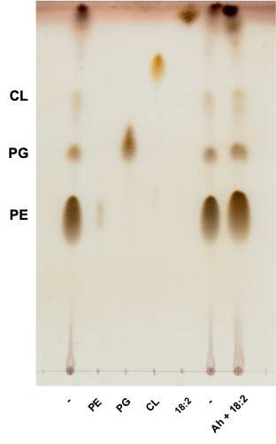

S2

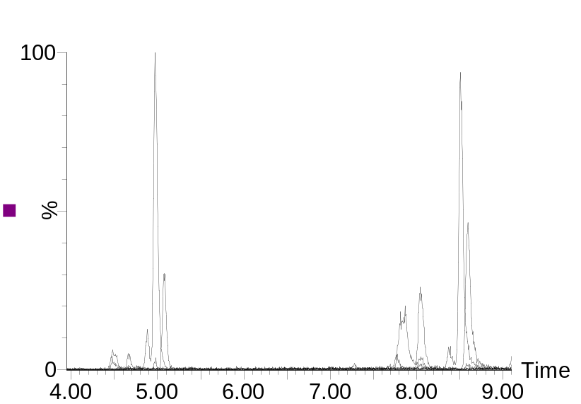
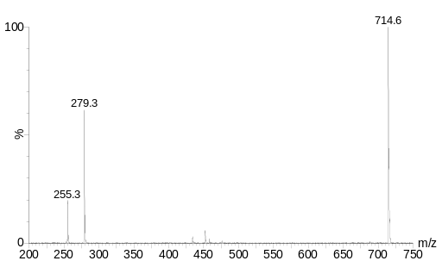
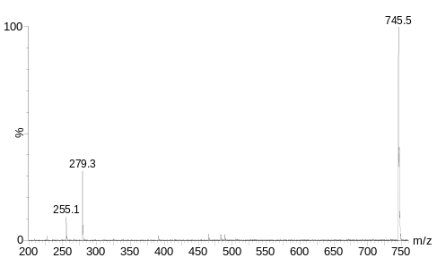
PG 18:2/18:2
PG 16:1/18:2
PG 18:1/18:2
PE 16:1/18:2
PE 16:0/18:2
PE 18:2/18:2
PE 18:1/18:2
PG 16:0/18:2
PG 16:0/18:2
PE 16:0/18:2
Retention Time (min.)

S3

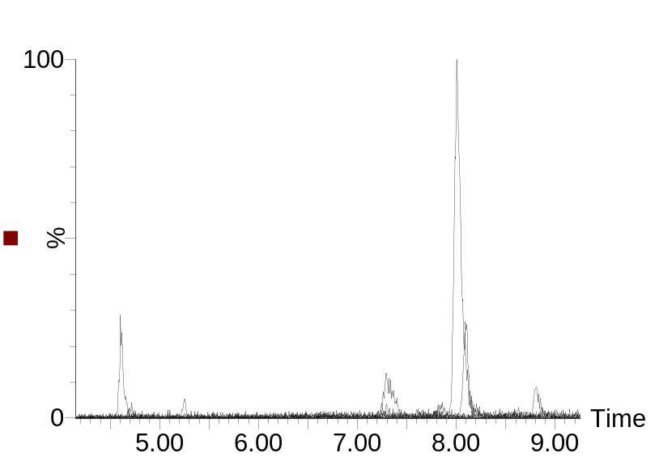
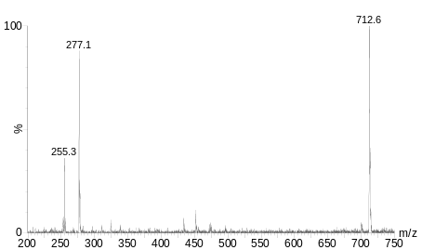
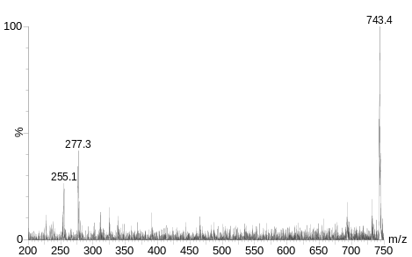
PG 18:0/18:3
PG 18:1/18:3
PE 16:1/18:3
PE 16:0/18:3
PE 18:0/18:3
PE 18:1/18:3
PG 16:0/18:3
PG 16:0/18:3
PE 16:0/18:3
Retention Time (min.)

S4

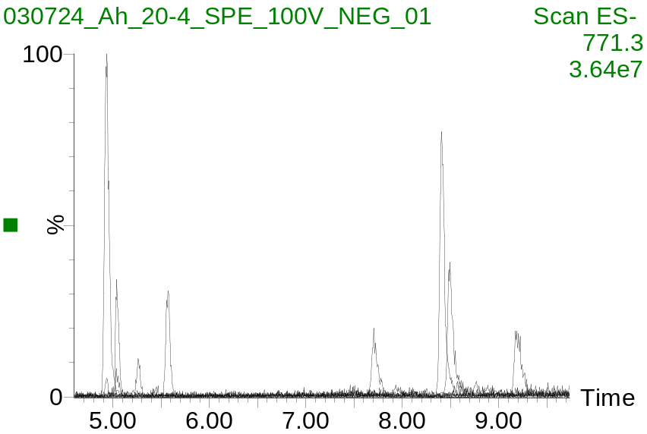
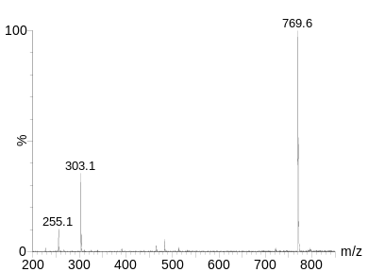
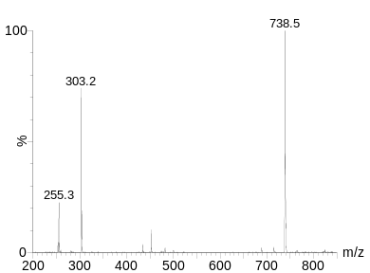
PG 17:0/20:4
PG 18:1/20:4
PG 18:0/20:4
PE 16:1/20:4
PE 16:0/20:4
PE 18:1/20:4
PE 18:0/20:4
PG 16:0/20:4
PG 16:0/20:4
PE 16:0/20:4
Retention Time (min.)

S5

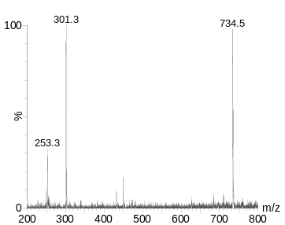
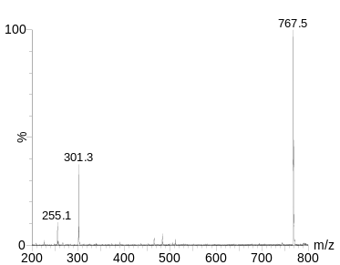
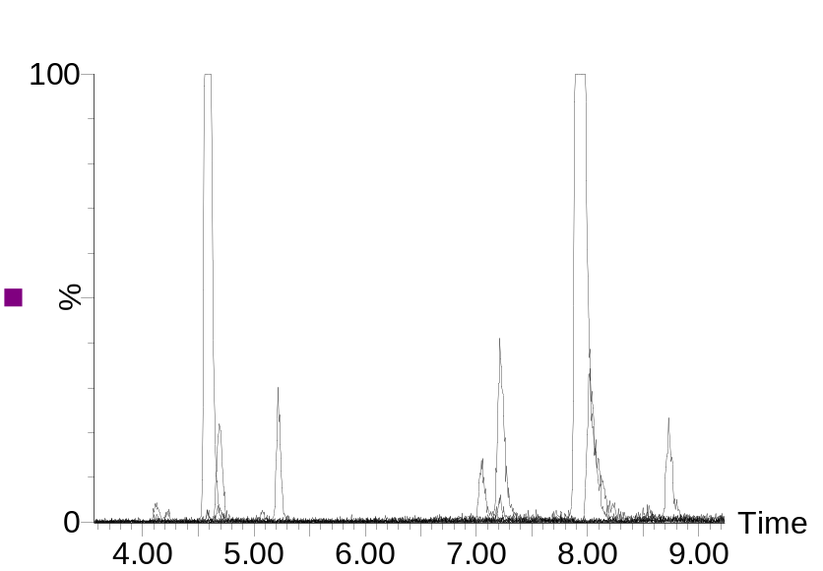
PG 16:1/20:5
PG 18:1/20:5
PG 18:0/20:5
PE 16:1/20:5
PE 16:0/20:5
PE 18:1/20:5
PE 18:0/20:5
PG 16:0/20:5
PE 14:0/20:5
PG 16:0/20:5
PE 16:1/20:5
Retention Time (min.)

S6

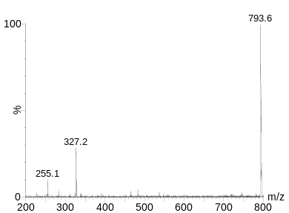
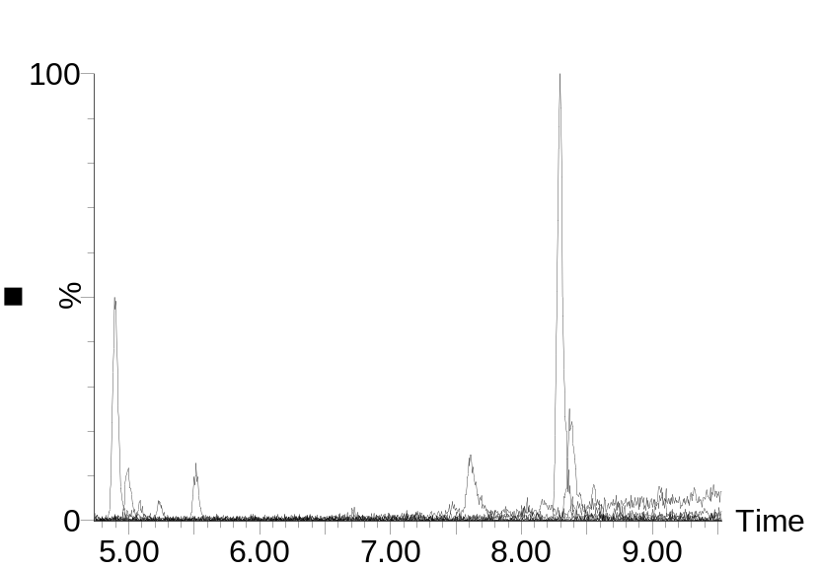
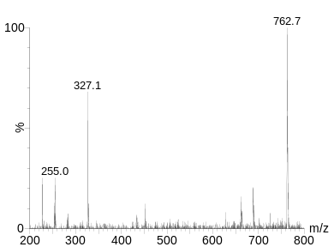
PG 18:1/22:6
PG 18:0/22:6
PE 16:1/22:6
PE 16:0/22:6
PE 18:1/22:6
PE 18:0/22:6
PG 16:0/22:6
PG 16:0/22:6
PE 16:0/22:6
Retention Time (min.)

Table S1. LC-MS data for 18:2 culture
Retention Time (min) | Parent [M – H]⁻ | Fragment [M – H]⁻ | Fragment [M – H]⁻ | Identity
4.48 | 743.5 | 253.2 | 279.2 | PG 16:1/18:2
4.66 | 769.4 | 279.2 | 279.2 | PG 18:2/18:2
4.97 | 745.5 | 255.2 | 279.2 | PG 16:0/18:2
5.08 | 771.5 | 281.3 | 279.2 | PG 18:1/18:2
7.87 | 712.6 | 253.3 | 279.1 | PE 16:1/18:2
8.05 | 738.6 | 279.2 | 279.2 | PE 18:2/18:2
8.51 | 714.5 | 255.2 | 279.2 | PE 16:0/18:2
8.59 | 740.6 | 281.2 | 279.2 | PE 18:1/18:2

Table S2. LC-MS data for 18:3α and 18:3γ cultures
Retention Time* (min) | Parent [M – H]⁻ | Fragment [M – H]⁻ | Fragment [M – H]⁻ | Identity
4.61/4.68 | 743.4 | 255.2 | 277.3 | PG 16:0/18:3
4.72/4.76 | 769.5 | 281.3 | 277.2 | PG 18:1/18:3
5.25/5.33 | 771.5 | 283.2 | 277.2 | PG 18:0/18:3
7.29/7.36 | 710.4 | 253.3 | 277.4 | PE 16:1/18:3
8.00/8.09 | 712.5 | 255.2 | 277.3 | PE 16:0/18:3
8.09/8.18 | 738.6 | 281.2 | 277.1 | PE 18:1/18:3
8.80/8.89 | 740.4 | 283.2 | 277.3 | PE 18:0/18:3
*Phospholipids containing 18:3α elute before 18:3γ and are listed first

Table S3. LC-MS data for 20:3 culture
Retention Time (min) | Parent [M – H]⁻ | Fragment [M – H]⁻ | Fragment [M – H]⁻ | Identity
5.09 | 821.5 | 305.4 | 305.4 | PG 20:3/20:3
5.20 | 771.6 | 255.2 | 305.3 | PG 16:0/20:3
5.30 | 797.7 | 281.2 | 305.1 | PG 18:1/20:3
5.80 | 799.6 | 283.1 | 305.2 | PG 18:0/20:3
8.18 | 738.6 | 253.2 | 305.4 | PE 16:1/20:3
8.54 | 790.4 | 305.3 | 305.3 | PE 20:3/20:3
8.76 | 740.5 | 255.2 | 305.2 | PE 16:0/20:3
8.82 | 766.6 | 281.2 | 305.4 | PE 18:1/20:3
9.53 | 768.5 | 283.2 | 305.3 | PE 18:0/20:3

Table S4. LC-MS data for 20:4 culture
Retention Time (min) | Parent [M – H]⁻ | Fragment [M – H]⁻ | Fragment [M – H]⁻ | Identity
4.93 | 769.6 | 255.2 | 303.3 | PG 16:0/20:4
5.04 | 795.4 | 281.2 | 303.2 | PG 18:1/20:4
5.26 | 783.5 | 269.2 | 303.4 | PG 17:0/20:4
5.57 | 797.5 | 283.1 | 303.1 | PG 18:0/20:4
7.71 | 736.6 | 253.1 | 303.3 | PE 16:1/20:4
8.41 | 738.5 | 255.2 | 303.3 | PE 16:0/20:4
8.50 | 764.6 | 281.2 | 303.2 | PE 18:1/20:4
9.21 | 766.6 | 283.2 | 303.4 | PE 18:0/20:4

Table S5, LC-MS data for 20:5 culture
Retention Time (min) | Parent [M – H]⁻ | Fragment [M – H]⁻ | Fragment [M – H]⁻ | Identity
4.12 | 765.5 | 253.2 | 301.3 | PG 16:1/20:5
4.58 | 767.5 | 255.2 | 301.1 | PG 16:0/20:5
4.69 | 793.4 | 281.2 | 301.4 | PG 18:1/20:5
5.22 | 795.3 | 283.1 | 301.2 | PG 18:0/20:5
7.06 | 708.5 | 227.1 | 301.4 | PE 14:0/20:5
7.21 | 734.6 | 253.2 | 301.4 | PE 16:1/20:5
7.93 | 736.4 | 255.2 | 301.2 | PE 16:0/20:5
8.03 | 762.5 | 281.2 | 301.4 | PE 18:1/20:5
8.73 | 764.6 | 283.2 | 301.3 | PE 18:0/20:5

Table S6. LC-MS data for 22:6 culture
Retention Time (min) | Parent [M – H]⁻ | Fragment [M – H]⁻ | Fragment [M – H]⁻ | Identity
4.90 | 793.7 | 255.2 | 327.2 | PG 16:0/22:6
5.00 | 819.4 | 281.3 | 327.2 | PG 18:1/22:6
5.52 | 821.5 | 283.2 | 327.2 | PG 18:0/22:6
7.61 | 760.5 | 253.3 | 327.2 | PE 16:1/22:6
8.30 | 762.3 | 255.2 | 327.2 | PE 16:0/22:6
8.37 | 788.4 | 281.2 | 327.2 | PE 18:1/22:6
9.06 | 790.5 | 283.2 | 327.2 | PE 18:0/22:6

