Supplementary material
Yandi Peng^{1,3},Zhuoma Cisang¹,Yangji Cidan¹, Guifang Liu¹, Dan Wu¹, Fei Gao², Shijun Wen² and Yanbin Zhu^{1*}

- Institute of Animal Husbandry and Veterinary Medicine, Xizang Academy of Agriculture and Animal Husbandry Sciences, Lhasa 850009, China
- Tibet Agri-Investment Lingmu Breeding Co., Ltd，Lhasa 850000，China
- College of Agriculture and Biology, Liaocheng University, Liaocheng 252059, China.
*Corresponding author: Yanbin Zhu. Zhuyanbin126@126.com.

Table S1 The rumen fluid of yak calves supplemented with YC showed significantly differential metabolites.
Metabolites | Compound ID | Formula | m/z | Retention time (min) | VIP | FC | P-value
Glycerophospholipids
PHOOA-PE | FT7953NR | C29H54NO10P | 588.33 | 12.05 | 2.57 | 1717.51 | 0.001
PA(10:0/i-12:0) | FT7453PR | C25H49O8P | 531.31 | 12.00 | 2.52 | 984.06 | <0.001
PC(12:0/0:0) | FT6470PR | C20H42NO7P | 440.28 | 8.72 | 2.58 | 1393.14 | <0.001
PG(14:1/12:0) | FT8321PR | C32H61O10P | 659.39 | 12.64 | 2.58 | 1306.74 | <0.001
PE(O-18:1/0:0) | FT6595NR | C23H48NO6P | 464.31 | 11.88 | 2.58 | 2017.75 | <0.001
LysoPC(14:0/0:0) | FT6828PR | C22H46NO7P | 468.31 | 9.84 | 2.59 | 2012.23 | <0.001
LysoPC(0:0/18:0) | FT7613PR | C26H54NO7P | 546.35 | 11.46 | 2.57 | 1925.20 | 0.001
PC(O-18:1/0:0) | FT7259PR | C26H54NO6P | 508.38 | 12.05 | 2.61 | 3101.60 | 0.003
LysoPC(18:0/0:0) | FT7612PR | C26H54NO7P | 546.35 | 11.68 | 2.55 | 2619.34 | 0.001
PE(19:1/0:0) | FT7088PR | C24H48NO7P | 494.32 | 11.37 | 2.90 | 11246.80 | <0.001
PC(P-15:0/0:0) | FT6801PR | C23H48NO6P | 466.33 | 10.44 | 2.79 | 6955.76 | 0.001
LysoPE(20:3/0:0) | FT7359PR | C25H46NO7P | 521.34 | 10.95 | 2.59 | 1960.53 | <0.001
PC(18:3/0:0) | FT7327PR | C26H48NO7P | 518.32 | 9.97 | 2.77 | 8665.39 | 0.001
LysoPE(20:1/0:0) | FT7256PR | C25H50NO7P | 508.34 | 11.52 | 2.98 | 20710.07 | <0.001
LysoPC(17:0/0:0) | FT7280PR | C25H52NO7P | 510.36 | 11.15 | 2.72 | 3737.04 | <0.001
PC(18:1/0:0)[rac] | FT7295NR | C26H52NO7P | 520.34 | 12.05 | 2.92 | 12659.21 | <0.001
LysoPE(P-18:1/0:0) | FT6773PR | C23H46NO6P | 464.31 | 11.12 | 2.90 | 12256.89 | <0.001
LysoPC(P-16:0/0:0) | FT6947PR | C24H50NO6P | 480.34 | 10.97 | 2.94 | 19481.25 | <0.001
LysoPC(P-18:1/0:0) | FT7237PR | C26H52NO6P | 506.36 | 11.18 | 2.73 | 5117.23 | 0.001
Fatty Acyls
Panaxydol linoleate | FT7559PR | C35H54O3 | 540.44 | 15.00 | 2.56 | 1649.11 | 0.001
DG(2:0/0:0/22:6-OH) | FT6915PR | C27H40O6 | 478.32 | 11.97 | 2.53 | 1383.04 | 0.001
(9Z,11E,13Z)-Octadeca-9,11,13-trienoylcarnitine | FT6722PR | C25H43NO4 | 460.28 | 9.88 | 2.58 | 1950.56 | <0.001
N-(hexadecanoyl)-deoxysphing-4-enine-1-sulfonate | FT8158PR | C34H67NO5S | 624.46 | 14.41 | 2.59 | 1435.70 | <0.001
O-arachidonoylcarnitine | FT7025PR | C27H45NO4 | 486.30 | 11.11 | 2.72 | 3969.92 | <0.001
13-MethylHexadecanoylcarnitine | FT6626PR | C24H47NO4 | 452.31 | 11.03 | 2.68 | 3046.91 | <0.001
DG(18:4n3/0:0/20:5n3) | FT8315PR | C41H62O5 | 657.45 | 14.24 | 2.74 | 3298.11 | <0.001
DG(18:4n3/0:0/20:4n3) | FT8322PR | C41H64O5 | 659.47 | 14.11 | 2.66 | 2114.91 | <0.001
SCHEMBL13694070 | FT6149NR | C22H41NO5 | 434.27 | 10.35 | 2.67 | 3670.30 | <0.001
PA(8:0/5-iso PGF2VI) | FT8154PR | C29H51O11P | 624.35 | 11.60 | 2.60 | 1467.47 | <0.001
(16Z)-14-Hydroxydocos-16-enoylcarnitine | FT7522PR | C29H55NO5 | 536.37 | 12.67 | 2.81 | 6787.71 | <0.001
Prenol lipids
Phorbolol myristate acetate | FT8312PR | C36H58O8 | 657.38 | 12.83 | 2.62 | 1643.68 | <0.001
OH-Demethylspheroidene | FT8096PR | C40H60O2 | 611.42 | 12.14 | 2.54 | 1159.40 | <0.001
2alpha-Hydroxypyracrenic acid | FT8283PR | C39H54O7 | 652.42 | 12.84 | 2.56 | 1186.70 | <0.001
2-beta-Ethoxydihydrophytuberin | FT5378PR | C19H32O5 | 358.26 | 11.35 | 2.62 | 2005.70 | <0.001
Astaxanthin-5,6-peroxide | FT8183PR | C40H52O6 | 629.38 | 12.96 | 2.79 | 4598.96 | <0.001
Steroids and steroid derivatives
(5alpha)-23-Methyl-4-aza-21-norchol-1-ene-3,20-dione | FT5697PR | C23H35NO2 | 380.26 | 9.53 | 2.55 | 1549.43 | 0.001
(4alpha,5alpha)-4,14-Dimethyl-9,19-cyclocholest-20-en-3-one | FT6076PR | C29H46O | 411.36 | 13.30 | 2.56 | 1205.21 | <0.001
Deoxycholylisoleucine | FT7599PR | C30H51NO5 | 544.34 | 12.05 | 2.81 | 7229.33 | 0.001
Carboxylic acids and derivatives
SCHEMBL22457451 | FT5895PR | C20H39NO4 | 396.25 | 9.60 | 2.59 | 1980.73 | <0.001
N-Docosahexaenoyl Lysine | FT6935PR | C28H44N2O3 | 479.33 | 10.66 | 2.65 | 2574.58 | <0.001
N-Palmitoyl Glutamic acid | FT5766PR | C21H39NO5 | 386.29 | 11.35 | 2.62 | 1683.91 | <0.001
Benzene and substituted derivatives
Almitrine | FT6768NR | C26H29F2N7 | 476.24 | 10.05 | 2.53 | 1489.41 | <0.001
Trioctyl trimellitate | FT7942PR | C33H54O6 | 585.36 | 13.65 | 2.62 | 1672.13 | <0.001
Phenylpropanoic acids
3-{2-[3-(4-Pentylcarbamoyl-oxazol-2-yl)-7-oxa-bicyclo[2.2.1]hept-2-ylmethyl]-phenyl}-propionic acid | FT6694PR | C25H32N2O5 | 458.26 | 10.36 | 2.69 | 3780.99 | <0.001
Benzopyrans
Calofloride | FT7157PR | C30H36O5 | 499.25 | 11.96 | 2.58 | 1332.07 | <0.001
Organooxygen compounds
10-Deoxymethymycin | FT6912NR | C25H43NO6 | 488.28 | 10.84 | 2.59 | 1948.29 | <0.001
Glycerolipids
MG(0:0/21:0) | FT6214PR | C24H48O4 | 423.35 | 14.98 | 2.65 | 1990.03 | <0.001
Flavonoids
catechin 3-octadecanoate | FT7731PR | C33H48O7 | 557.35 | 12.97 | 2.53 | 1040.67 | <0.001
Phenols
Adipostatin I | FT5754NR | C24H42O2 | 407.32 | 14.60 | 2.60 | 1733.14 | <0.001
Sphingolipids
C19 Sphingosine-1-phosphate | FT5864PR | C19H40NO5P | 394.27 | 9.96 | 2.66 | 4071.44 | <0.001
VIP, variable importance in the projection.
FC (Fold Change): the ratio of the average peak area (natural grazing / YC-supplemented).
PA, Phosphatidic; PC, Phosphatidylcholine; PG, Phosphatidylglycerol; PE, Phosphatidylethanolamine; DG,Diacylglycerol

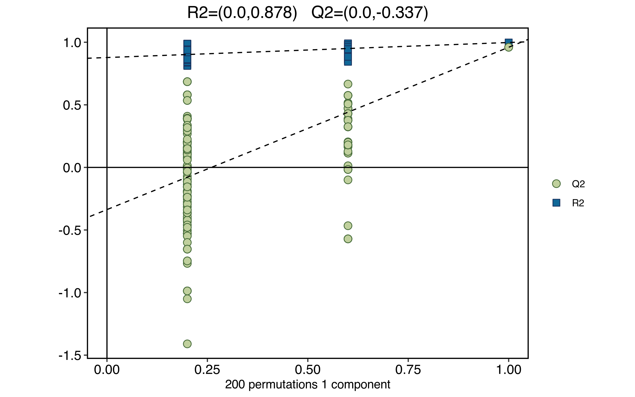
Fig. S1 Response Permutation Testing (RPT): R2 and Q2: Used for Response Permutation Testing (RPT) to evaluate whether the model is overfitted. R2 represents the explanatory power of the model, and Q2 represents the predictive ability of the model.

