Association of the residual feed intake (RFI) with the rumen microbiota composition and metabolism in Dorper-Hu crossbred lambs
Bibo Li^{1,2}*, Xiaolong Shi¹, Xiaoyu Yao¹, Yining Yan¹, Ke Wu¹, Chunxiang Zhang^{1,2}*and Youshe Ren^{1,2}*
¹ College of Animal Science, Shanxi Agricultural University, Taigu 030801, China; libibo1988@126.com (B.L.); xl1348473271@163.com (X.S.); 13453217750@163.com (X.Y.); 15934508623@163.com (Y.Y.); wuke1227@163.com (K.W);
² Shanxi Provincial Key Laboratory of Livestock and Poultry Genetic Resources Exploration and Biotechnology breeding, Shanxi Agricultural University, Taigu 030801, China;
*Author to whom correspondence should be addressed. Correspondence: libibo1988@126.com (B.L.); chunxiangzhang@sxau.edu.cn (C.Z.); rys925@126.com (Y.R.)

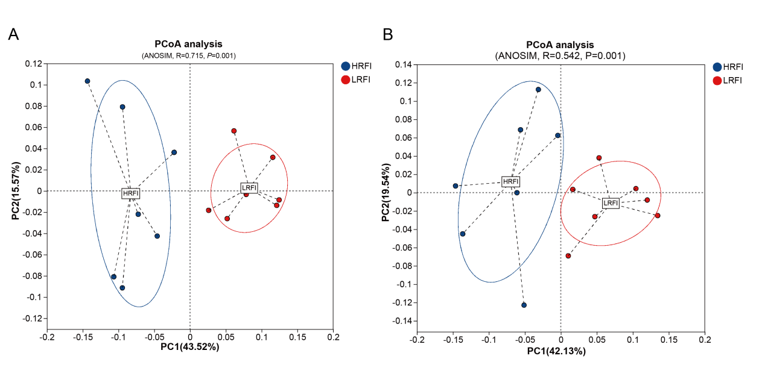
Figure S1 PCoA plot of KEGG (A) and CAZy function (B)

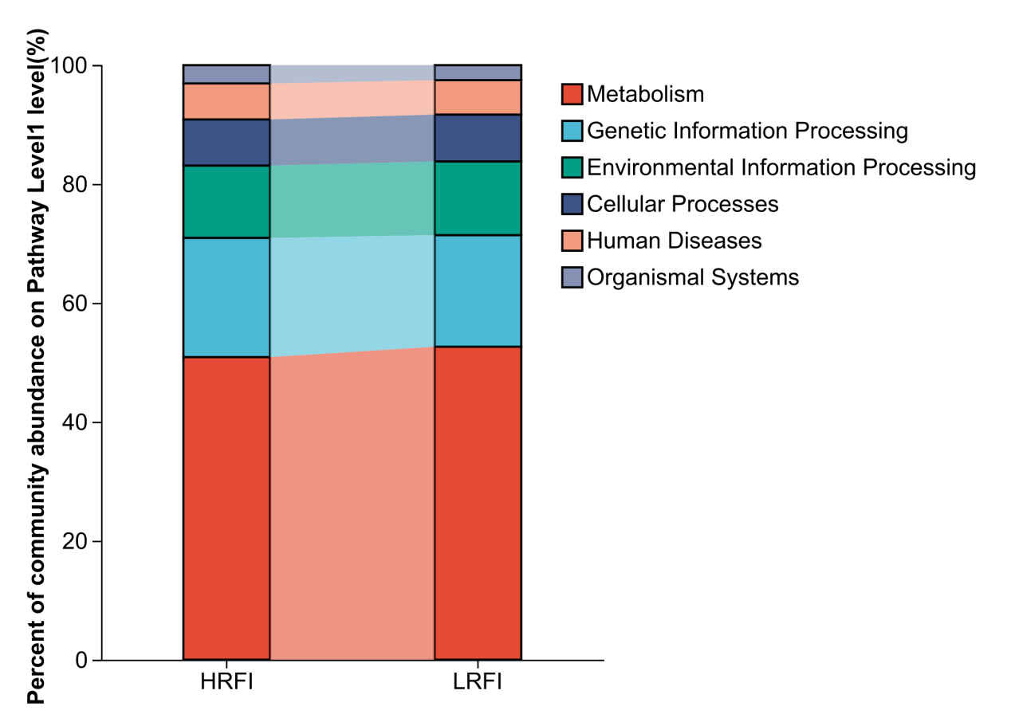
Figure S2 KEGG pathway composition (At the KEGG level 1)

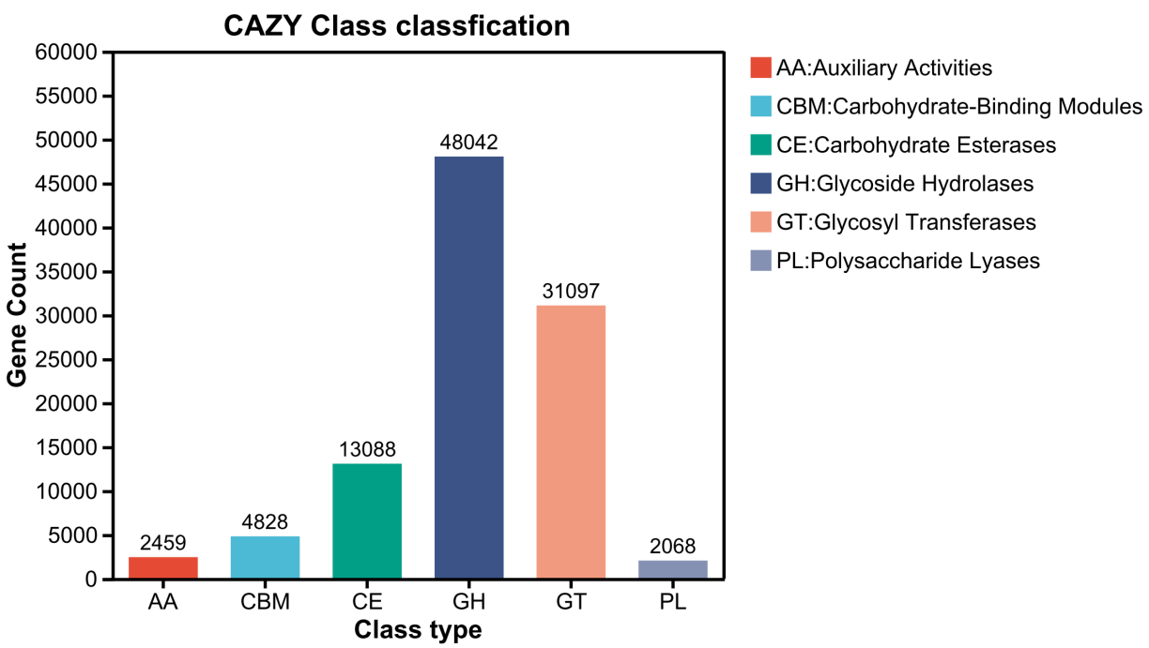
Figure S3 CAZy class classfication

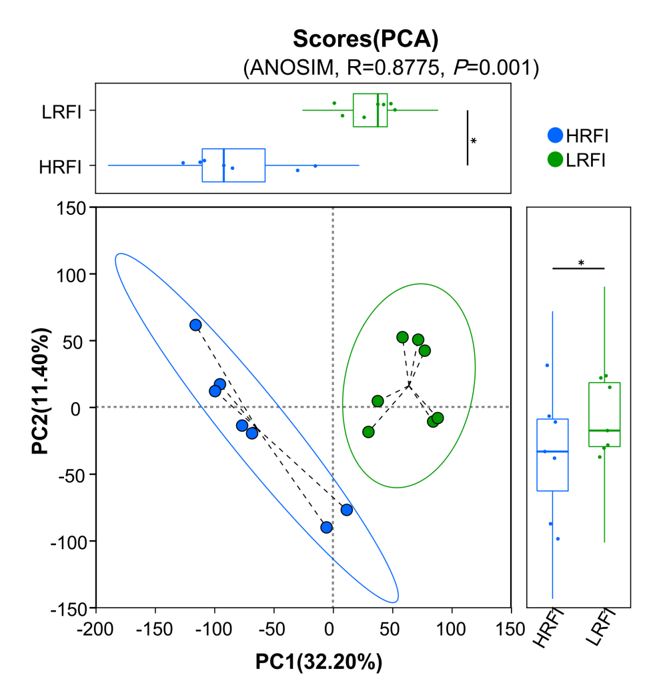
Figure S4 Metabolic profiles of rumen anions and cations based on principal component analysis (PCA)

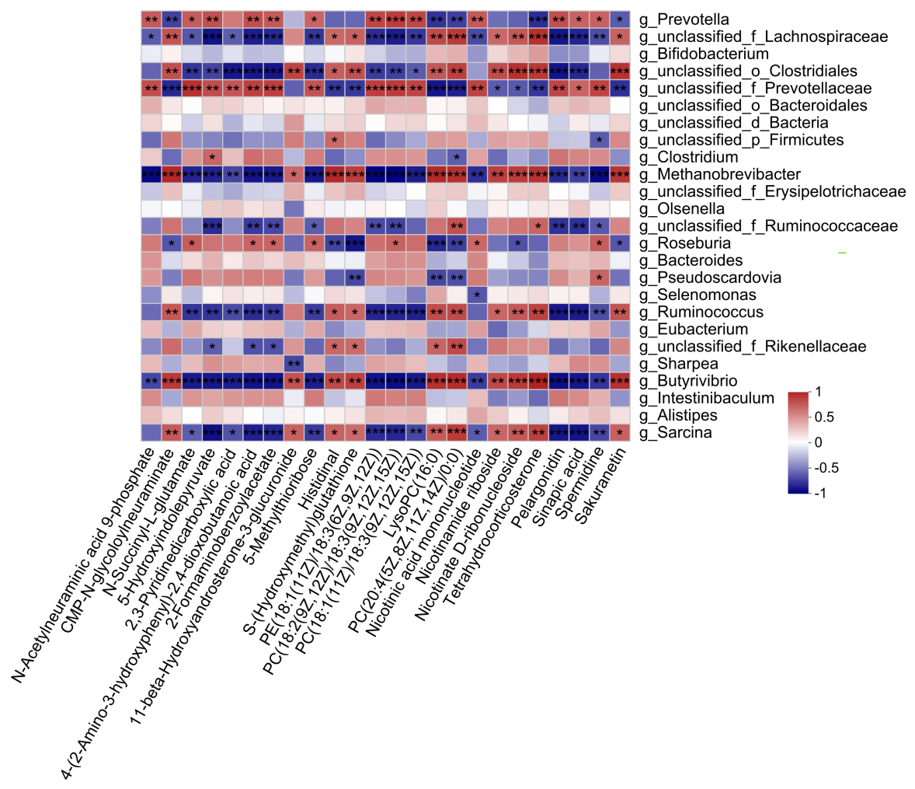

Figure S5 Correlation analysis between rumen microorganisms and metabolites

Table S1 The sequence quality of metagenome
Sample | Raw reads | Clean reads | Percent in raw reads(%) | Optimized reads | Percent in raw reads(%)
H1 | 43,597,086 | 43,069,566 | 98.79 | 32,517,582 | 74.59
H2 | 50,871,686 | 50,248,496 | 98.77 | 38,965,790 | 76.60
H3 | 45,867,136 | 45,429,902 | 99.05 | 33,154,870 | 72.28
H4 | 44,853,976 | 44,300,852 | 98.77 | 32,958,332 | 73.48
H5 | 44,582,644 | 44,093,020 | 98.90 | 30,153,222 | 67.63
H6 | 56,656,374 | 56,063,306 | 98.95 | 46,285,832 | 81.70
H7 | 51,439,312 | 50,697,244 | 98.56 | 40,693,172 | 79.11
L1 | 49,813,052 | 49,159,982 | 98.69 | 39,165,224 | 78.62
L2 | 49,743,570 | 49,053,018 | 98.61 | 40,661,888 | 81.74
L3 | 47,576,932 | 46,775,840 | 98.32 | 37,041,780 | 77.86
L4 | 45,749,842 | 44,911,402 | 98.17 | 33,900,452 | 74.10
L5 | 45,570,876 | 44,928,276 | 98.59 | 36,153,588 | 79.33
L6 | 47,268,664 | 46,578,368 | 98.54 | 38,176,032 | 80.76
L7 | 49,477,734 | 48,888,366 | 98.81 | 39,750,780 | 80.34
Total | 673,068,884 | 664,197,638 | - | 519,578,544 | -

Table S2 Sequence and assembly data for analyzed samples of lamb rumen microbiota
Sample | Contigs | N50, bp | N90, bp | Max，bp | Min,bp
H1 | 271,184 | 1,336 | 408 | 186,156 | 300
H2 | 340,176 | 1,586 | 420 | 371,602 | 300
H3 | 362,309 | 1,007 | 381 | 249,309 | 300
H4 | 246,494 | 1,082 | 389 | 217,976 | 300
H5 | 378,012 | 1,011 | 387 | 205,436 | 300
H6 | 322,164 | 1,226 | 390 | 328,407 | 300
H7 | 397,351 | 1,015 | 386 | 176,011 | 300
L1 | 100,362 | 5,679 | 486 | 361,804 | 300
L2 | 128,667 | 3,387 | 468 | 336,157 | 300
L3 | 230,406 | 1,941 | 444 | 342,869 | 300
L4 | 167,748 | 2,100 | 422 | 192,219 | 300
L5 | 142,005 | 3,075 | 458 | 265,614 | 300
L6 | 178,402 | 2,310 | 448 | 331,549 | 300
L7 | 250,618 | 1,613 | 418 | 407,502 | 300
Total | 3,515,898 | - | - | - | -
Average | 251,136 | 2,026 | 422 | 283,758 | 300
ORF, open read frame.

Table S3 Results of gene prediction
Sample | ORF | Total length, bp | Average length, bp | Max(bp) | Min(bp)
H1 | 430,881 | 238,520,202 | 553.56 | 43,761 | 102
H2 | 555,827 | 322,275,690 | 579.81 | 26,442 | 102
H3 | 530,314 | 275,338,872 | 519.2 | 26,706 | 102
H4 | 368,660 | 195,862,443 | 531.28 | 23,436 | 102
H5 | 555,709 | 288,794,514 | 519.69 | 23,382 | 102
H6 | 495,580 | 265,806,123 | 536.35 | 26,520 | 102
H7 | 596,363 | 301,448,961 | 505.48 | 25,566 | 102
L1 | 205,636 | 139,052,553 | 676.21 | 14,718 | 102
L2 | 244,122 | 159,482,274 | 653.29 | 35,025 | 102
L3 | 394,017 | 242,013,966 | 614.22 | 22,041 | 102
L4 | 282,512 | 171,182,010 | 605.93 | 15,084 | 102
L5 | 264,136 | 168,854,838 | 639.27 | 14,718 | 102
L6 | 315,607 | 196,472,853 | 622.52 | 49,752 | 102
L7 | 412,256 | 238,508,874 | 578.55 | 38,595 | 102
Total | 5,651,620 | 3,203,614,173 | - | - | -
Average | 403,687 | 228,829,584 | 581.10 | 27,553 | 102

Table S4 Results of NR species Annotation
Domain | Total reads | Percent,% | Gene counts
Archaea | 6824630 | 3.04 | 63635
Bacteria | 244526648 | 95.86 | 2029199
Eukaryota | 1136450 | 0.56 | 58908
Viruses | 1312818 | 0.47 | 7479
unclassified | 158704 | 0.06 | 1767

Table S5 Microbial community comparison between in HRFI and LRFI group at the domain level (%)
Item | HRFI | LRFI | P
Bacteria | 93.51±1.75 | 98.19±0.99 | <0.001
Archaea | 4.87±0.14 | 1.22±0.72 | <0.001
Eukaryota | 0.86±0.73 | 0.27±0.26 | 0.087
Viruses | 0.68±0.58 | 0.27±0.29 | 0.123
Unclassified taxa | 0.08±0.02 | 0.04±0.02 | 0.018

Table S6 Significantly different ruminal metabolites of Dorpor-Hu crossbred lambs between in the LRFI and HRFI groups
Metabolites | Formula | VIPª | FDR^{b} | Fold change | Trend^{c}
Amino sugar and nucleotide sugar metabolism
N-Acetylneuraminic acid 9-phosphate | C₁₁H₂₀NO₁₂P | 2.999 | 0.002 | 1.779 | up
CMP-N-glycoloylneuraminate | C₂₀H₃₁N₄O₁₇P | 2.328 | 0.010 | 0.691 | down
Arginine and proline metabolism
N-Succinyl-L-glutamate | C₉H₁₃NO₇ | 2.962 | <0.001 | 1.586 | up
Tryptophan metabolism
5-Hydroxyindolepyruvate | C₁₁H₉NO₄ | 2.916 | 0.012 | 2.308 | up
2,3-Pyridinedicarboxylic acid | C₇H₅NO₄ | 2.621 | 0.005 | 1.601 | up
4-(2-Amino-3-hydroxyphenyl)-2,4-dioxobutanoic acid | C₁₀H₉NO₅ | 2.378 | 0.005 | 1.301 | up
2-Formaminobenzoylacetate | C₁₀H₉NO₄ | 2.214 | 0.004 | 1.208 | up
11-beta-Hydroxyandrosterone-3-glucuronide | C₂₅H₃₈O₉ | 2.232 | 0.038 | 0.655 | down
Cysteine and methionine metabolism
5-Methylthioribose | C₆H₁₂O₄S | 2.536 | 0.003 | 1.531 | up
Histidine metabolism
Histidinal | C₆H₉N₃O | 2.275 | 0.008 | 0.711 | down
Methane metabolism
S-(Hydroxymethyl)glutathione | C₁₁H₁₉N₃O₇S | 2.818 | 0.015 | 0.566 | down
Glycerophospholipid metabolism
PE(18:1(11Z)/18:3(6Z,9Z,12Z)) | C₄₁H₇₄NO₈P | 2.911 | <0.001 | 1.546 | up
PC(18:2(9Z,12Z)/18:3(9Z,12Z,15Z)) | C₄₄H₇₈NO₈P | 2.410 | <0.001 | 1.244 | up
PC(18:1(11Z)/18:3(9Z,12Z,15Z)) | C₄₄H₈₀NO₈P | 2.177 | 0.001 | 1.200 | up
LysoPC(16:0) | C₂₄H₅₀NO₇P | 2.485 | 0.003 | 0.752 | down
PC(20:4(5Z,8Z,11Z,14Z)/0:0) | C₂₈H₅₀NO₇P | 2.463 | 0.009 | 0.767 | down
Metabolism of cofactors and vitamins
Nicotinic acid mononucleotide | C₁₁H₁₄NO₉P | 2.539 | 0.007 | 1.442 | up
Nicotinamide riboside | C₁₁H₁₄N₂O₅ | 2.684 | 0.017 | 0.570 | down
Nicotinate D-ribonucleoside | C₁₁H₁₃NO₆ | 2.202 | 0.009 | 0.698 | down
Steroid hormone biosynthesis
Tetrahydrocorticosterone | C₂₁H₃₄O₄ | 2.180 | 0.003 | 0.760 | down
ªvip, Variable importance; ^{b}FDR, false discovery rate, i.e. the corrected P-value; ^{c}down, downregulated; up, upregulated.

Table S7 Significantly deferentially ruminal metabolites associated with flavonoid biosynthesis between the LRFI and HRFI groups
Metabolites | Formula | VIPª | FDR^{b} | Fold change | Trend^{c}
Pelargonidin | C₁₅H₁₀O₅ | 1.484 | 0.004 | 1.121 | up
Sinapic acid | C₁₁H₁₂O₅ | 1.170 | 0.015 | 1.107 | up
Spermidine | C₇H₁₉N₃ | 1.008 | 0.002 | 1.039 | up
Sakuranetin | C₁₆H₁₄O₅ | 1.693 | 0.002 | 0.860 | down
ªvip, Variable importance; ^{b}FDR, false discovery rate, i.e. the corrected P-value; ^{c}down, downregulated; up, upregulated.

