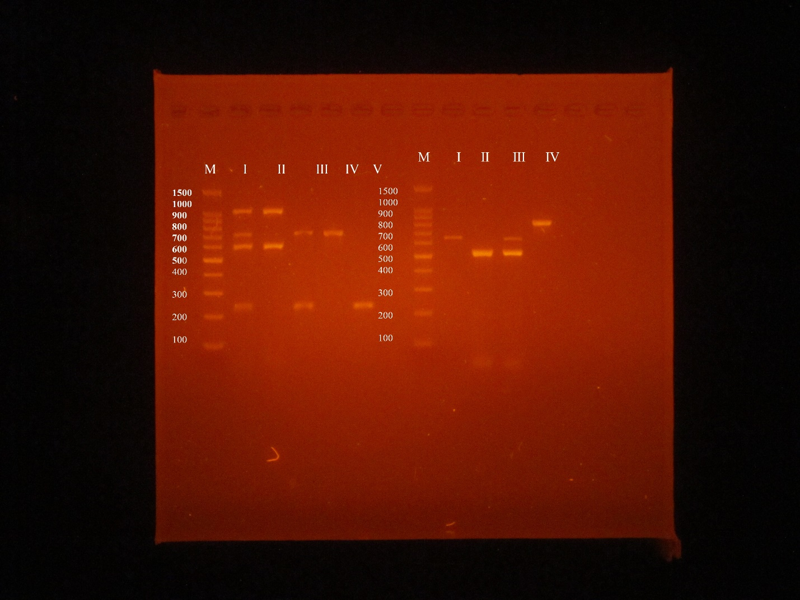
The figure showed the electrophoresis of the multiplex products of carbapenemase encoding genes (I, II, III, IV) and virulence genes (I, II, III, IV, V). M: 100bp DNA ladder. The figure is clearly defined edges
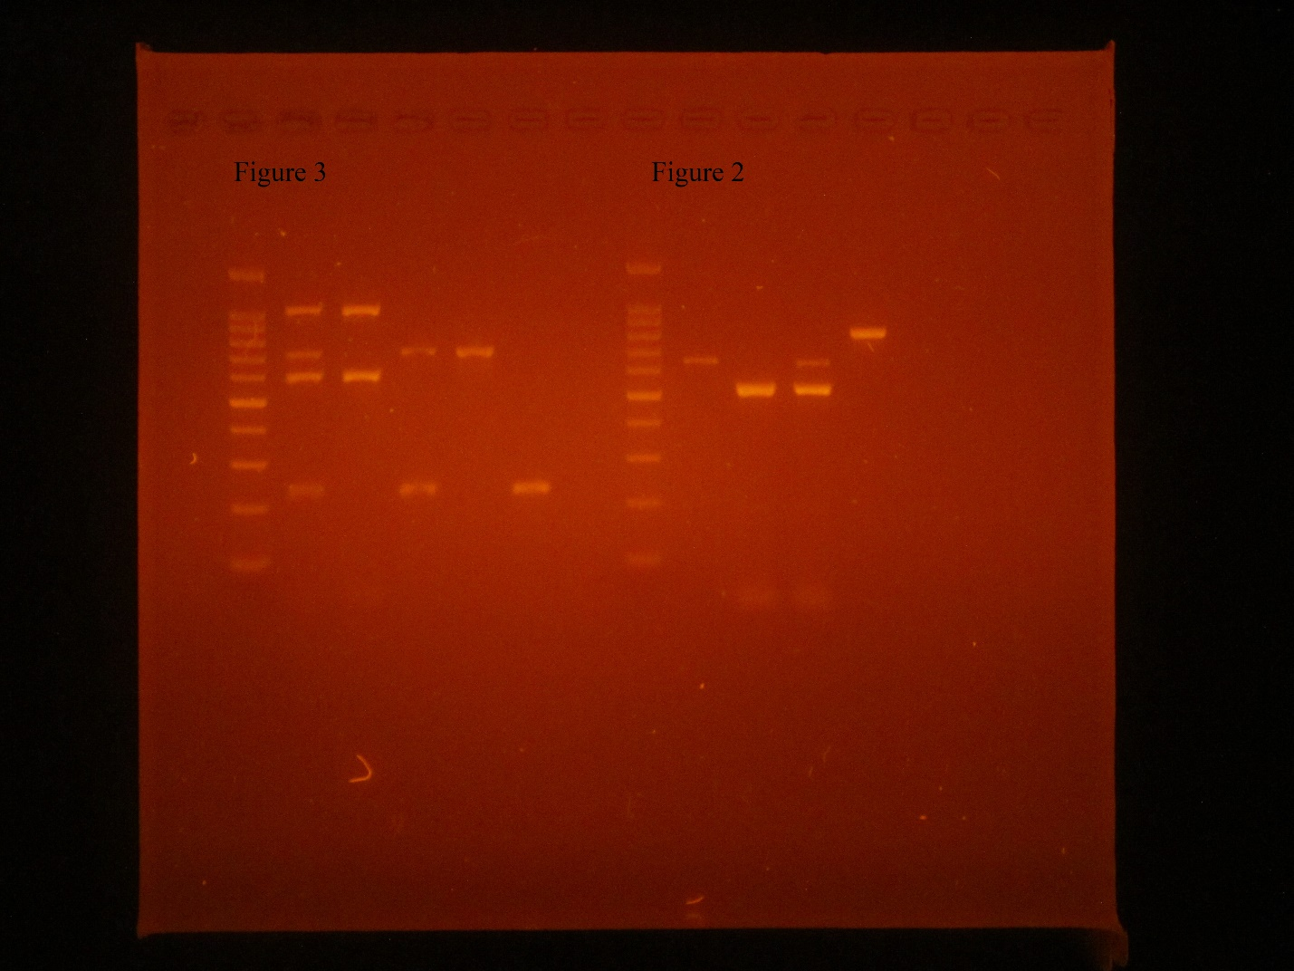
The figure showed the electrophoresis of the multiplex products of carbapenemase encoding genes (figure 2) and virulence genes (figure 3). The figure is clearly defined edges

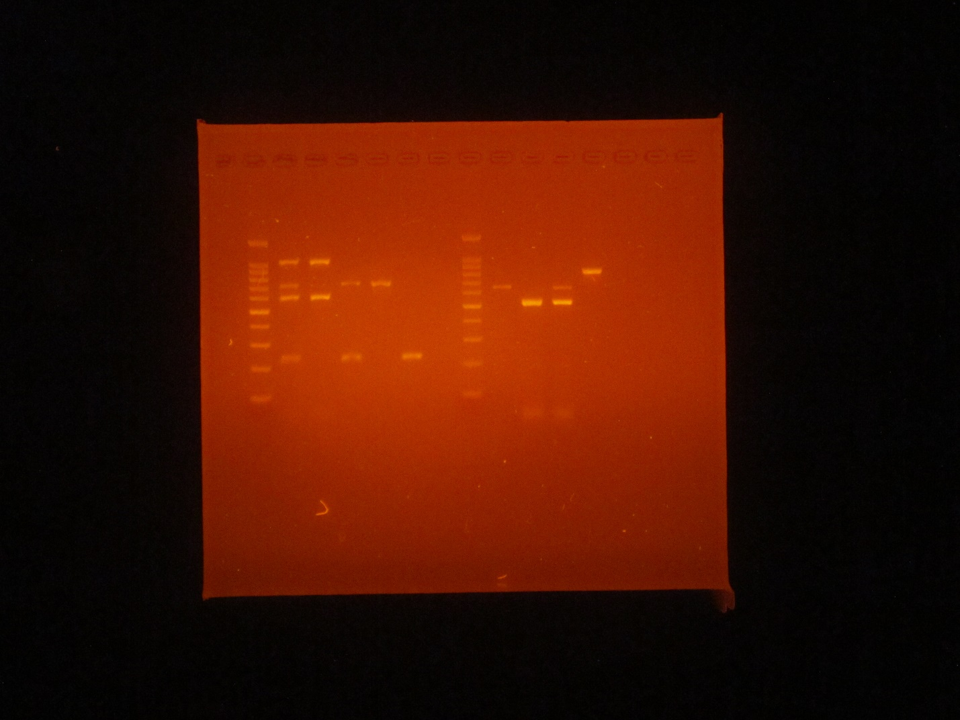
The figure represented another replica for the electrophoresis of the multiplex products of carbapenemase encoding genes (figure 2) and virulence genes (figure 3). The figure is clearly defined edges

