Supplementary materials
Supplementary figure legends
Fig. S1 Precipitation and temperature conditions at the experimental site in Yuncheng, China.

Fig. S2 Compartment-specific and Core-pan gene signatures of rhizosphere and rhizoplane soils under Streptomyces pactum Act12 inoculation. Act12R, rhizosphere of S. pactum Act12-inoculated wheat; Act12S, rhizoplane of S. pactum Act12-inoculated wheat; CtrlR, rhizosphere of non-inoculated wheat; CtrlS, rhizoplane of non-inoculated wheat.

Fig. S3 Alpha diversity in root-associated soils affected by S. pactum Act12 inoculation. * P < 0.05.

Fig. S4 Abundance changes of Actinomycetota and Streptomyces following S. pactum Act12 inoculation. * P < 0.05.

Fig. S5 Relationships of top10 differential metabolic pathways enriched in the top10 differential microbial genera. a rhizosphere at flowering, b rhizoplane at flowering, c rhizosphere at maturation, d rhizoplane at maturation. Red / black labels denote significant increase / decrease in relative abundance following S. pactum Act12 inoculation versus the non-inoculated control. In the pathway panel, pink / blue indicate significant elevation / reduction of the genus-associated pathway; “-” indicates the pathway was not detected.

Supplementary table legends
Table S1 Molecular identification of strains

Table S2 Strains function analysis

Supplementary figures
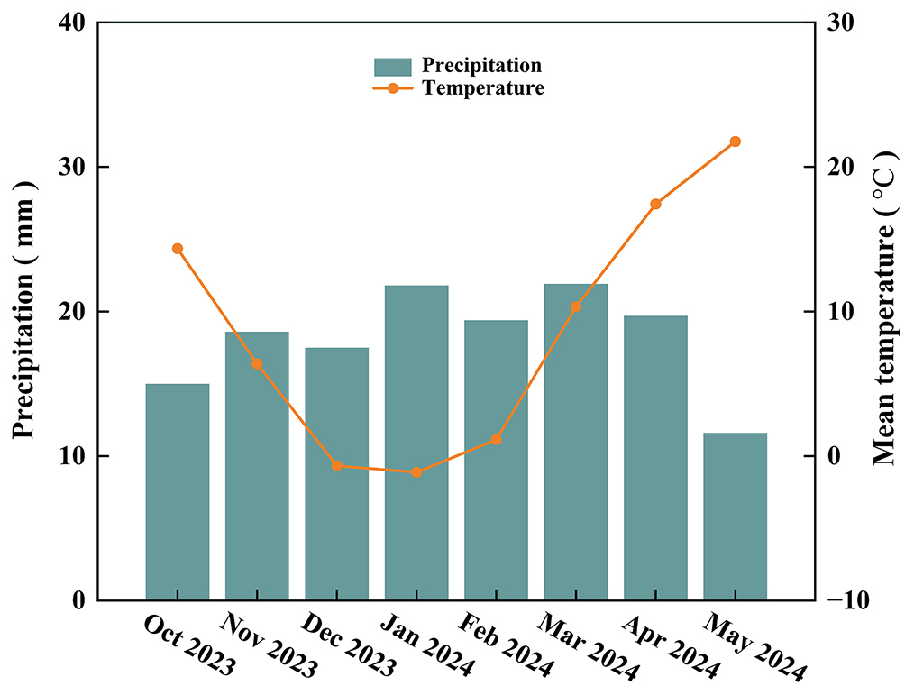Fig. S1 Precipitation and temperature conditions at the experimental site in Yuncheng, China.

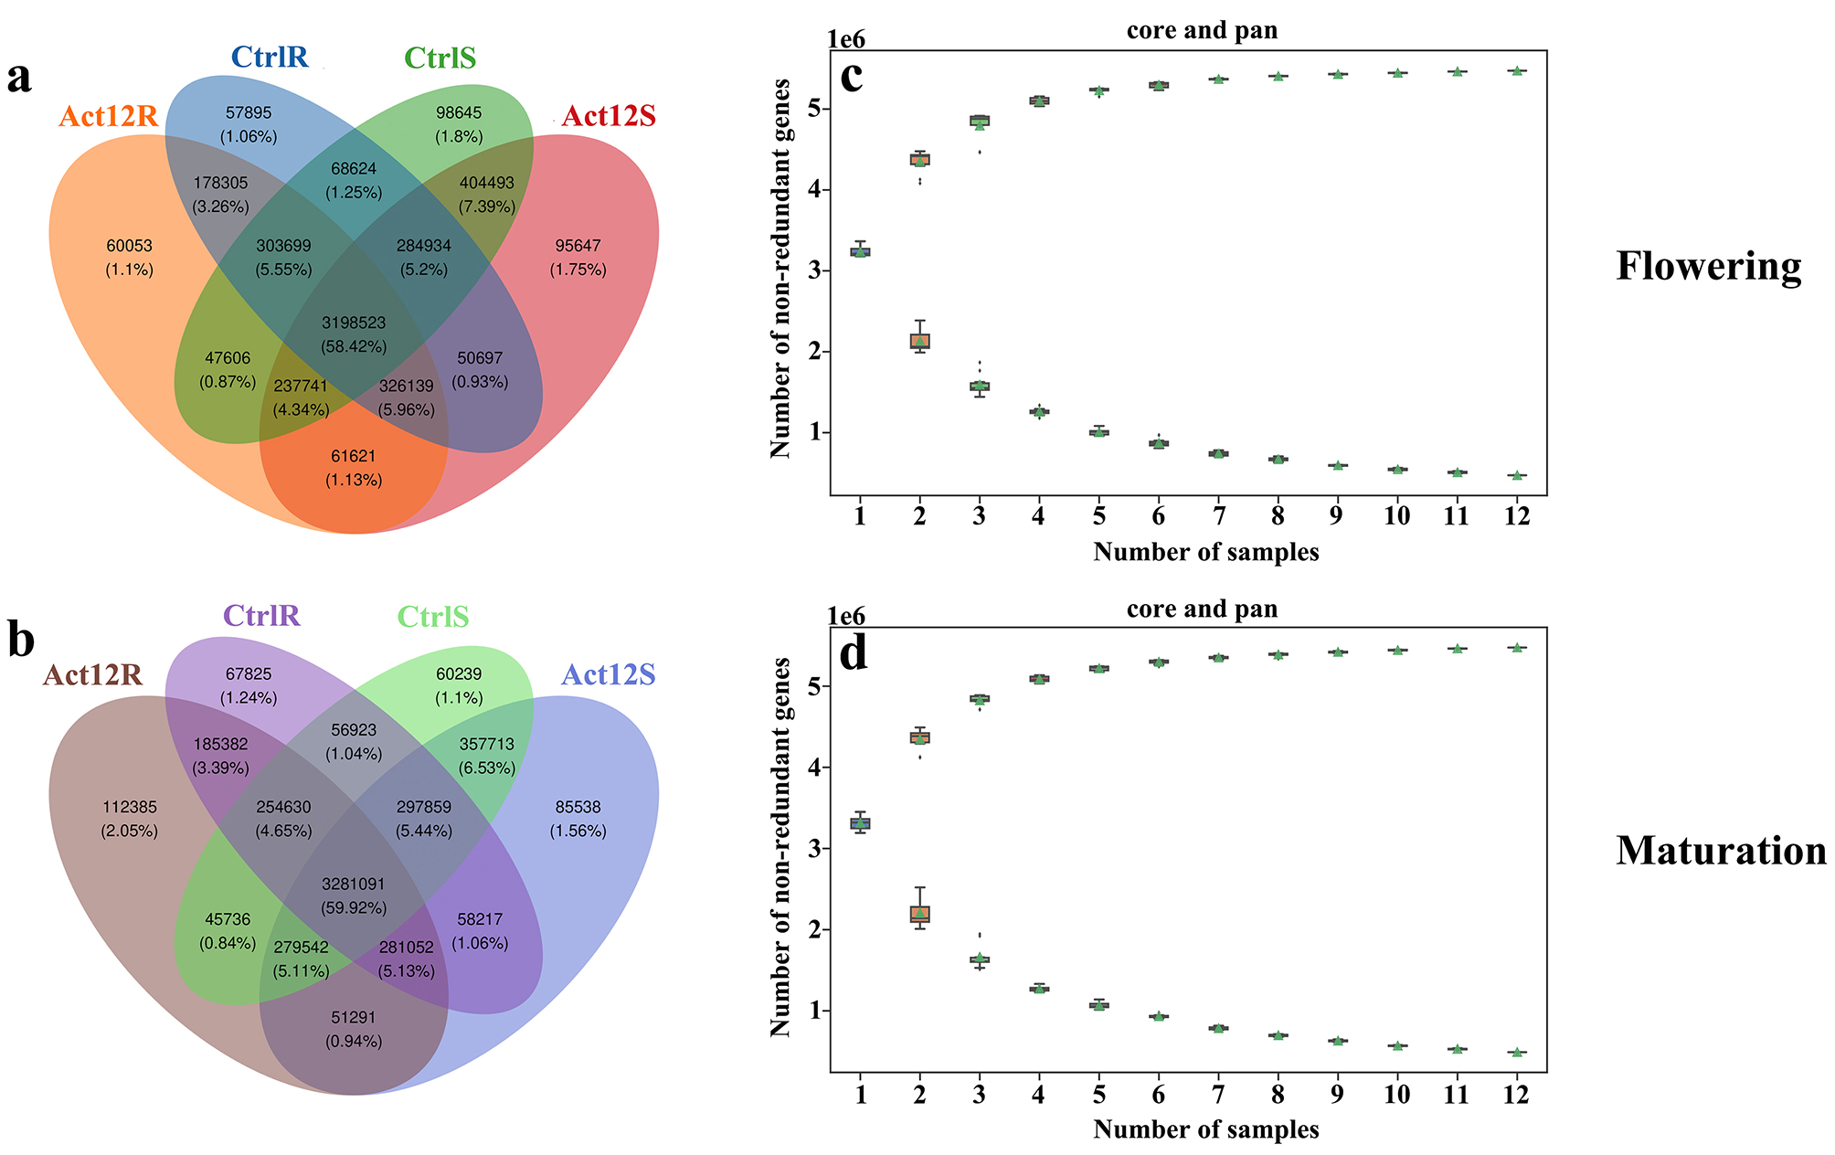
Fig. S2 Compartment-specific and Core-pan gene signatures of rhizosphere and rhizoplane soils under Streptomyces pactum Act12 inoculation. Act12R, rhizosphere of S. pactum Act12-inoculated wheat; Act12S, rhizoplane of S. pactum Act12-inoculated wheat; CtrlR, rhizosphere of non-inoculated wheat; CtrlS, rhizoplane of non-inoculated wheat.

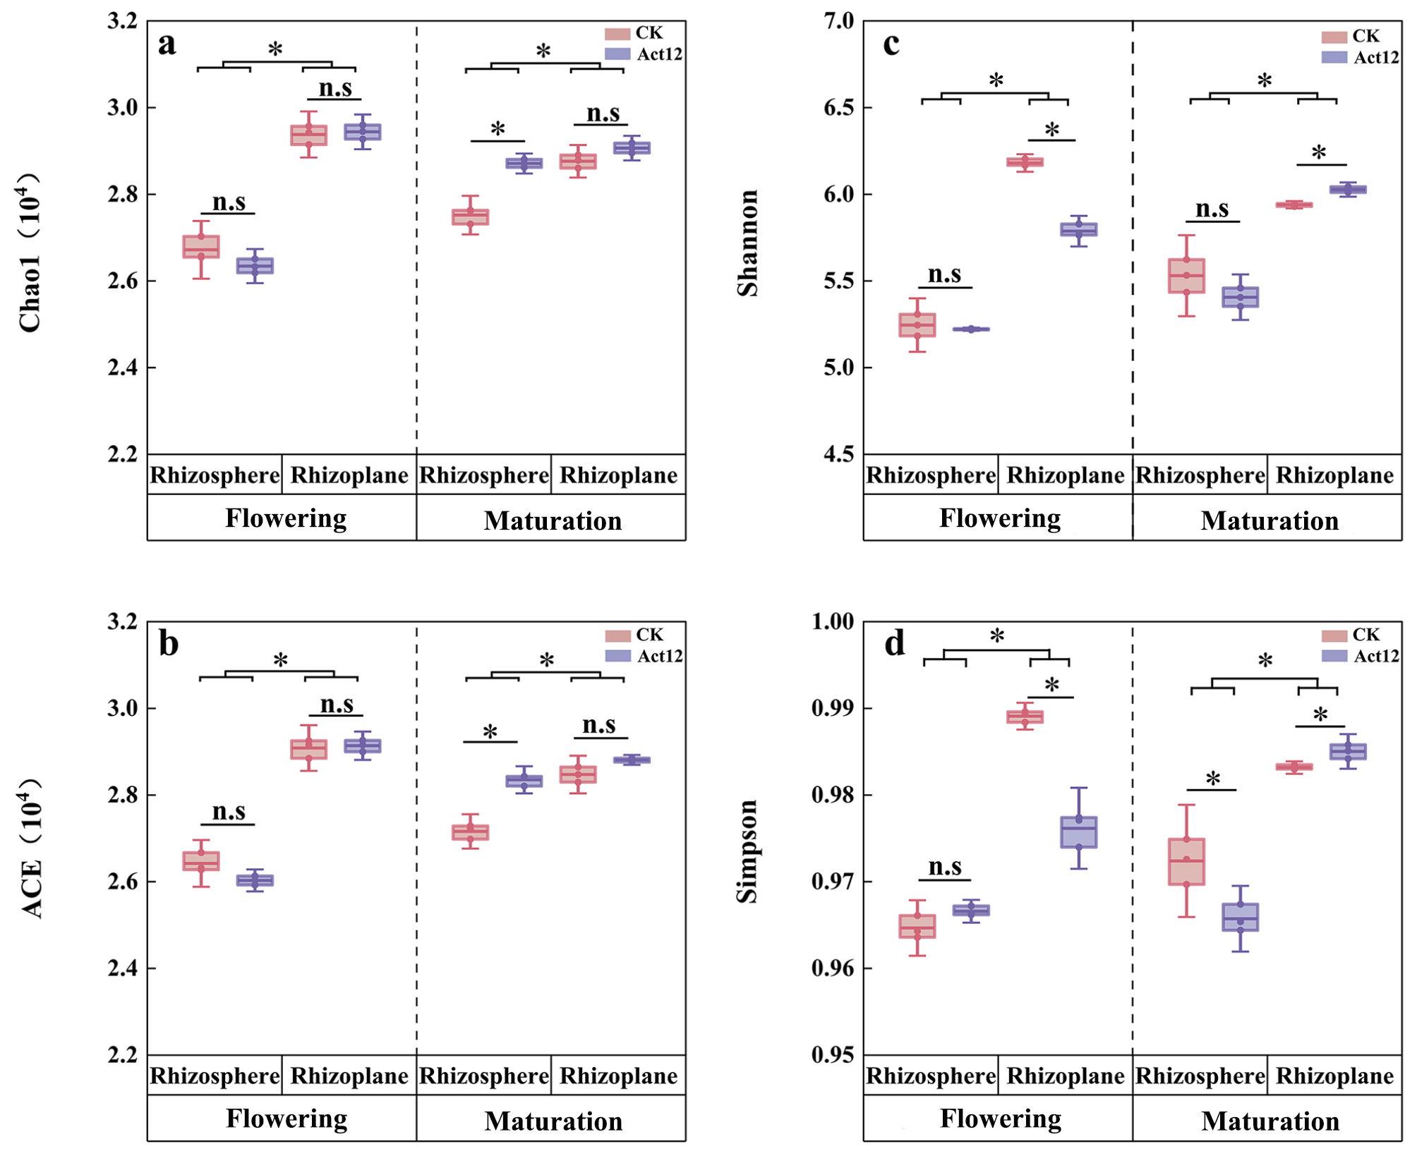Fig. S3 Alpha diversity in root-associated soils affected by S. pactum Act12 inoculation. * P < 0.05.

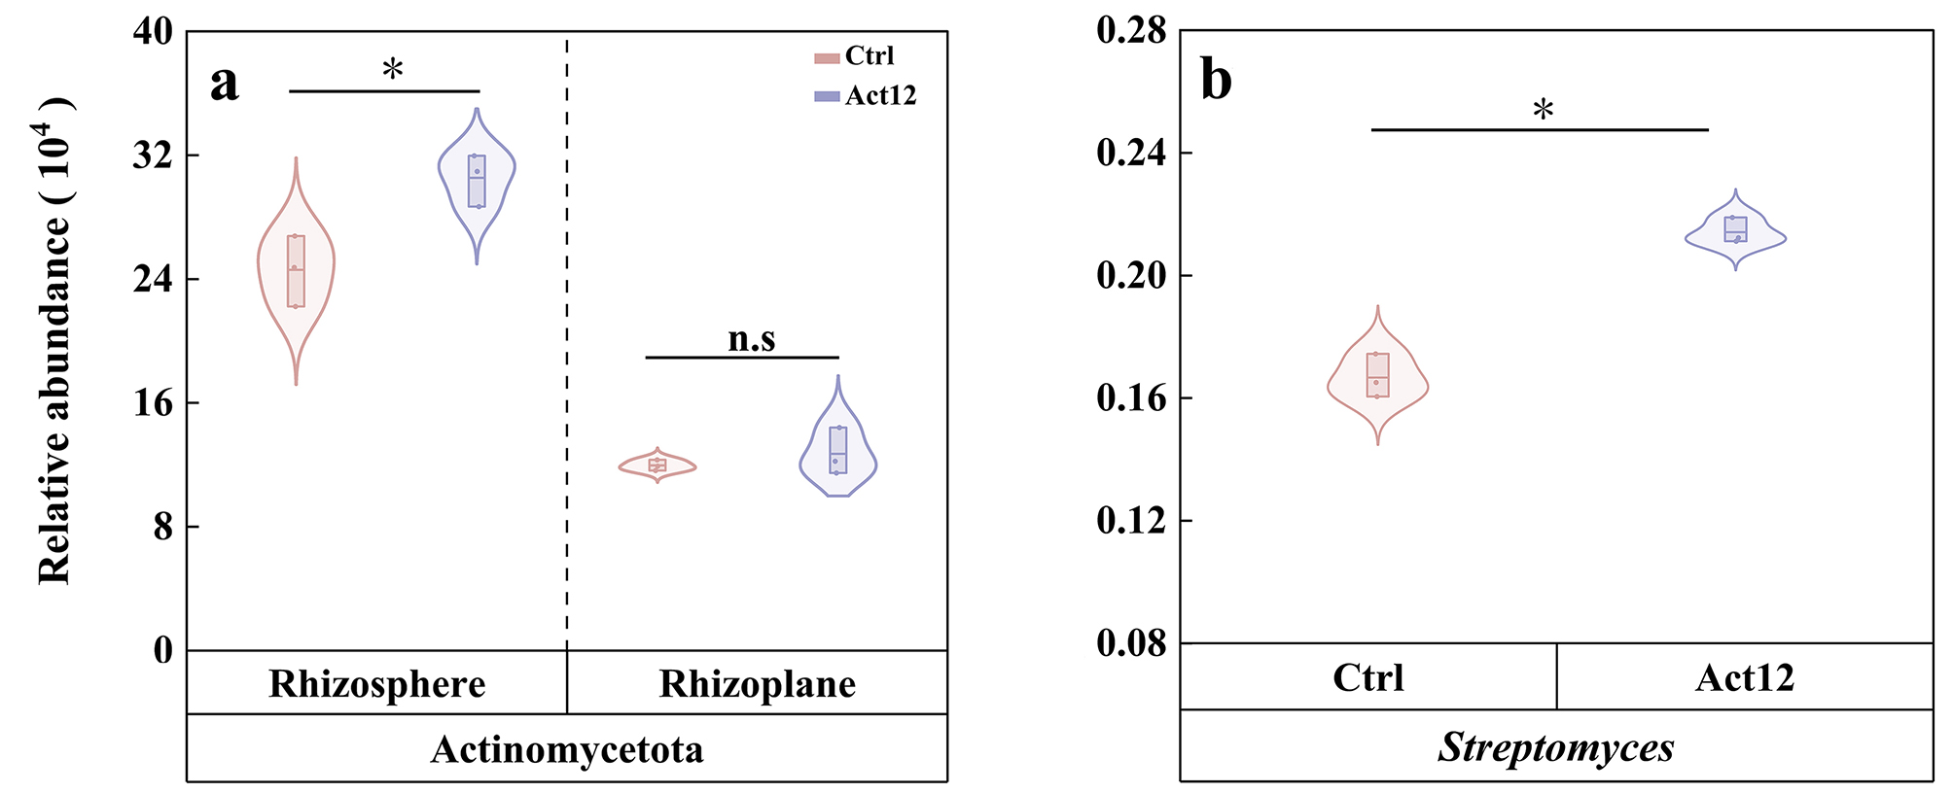Fig. S4 Abundance changes of Actinomycetota and Streptomyces following S. pactum Act12 inoculation. * P < 0.05.

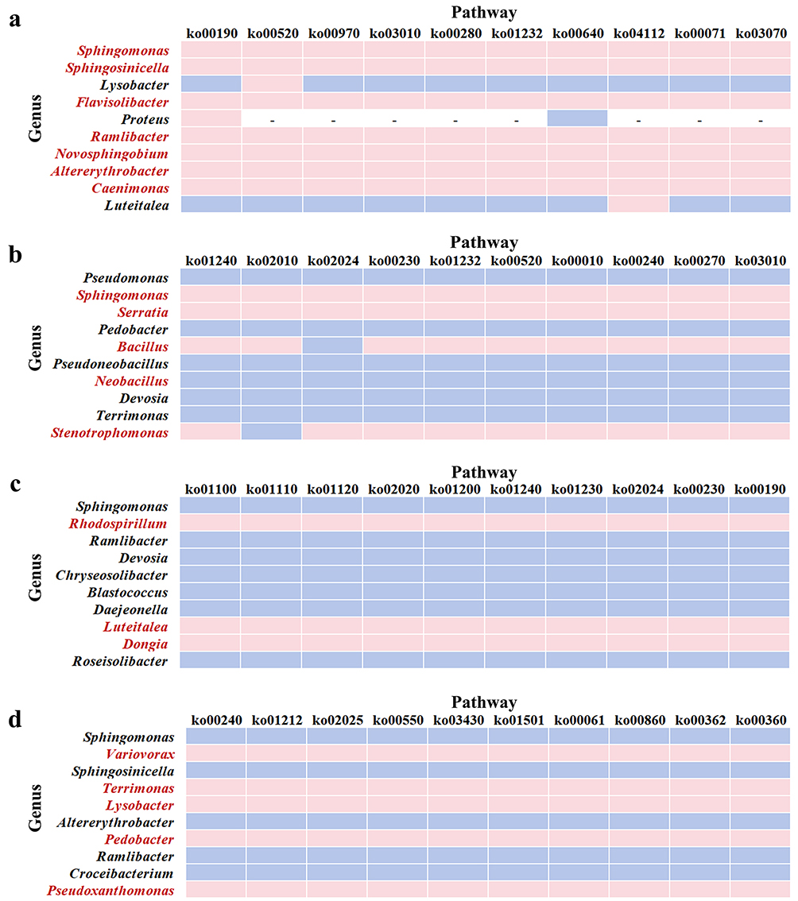
Fig. S5 Relationships of top10 differential metabolic pathways enriched in the top10 differential microbial genera. a rhizosphere at flowering, b rhizoplane at flowering, c rhizosphere at maturation, d rhizoplane at maturation. Red / black labels denote significant increase / decrease in relative abundance following S. pactum Act12 inoculation versus the non-inoculated control. In the pathway panel, pink / blue indicate significant elevation / reduction of the genus-associated pathway; “-” indicates the pathway was not detected.

Supplementary tables
Table S1 Molecular identification of strains
Strains number | DNA identification results | Identities
A1 | Kribbella italica | 99.01%
A2 | Streptomyces seymenliensis | 99.02%
A3 | Kribbella italica | 99.08%
A4 | Glycomyces lechevalierae | 98.87%
B1 | Pseudomonas azotoformans | 99.72%
B2 | Bacillus pumilus | 99.65%
B3 | Microbacterium algeriense | 99.30%
B4 | Pseudomonas azotoformans | 99.72%
B5 | Advenella kashmirensis | 99.86%
F1 | Penicillium aurantiogriseum | 99.10%
F2 | Penicillium janthinellum | 99.27%
F3 | Trichoderma harzianum | 99.31%
F4 | Talaromyces purpureogenus | 99.63%
F5 | Fusarium concolor | 99.22%
F6 | Trichoderma atrobrunneum | 99.49%
F7 | Trichoderma peberdyi | 99.48%
F8 | Fusarium concolor | 99.20%
F9 | Penicillium cyclopium | 99.81%
F10 | Penicillium cellarum | 99.64%
F11 | Fusarium oxysporum | 100.00%

Table S2 Strains function analysis
Strain | Produce ACC deaminase | Dissolve organic phosphorus | Dissolve inorganic phosphorus | Nitrogen fixation | Solubilize potassium | Siderophore production | Produce EPS | Produce IAA
A4 | － | － | － | ＋ | ＋ | － | － | ＋
B3 | － | － | － | ＋ | ＋ | － | － | ＋
Note: "+" indicates the presence of this function, while "-" indicates the absence of it.

