Supplementary Material
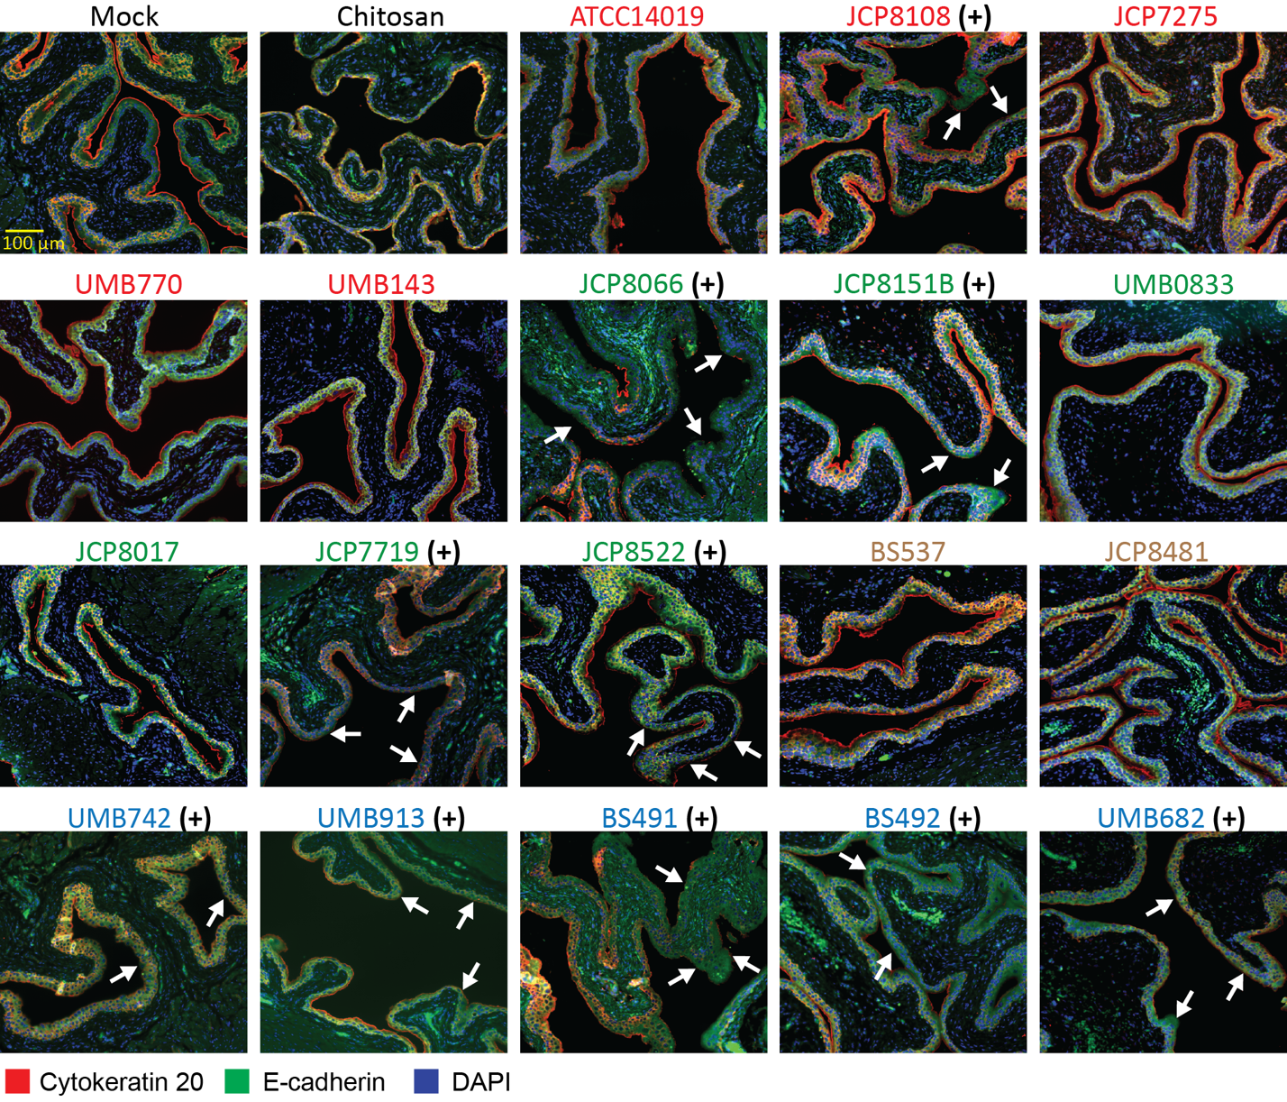

Supplementary Figure 1: Strain wise exfoliation of urothelium in mouse urinary bladder following Gardnerella exposure: Immunostaining images of mouse urinary bladder sections collected after two transurethral exposures of Gardnerella. DAPI (blue), e-cadherin (AF488, green) and cytokeratin-20 (AF647, red; marker of terminally differentiated superficial umbrella cells lining the bladder lumen). Areas of exfoliation are denoted by white arrows. Panels display bladder sections from Mock (PBS), Chitosan-treated mice (a transient urothelial disruptor serving as a positive control), and 18 tested Gardnerella strains. Scale bar: 100 μm. (+) denotes “Exfoliator” strains based on the statistical analysis shown in Fig 2B.

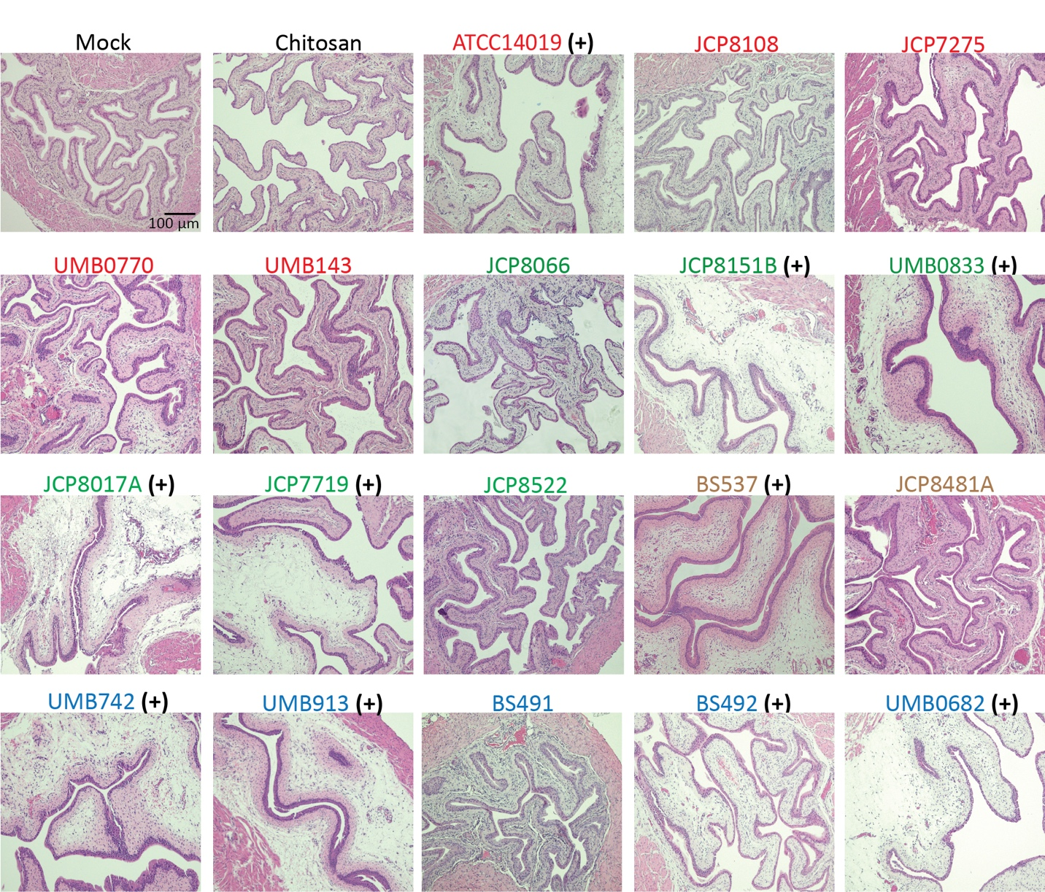

Supplementary Figure 2: Strain differences in Gardnerella-induced edema in the mouse urinary bladder. Representative hematoxylin and eosin (H&E)–stained sections of mouse urinary bladder tissues collected after two transurethral exposures of Gardnerella. Panels display bladder sections from Mock (PBS), Chitosan-treated mice (a transient urothelial disruptor), and 18 tested Gardnerella strains (Scale bar: 100 μm). (+) denotes “Edema” strains based on the statistical analysis shown in Fig 3B.

Table S1. Detailed characterization of the 45 associated genes from panaroo, scoary, eggNOG mapper, and BLASTP.
Table S2. Detailed information on gene presence/absence from the 291 genome Gardnerella pan-genome characterization.

