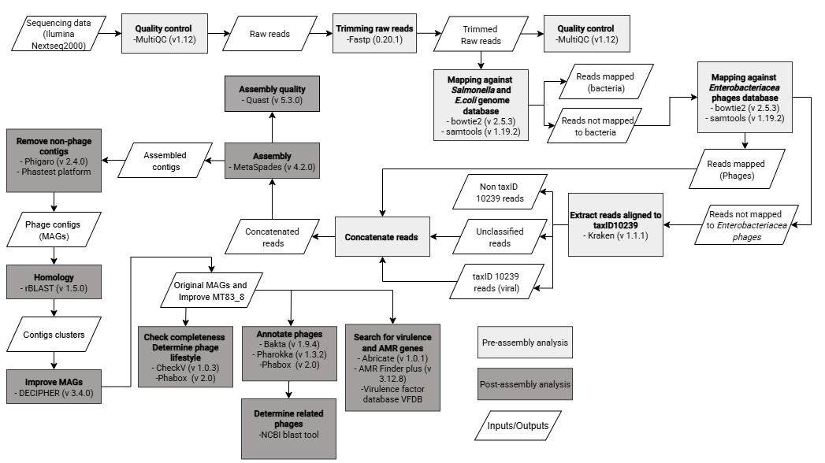
Supplementary Figure 1. Pipeline of metagenomic analysis of phage cocktail MT83. From sequencing to genome taxonomy analysis. Sequencing quality was assessed in MultiQC (v1.12) and reads were trimmed using Fastp (0.20.1). Trimmed Raw reads were filtered to removed Salmonella enterica and Escherichia coli contaminant reads using Bowtie2 (v 2.5.3) [160] in the Galaxy platform (v25.0.2.dev0) [63]. The remaining reads mapped to an Enterobacteriaceae phage database. The unmapped reads were analyzed by Kraken (v 1.1.1) [161], and reads corresponding to TaxID 10239 (Virus) and unclassified were removed. Finally, Enterobacteriaceae phage reads from Bowtie2 and viral and unclassified reads from Kraken were concatenated into one file. Phage assembly was performed in MetaSpades (v 4.2.0) [59–62]. Metagenome assembled genomes (MAGs) contigs were analyzed in Phigaro (v.2.4.0) [64] and Phastest platform [65] to remove non-phage contigs. Homology between viral contigs was established using rBLAST (v 1.5.0) [66]. Contigs with 99% homology were aligned and clustered to improve the MAGs quality with DECIPHER (v.3.4.0) [67] Phage MAGs were annotated using pharokka (v 1.3.2) [68] and Bakta (v 1.9.4) [69] through galaxy.eu server and Phabox platform(v 2.0) [70] . Phage MAGs graphics were generated using the Proksee platform [71]. To determine virulence and antimicrobial resistance genes, we used AMR Finder Plus (v 3.12.8) [72], ABRicate (v 1.0.1) [73] and virulence factor database VFDB [74]. To confirm that the phages found were not lysogenic, we used CheckV(v 1.0.3) [75] on Galaxy Europe and Phabox platform (v 2.0) [70]. The NCBI Blast tool was used to identify similar sequences, to determine related phages, and to understand their taxonomy [76]. Grey boxes indicate the processing steps (light grey: before assembly, dark grey: after assembly). White boxes represent the inputs and outputs associated with each step.

