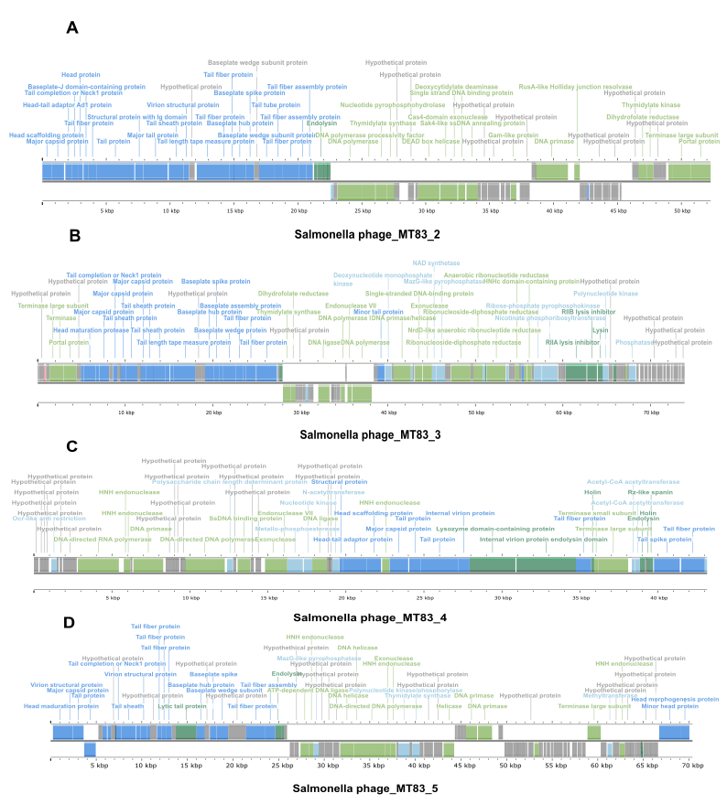

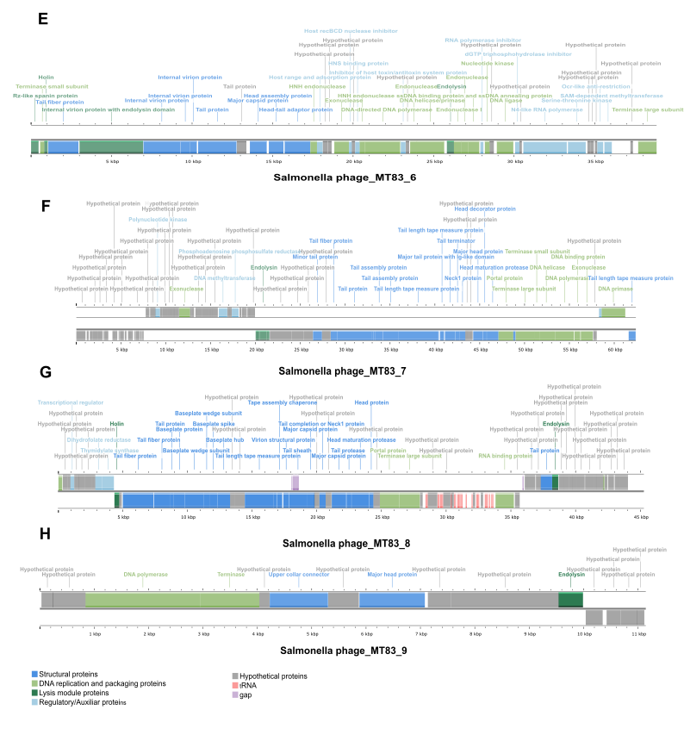
Supplementary Figure 2. Genome maps of the MAGs phages of the MT83 cocktail, highlighting genes related to structure, replication, lysis, regulation and hypothetical proteins. A. Salmonella phage MT83_2 B. Salmonella phage MT83_3 C. Salmonella phage MT83_4 D. Salmonella phage MT83_5 E. Salmonella phage MT83_6 F. Salmonella phage MT83_7 G. Salmonella phage MT83_8 H. Salmonella phage MT83_9

