Supp. Figure 1: Maximum likelihood phylogenies of representative Rickettsia ompB gene sequences amplified from tick tissues of Amblyomma gemma and Hyalomma rufipes camel ticks collected in North Kenya. The study sequences are highlighted in bold. The bootstrap values at the nodes are the indicating percentage agreement from 1000 replicates. The branch length scale represents the substitution per site. Trees are rooted to outgroup sequences (indicated in brackets).

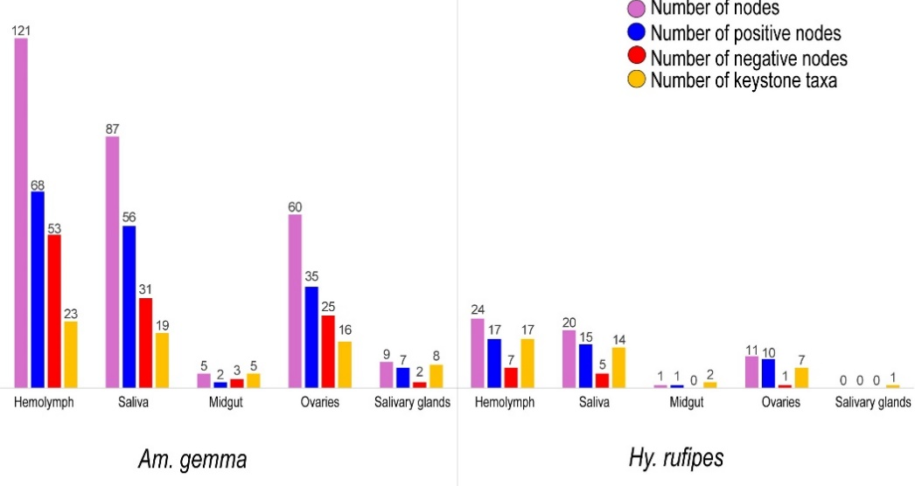

Supp. Figure 2: Bar plot showing the number of nodes (positive and negative) and the number of keystone taxa identified in different tick tissues of Amblyomma gemma and Hyalomma rufipes.

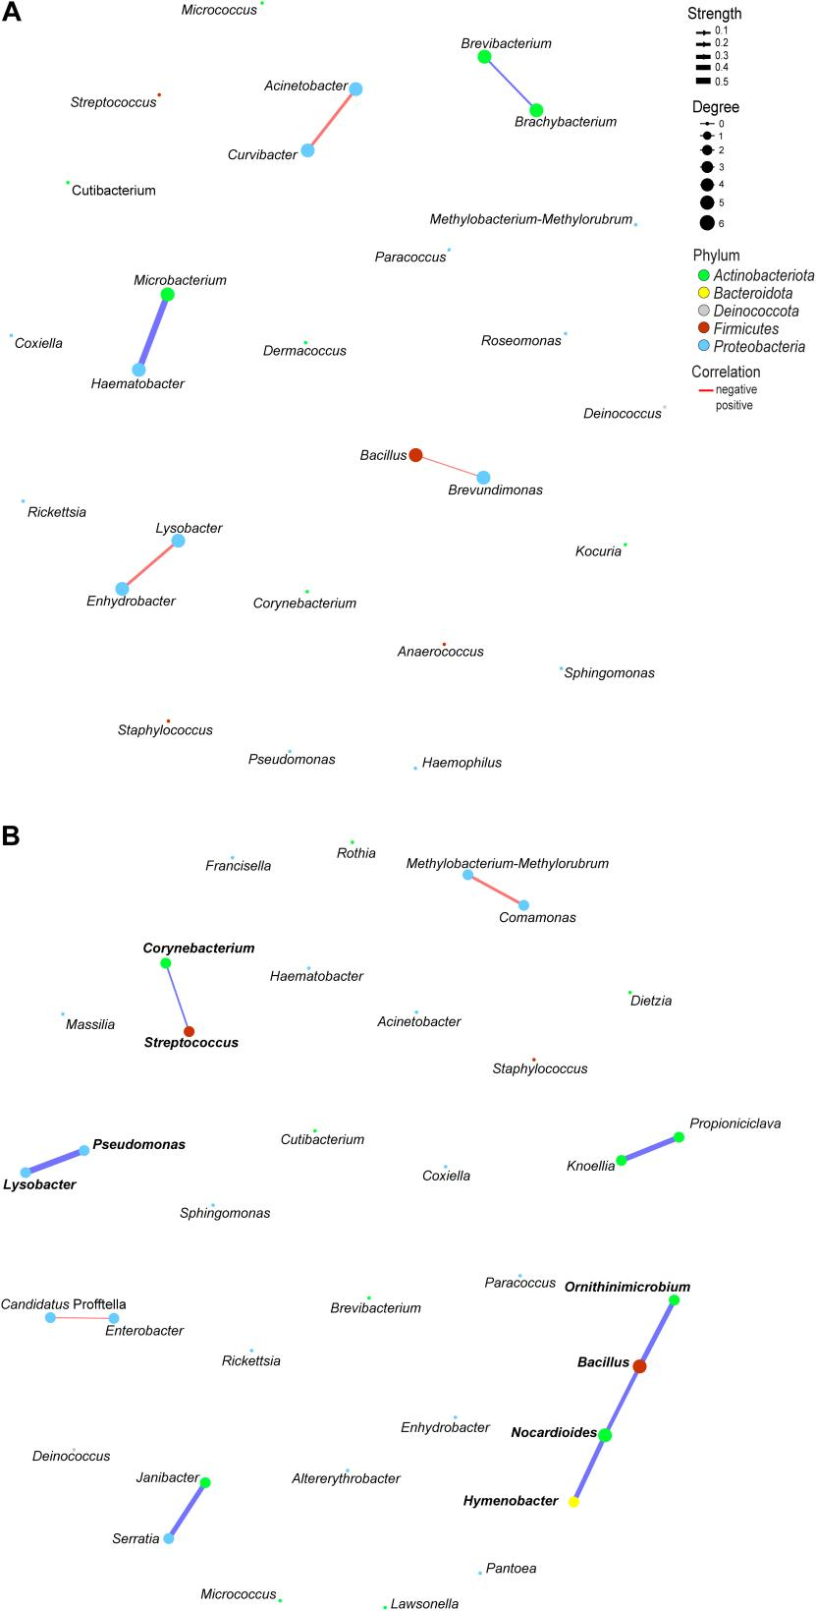

Supp. Figure 3: Co-occurrence network analysis of bacterial 16S rRNA genes in the (A) midgut and (B) salivary glands of Amblyomma gemma ticks. Nodes represent individual bacterial genera, with their size indicating the degree of network. Node colours correspond to bacterial phyla. Edges between nodes indicate significant co-occurrence relationships, with edge thickness reflecting the strength of associations and colour reflects the positive (blue) and negative (red) co-occurrence. Keystone taxa are bolded.

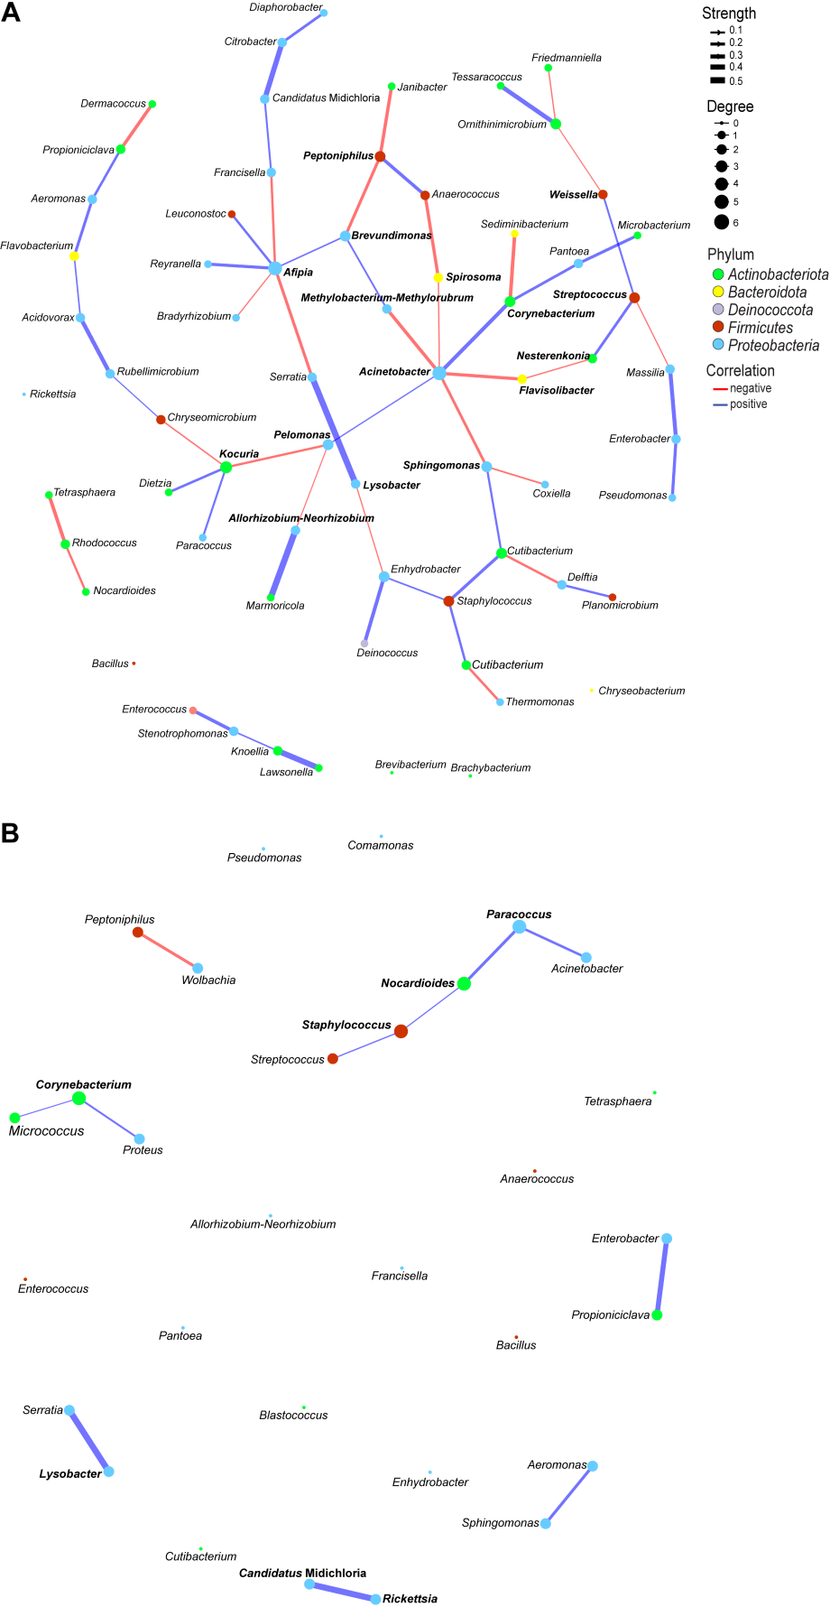

Supp. Figure 4: Co-occurrence network analysis of bacterial 16S rRNA genes in the ovaries of (A) Amblyomma gemma and (B) Hyalomma rufipes ticks. Nodes represent individual bacterial genera, with their size indicating the degree of network. Node colours correspond to bacterial phyla. Edges between nodes indicate significant co-occurrence relationships, with edge thickness reflecting the strength of associations and colour reflects the positive (blue) and negative (red) co-occurrence. Keystone taxa are bold.

Supp. Table 1: Centred log-ratio transformation (CLR) of bacterial genera abundances in Amblyomma gemma and Hyalomma rufipes.
 | Tick Species
Genus | Am. gemma | Hy. rufipes
Aerococcus | 1.06 | -1.09
Anaerococcus | -5.96 | 6.43
Chryseobacterium | 1.39 | -1.42
Comamonas | 0.01 | 0.03
Corynebacterium | 0.94 | -0.91
Coxiella | 4.29 | -4.47
Dietzia | 1.01 | -1.05
Enterobacter | 1.57 | -1.60
Escherichia-Shigella | -1.04 | 1.15
Francisella | -3.86 | 4.18
Helcococcus | -2.87 | 3.13
Lysinibacillus | 1.96 | -2.03
Methylobacterium-Methylorubrum | 2.88 | -3.00
Microbacterium | 1.18 | -1.23
Oceanobacillus | 1.39 | -1.44
Paenibacillus | 0.12 | -0.07
Planomicrobium | 0.09 | -0.06
Porphyromonas | -1.73 | 1.88
Propioniciclava | 0.74 | -0.76
Proteus | -2.98 | 3.25
Rickettsia | 0.44 | -0.35
Salinicoccus | 1.50 | -1.56
Solibacillus | 4.42 | -4.50
Stenotrophomonas | 0.57 | -0.55

Supp. Table 2: Centred log-ratio transformation (CLR) of bacterial genera abundances in the tissues of Amblyomma gemma and Hyalomma rufipes.
Am. gemma |  | Tick tissues
 | haemolymph |  | midgut | ovaries | salivary glands | saliva
Genus
Acinetobacter | 18.8 |  | -16.3 | -5.7 | -19.2 | 26.8
Candidatus Midichloria | -0.6 |  | -0.4 | 1.1 | 0.1 | -0.6
Corynebacterium | 17.6 |  | -14.0 | -5.9 | -13.6 | 20.1
Coxiella | -6.3 |  | 4.0 | 2.7 | 7.3 | -8.3
Francisella | 0.2 |  | -1.2 | 0.7 | 1.5 | -1.5
Paracoccus | 1.6 |  | -3.3 | 2.9 | -1.9 | 0.5
Proteus | 0.4 |  | -0.2 | 0.0 | -0.2 | 0.1
Pseudomonas | 13.5 |  | -17.8 | -1.8 | -10.2 | 12.2
Rickettsia | -2.1 |  | 0.6 | 3.4 | 2.4 | -4.3
Rickettsiella | 3.5 |  | -1.4 | -1.1 | -1.0 | 0.2
Sphingomonas | 3.6 |  | -3.4 | 0.5 | -3.4 | 3.0
Staphylococcus | 22.9 |  | -11.9 | -4.6 | -16.5 | 11.4
Wolbachia | 8.3 |  | -3.8 | -0.5 | -2.0 | -0.9
Hy. rufipes
Genus
Acinetobacter | 5.6 |  | -4.8 | -0.6 | -6.4 | 4.3
Candidatus Midichloria | -2.8 |  | 2.1 | -1.6 | 7.5 | -5.0
Corynebacterium | 20.7 |  | -11.7 | -10.3 | -17.3 | 18.9
Francisella | -6.1 |  | 4.3 | -0.4 | 9.6 | -6.6
Paracoccus | 0.6 |  | 0.2 | 0.7 | -2.6 | -0.2
Proteus | 0.0 |  | 1.7 | 1.9 | -5.4 | 2.5
Pseudomonas | 20.1 |  | -12.9 | 11.5 | -34.7 | 11.1
Rickettsia | -1.8 |  | 2.6 | 0.4 | 2.6 | -3.3
Rickettsiella | 0.8 |  | -0.6 | 0.3 | -0.6 | -0.2
Sphingomonas | 0.1 |  | 0.6 | 0.0 | -0.6 | -1.0
Staphylococcus | 15.4 |  | -9.7 | -3.5 | -14.8 | 8.5
Wolbachia | 0.1 |  | -1.3 | 3.1 | -1.0 | -0.8

Supp. Table 3: Alpha diversity of bacterial species communities P-values based on different tick tissues of Amblyomma gemma and Hyalomma rufipes.
Sample name | Am. gemma |  | Hy. rufipes
 | Observed | Shannon | Observed | Shannon
HL vs MG | 0.001*** | 0.043* | 0.001*** | 0.04*
HL vs OVs | 0.16 | 0.043* | 0.87 | 0.16
HL vs SGs | 0.01** | 0.01** | 0.69 | 0.001***
HL vs SL | 0.78 | 0.8 | 0.35 | 0.26
MG vs OVs | 0.02* | 0.88 | 0.01** | 0.39
MG vs SGs | 0.65 | 0.65 | 0.03* | 0.0078**
MG vs SL | 0.01* | 0.022* | 0.05* | 0.011**
OVs vs SGs | 0.13 | 0.55 | 0.83 | 0.001***
OVs vs SL | 0.16 | 0.013* | 0.53 | 0.0078**
SGs vs SL | 0.01** | 0.0057** | 0.69 | 0.001***
HL, haemolymph; MG, midgut; OVs, ovaries; SGs, salivary glands; SL, saliva.
P-value (*P < 0.05, **P < 0.01, ***P < 0.001)

Supp. Table 4: The keystone taxa identified in the haemolymph of Amblyomma gemma with their centrality measures
Genus | Degree | Betweenness | Closeness | Eigenvector
Reyranella | 6 | 389.424 | 0.003 | 1.000
Sphingomonas | 6 | 269.894 | 0.003 | 0.928
Delftia | 5 | 260.504 | 0.003 | 0.914
Aeromonas | 6 | 241.472 | 0.003 | 0.873
Flavobacterium | 5 | 148.159 | 0.003 | 0.866
Rickettsia | 5 | 301.112 | 0.003 | 0.848
Friedmanniella | 5 | 139.535 | 0.003 | 0.824
Dietzia | 7 | 408.616 | 0.003 | 0.808
Cloacibacterium | 4 | 105.021 | 0.003 | 0.798
Microbacterium | 4 | 124.011 | 0.003 | 0.796
Solibacillus | 5 | 314.926 | 0.003 | 0.633
Gemella | 5 | 274.433 | 0.003 | 0.626
Citricoccus | 5 | 267.437 | 0.003 | 0.622
Nesterenkonia | 7 | 308.267 | 0.003 | 0.614
Staphylococcus | 5 | 269.046 | 0.003 | 0.566
Brevibacterium | 6 | 190.235 | 0.003 | 0.557
Novosphingobium | 4 | 161.558 | 0.003 | 0.491
Ramlibacter | 4 | 107.046 | 0.003 | 0.457
Pantoea | 5 | 273.474 | 0.003 | 0.423
Aureimonas | 4 | 279.081 | 0.003 | 0.419
Atopostipes | 4 | 188.770 | 0.003 | 0.361
Tolumonas | 5 | 294.969 | 0.003 | 0.356
Janibacter | 5 | 307.495 | 0.003 | 0.316

Supp. Table 5: Bacterial co-occurrence node strength and correlation the haemolymph of Amblyomma gemma
From genus | To genus | Strength | Correlation
Pseudomonas | Lysobacter | 0.48 | positive
Pseudomonas | Aeromonas | 0.04 | negative
Pseudomonas | Serratia | 0.50 | positive
Pseudomonas | Elizabethkingia | 0.42 | positive
Acinetobacter | Sphingomonas | 0.06 | negative
Acinetobacter | Glutamicibacter | 0.11 | positive
Rickettsia | Aeromonas | 0.06 | positive
Rickettsia | Sphingomonas | 0.12 | negative
Rickettsia | Novosphingobium | 0.02 | positive
Solibacillus | Cutibacterium | 0.18 | negative
Solibacillus | Citricoccus | 0.01 | positive
Solibacillus | Tessaracoccus | 0.08 | negative
Solibacillus | Friedmanniella | 0.09 | negative
Bacillus | Oceanobacillus | 0.25 | positive
Bacillus | Brevibacterium | 0.14 | negative
Bacillus | Aureimonas | 0.11 | negative
Bacillus | Dietzia | 0.05 | negative
Lysobacter | Aeromonas | 0.00 | negative
Lysobacter | Gemella | 0.23 | negative
Rickettsiella | Micrococcus | 0.31 | positive
Cutibacterium | Staphylococcus | 0.12 | positive
Cutibacterium | Sphingomonas | 0.25 | positive
Cutibacterium | Gemella | 0.02 | negative
Staphylococcus | Corynebacterium | 0.02 | positive
Staphylococcus | Kocuria | 0.03 | negative
Corynebacterium | Pantoea | 0.06 | negative
Corynebacterium | Gemella | 0.05 | negative
Citricoccus | Paenibacillus | 0.00 | positive
Citricoccus | Flavobacterium | 0.20 | negative
Citricoccus | Diaphorobacter | 0.03 | negative
Citricoccus | Georgenia | 0.44 | positive
Micrococcus | Candidatus Profftella | 0.22 | positive
Micrococcus | Thermomonas | 0.03 | negative
Lysinibacillus | Jeotgalicoccus | 0.05 | positive
Lysinibacillus | Pseudarthrobacter | 0.50 | positive
Desemzia | Peptoniphilus | 0.02 | negative
Enhydrobacter | Paracoccus | 0.43 | positive
Enhydrobacter | Agrococcus | 0.11 | negative
Paracoccus | Enteractinococcus | 0.03 | positive
Aerococcus | Brevundimonas | 0.18 | positive
Aerococcus | Stenotrophomonas | 0.03 | positive
Aerococcus | Thermomonas | 0.09 | positive
Wolbachia | Afipia | 0.04 | negative
Wolbachia | Tolumonas | 0.29 | positive
Wolbachia | Trueperella | 0.05 | positive
Afipia | Sediminibacterium | 0.09 | positive
Afipia | Reyranella | 0.30 | positive
Jeotgalicoccus | Sporosarcina | 0.04 | positive
Methylobacterium-Methylorubrum | Aeromonas | 0.15 | positive
Enterobacter | Chryseobacterium | 0.25 | positive
Enterobacter | Massilia | 0.06 | negative
Oceanobacillus | Dietzia | 0.03 | negative
Serratia | Reyranella | 0.13 | negative
Serratia | Elizabethkingia | 0.04 | positive
Sediminibacterium | Comamonas | 0.40 | positive
Sphingomonas | Cloacibacterium | 0.09 | negative
Sphingomonas | Gemella | 0.03 | negative
Paenibacillus | Sporosarcina | 0.46 | positive
Anaerococcus | Nocardioides | 0.24 | positive
Anaerococcus | Friedmanniella | 0.09 | positive
Brachybacterium | Deinococcus | 0.03 | negative
Brachybacterium | Propioniciclava | 0.17 | negative
Brevundimonas | Diaphorobacter | 0.18 | positive
Brevundimonas | Dietzia | 0.01 | negative
Nocardioides | Ornithinimicrobium | 0.16 | positive
Nocardioides | Streptococcus | 0.01 | positive
Nocardioides | Dietzia | 0.04 | negative
Flavobacterium | Delftia | 0.13 | negative
Flavobacterium | Friedmanniella | 0.04 | positive
Romboutsia | Ornithinimicrobium | 0.10 | negative
Romboutsia | Pantoea | 0.20 | negative
Romboutsia | Nesterenkonia | 0.09 | positive
Candidatus Profftella | Tessaracoccus | 0.22 | positive
Ornithinimicrobium | Enteractinococcus | 0.30 | negative
Pantoea | Klebsiella | 0.09 | positive
Pantoea | Atopostipes | 0.06 | negative
Tessaracoccus | Delftia | 0.19 | negative
Peptoniphilus | Janthinobacterium | 0.10 | positive
Deinococcus | Brevibacterium | 0.23 | positive
Reyranella | Francisella | 0.10 | negative
Reyranella | Delftia | 0.09 | negative
Streptococcus | Stenotrophomonas | 0.11 | positive
Streptococcus | Ramlibacter | 0.09 | positive
Nesterenkonia | Brevibacterium | 0.03 | positive
Nesterenkonia | Aureimonas | 0.04 | positive
Nesterenkonia | Lawsonella | 0.17 | positive
Comamonas | Propioniciclava | 0.23 | positive
Francisella | Blastococcus | 0.05 | positive
Coxiella | Enterococcus | 0.40 | positive
Coxiella | Novosphingobium | 0.27 | positive
Rubellimicrobium | Microvirga | 0.45 | negative
Propioniciclava | Glutamicibacter | 0.08 | negative
Propioniciclava | Lawsonella | 0.05 | positive
Lactobacillus | Actinomyces | 0.31 | positive
Janibacter | Aureimonas | 0.29 | negative
Janibacter | Stenotrophomonas | 0.20 | positive
Janibacter | Piscicoccus | 0.23 | negative
Flavisolibacter | Stenotrophomonas | 0.01 | positive
Flavisolibacter | Luteimonas | 0.50 | positive
Kocuria | Rhodococcus | 0.02 | negative
Kocuria | Janthinobacterium | 0.36 | negative
Kocuria | Lawsonella | 0.14 | positive
Microbacterium | Dietzia | 0.24 | negative
Microbacterium | Cloacibacterium | 0.29 | negative
Hymenobacter | Acidovorax | 0.51 | positive
Diaphorobacter | Enteractinococcus | 0.05 | negative
Atopostipes | Ramlibacter | 0.16 | negative
Atopostipes | Thermomonas | 0.06 | positive
Dietzia | Ramlibacter | 0.05 | negative
Stenotrophomonas | Tolumonas | 0.00 | negative
Ramlibacter | Novosphingobium | 0.04 | negative
Delftia | Friedmanniella | 0.02 | negative
Thermomonas | Georgenia | 0.04 | positive
Blastococcus | Agrococcus | 0.27 | positive
Cloacibacterium | Friedmanniella | 0.13 | positive
Actinomyces | Novosphingobium | 0.02 | negative
Agrococcus | Tolumonas | 0.16 | positive
Agrococcus | Piscicoccus | 0.12 | positive
Sphingobacterium | Trueperella | 0.42 | positive
Pelomonas | Rothia | 0.50 | positive
Trueperella | Piscicoccus | 0.09 | positive

Supp. Table 6: Keystone taxa identified in the saliva of Amblyomma gemma with their centrality measures
Genus | Degree | Betweenness | Closeness | Eigenvector
Flavobacterium | 5 | 315.255 | 0.003 | 1.000
Alkalibacterium | 5 | 306.743 | 0.003 | 0.910
Paenibacillus | 5 | 398.605 | 0.003 | 0.798
Comamonas | 5 | 182.757 | 0.002 | 0.731
Stenotrophomonas | 3 | 39.402 | 0.003 | 0.713
Streptococcus | 4 | 197.976 | 0.003 | 0.671
Enterobacter | 5 | 214.867 | 0.003 | 0.666
Sphingomonas | 4 | 318.341 | 0.003 | 0.635
Rhodococcus | 3 | 89.019 | 0.003 | 0.575
Solibacillus | 3 | 270.255 | 0.003 | 0.444
Bacillus | 5 | 891.041 | 0.003 | 0.438
Lysinibacillus | 3 | 225.221 | 0.003 | 0.430
Enteractinococcus | 4 | 478.417 | 0.003 | 0.418
Enterococcus | 5 | 340.605 | 0.003 | 0.407
Citricoccus | 3 | 632.257 | 0.003 | 0.195
Salinicoccus | 4 | 387.548 | 0.003 | 0.176
Pseudomonas | 3 | 614.033 | 0.003 | 0.149
Brevundimonas | 4 | 497.088 | 0.003 | 0.095
Citrobacter | 3 | 449.000 | 0.002 | 0.049

Supp. Table 7: Bacterial co-occurrence nodes’ strength and correlation in the saliva of Amblyomma gemma
From genus | To genus | Strength | Correlation
Pseudomonas | Bacillus | 0.02 | negative
Pseudomonas | Lysobacter | 0.34 | positive
Pseudomonas | Citrobacter | 0.25 | positive
Acinetobacter | Microbacterium | 0.01 | positive
Bacillus | Solibacillus | 0.09 | positive
Bacillus | Lysinibacillus | 0.13 | positive
Bacillus | Citricoccus | 0.10 | positive
Cutibacterium | Comamonas | 0.23 | negative
Cutibacterium | Rhizorhapis | 0.12 | positive
Corynebacterium | Enhydrobacter | 0.14 | positive
Corynebacterium | Arcanobacterium | 0.14 | positive
Lysobacter | Afipia | 0.23 | negative
Staphylococcus | Paenibacillus | 0.13 | negative
Enterococcus | Micrococcus | 0.13 | positive
Enterococcus | Rickettsiella | 0.12 | positive
Enterococcus | Allorhizobium-Neorhizobium-Pararhizobium-Rhizobium | 0.12 | negative
Enterococcus | Noviherbaspirillum | 0.12 | positive
Salinicoccus | Enteractinococcus | 0.05 | positive
Salinicoccus | Brachybacterium | 0.07 | negative
Salinicoccus | Cloacibacterium | 0.08 | negative
Candidatus Profftella | Rhizorhapis | 0.01 | positive
Micrococcus | Paenibacillus | 0.02 | negative
Micrococcus | Altererythrobacter | 0.02 | negative
Sphingobacterium | Aerococcus | 0.09 | negative
Sphingobacterium | Desemzia | 0.08 | negative
Lysinibacillus | Atopostipes | 0.07 | positive
Lysinibacillus | Enterobacter | 0.02 | negative
Comamonas | Chryseobacterium | 0.18 | positive
Comamonas | Rhizorhapis | 0.05 | negative
Stenotrophomonas | Flavobacterium | 0.08 | positive
Stenotrophomonas | Alkalibacterium | 0.35 | positive
Stenotrophomonas | Streptococcus | 0.17 | negative
Paracoccus | Methylobacterium-Methylorubrum | 0.11 | positive
Paracoccus | Aeromonas | 0.10 | negative
Flavobacterium | Microbacterium | 0.15 | positive
Flavobacterium | Paenibacillus | 0.05 | positive
Brevundimonas | Citricoccus | 0.09 | negative
Serratia | Arthrobacter | 0.20 | negative
Atopostipes | Enterobacter | 0.10 | negative
Atopostipes | Enteractinococcus | 0.22 | positive
Atopostipes | Marmoricola | 0.17 | negative
Arthrobacter | Enterobacter | 0.08 | negative
Enterobacter | Sphingomonas | 0.05 | positive
Methylobacterium-Methylorubrum | Nocardioides | 0.09 | positive
Tessaracoccus | Rhodococcus | 0.22 | positive
Tessaracoccus | Altererythrobacter | 0.06 | positive
Alkalibacterium | Sphingomonas | 0.10 | negative
Alkalibacterium | Rhodococcus | 0.09 | positive
Enteractinococcus | Sphingomonas | 0.01 | negative
Enteractinococcus | Noviherbaspirillum | 0.02 | negative
Microbacterium | Aerococcus | 0.07 | negative
Microbacterium | Erysipelothrix | 0.17 | positive
Dietzia | Allorhizobium-Neorhizobium-Pararhizobium-Rhizobium | 0.12 | positive
Citricoccus | Desemzia | 0.02 | positive
Sphingomonas | Erysipelothrix | 0.07 | negative
Christensenellaceae R-7 group | Exiguobacterium | 0.08 | positive
Streptococcus | Rickettsiella | 0.02 | positive
Streptococcus | Paenibacillus | 0.05 | negative
Streptococcus | Rhizorhapis | 0.08 | positive
Escherichia-Shigella | Exiguobacterium | 0.30 | positive
Massilia | Ornithinimicrobium | 0.01 | negative
Wolbachia | Hymenobacter | 0.36 | positive
Wolbachia | Lawsonella | 0.04 | positive
Kocuria | Propioniciclava | 0.36 | positive
Planomicrobium | Romboutsia | 0.24 | positive
Exiguobacterium | Neisseria | 0.01 | negative
Ornithinimicrobium | Noviherbaspirillum | 0.10 | negative
Afipia | Deinococcus | 0.10 | positive
Deinococcus | Brevibacterium | 0.09 | negative
Pantoea | Citrobacter | 0.05 | positive
Rickettsiella | Altererythrobacter | 0.12 | negative
Citrobacter | Janthinobacterium | 0.28 | positive
Truepera | Rubellimicrobium | 0.36 | positive
Propioniciclava | Haemophilus | 0.07 | positive
Janthinobacterium | Lawsonella | 0.11 | positive
Erwinia | Blastococcus | 0.06 | positive
Erwinia | Neisseria | 0.22 | positive
Blastococcus | Aeromonas | 0.12 | positive
Blastococcus | Porphyrobacter | 0.01 | positive
Xanthomonas | Lawsonella | 0.13 | positive
Janibacter | Porphyrobacter | 0.27 | positive
Janibacter | Cloacibacterium | 0.11 | positive
Klebsiella | Anaerococcus | 0.20 | positive
Anaerococcus | Desemzia | 0.02 | positive
Agrococcus | Brachybacterium | 0.24 | positive
Brachybacterium | Cloacibacterium | 0.08 | positive
Haemophilus | Neisseria | 0.02 | positive

Supp. Table 8: Keystone taxa identified in the midgut of Amblyomma gemma with their centrality measures
Genus | Degree | Betweenness | Closeness | Eigenvector
Brevibacterium | 1 | 0 | 1 | 1
Brachybacterium | 1 | 0 | 1 | 1
Enhydrobacter | 1 | 0 | 1 | 0.42
Lysobacter | 1 | 0 | 1 | 0.42
Acinetobacter | 1 | 0 | 1 | 0

Supp. Table 9: Bacterial co-occurrence nodes’ strength and correlation in the midgut of Amblyomma gemma
From genus | To genus | Strength | Correlation
Enhydrobacter | Lysobacter | 0.074 | negative
Acinetobacter | Curvibacter | 0.076 | negative
Haematobacter | Microbacterium | 0.20 | positive
Brevibacterium | Brachybacterium | 0.04 | positive
Brevundimonas | Bacillus | 0.01 | negative

Supp. Table 10: Keystone taxa identified in the salivary glands of Amblyomma gemma with their centrality measures
Genus | Degree | Betweenness | Closeness | Eigenvector
Bacillus | 2 | 2 | 0.25 | 1
Nocardioides | 2 | 2 | 0.25 | 1
Hymenobacter | 1 | 0 | 0.17 | 0.62
Ornithinimicrobium | 1 | 0 | 0.17 | 0.62
Pseudomonas | 1 | 0 | 1 | 4.61E-17
Corynebacterium | 1 | 0 | 1 | 4.61E-17
Lysobacter | 1 | 0 | 1 | 0
Streptococcus | 1 | 0 | 1 | 0

Supp. Table 11: Bacterial co-occurrence nodes’ strength and correlation in the salivary glands of Amblyomma gemma
From genus | To genus | Strength | Correlation
Pseudomonas | Lysobacter | 0.21 | positive
Streptococcus | Corynebacterium | 0.03 | positive
Bacillus | Nocardioides | 0.12 | positive
Bacillus | Ornithinimicrobium | 0.16 | positive
Nocardioides | Hymenobacter | 0.15 | positive
Methylobacterium-Methylorubrum | Comamonas | 0.07 | negative
Candidatus Profftella | Enterobacter | 0.00 | negative
Propioniciclava | Knoellia | 0.17 | positive
Serratia | Janibacter | 0.15 | positive

Supp. Table 12: Keystone taxa identified in the ovaries of Amblyomma gemma with their centrality measures
Genus | Degree | Betweenness | Closeness | Eigenvector
Acinetobacter | 7 | 1092.3 | 0.004 | 1.000
Pelomonas | 4 | 302.4 | 0.004 | 0.732
Spirosoma | 3 | 111.5 | 0.003 | 0.580
Allorhizobium-Neorhizobium-Pararhizobium-Rhizobium | 3 | 64.0 | 0.003 | 0.566
Corynebacterium | 4 | 249.0 | 0.003 | 0.411
Sphingomonas | 3 | 476.8 | 0.004 | 0.378
Methylobacterium-Methylorubrum | 2 | 347.9 | 0.004 | 0.354
Flavisolibacter | 2 | 518.8 | 0.004 | 0.335
Kocuria | 4 | 366.4 | 0.003 | 0.312
Brevundimonas | 3 | 417.3 | 0.003 | 0.188
Peptoniphilus | 4 | 150.3 | 0.003 | 0.146
Afipia | 6 | 635.3 | 0.003 | 0.130
Nesterenkonia | 3 | 500.8 | 0.003 | 0.125
Streptococcus | 3 | 556.4 | 0.003 | 0.048
Lysobacter | 3 | 345.3 | 0.003 | 0.039
Weissella | 3 | 464.0 | 0.003 | 0.018

Supp. Table 13: Bacterial co-occurrence nodes’ strength and correlation in the ovaries of Amblyomma gemma
From genus | To genus | Strength | Correlation
Coxiella | Sphingomonas | 0.04 | negative
Lysobacter | Enhydrobacter | 0.01 | negative
Cutibacterium | Delftia | 0.10 | negative
Acinetobacter | Sphingomonas | 0.12 | negative
Acinetobacter | Methylobacterium- Methylorubrum | 0.16 | negative
Acinetobacter | Flavisolibacter | 0.15 | negative
Acinetobacter | Spirosoma | 0.02 | negative
Francisella | Afipia | 0.10 | negative
Micrococcus | Thermomonas | 0.10 | negative
Corynebacterium | Sediminibacterium | 0.18 | negative
Serratia | Afipia | 0.14 | negative
Ornithinimicrobium | Weissella | 0.01 | negative
Ornithinimicrobium | Friedmanniella | 0.02 | negative
Janibacter | Peptoniphilus | 0.16 | negative
Dermacoccus | Propioniciclava | 0.16 | negative
Nocardioides | Rhodococcus | 0.08 | negative
Afipia | Bradyrhizobium | 0.01 | negative
Streptococcus | Massilia | 0.01 | negative
Kocuria | Chryseomicrobium | 0.03 | negative
Kocuria | Pelomonas | 0.09 | negative
Allorhizobium-Neorhizobium-Pararhizobium-Rhizobium | Pelomonas | 0.00 | negative
Flavisolibacter | Nesterenkonia | 0.02 | negative
Tetrasphaera | Rhodococcus | 0.18 | negative
Peptoniphilus | Brevundimonas | 0.14 | negative
Anaerococcus | Spirosoma | 0.15 | negative
Pseudomonas | Enterobacter | 0.14 | positive
Lysobacter | Serratia | 0.37 | positive
Cutibacterium | Staphylococcus | 0.14 | positive
Cutibacterium | Sphingomonas | 0.08 | positive
Enhydrobacter | Staphylococcus | 0.05 | positive
Enhydrobacter | Deinococcus | 0.19 | positive
Staphylococcus | Micrococcus | 0.10 | positive
Paracoccus | Kocuria | 0.07 | positive
Acinetobacter | Corynebacterium | 0.19 | positive
Acinetobacter | Pelomonas | 0.02 | positive
Enterobacter | Massilia | 0.22 | positive
Francisella | Candidatus Midichloria | 0.06 | positive
Corynebacterium | Pantoea | 0.12 | positive
Ornithinimicrobium | Tessaracoccus | 0.24 | positive
Pantoea | Microbacterium | 0.14 | positive
Stenotrophomonas | Enterococcus | 0.17 | positive
Stenotrophomonas | Knoellia | 0.04 | positive
Methylobacterium-Methylorubrum | Brevundimonas | 0.05 | positive
Candidatus Midichloria | Citrobacter | 0.30 | positive
Acidovorax | Flavobacterium | 0.04 | positive
Acidovorax | Rubellimicrobium | 0.22 | positive
Afipia | Leuconostoc | 0.09 | positive
Afipia | Reyranella | 0.14 | positive
Afipia | Brevundimonas | 0.04 | positive
Streptococcus | Nesterenkonia | 0.12 | positive
Streptococcus | Weissella | 0.06 | positive
Aeromonas | Propioniciclava | 0.10 | positive
Aeromonas | Flavobacterium | 0.13 | positive
Kocuria | Dietzia | 0.11 | positive
Allorhizobium-Neorhizobium-Pararhizobium-Rhizobium | Marmoricola | 0.38 | positive
Peptoniphilus | Anaerococcus | 0.16 | positive
Planomicrobium | Delftia | 0.09 | positive
Citrobacter | Diaphorobacter | 0.12 | positive
Chryseomicrobium | Rubellimicrobium | 0.01 | positive
Knoellia | Lawsonella | 0.33 | positive

Supp. Table 14: Keystone taxa identified in the haemolymph of Hyalomma rufipes with their centrality measures
Genus | Degree | Betweenness | Closeness | Eigenvector
Paenibacillus | 5 | 17 | 0.071 | 1
Brachybacterium | 4 | 10 | 0.067 | 0.911
Wolbachia | 4 | 20 | 0.071 | 0.822
Brevundimonas | 2 | 0 | 0.050 | 0.632
Serratia | 1 | 0 | 0.045 | 0.331
Moraxella | 1 | 0 | 0.045 | 0.331
Aeromonas | 2 | 8 | 0.050 | 0.305
Staphylococcus | 1 | 0 | 1 | 0
Proteus | 1 | 0 | 1 | 0
Francisella | 1 | 0 | 1 | 0
Bacillus | 1 | 0 | 1 | 0
Brevibacterium | 1 | 0 | 1 | 0
Microbacterium | 1 | 0 | 1 | 0
Peptoniphilus | 2 | 1 | 0.5 | 0
Solibacillus | 2 | 2 | 0.25 | 0
Gallicola | 3 | 5 | 0.2 | 0
Porphyromonas | 2 | 3 | 0.167 | 0
Supp. Table 15: Bacterial co-occurrence nodes’ strength and correlation in the haemolymph of Hyalomma rufipes
From genus | To genus | Strength | Correlation
Staphylococcus | Brevibacterium | 0.064 | negative
Proteus | Bacillus | 0.098 | negative
Brachybacterium | Wolbachia | 0.003 | negative
Brachybacterium | Sphingomonas | 0.022 | negative
Paenibacillus | Serratia | 0.123 | negative
Paenibacillus | Wolbachia | 0.011 | negative
Devosia | Massilia | 0.093 | negative
Anaerococcus | Peptoniphilus | 0.167 | positive
Ezakiella | Gallicola | 0.129 | positive
Peptoniphilus | Helcococcus | 0.099 | positive
Solibacillus | Streptococcus | 0.005 | positive
Solibacillus | Enterococcus | 0.018 | positive
Cutibacterium | Micrococcus | 0.031 | positive
Brevundimonas | Brachybacterium | 0.005 | positive
Francisella | Microbacterium | 0.009 | positive
Porphyromonas | Actinomyces | 0.041 | positive
Escherichia-Shigella | Enterobacter | 0.034 | positive
Escherichia-Shigella | Finegoldia | 0.052 | positive
Brachybacterium | Paenibacillus | 0.156 | positive
Gallicola | Ignavigranum | 0.026 | positive
Enterococcus | Paracoccus | 0.072 | positive
Aeromonas | Wolbachia | 0.058 | positive
Wolbachia | Klebsiella | 0.016 | positive
Kocuria | Propioniciclava | 0.208 | positive

Supp. Table 16: Keystone taxa identified in the saliva of Hyalomma rufipes with their centrality measures
Genus | Degree | Betweenness | Closeness | Eigenvector
Gallicola | 3 | 21 | 0.031 | 1.000
Cutibacterium | 3 | 9 | 0.026 | 0.954
Enhydrobacter | 2 | 0 | 0.026 | 0.833
Ezakiella | 2 | 24 | 0.034 | 0.559
Micrococcus | 1 | 0 | 0.021 | 0.407
Helcococcus | 2 | 25 | 0.036 | 0.313
Corynebacterium | 2 | 24 | 0.034 | 0.175
Brevundimonas | 2 | 21 | 0.031 | 0.097
Anaerococcus | 2 | 1 | 0.5 | 2.49E-16
Stenotrophomonas | 1 | 0 | 1 | 0
Delftia | 1 | 0 | 1 | 0
Allorhizobium-Neorhizobium-Pararhizobium-Rhizobium | 1 | 0 | 1 | 0
Pseudoxanthomonas | 1 | 0 | 1 | 0
Anaerosphaera | 1 | 0 | 1 | 0

Supp. Table 17: Bacterial co-occurrence nodes’ strength and correlation in the saliva of Hyalomma rufipes
From genus | To genus | Strength | Correlation
Lysobacter | Serratia | 0.098 | positive
Ezakiella | Gallicola | 0.109 | positive
Anaerococcus | Peptoniphilus | 0.172 | positive
Anaerococcus | Porphyromonas | 0.163 | positive
Corynebacterium | Helcococcus | 0.096 | positive
Stenotrophomonas | Delftia | 0.190 | positive
Bacillus | Ignavigranum | 0.004 | negative
Bacillus | Alkalibacterium | 0.209 | positive
Cutibacterium | Enhydrobacter | 0.021 | positive
Cutibacterium | Micrococcus | 0.021 | positive
Brevundimonas | Paenibacillus | 0.190 | positive
Escherichia-Shigella | Ignavigranum | 0.003 | negative
Paenibacillus | Serratia | 0.001 | negative
Allorhizobium-Neorhizobium-Pararhizobium-Rhizobium | Pseudoxanthomonas | 0.158 | positive
Gallicola | Enhydrobacter | 0.004 | negative
Anaerosphaera | Globicatella | 0.147 | positive
Enterobacter | Aeromonas | 0.108 | positive
Alkalibacterium | Propioniciclava | 0.064 | negative
Finegoldia | Campylobacter | 0.204 | positive
Candidatus Midichloria | Rickettsia | 0.015 | positive

Supp. Table 18: Keystone taxa identified in the ovaries of Hyalomma rufipes with their centrality measures
Genus | Degree | Betweenness | Closeness | Eigenvector
Nocardioides | 2 | 4 | 0.167 | 1
Paracoccus | 2 | 3 | 0.143 | 0.866
Staphylococcus | 2 | 3 | 0.143 | 0.866
Rickettsia | 1 | 0 | 1 | 0
Lysobacter | 1 | 0 | 1 | 0
Candidatus Midichloria | 1 | 0 | 1 | 0
Corynebacterium | 2 | 1 | 0.5 | 0

Supp. Table 19: Bacterial co-occurrence nodes’ strength and correlation in the ovaries of Hyalomma rufipes
From genus | To genus | Strength | Correlation
Wolbachia | Peptoniphilus | 0.079 | negative
Rickettsia | Candidatus Midichloria | 0.197 | positive
Lysobacter | Serratia | 0.204 | positive
Proteus | Corynebacterium | 0.041 | positive
Staphylococcus | Nocardioides | 0.015 | positive
Staphylococcus | Streptococcus | 0.018 | positive
Corynebacterium | Micrococcus | 0.008 | positive
Acinetobacter | Paracoccus | 0.063 | positive
Enterobacter | Propioniciclava | 0.156 | positive
Nocardioides | Paracoccus | 0.078 | positive
Aeromonas | Sphingomonas | 0.077 | positive

