Supplementary Material

Supplementary Figures
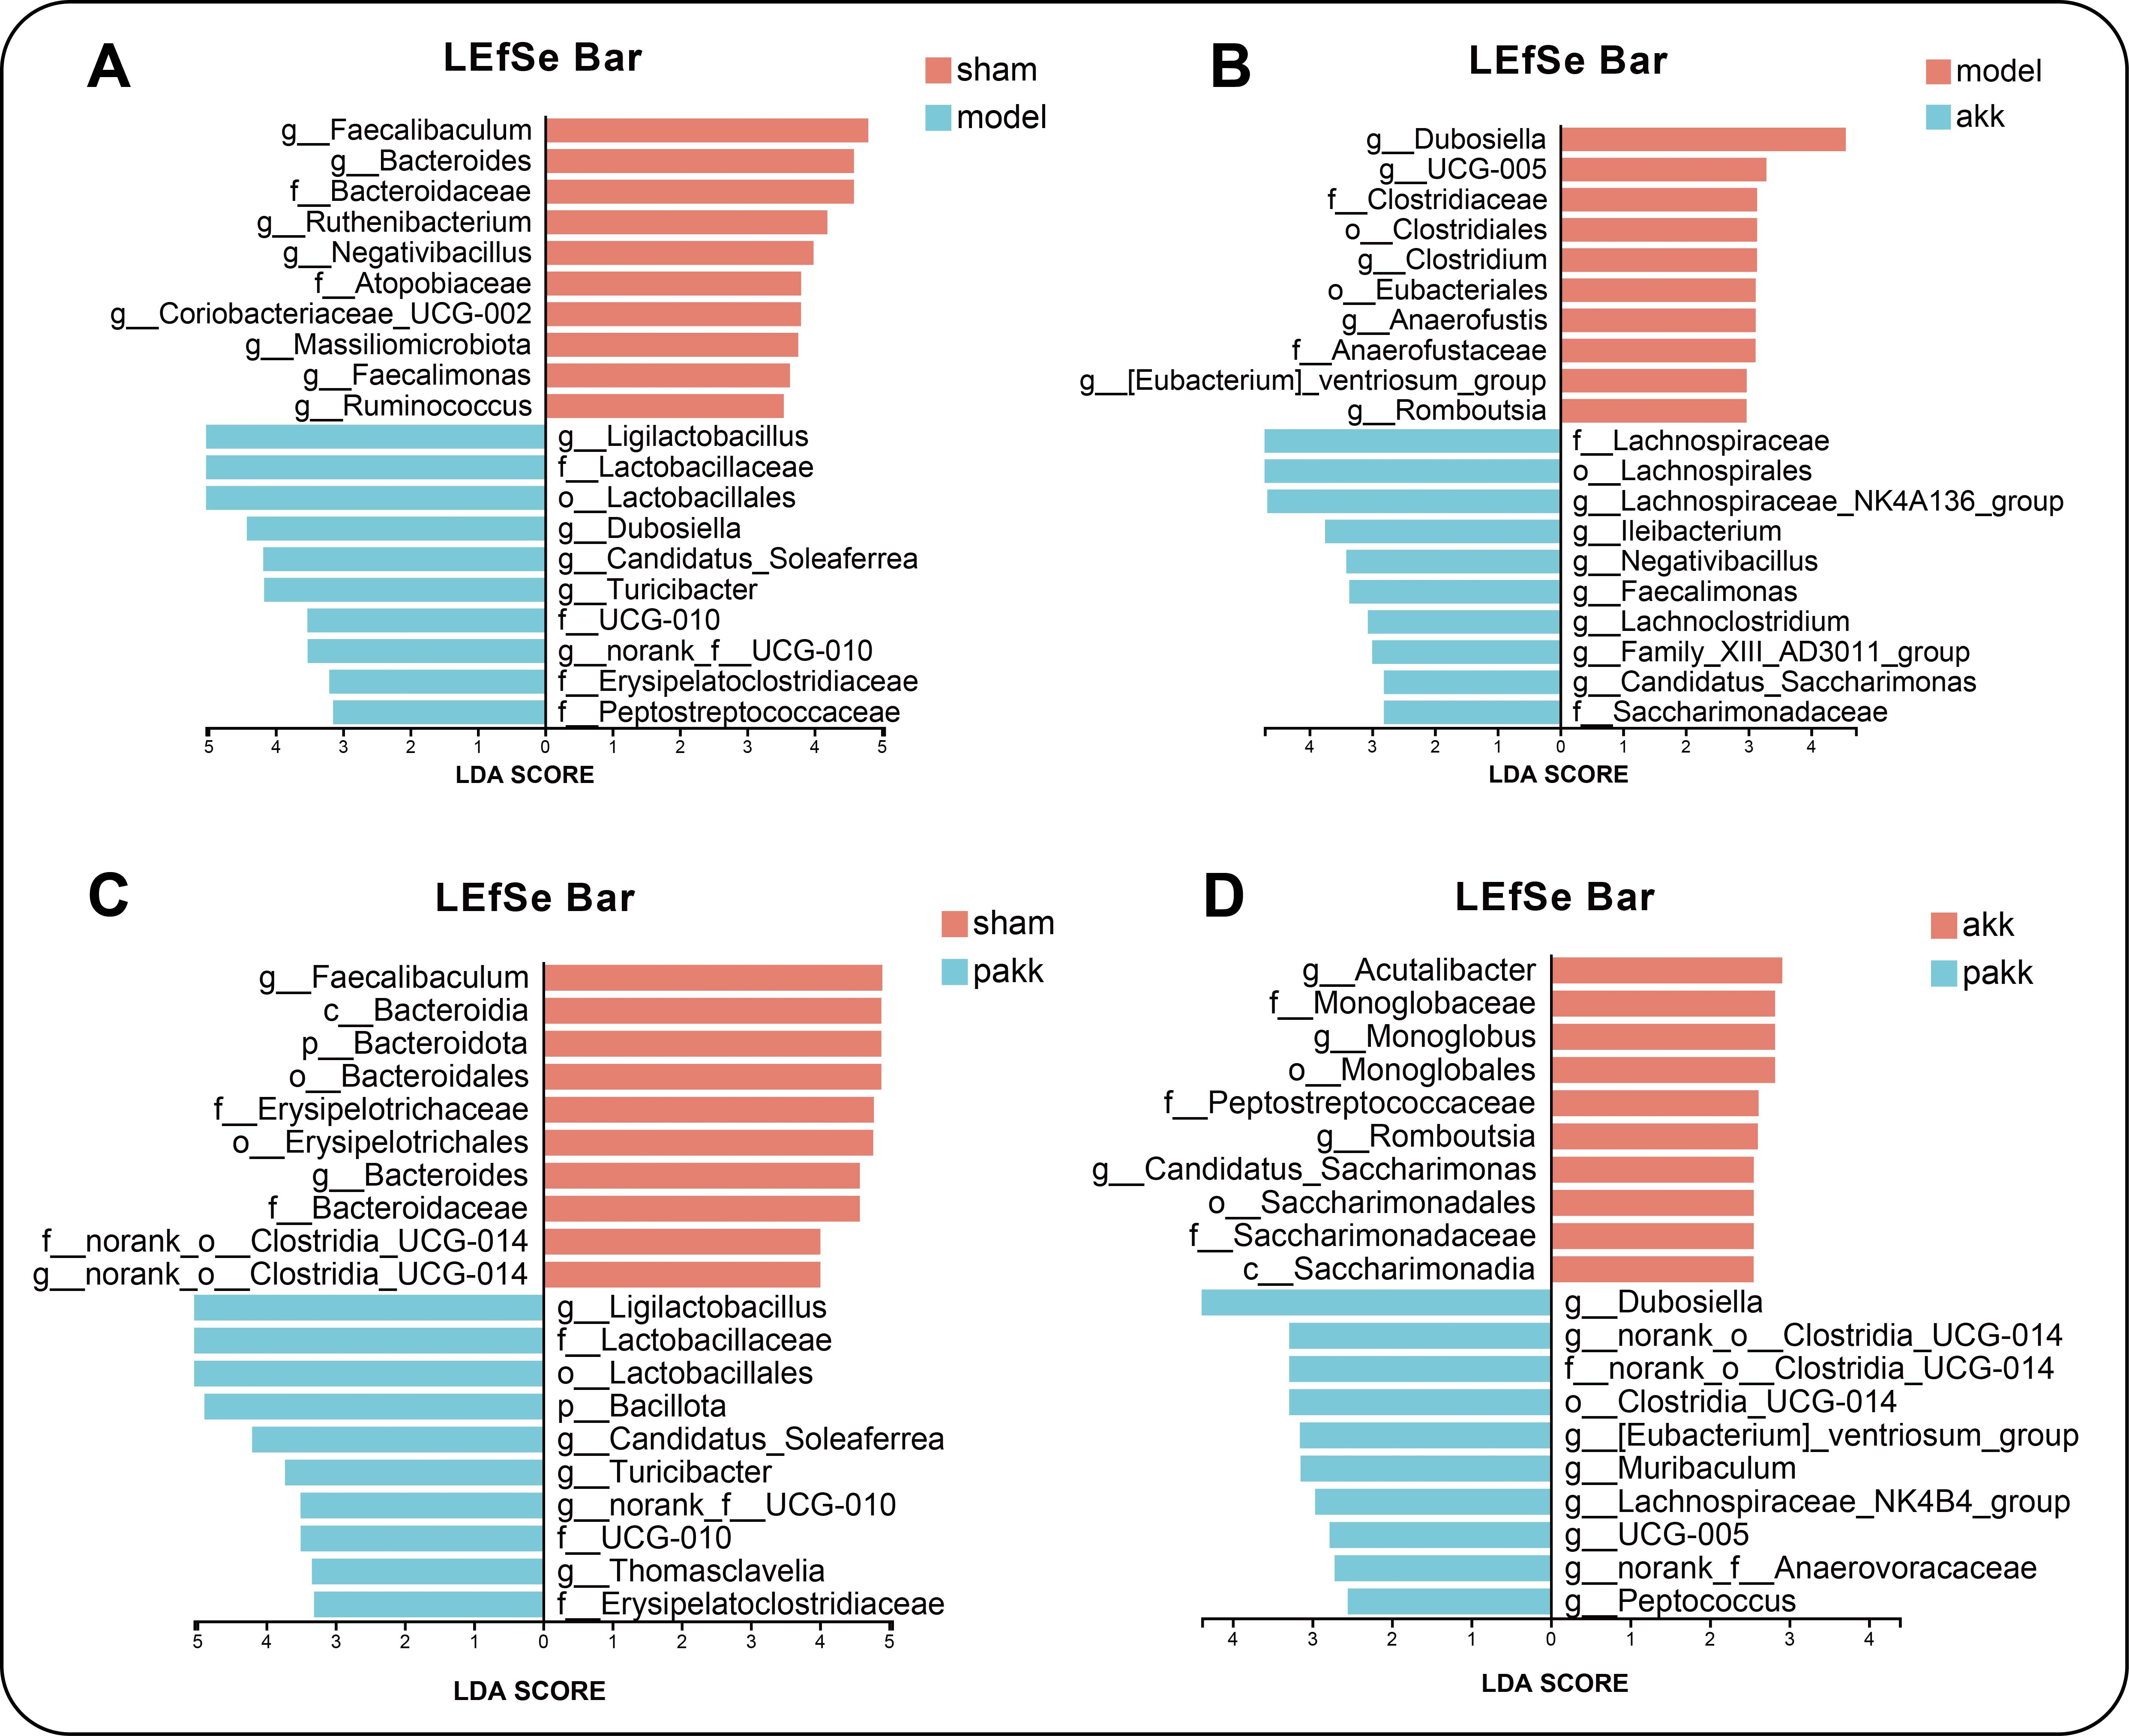
Supplementary Figure 1. Multilevel species difference discriminant analysis of Lefse from phylum level to genus level. (A) Linear discriminant analysis between sham and model groups; (B) Linear discriminant analysis between model and akk groups; (C) Linear discriminant analysis between sham and pakk groups; (D) Linear discriminant analysis between akk and pakk groups. The larger the LDA score, the greater the impact of species abundance on the differential effect. Number of mice in each group: sham: 7, model: 6, akk: 8, pakk: 7, vakk: 7.
Supplementary Figure 2. OPLS-DA models with corresponding values of R2x, R2Y, and Q2. (A) OPLS-DA score plot of sham vs model group; (B) OPLS-DA score plot of akk vs model group; (C) OPLS-DA score plot of vakk vs model group; (G) OPLS-DA score plot of akk vs pakk group; (H) OPLS-DA score plot of vakk vs akk group; (D, E, F, I, J) Validation plot obtained from 200 tests, respectively. Number of mice in each group: sham: 7, model: 6, akk: 8, pakk: 7, vakk: 7.
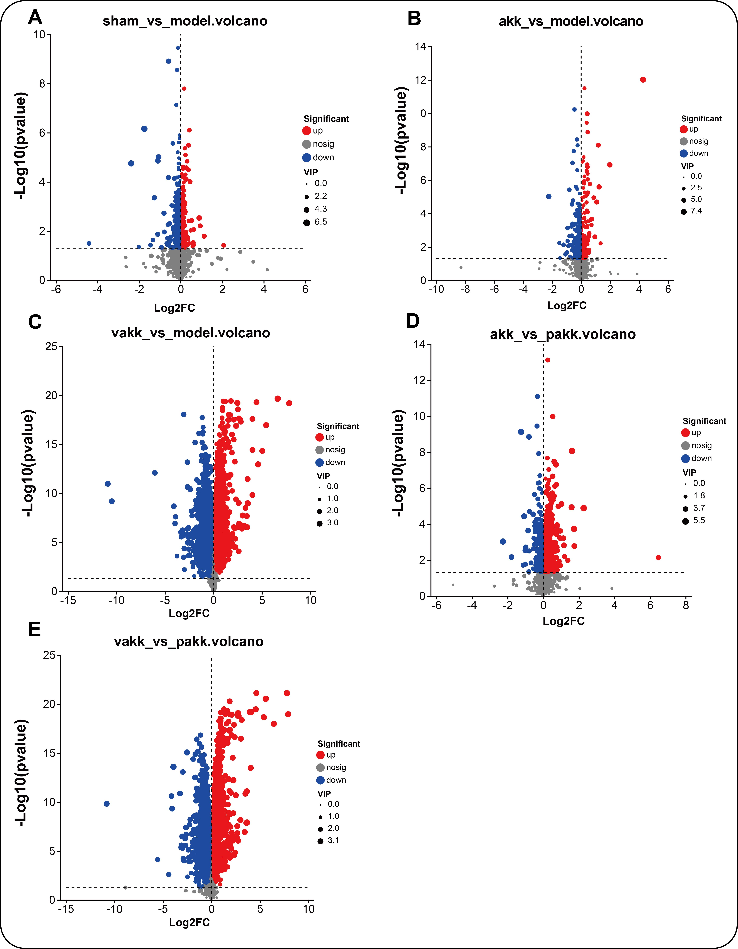
Supplementary Figure 3. Volcano plot of different metabolites for different comparison groups. (A)sham vs model group; (B) akk vs model group; (C) vakk vs model group; (D) akk vs pakk group; (E) vakk vs pakk group. Red dots indicate significantly up-regulated metabolites, blue dots indicate significantly down-regulated metabolites, and gray dots indicate non-significantly differential metabolites. Number of mice in each group: sham: 7, model: 6, akk: 8, pakk: 7, vakk: 7. (p < 0.05, VIP value > 1).
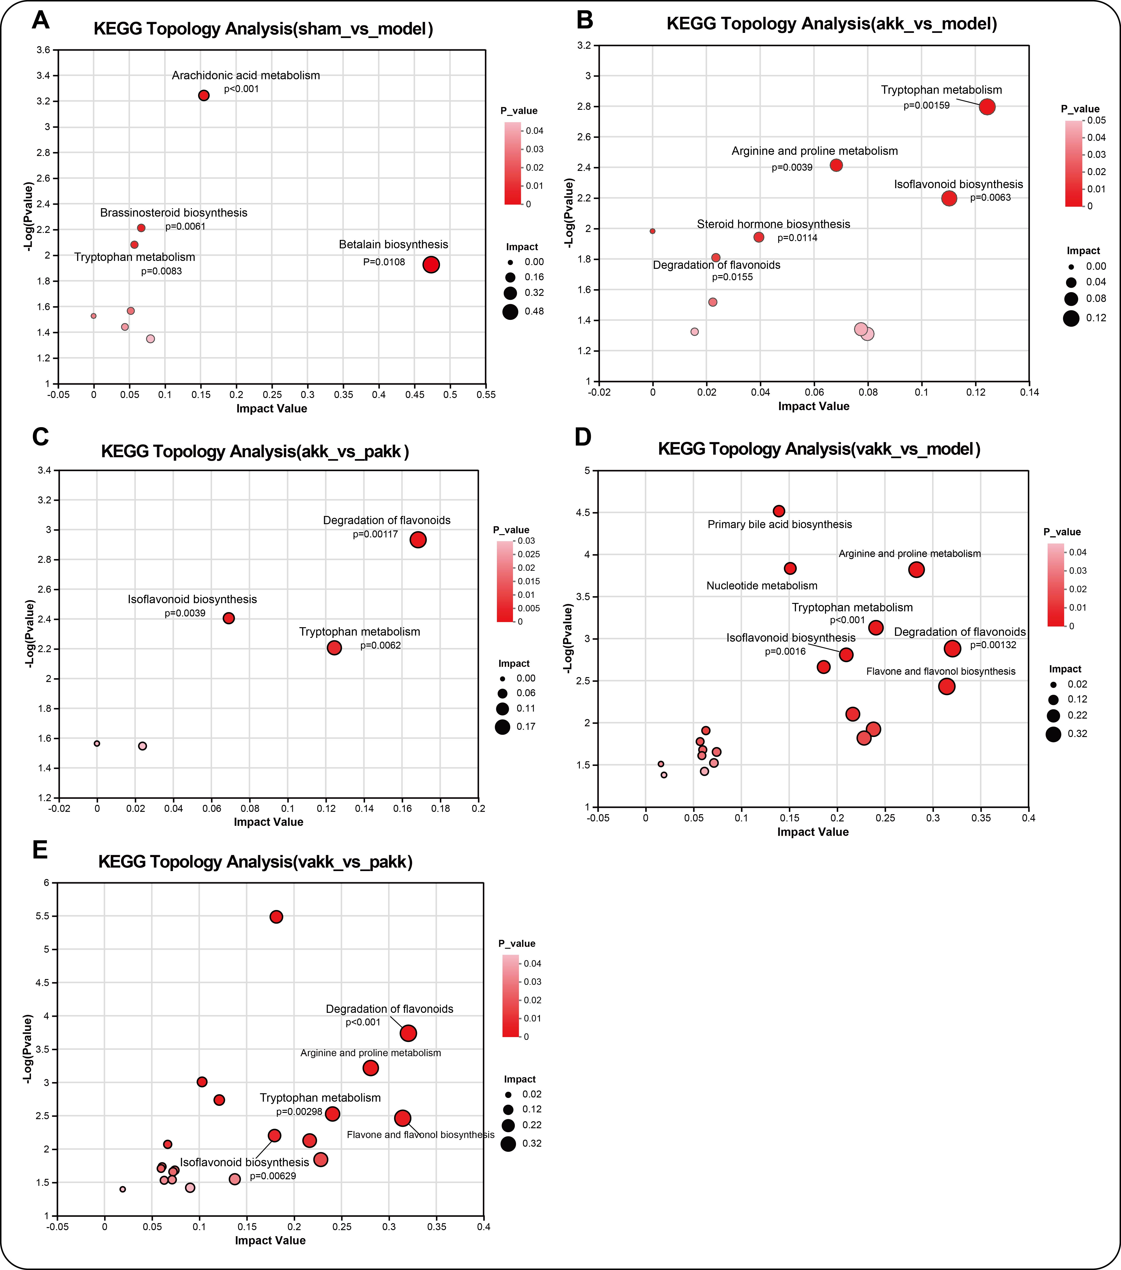
Supplementary Figure 4. Pathway analysis of the identified differential metabolites between different comparison groups. (A)sham vs model group; (B) akk vs model group; (C) akk vs pakk group; (D) vakk vs model group; (E) vakk vs pakk group. The horizontal axis represents the impact value of the relative importance of metabolites in the pathway. The vertical axis represents the enrichment significance-log10 (p value) of metabolites involved in pathways. The bubble size represents the impact value. The larger the bubble, the greater the importance of the pathway. Number of mice in each group: sham: 7, model: 6, akk: 8, pakk: 7, vakk: 7.
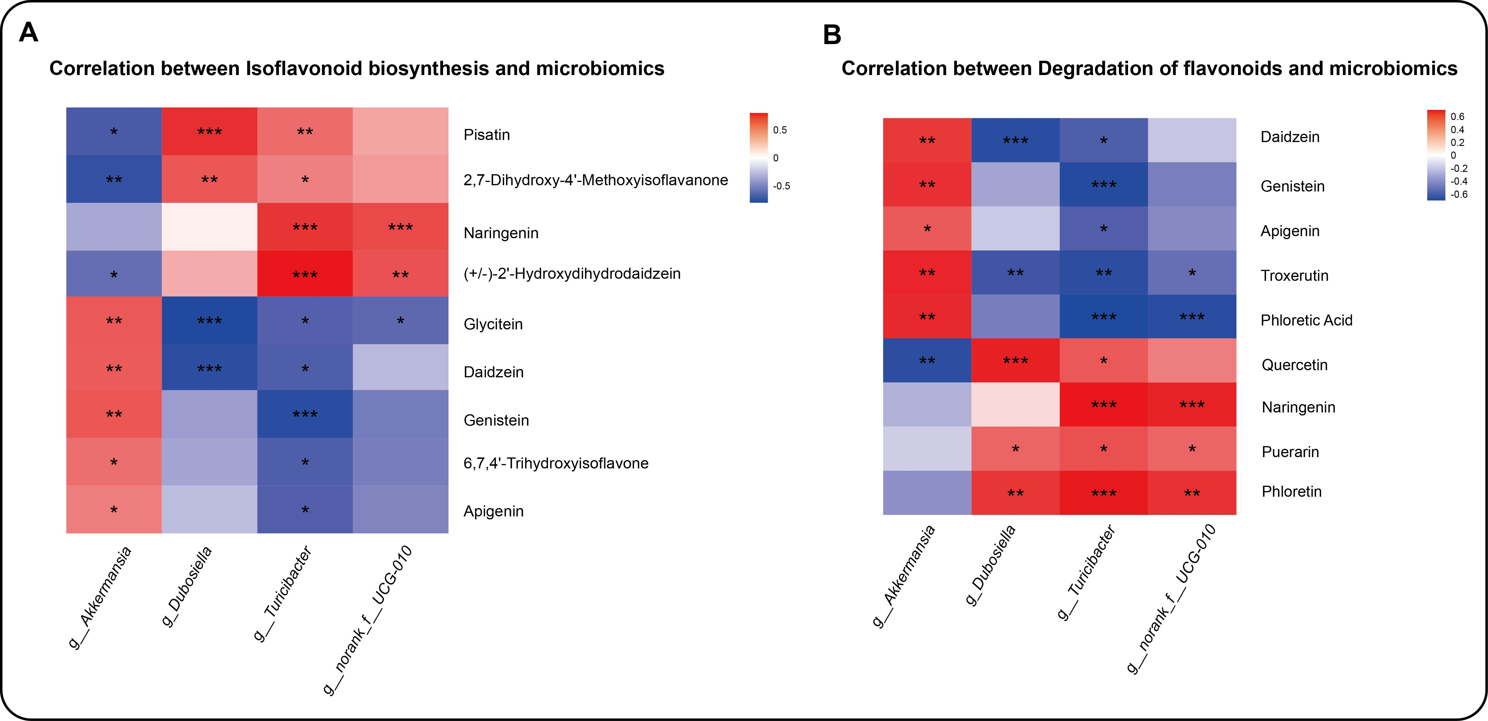
Supplementary Figure 5. Differences in bacterial genera and metabolic pathways related to kidney-related metabolic pathways. (A) Correlation analysis of different bacterial genera with isoflavone biosynthesis pathways; (B) Correlation analysis of different bacterial genera with flavonoid degradation pathways. Spearman correlation analysis was used, Positive correlation: red, negative correlation: purple. *, p≤0.05; **, p≤0.01; ***, p≤0.001.

