Supplementary Data
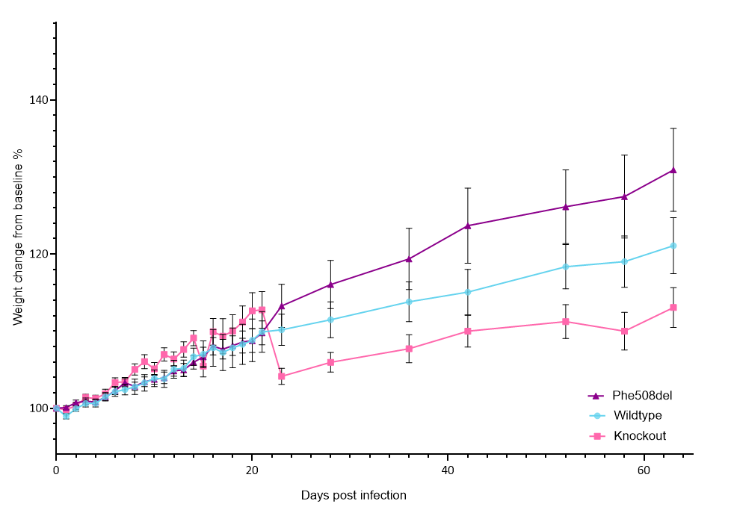

Supplementary Figure 1: Percent weight change from day 0 in wildtype, Phe508del and knockout rats post infection
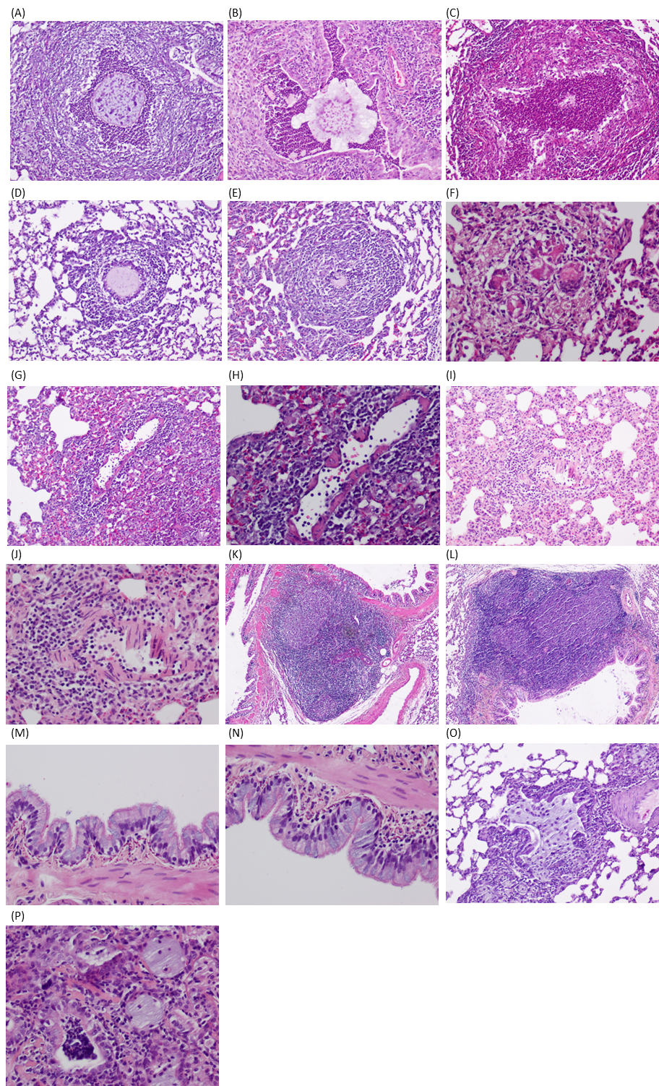
Supplementary Figure 2: Detailed images of haematoxylin and eosin histology post-infection. (A) Phe508del 7 days: A bacteria (arrows)-laden bead in a bronchiole is surrounded by abundant neutrophils. The necrotizing inflammatory reaction has almost completely destroyed the airway wall. (B) wildtype 7 days: A bronchus contains a partially disintegrated agar bead, with the lumen filled by abundant neutrophils (acute suppurative bronchopneumonia). (C) Phe508del 14 days: A bronchial lumen contains numerous neutrophils, with almost complete dissolution of the agar bead. There is severe destruction of the airway wall. (D, E) Phe508del 7 days: the agar bead is surrounded by macrophages, and the severely damaged airway wall is heavily infiltrated by lymphocytes. (F) Phe508del day 31: Small, disintegrated fragments of the agar bead are being phagocytosed by multinucleated giant cells. (G) Phe508del 7 days: Severe lymphocytic vasculitis with perivascular lymphocytic cuffing. (H) Phe508del 7 days: Higher power view of showing many luminal lymphocytes with lymphocytic infiltration, and segmental destruction, of the blood vessel wall, which shows fibrinoid necrosis. (I) knockout day 21: Lymphocytic vasculitis and perivascular lymphoplasmacytic cuffing. Surrounding alveolar walls are thickened by infiltrating chronic inflammatory cells. (J) Knockout day 21: Higher power view of (I). (K,L) Knockout day 21: Bronchial-associated lymphoid tissue (BALT) hyperplasia, with prominent germinal centres in lymphoid follicles. (M,N) Knockout day 21 and Phe508del 7 days: The bronchial lining shows goblet cell hyperplasia, with mucus extrusion into the lumen evident from some of these cells. (O) Phe508del 7 days: A bronchiolar lumen contains abundant mucus, with attendant macrophages. (P) Phe508del day 21: Several bronchiolar lumina are filled with mucus, while a bronchiole (left of image) contains luminal necrotic cellular debris, admixed with neutrophils.

