Supplementary Data

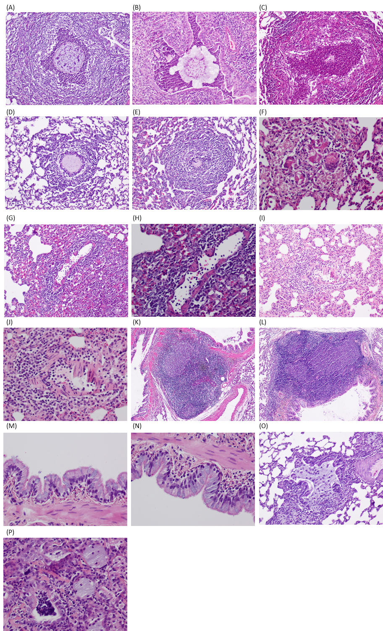
Supplementary Figure 1: Detailed images of haematoxylin and eosin histology post-infection. (A) Phe508del 7 days: A bacteria (arrows)-laden bead in a bronchiole is surrounded by abundant neutrophils. The necrotizing inflammatory reaction has almost completely destroyed the airway wall. (B) wildtype 7 days: A bronchus contains a partially disintegrated agar bead, with the lumen filled by abundant neutrophils (acute suppurative bronchopneumonia). (C) Phe508del 14 days: A bronchial lumen contains numerous neutrophils, with almost complete dissolution of the agar bead. There is severe destruction of the airway wall. (D, E) Phe508del 7 days: the agar bead is surrounded by macrophages and the severely damaged airway wall is heavily infiltrated by lymphocytes. (F) Phe508del day 31: Small, disintegrated fragments of the agar bead are being phagocytosed by multinucleated giant cells. (G) Phe508del 7 days: Severe lymphocytic vasculitis with perivascular lymphocytic cuffing. (H) Phe508del 7 days: Higher power view of showing many luminal lymphocytes with lymphocytic infiltration, and segmental destruction, of the blood vessel wall, which shows fibrinoid necrosis. (I) knockout day 21: Lymphocytic vasculitis and perivascular lymphoplasmacytic cuffing. Surrounding alveolar walls are thickened by infiltrating chronic inflammatory cells. (J) Knockout day 21: Higher power view of (I). (K,L) Knockout day 21: Bronchial-associated lymphoid tissue (BALT) hyperplasia, with prominent germinal centres in lymphoid follicles. (M,N) Knockout day 21 and Phe508del 7 days: The bronchial lining shows goblet cell hyperplasia, with mucus extrusion into the lumen evident from some of these cells. (O) Phe508del 7 days: A bronchiolar lumen contains abundant mucus, with attendant macrophages. (P) Phe508del day 21: Several bronchiolar lumina are filled with mucus, while a bronchiole (left of image) contains luminal necrotic cellular debris, admixed with neutrophils.

Supplementary Table 1: Distribution of animal numbers by genotype, sex, and infection time point.
Genotype | Timepoint | Male | Female | Total
Wildtype | D07 | 5 | 4 | 9
Wildtype | D14 | 6 | 6 | 12
Wildtype | D21 | 5 | 5 | 10
Wildtype | D63 | 3 | 4 | 7
Phe508del | D07 | 5 | 4 | 9
Phe508del | D14 | 3 | 5 | 8
Phe508del | D21 | 6 | 4 | 10
Phe508del | D63 | 4 | 3 | 7
Knockout | D07 | 1 | 6 | 7
Knockout | D14 | 3 | 4 | 7
Knockout | D21 | 9 | 2 | 11
Knockout | D63 | 3 | 5 | 8

