Supplementary material

Figure S1

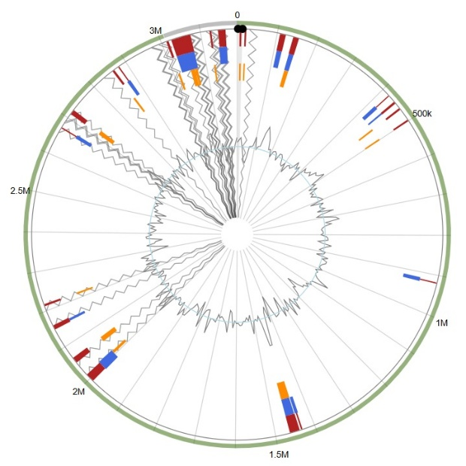

Fig. S1 Genomic islands in the 'Ca. A. phytopathogenicus' assembly aligned to the A. nasoniae FIN genome. GIs predicted by SIGI-HMM are shown in orange, those predicted by IslandPath-DIMOB in blue, and GIs predicted by one or more tools are displayed in the integrated view as red regions.

