Supplement material

Content

Supplementary table 1. The final ASV abundances, taxon abundances, and Tax4Fun2 pathway abundances.

Supplementary table 2. Core Results Table of MaasLin2 Association Analysis.

Supplementary Figure 1. Binary map of sample distribution.

Supplementary Figure 2. Data Processing Flowchart.

Supplementary Figure 3. Core and unique infant gut microbiota across postnatal time points.

Supplementary Figure 4. Single factors associated with variation in gut microbiota composition.

Supplementary Figure 5. Temporal trend plot for 6 clustering groups.

Supplementary Figure 6. Heatmap of the relative abundances of Level 1 (L1) functional categories.

Supplementary Figure 7. Heatmap of the relative abundances of Level 2 (L2) functional modules.

Supplementary Figure 8. Heatmap of the relative abundances of Level 3 (L3) metabolic pathways.

Supplement Figure legends

Supplementary table 1. The final ASV abundances, taxon abundances, and Tax4Fun2 pathway abundances. All data included in this table are the final analytical data obtained following a series of filtration and screening procedures.
Given the substantial volume of data contained in Supplementary Table 1, this dataset is provided as supplementary material in the form of a table file.

Supplementary table 2. Core Results Table of MaasLin2 Association Analysis. N represents the total sample size included in the analysis; N.not.0 denotes the number of samples with non-zero abundance for this cluster; pval is the raw P-value (statistical significance without correction); qval is the P-value adjusted via the Benjamini-Hochberg (BH) multiple testing correction (a qval < 0.05 was considered statistically significant in this study).

Cluster | value | N | N.not.0 | pval | qval
Cluster_2 | days | 68 | 36 | 0.03 | 0.19
Cluster_1 | days | 68 | 34 | 0.17 | 0.34
Cluster_4 | days | 68 | 10 | 0.12 | 0.34
Cluster_5 | days | 68 | 13 | 0.41 | 0.62
Cluster_3 | days | 68 | 17 | 0.52 | 0.63
Cluster_6 | days | 68 | 7 | 0.89 | 0.89

Supplementary Figure 1. Binary map of sample distribution. Circles in the same row represent the same infant, circles in different colors represent different ages of the infant, and blank circles represent the absence of sample data.
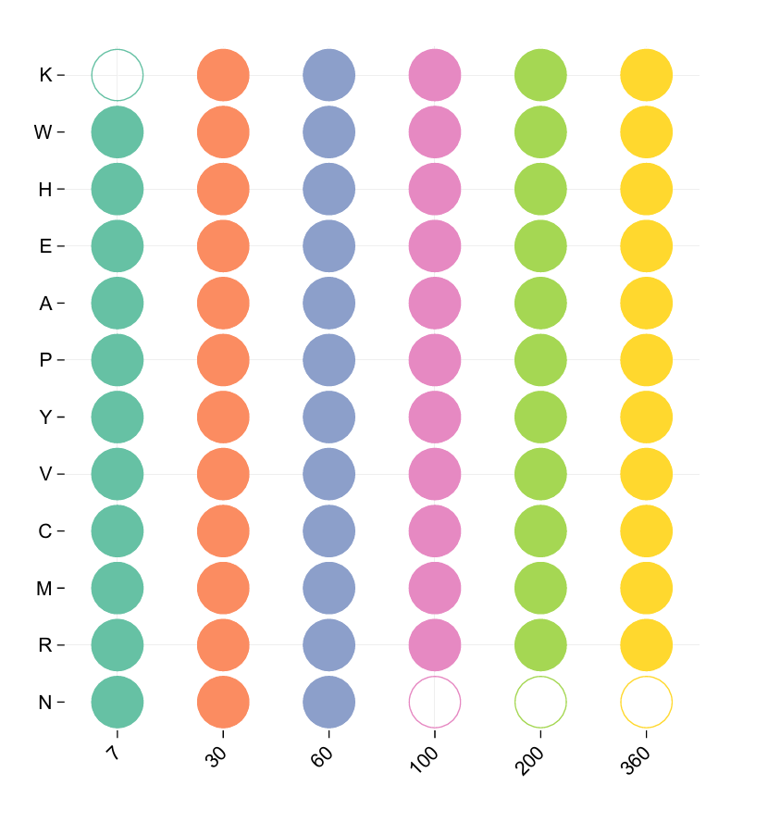

Supplementary Figure 2. Data Processing Flowchart. This figure illustrates the processing workflow of neonatal gut microbiome data: raw sequencing data yield high-quality clean reads following quality control and filtering, and a series of analytical steps are then performed in sequence, including taxonomic annotation, screening of dominant taxa, temporal analysis of dominant species, and functional pathway prediction.
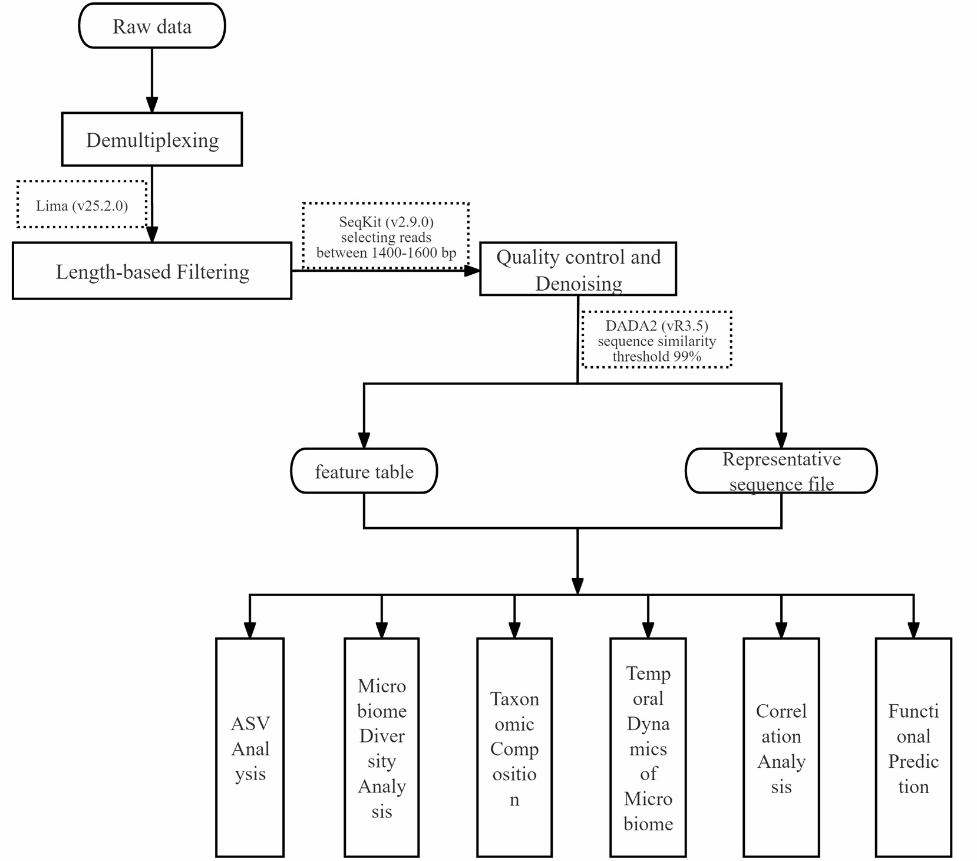

Supplementary Figure 3. Core and unique infant gut microbiota across postnatal time points. UpSet plot illustrating the overlap of bacterial species across six postnatal time points (7, 30, 60, 100, 200, and 360 days). The intersection of all six points represents the 67 core bacterial species shared across all sampling time points, and each individual point denotes the number of bacterial taxa unique to the corresponding postnatal time point.
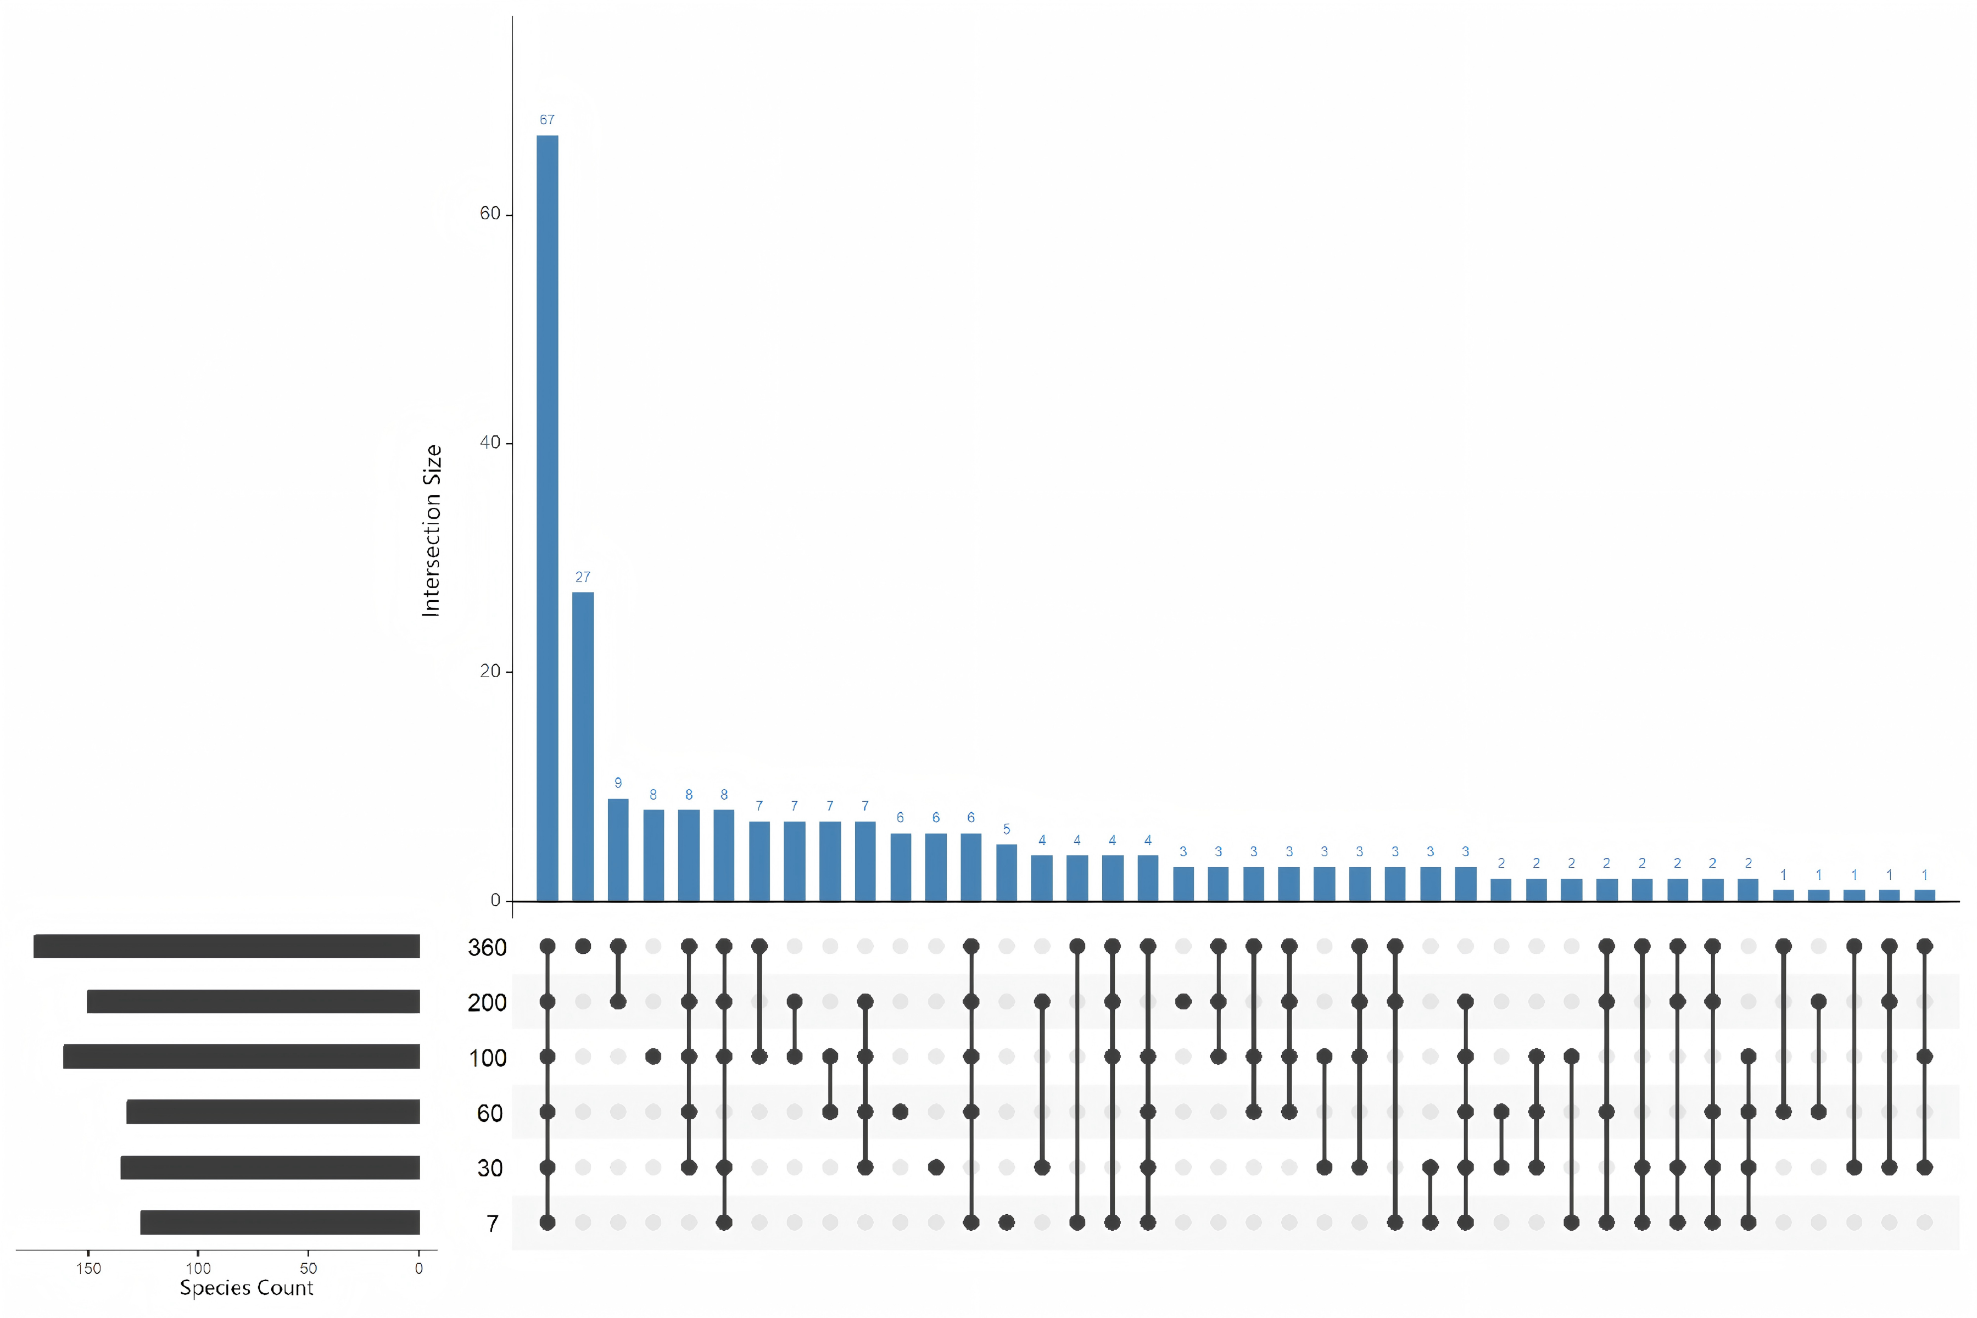

Supplementary Figure 4. Single factors associated with variation in gut microbiota composition. Alpha diversity (Shannon index) stratified by individual, ethnicity, delivery mode, and postnatal age (days), age at weaning, gender, maternal age, parity and pets. For each boxplots depict the distribution of values: the horizontal line indicates the median; the box spans the interquartile range (25th-75th percentiles); whiskers extend to the most extreme data points within 1.5 × IQR from the hinges; individual data points are shown as dots. For comparisons among multiple groups in this study, we used one-way analysis of variance (one-way ANOVA); for comparisons involving two independent samples, we used the t-test. P ≤ 0.05: statistically significant difference.
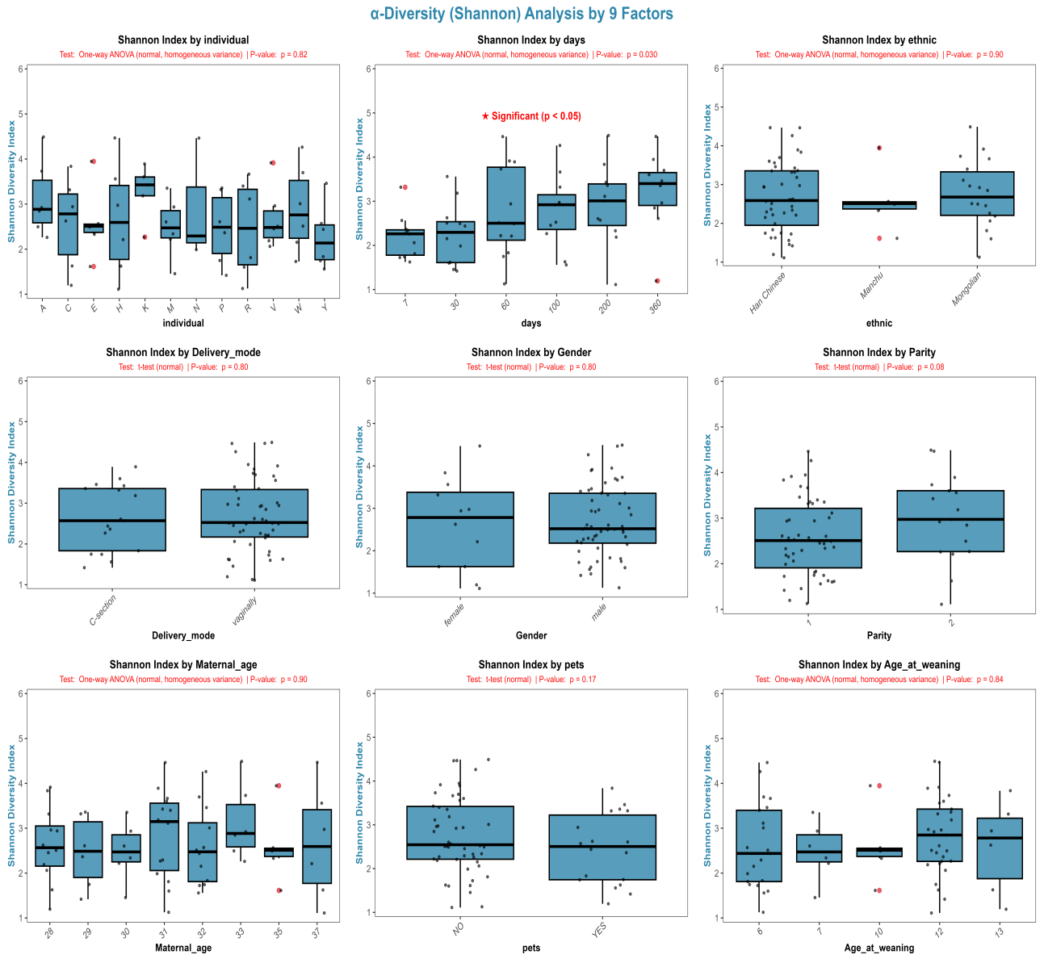

Supplementary Figure 5. Temporal trend plot for 6 clustering groups. (A) Determination of the optimal number of clusters (K) via the elbow method. The elbow method to identify the optimal K for neonatal gut microbiome clustering analysis. The K at the inflection point (curve trend shifts from steep to gentle decline) is the optimal value (K=6). (B) Temporal trend comparison plot for 6 clustering groups. The horizontal axis as postnatal time points and the vertical axis as Z_ScoreExpression . Different colors/line types represent different clustering groups.
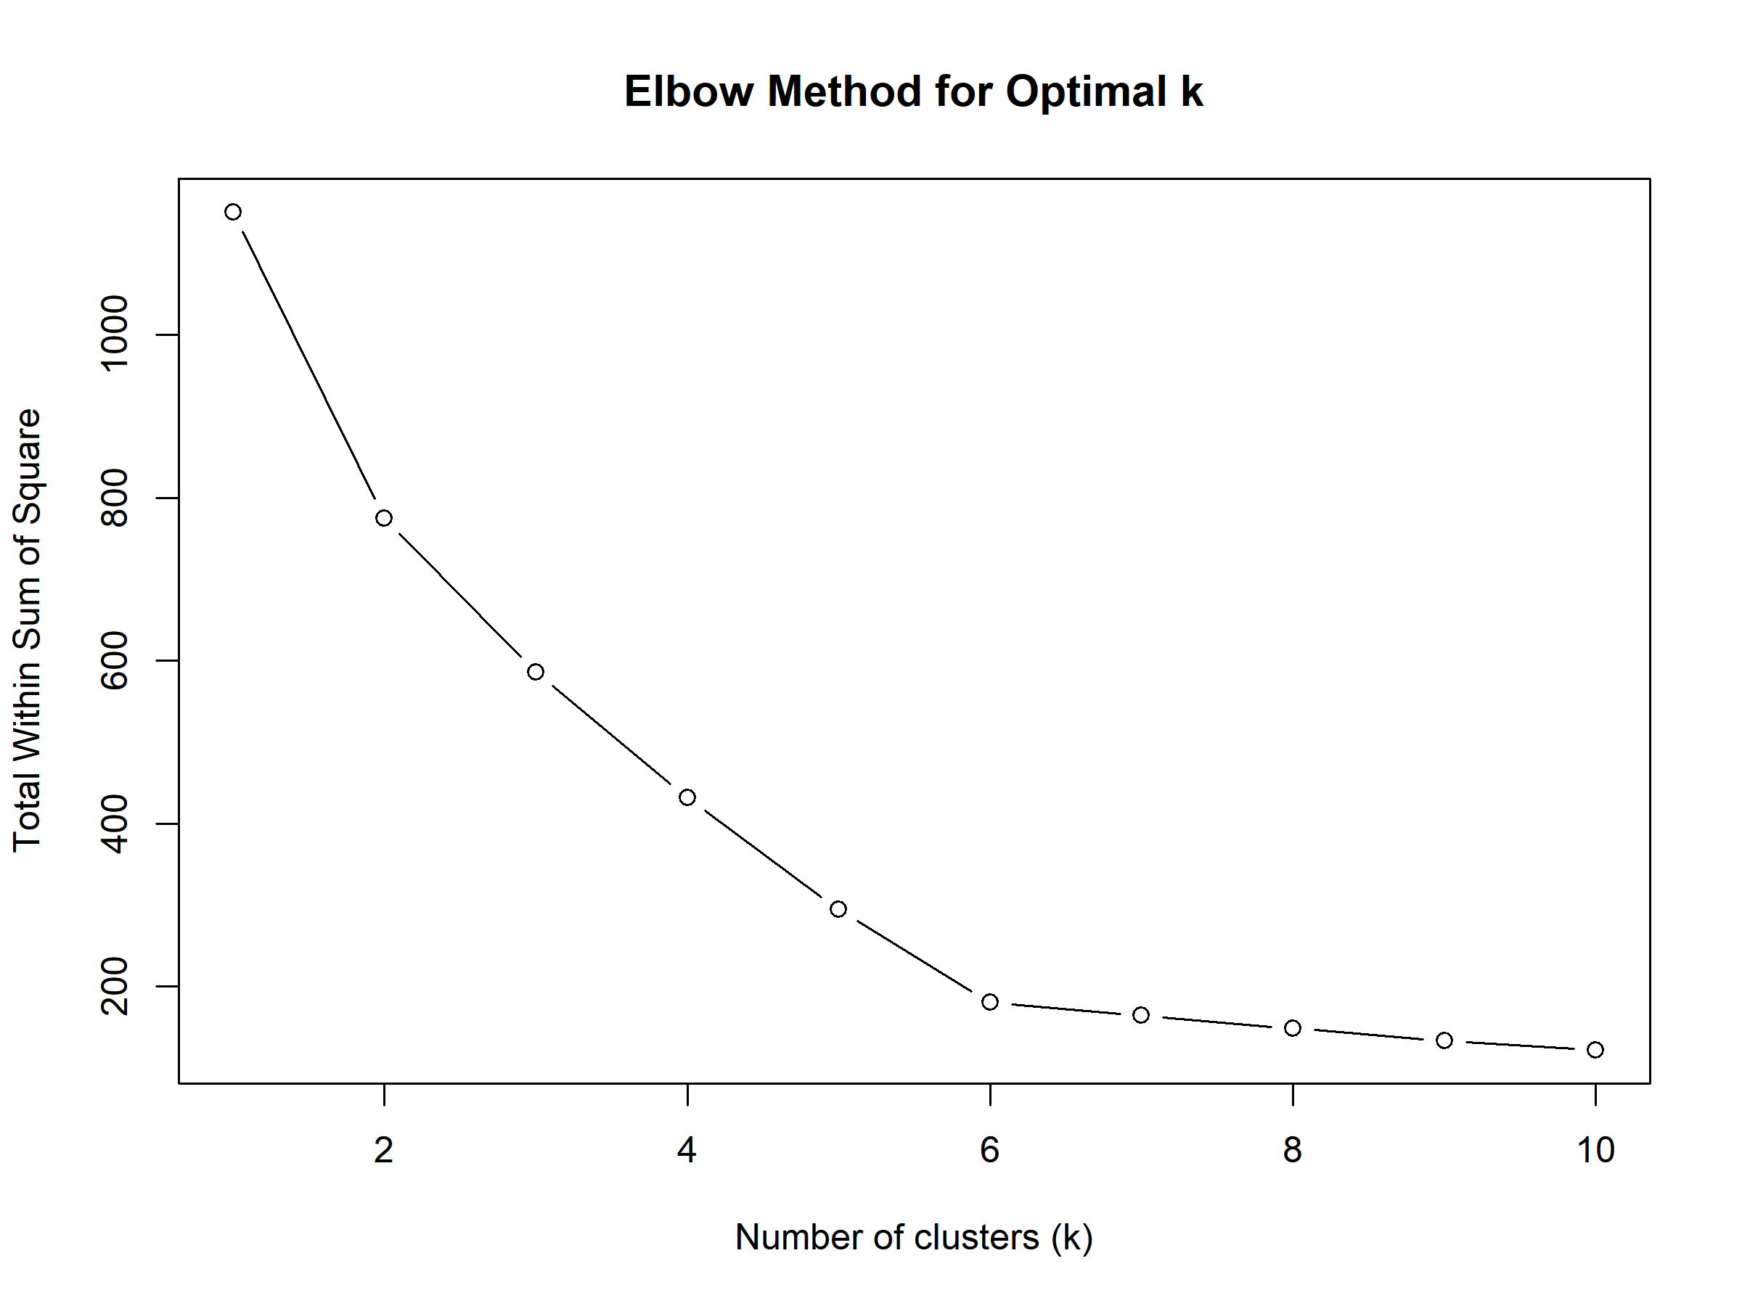(A)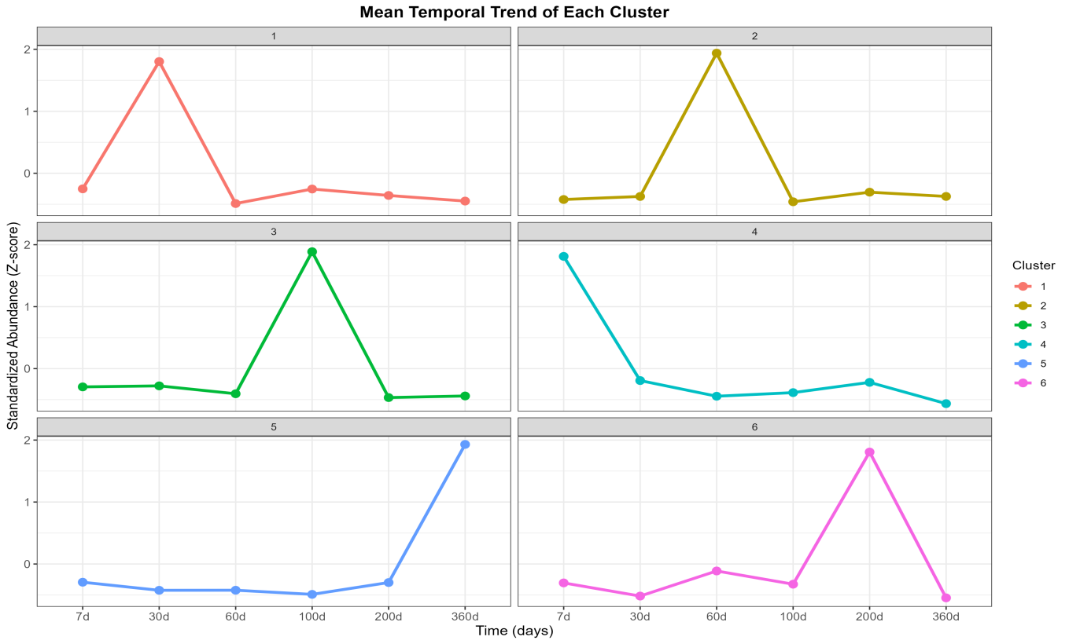(B)
Supplementary Figure 6. Heatmap of the relative abundances of Level 1 (L1) functional categories. Predicted metagenomic functional profiles (based on 16S rRNA gene sequencing) showing the relative abundance of broad functional categories (L1) across infant samples over time. The color scale illustrate relative abundance, ranging from high (red) to low (blue).
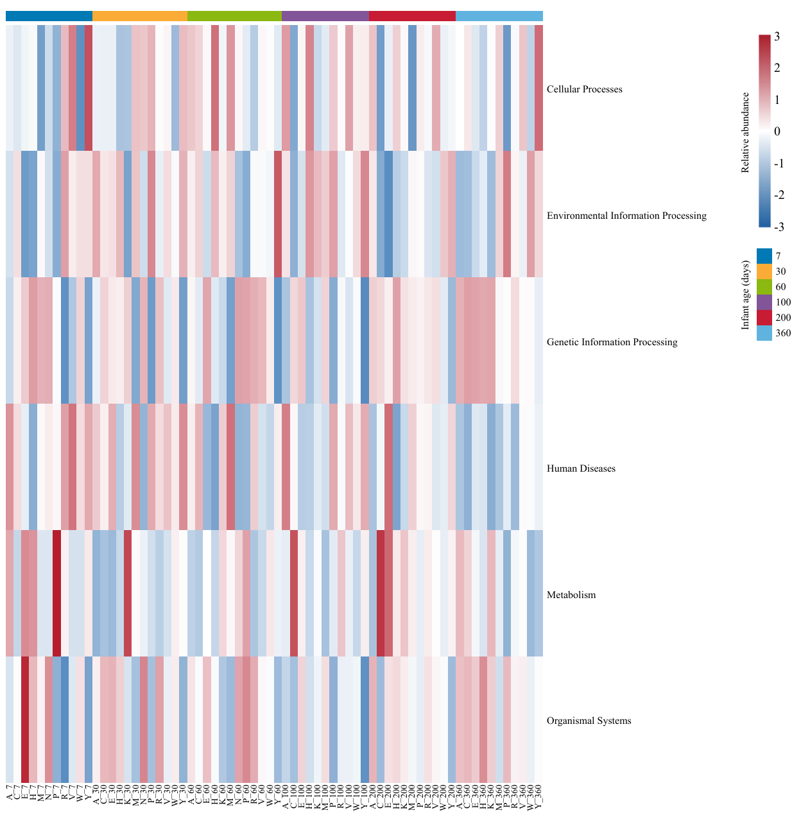

Supplementary Figure 7. Heatmap of the relative abundances of Level 2 (L2) functional modules. Predicted metagenomic functional profiles (based on 16S rRNA gene sequencing) showing the relative abundance of broad functional modules (L2) across infant samples over time. The color scale illustrate relative abundance, ranging from high (red) to low (blue).
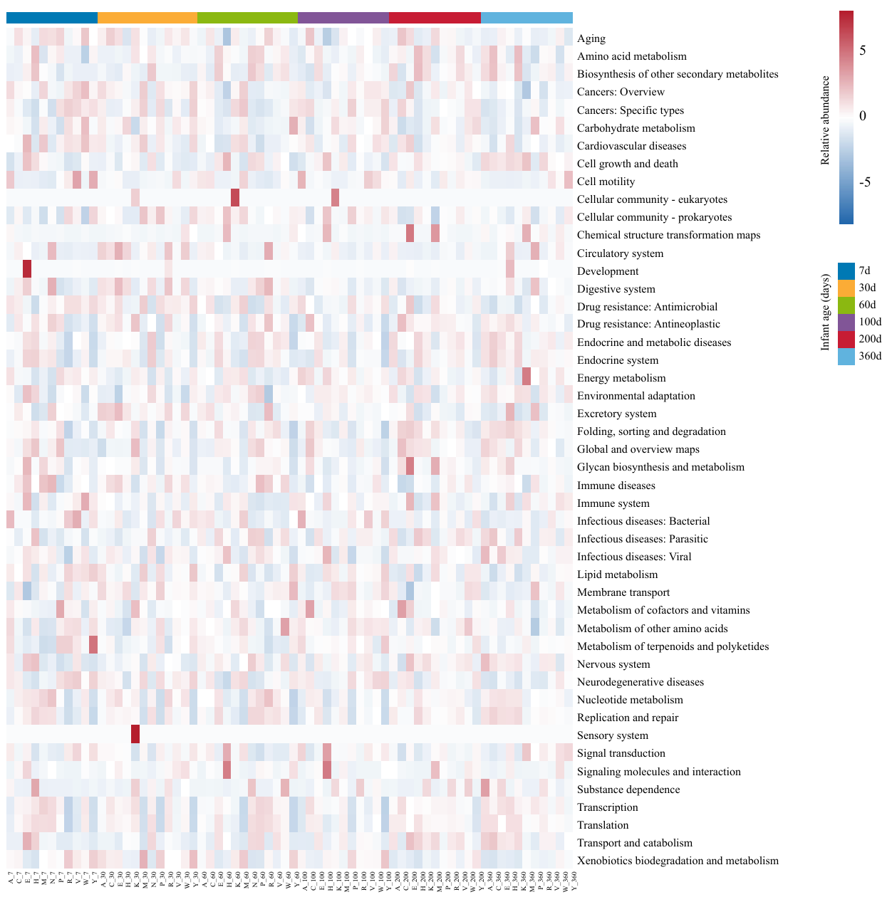

Supplementary Figure 8. Heatmap of the relative abundances of Level 3 (L3) metabolic pathways. Predicted metagenomic functional profiles (based on 16S rRNA gene sequencing) showing the relative abundance of broad metabolic pathways (L3) across infant samples over time. The color scale illustrate relative abundance, ranging from high (red) to low (blue).
