Supplementary material-TableS1-S3
Table S 1 Box-Benhnken Experimental Design and Results of Bacteria Y9
standard order | A-pH | B- temperature | C- inoculum size | degradation rate
1 | 4 | 10 | 5 | 37.2693
2 | 10 | 10 | 5 | 34.1547
3 | 4 | 40 | 5 | 27.994
4 | 10 | 40 | 5 | 67.6
5 | 4 | 25 | 1 | 25.99
6 | 10 | 25 | 1 | 37.758
7 | 4 | 25 | 9 | 91.4887
8 | 10 | 25 | 9 | 92.926
9 | 7 | 10 | 1 | 16.6953
10 | 7 | 40 | 1 | 18.9307
11 | 7 | 10 | 9 | 46.734
12 | 7 | 40 | 9 | 95.0447
13 | 7 | 25 | 5 | 90.0253
14 | 7 | 25 | 5 | 92.9847
15 | 7 | 25 | 5 | 98.1356
16 | 7 | 25 | 5 | 90.0847
17 | 7 | 25 | 5 | 98.0301

Table S 2 Analysis of Variance for Response Surface Regression Models
source | sum of squares | mean square value | F | P | significance
model | 16405.69 | 1822.85 | 51.77 | < 0.0001 | Highly significant
A-pH | 308.72 | 308.72 | 8.77 | 0.0211 | significant
B- temperature | 697.81 | 697.81 | 19.82 | 0.0030 | significant
C- inoculum size | 6430.88 | 6430.88 | 182.64 | < 0.0001 | Highly significant
AB | 456.26 | 456.26 | 12.96 | 0.0087 | significant
AC | 26.68 | 26.68 | 0.7578 | 0.4129 | insignificant
BC | 530.73 | 530.73 | 15.07 | 0.0060 | significant
A² | 1246.23 | 1246.23 | 35.39 | 0.0006 | significant
B² | 5126.56 | 5126.56 | 145.60 | < 0.0001 | Highly significant
C² | 898.42 | 898.42 | 25.52 | 0.0015 | significant
anamorphism | 181.07 | 60.36 | 3.69 | 0.1197 | insignificant
pure error | 65.39 | 16.35
Note: p < 0.0001 The difference is extremely significant p < 0.05 The difference is significant

Table S 3Kinetic equation of degradation of atrazine by Y9
Initial concentration (mg/L) | Fitting equation | Degradation rate constant (h) | Half-life period  (h) |  | R²
50 | Y=100 (1- e^{-0.3424x}) | 0.3424 |  | 2.02 | 0.9792
100 | Y=100 (1- e^{-0.1432x}) | 0.1432 |  | 4.84 | 0.9738
200 | Y=100 (1- e^{-0.0514x}) | 0.0514 |  | 13.48 | 0.9754
500 | Y=100 (1- e^{-0.0196x}) | 0.0196 |  | 35.36 | 0.9890

Supplementary material- Figures S1
(a)
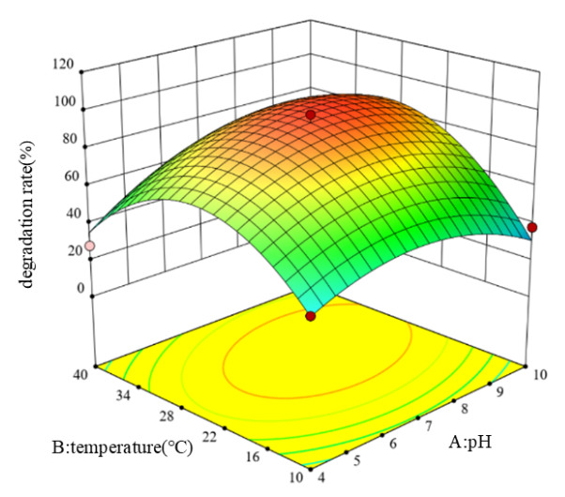  (c) | 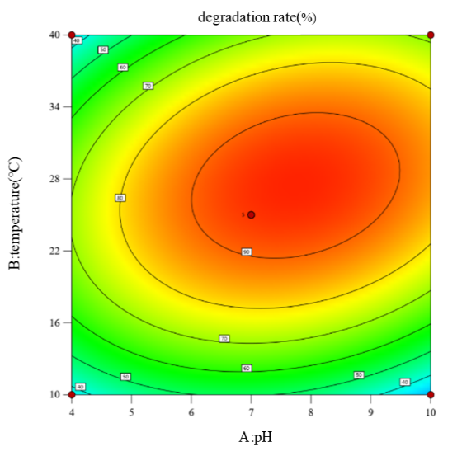  (d)  (b)
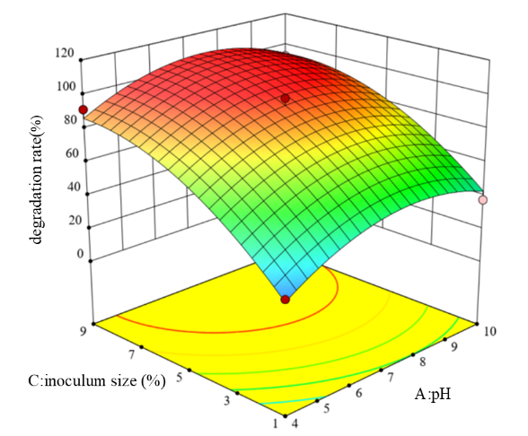 | 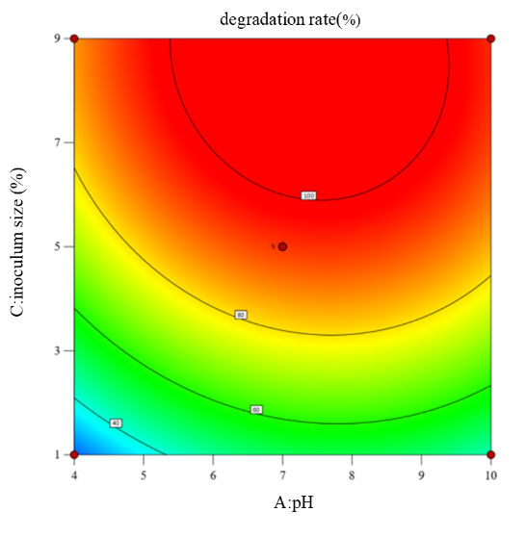
Figure S 1 Response surface plots and contour lines of effects of interaction between each factors
Note: (a) Response surface plot for pH and temperature interaction (b) Contour plot for pH and temperature interaction (c) Response surface plot for pH and inoculation amount interaction (d) Contour plot for pH and inoculation amount interaction.

