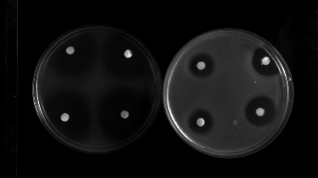
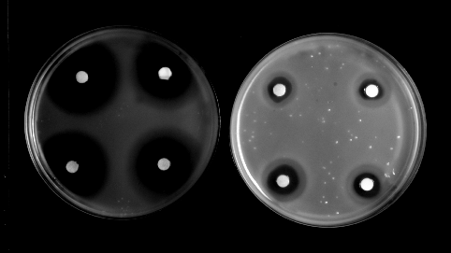
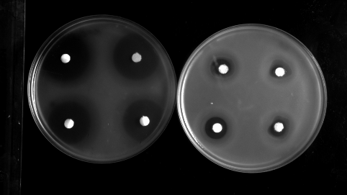
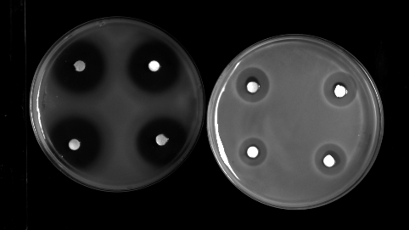
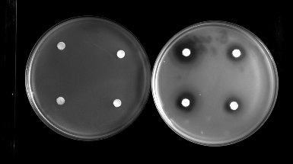
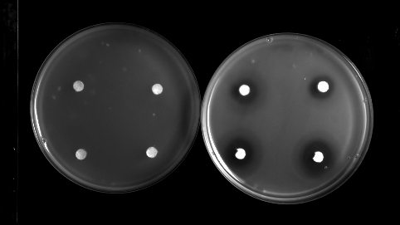
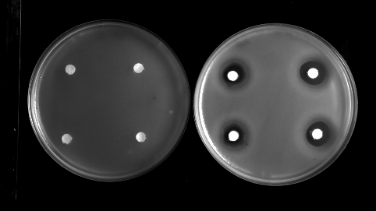
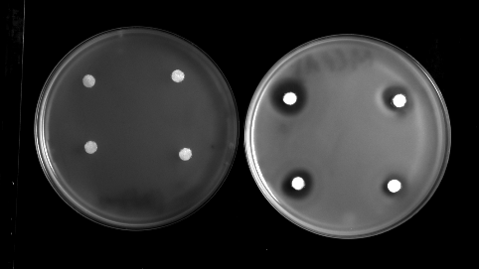
Supplementary files

E. coli
E. cloacae
K. pneumoniae
E. coli
S. Typhimurium
E. cloacae
K. pneumoniae

S. Typhimurium
B
A

Supplementary file 1. Antibacterial activity of preservatives (Nipagin/Propionic Acid) present in fly food against E. coli, S. Typhimurium, K. pneumoniae, and E. cloacae using agar overlay method. (A) For each pathogen panel, the left petri plate contains discs with 5 µL methanol acting as a negative control, while the right petri plate contains discs with 5 µL nipagin (B) For each pathogen panel, the left petri plate contains discs with 50 µg chloramphenicol as a positive control for bacterial killing, and the right petri plate contains discs with 5 µL of propionic acid.

Supplementary file 2. Kaplan–Meier survival curve depicting the percentage survival of infected flies over time. The Y-axis represents survival probability after infection, while the X-axis indicates days post-infection (dpi), with survival assessed upto 30 dpi. Each curve corresponds to flies infected with a specific bacterial strain, with each infection group consisting of 30 flies. Statistical analysis using the Log-rank (Mantel-Cox) test revealed no significant differences in survival among the infected groups.

Sample/infection group | Mean | Standard Deviation (SD)
Control (uninfected) | 97.6 | ±5.103
E. coli | 90.82 | ±6.642
S. Typhimurium | 91.07 | ±1.84
K. pneumoniae# | 101.56 | ±6.796
E. cloacae# | 100.07 | ±9.771

Supplementary file 3. Relative survival of Duox knockdown flies following infection. Data represent the per cent survival relative to the control (Actin GFP flies), N=3. Each repeat corresponds to flies infected with a specific bacterial strain, with each infection group consisting of 20 flies. No significant difference in survival was observed between Duox RNAi flies and their respective Actin GFP flies.
#As the mortality was higher in Actin-GFP flies infected with K. pneumoniae and E. cloacae compared to Duox knockdown flies with the same pathogen infection, the percent survival for these infection groups is higher than 100.

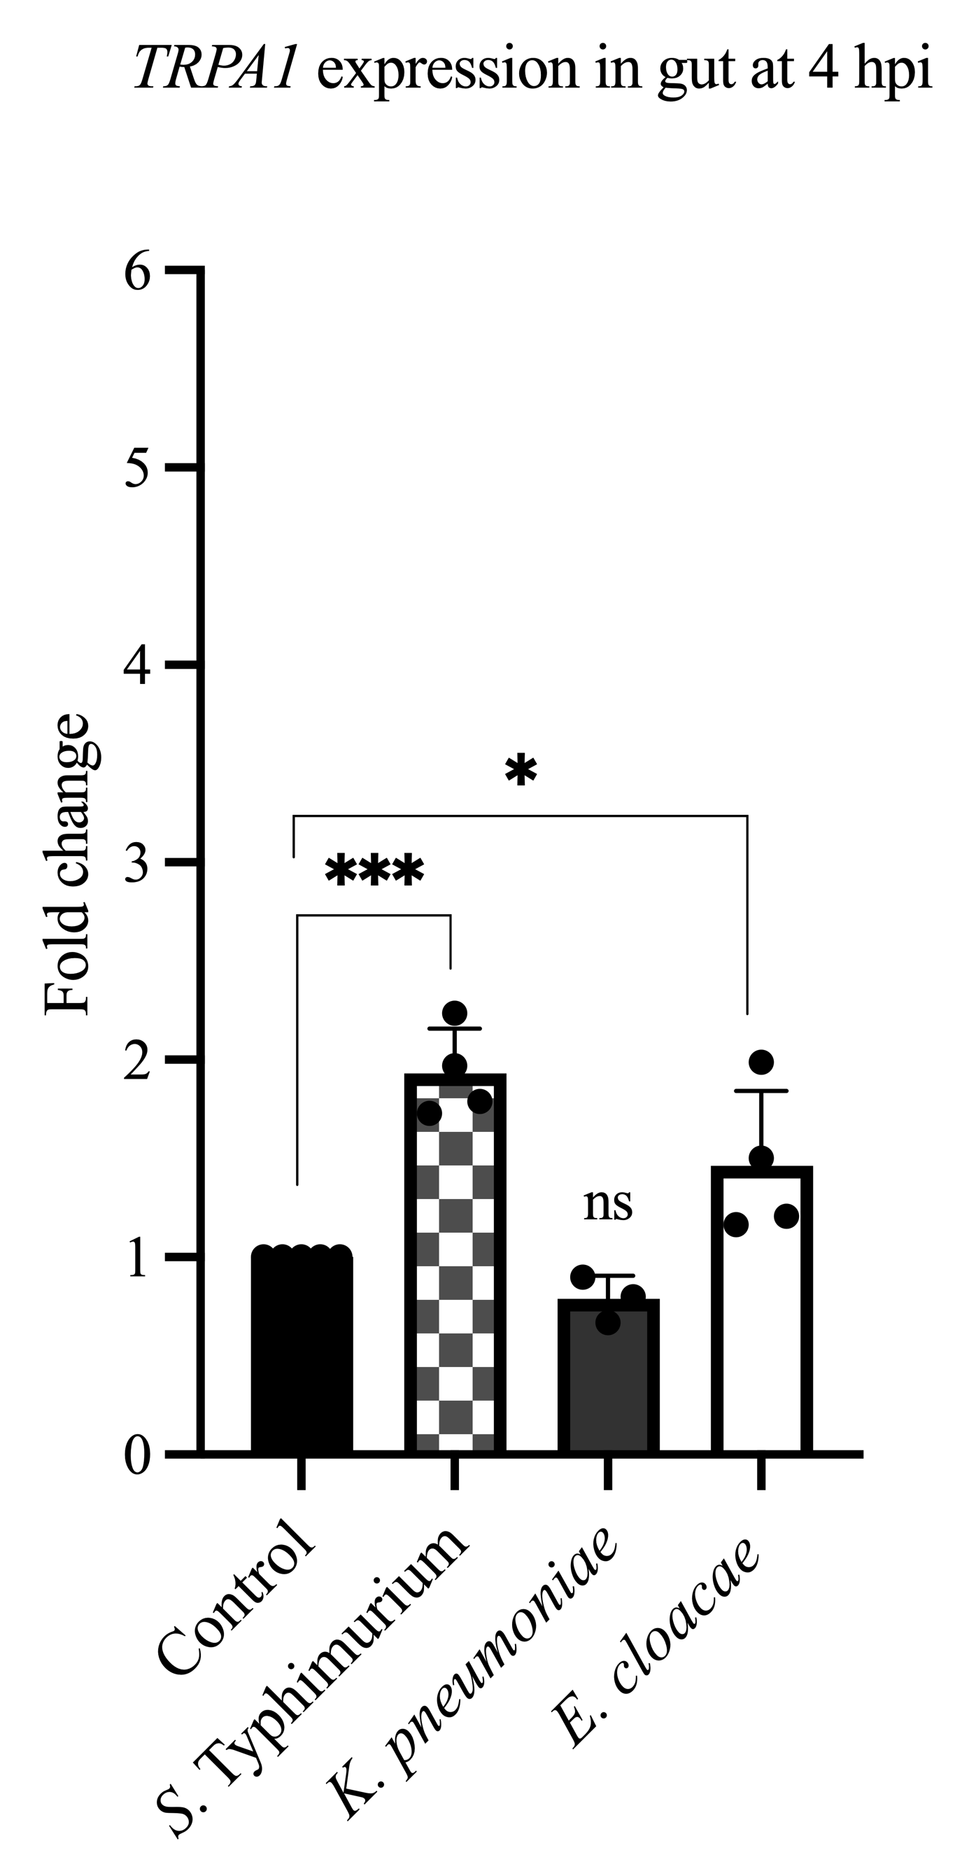

Supplementary file 4. Pathogen-specific regulation of TRPA1 transcript levels. TRPA1 transcript levels in the guts following bacterial infection at 4 hpi were quantified using qRT-PCR relative to uninfected control, using rp49 gene as an internal control. Each biological replicate consisted of 45 dissected guts. Data is represented as the mean ± SD from three independent biological replicates. Statistical significance for TRPA1 expression was assessed by comparing uninfected controls using one-way ANOVA followed by Dunnett’s post-hoc test *, p < 0.05 ; ***, p < 0.001 and ns, not significant.

Supplementary file 5. Representative DIC images of infected fly guts at 24 hpi following infection with various bacterial strains. (A). From top left: Control, E. coli, S. Typhimurium, K. pneumoniae and E. cloacae. (B). Illustration of gut width quantification. (C). Reduction in intestinal gut width of S. Typhimurium, K. pneumoniae- and E. cloacae-infected guts. No significant changes were observed in E. coli-infected guts. Data is represented as the mean ± SD from five independent biological replicates. Statistical significance for was assessed by comparing uninfected controls using one-way ANOVA followed by Dunnett’s post-hoc test. Significance levels are denoted as follows: *, p < 0.05; and ns, not significant.

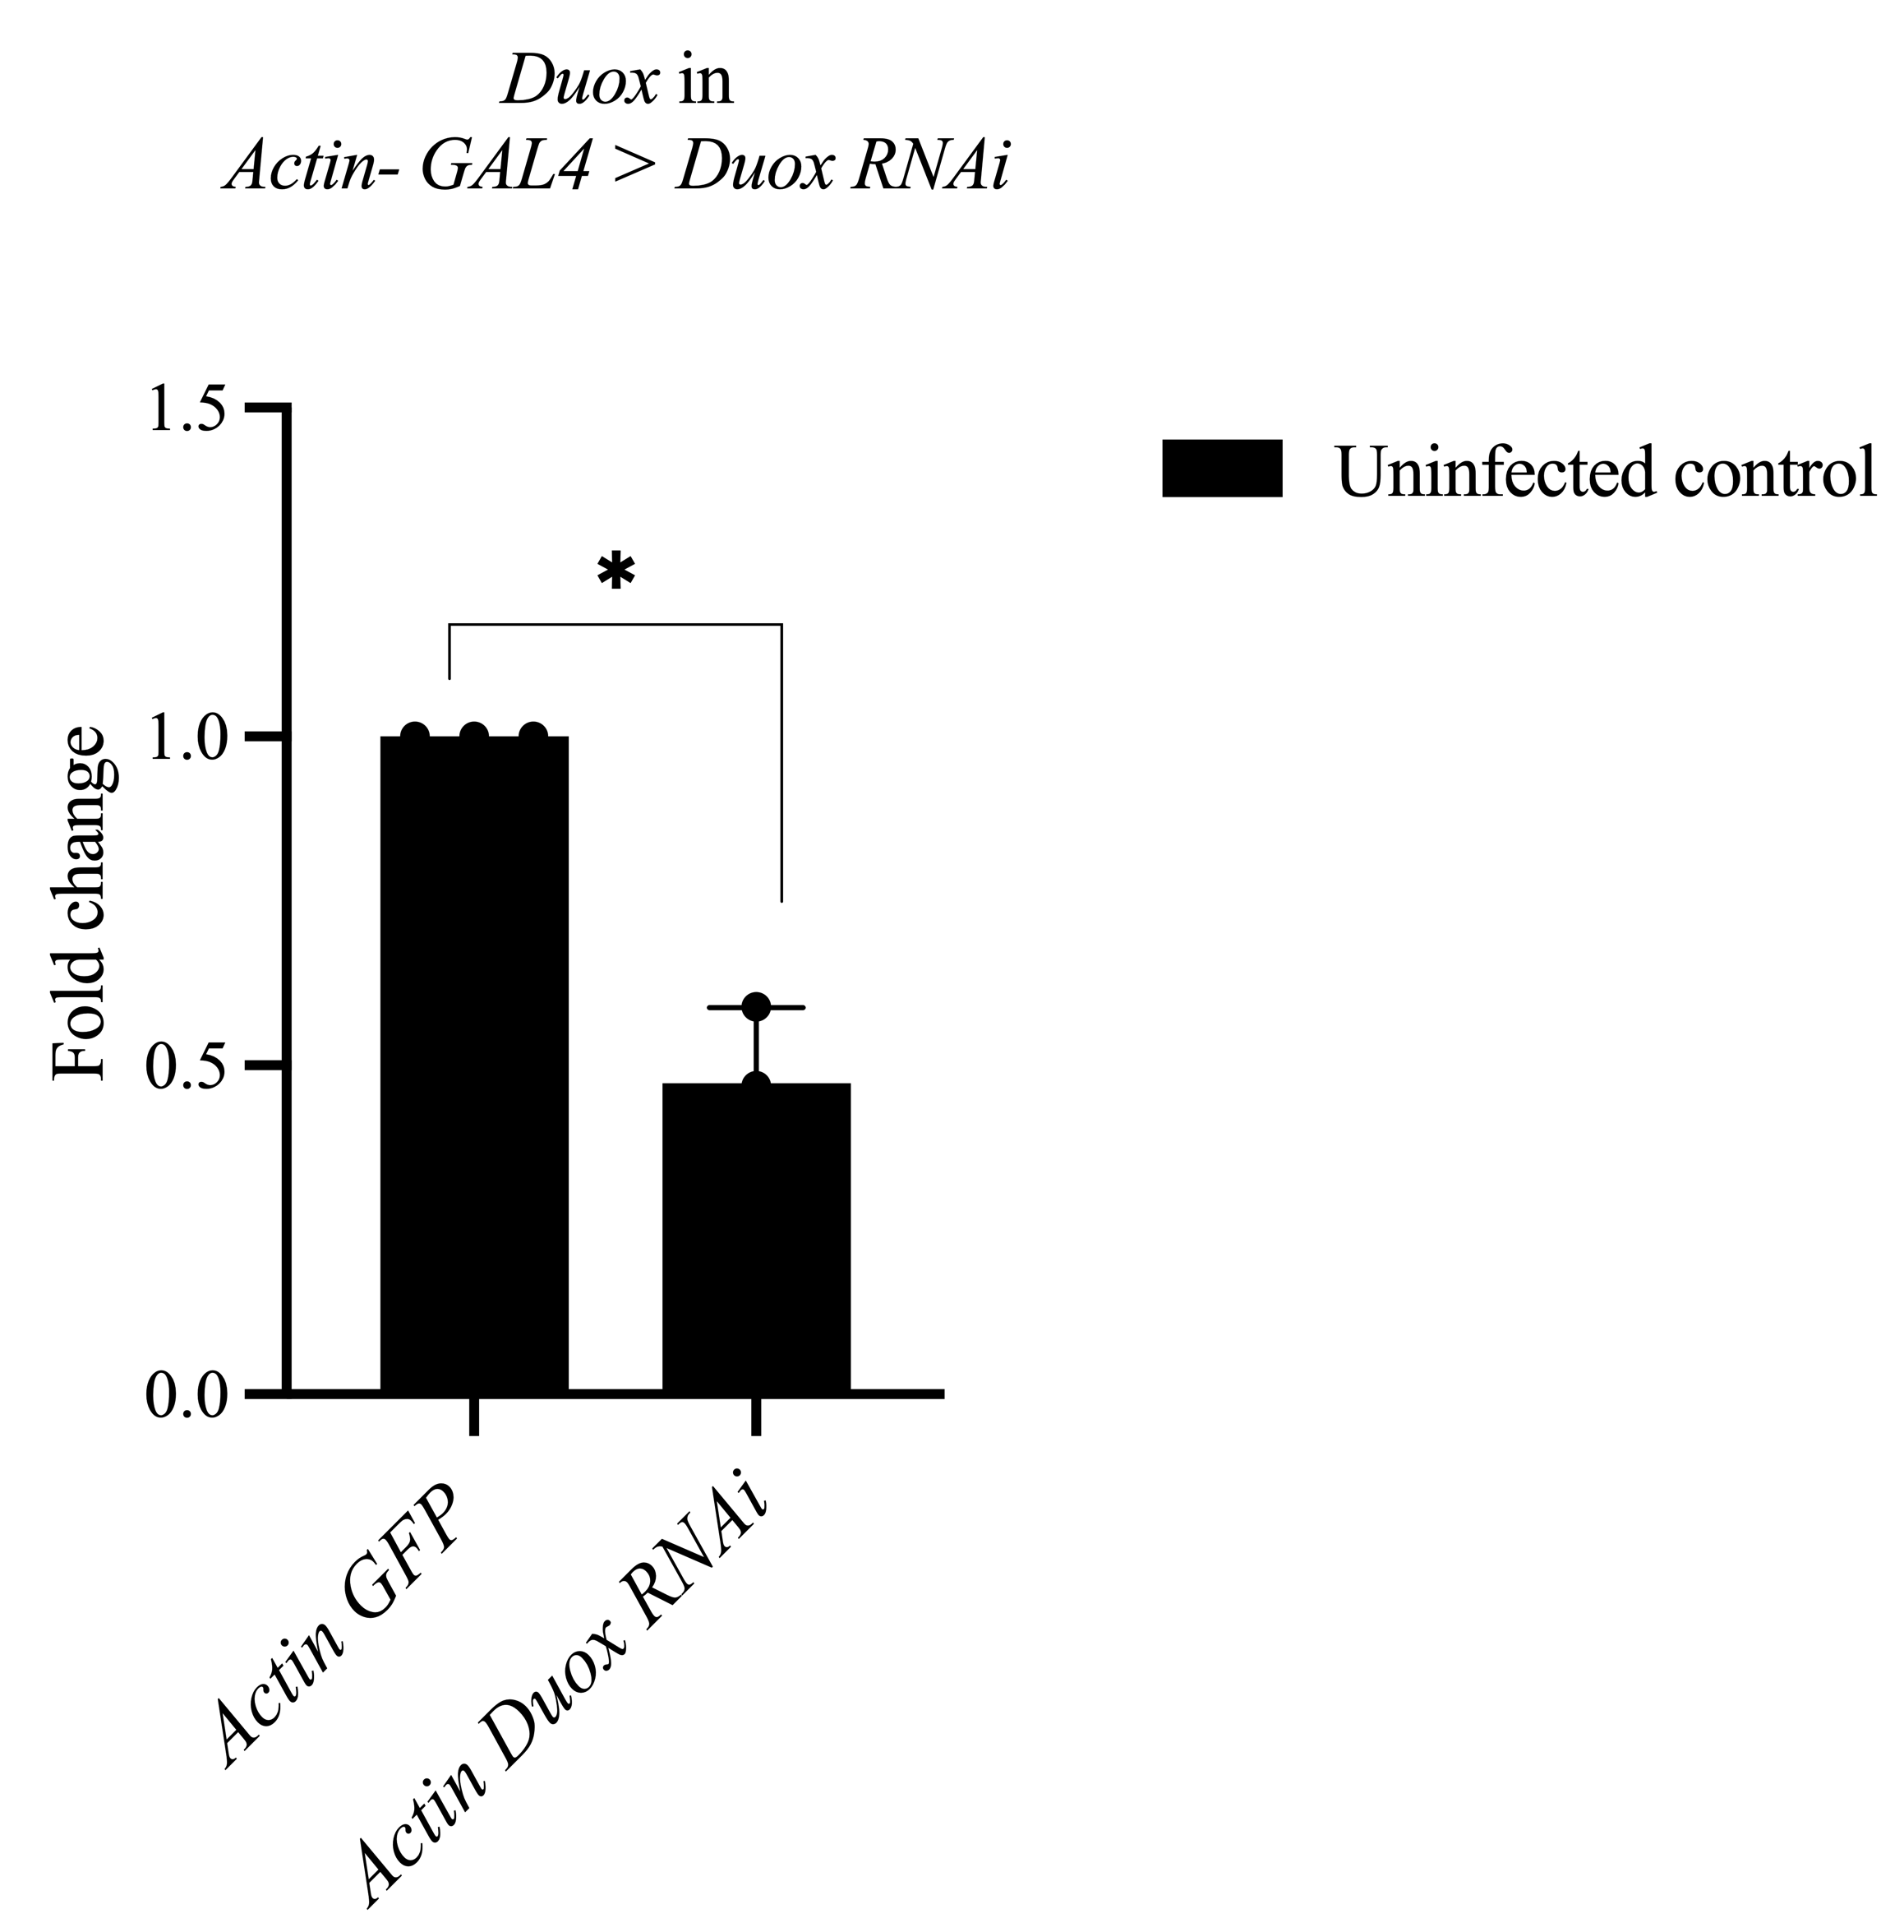
Supplementary file 6. Validation of Duox RNAi-mediated knockdown. RT-qPCR analysis was performed in uninfected guts to confirm the efficiency of Duox silencing in Actin-Gal4 >UAS-DuoxIR flies compared to Actin-Gal4>UAS-GFP control. Statistical significance for Duox expression was assessed by comparing to Actin-Gal4>UAS-GFP uninfected controls using Unpaired t-test and are denoted as *, p < 0.05. Each biological replicate consisted of 15 dissected guts.

Supplementary File 7. Primer pairs used for gene expression analysis, listed with their sequences.
Gene name | Primer sequence (5′–3′)
RP49 | GCGGGTGCGCTTGTTCGATCC
RP49 | CCAAGGACTTCATCCGCCACC
Cecropin A1 | GCTTCCGATTGTCCAATGCT
Cecropin A1 | CAGTCGCTCAGTTTCCACAG
Defensin | GCAGTAGCCGCCTTTGAACC
Defensin | CGCATAGAAGCGAGCCACATG
Relish | TGCCATGTGGAGTGATTAT
Relish | TCCTTAATGGAGTGCCAACC
TRPA1# | AATATCCTGAAGGGGCTGTCA
TRPA1# | GGGTCCCAAGCGGATTGAAAT`
Duox | CGCTGTTTCTCGGTCTGACT
Duox | AGCCCTGCTGCTTCTACTGA
Nox | GTCTTCTTGATGCTGCGTATGC
Nox | GCCGCAAACTGATTTCCTG
Duox RNAi confirmation | GTCAAGTTTTGCTAAGTGCGTT
Duox RNAi confirmation | GAGGCCTTTTTGTTGTTCTTGCT

# Also detects isoforms TRPA 1G, TRPA 1K, TRPA1 H

