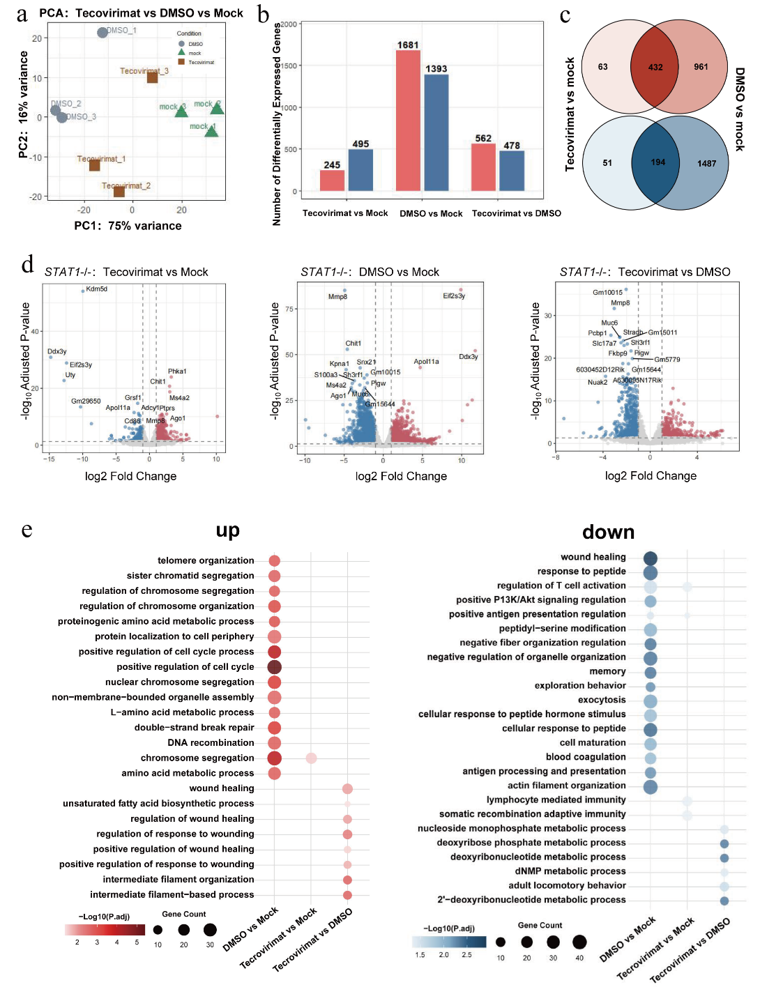
Supplementary Fig.1 Transcriptional profiling of the therapeutic response to Tecovirimat in MPXV infected STAT1^{-/-} mice.
a: Principal component analysis (PCA) of transcriptomes from Mock (green), DMSO-treated (grey), and Tecovirimat-treated (brown) samples (n=3). The percentage of variance explained by PC1 and PC2 is indicated on the axes. b: Numbers of up-(red) and down-(blue) regulated differentially expressed genes (DEGs) identified in the indicated comparisons. c:Venn diagrams illustrating the overlap of up- (red) and down- (blue) regulated DEGs between Tecovirimat vs Mock and DMSO vs Mock comparisons. d:Volcano plots displaying transcriptomic changes in STAT1^{-/-}mice for the indicated comparisons. Significant genes (|log₂FC| ≥ 1, adjusted P < 0.05) are marked with red dots (upregulated) and blue dots (downregulated), while non-significant genes are shown in gray. e: Dot plot showing the enriched biological process terms for the upregulated and downregulated genes in each group. Dot size: number of associated genes; color intensity: enrichment significance [-log₁₀(adjusted P-value)] (red: upregulated genes; blue: downregulated genes). Analysis tool: Metascape.
Alveolar Wall Scoring Criteria
Score 0 | Normal alveolar wall structure, uniform thickness, no abnormal changes.
Score 1 | Mild thickening from cell swelling or fibrosis, involving <20% of visual field.
Score 2 | Moderate thickening, marked swelling, fibrosis or inflammation, involving 20%-50% of visual field.
Score 3 | Severe thickening, destruction, massive fibrosis, partial rupture, involving >50% of visual field.
Edema scoring criteria
Score 0 | No pulmonary edema; normal alveolar and interstitial structures.
Score 1 | Mild edema, slightly widened pale septa, involving <20% of visual field.
Score 2 | Moderate edema, markedly widened septa, fluid accumulation, narrowed alveoli, involving 20%-50% visual field.
Score 3 | Severe edema, significantly widened septa, compressed and vanished alveoli, involving >50% visual field.
Inflammatory cell scoring criteria
Score 0 | No inflammatory cell infiltration in the lung tissue.
Score 1 | Mild scattered inflammatory infiltration in septa or perivascular areas, involving <20% visual field.
Score 2 | Moderate focal inflammatory cell infiltration, involving 20%-50% of the visual field.
Score 3 | Massive diffuse inflammatory infiltration destroying normal lung structure, involving >50% visual field.
Necrotic cell debris scoring criteria
Score 0 | Normal cell morphology, no necrotic cell debris in the lung tissue.
Score 1 | Rare scattered necrotic debris in alveoli or interstitium, involving <20% visual field.
Score 2 | Moderate necrotic debris, unclear cell outlines, karyorrhexis, involving 20%-50% visual field.
Score 3 | Massive diffuse necrotic debris, severe tissue disintegration, involving >50% visual field.
Hemorrhage scoring criteria
Score 0 | No hemorrhage; no red blood cell extravasation in alveoli or interstitium.
Score 1 | Scattered red blood cell extravasation in alveoli or interstitium, involving <20% visual field.
Score 2 | Moderate patchy hemorrhage in alveoli or interstitium, involving 20%-50% of visual field.
Score 3 | Massive hemorrhagic lung consolidation, extensive hemorrhage, involving >50% visual field.
Supplementary Tab.1 Histopathological scoring criteria for lung injury
This table presents a semi-quantitative histopathological scoring system used to evaluate the severity of lung tissue injury. Five parameters-alveolar wall changes, edema, inflammatory cell infiltration, necrotic cell debris, and hemorrhage-are individually graded on a scale of 0 to 3. The scores are assigned based on the severity of the lesions and the percentage of the microscopic visual field involved (0 = normal/none; 1 = mild, <20%; 2 = moderate, 20%-50%; 3 = severe, >50%).

