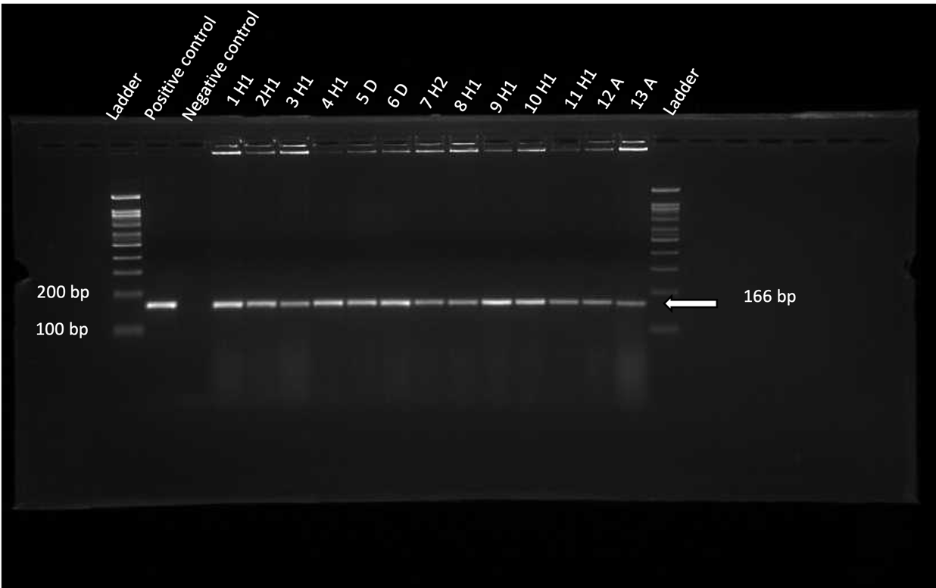
Supplementary Figure 1: E.coli identification through uidA gene amplification by colony PCR. Ladder: 100 bp ladder, Positive control: E.coli (ATCC 53323) (it shows the corresponding 166 bp band), Negative control: no template control, the remaining lanes are for the 13 uidA-positive E.coli isolates in the tested areas (all show the 166 bp band). The gel image was cropped to highlight relevant bands alongside the corresponding DNA ladder. The raw, uncut gel can is provided in in supplementary figure 2.
H1: Hebron H1, H2: Hebron H2, D: Dura, A: Aldahriyyah.

