The inclusion criteria encompassed the following:(a) aged between 18 and 65 years, (b) diagnosed with gallstones by B-scan ultrasound and intended to undergo laparoscopic cholecystectomy, (c) residing in Chengdu, China, (d) with normal cognitive function and complete verbal ability, and (e) willing to participate in this study.
The exclusion criteria encompassed the following: (a) history of gastrointestinal surgery, (b) concomitant metabolic diseases (diabetes, gout, etc.), infectious diseases and severe systemic diseases, (c) preoperative irritable bowel syndrome, inflammatory bowel disease, constipation, chronic diarrhea, infectious or idiopathic diarrhea, (d) the use of antibiotics, probiotics, prebiotics, laxative agents, or other drugs known to affect gut microbiota in the last one month; (e) patients who have undergone emergency surgery, (f) pregnant or lactating women.
The following criteria were established for the withdrawal of patients from the study:(a) patients with bile duct injury or bile duct stricture following laparoscopic cholecystectomy, (b) patients who were either lost to follow-up or who voluntarily withdrew from the study, and (c) patients with incomplete or invalid questionnaire data (exceeding the critical value or exhibiting obvious logical errors).

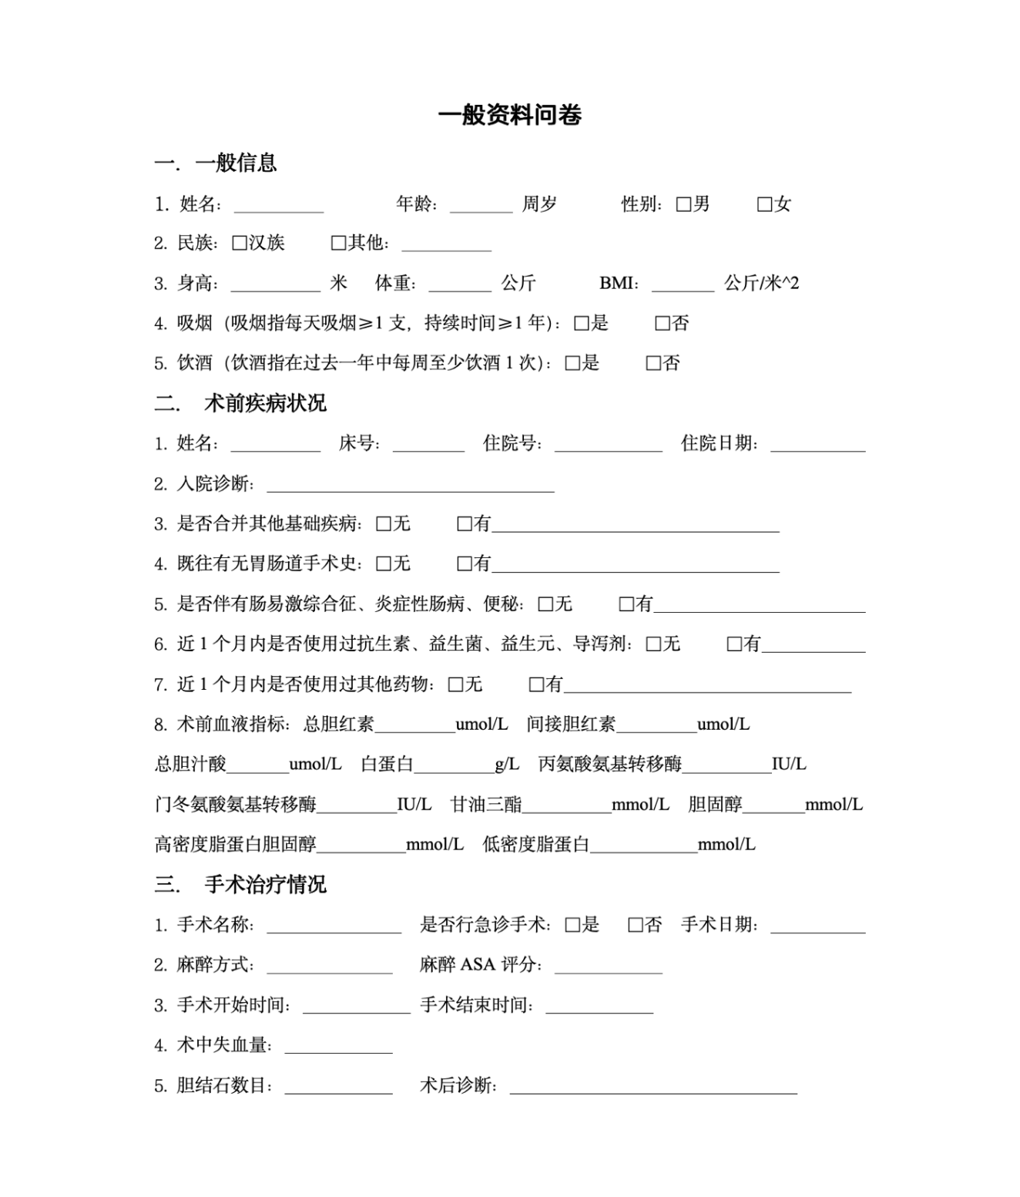
Demographic questionnaire
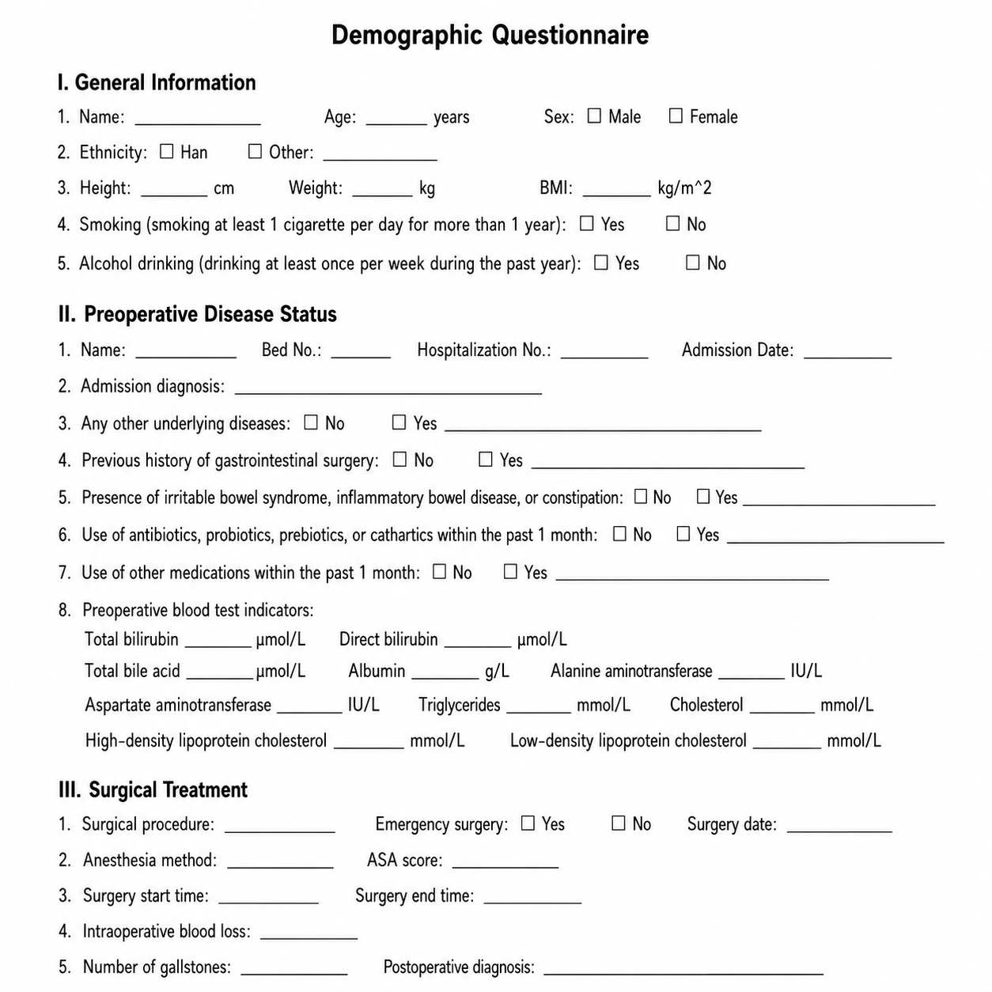
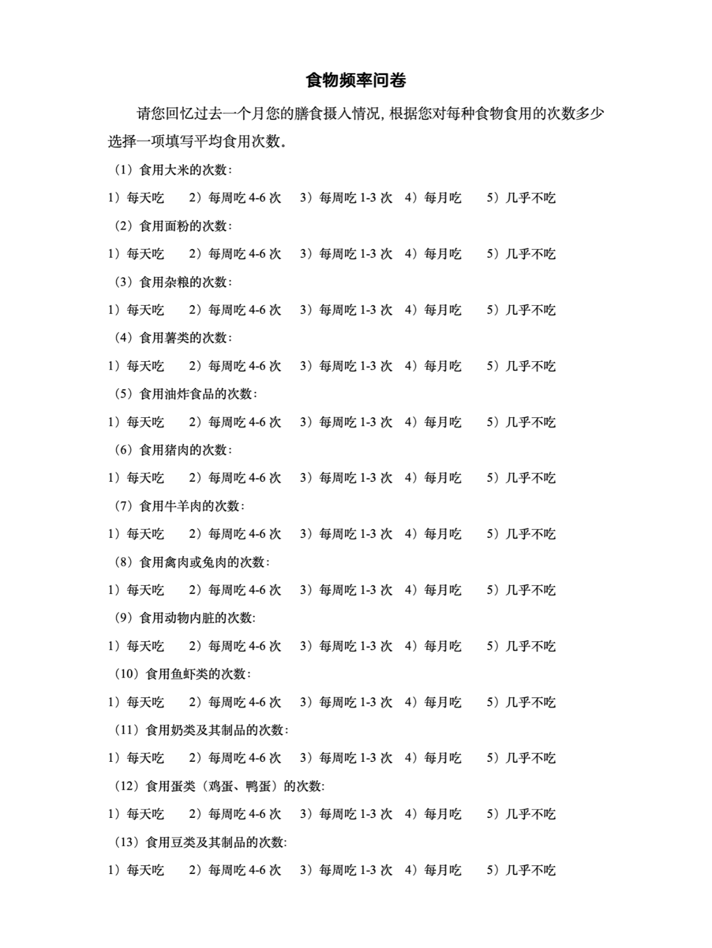
Food frequency questionnaire 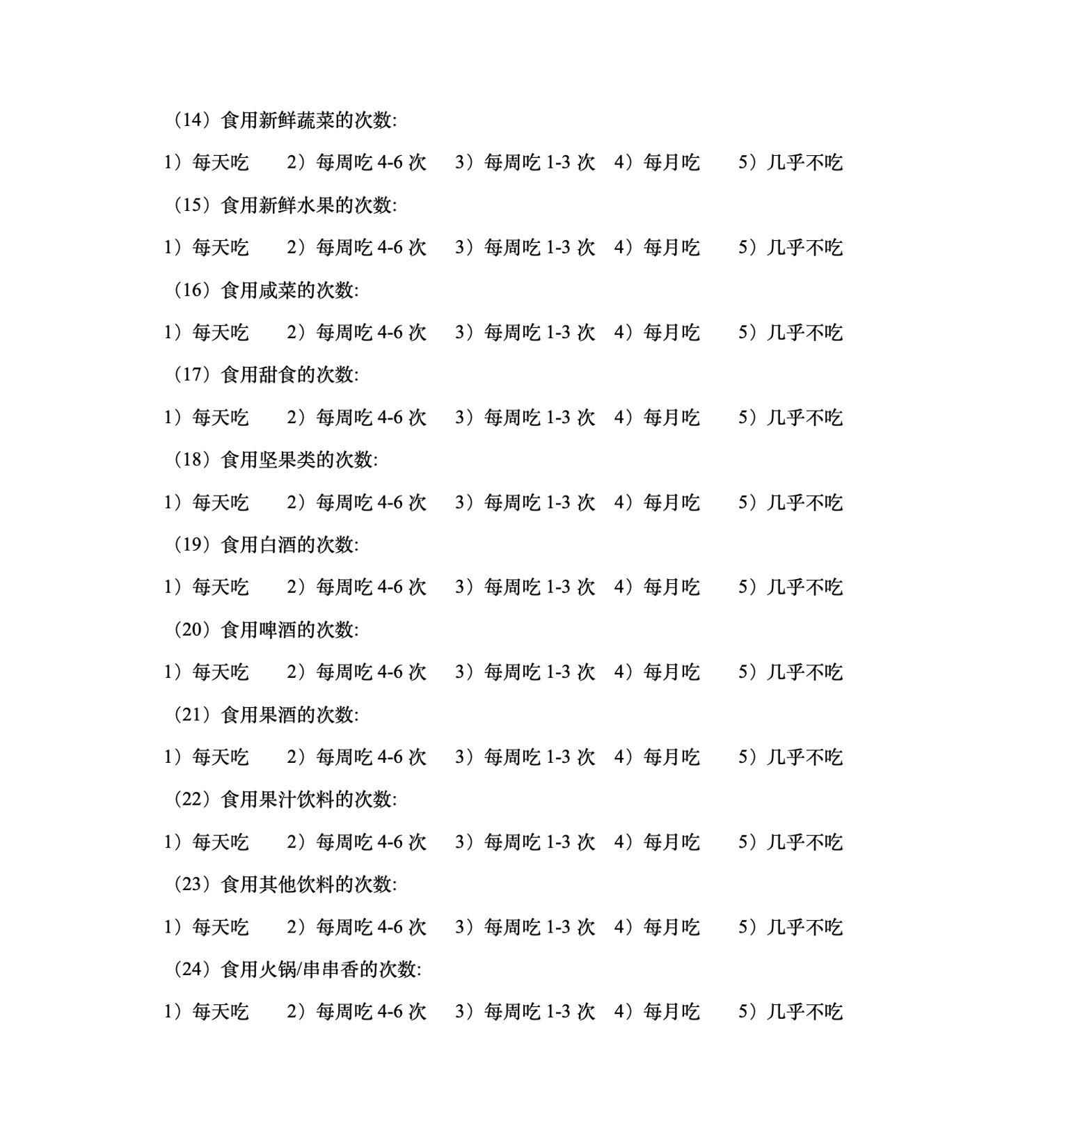
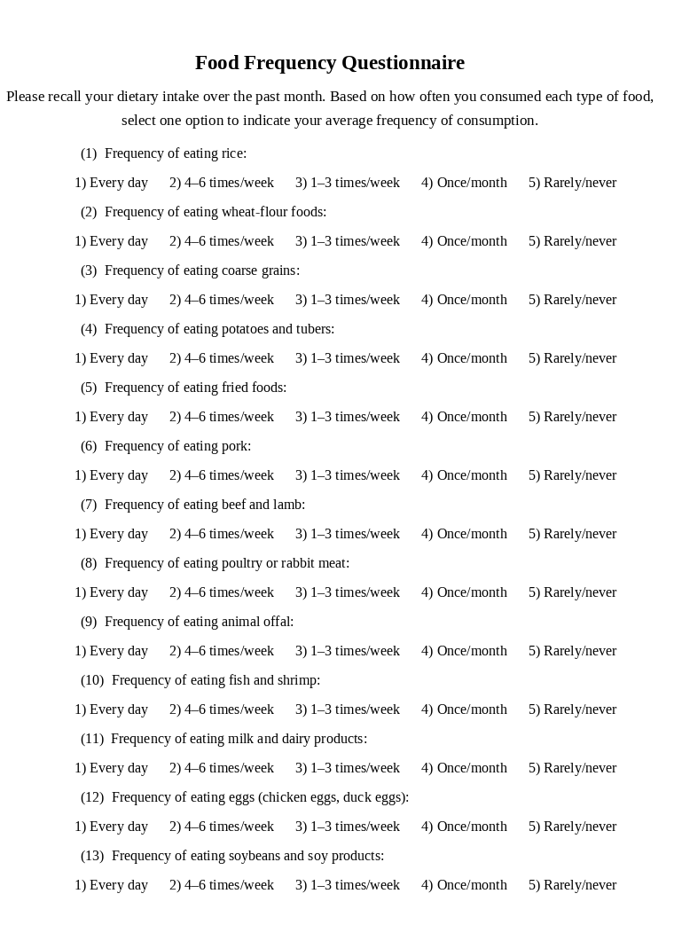
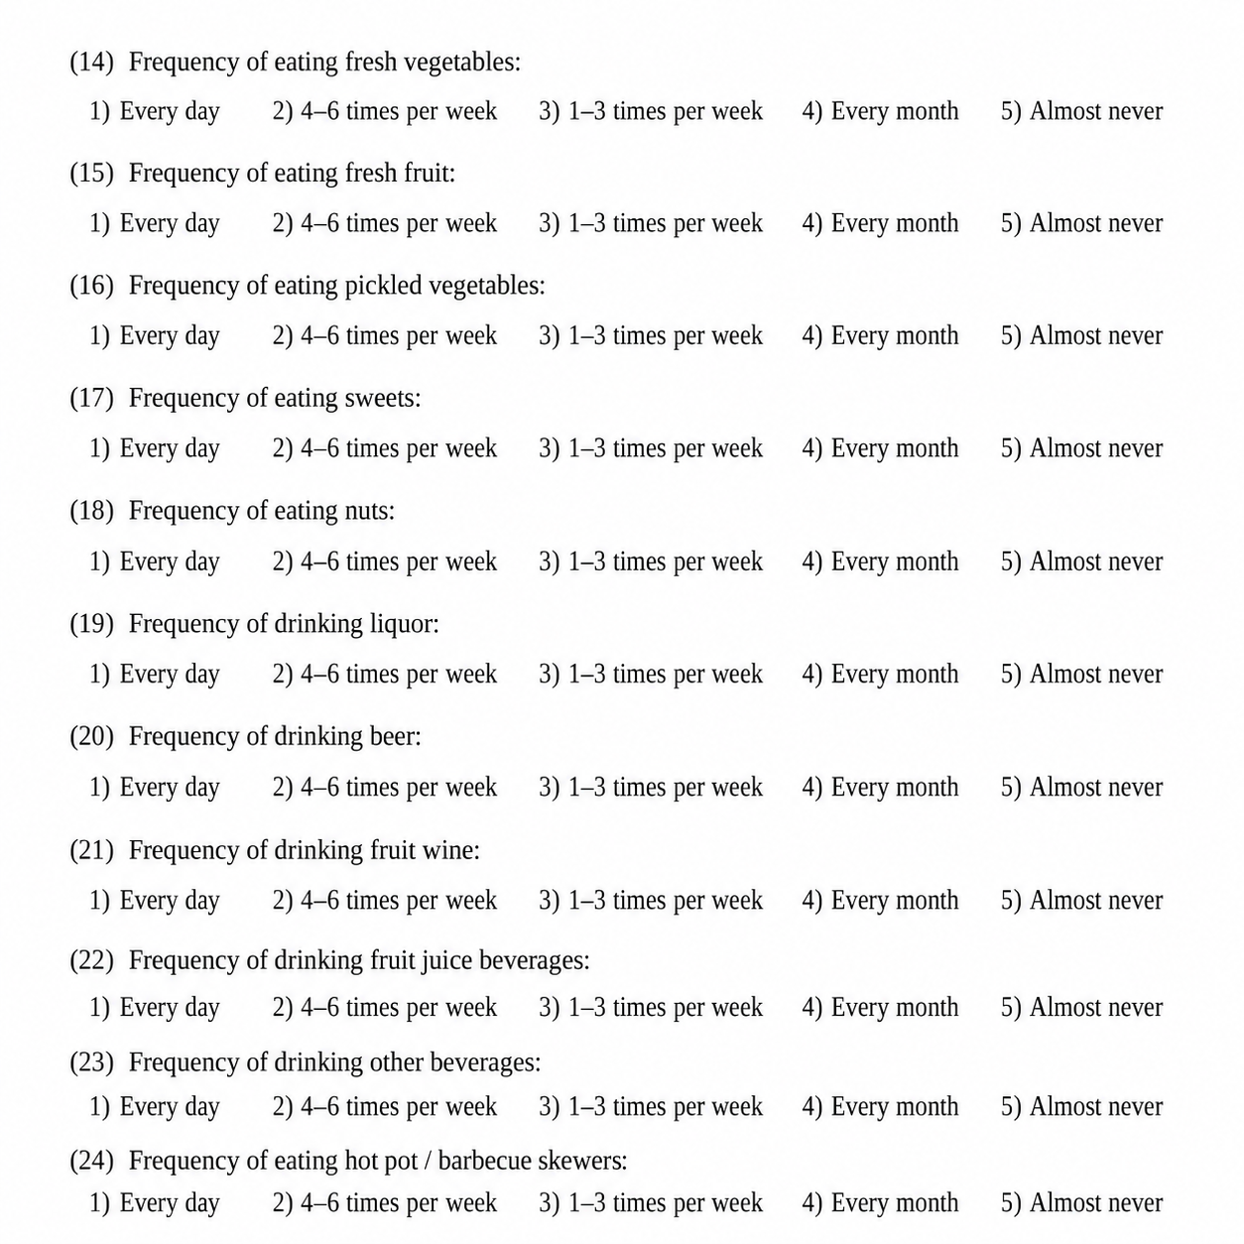

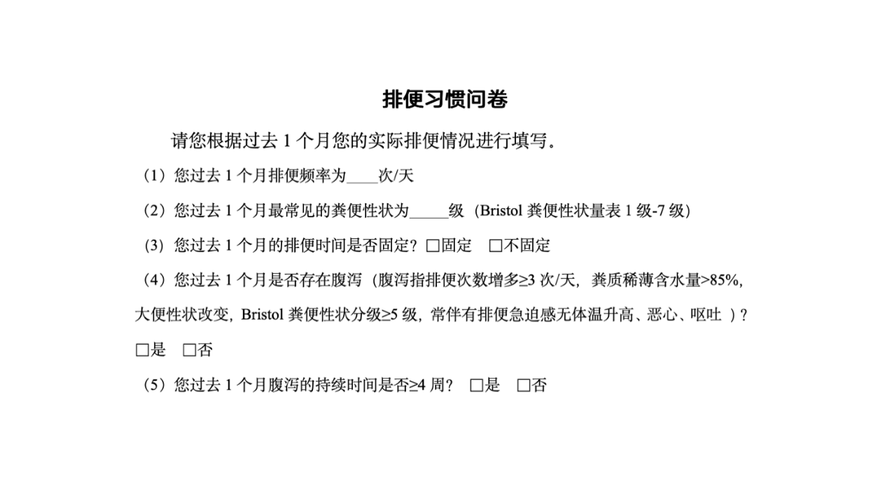
Bowel habit questionnaire
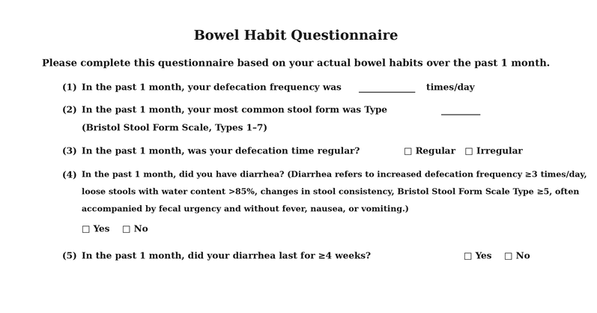

Bristol Stool Form Scale
