Table S1 Sampling point locations and elevation
Sampling | Location | Elevation (m)
Shrublands (SL) | 25°15'40''N, 98°49'27''E | 927.5
Shrublands (SL) | 25°15'41''N, 98°49'28''E | 928.2
Shrublands (SL) | 25°15'40''N, 98°49'28''E | 929.3
Coffee Fields (CF) | 25°15'48''N, 98°48'50''E | 973.4
Coffee Fields (CF) | 25°15'49''N, 98°48'53''E | 978.8
Coffee Fields (CF) | 25°15'48''N, 98°48'53''E | 979.5
Maize Fields (MF) | 25°15'52''N, 98°48'50''E | 987.9
Maize Fields (MF) | 25°15'51''N, 98°48'50''E | 998.8
Maize Fields (MF) | 25°15'52''N, 98°48'50''E | 1000.1
Orange Fields (OF) | 25°15'45''N, 98°48'59''E | 960.9
Orange Fields (OF) | 25°15'47''N, 98°48'55''E | 957.3
Orange Fields (OF) | 25°15'48''N, 98°48'58''E | 955.2
Shrublands (SL) | 25°16'55''N, 98°47'57''E | 1274.4
Shrublands (SL) | 25°16'55''N, 98°47'59''E | 1265.8
Shrublands (SL) | 25°16'54''N, 98°49'57''E | 1271.2
Coffee Fields (CF) | 25°16'58''N, 98°47'56''E | 1297.0
Coffee Fields (CF) | 25°16'57''N, 98°47'55''E | 1289.9
Coffee Fields (CF) | 25°16'56''N, 98°47'56''E | 1278.1
Maize Fields (MF) | 25°16'52''N, 98°47'50''E | 1260.9
Maize Fields (MF) | 25°16'53''N, 98°47'50''E | 1262.2
Maize Fields (MF) | 25°16'48''N, 98°47'51''E | 1226.7
Orange Fields (OF) | 25°17'08''N, 98°47'37''E | 1446.3
Orange Fields (OF) | 25°17'03''N, 98°47'36''E | 1409.8
Orange Fields (OF) | 25°17'03''N, 98°47'37''E | 1410.2
Shrublands (SL) | 25°17'23''N, 98°47'37''E | 1678.6
Shrublands (SL) | 25°17'23''N, 98°47'36''E | 1680.3
Shrublands (SL) | 25°17'22''N, 98°47'37''E | 1675.5
Coffee Fields (CF) | 25°17'22''N, 98°47'56''E | 1621.4
Coffee Fields (CF) | 25°17'21''N, 98°47'55''E | 1618.9
Coffee Fields (CF) | 25°17'20''N, 98°47'56''E | 1616.6
Maize Fields (MF) | 25°17'23''N, 98°47'45''E | 1650.8
Maize Fields (MF) | 25°17'23''N, 98°47'45''E | 1649.2
Maize Fields (MF) | 25°17'22''N, 98°47'45''E | 1647.6
Orange Fields (OF) | 25°17'22''N, 98°47'44''E | 1647.9
Orange Fields (OF) | 25°17'21''N, 98°47'44''E | 1646.6
Orange Fields (OF) | 25°17'22''N, 98°47'44''E | 1646.7

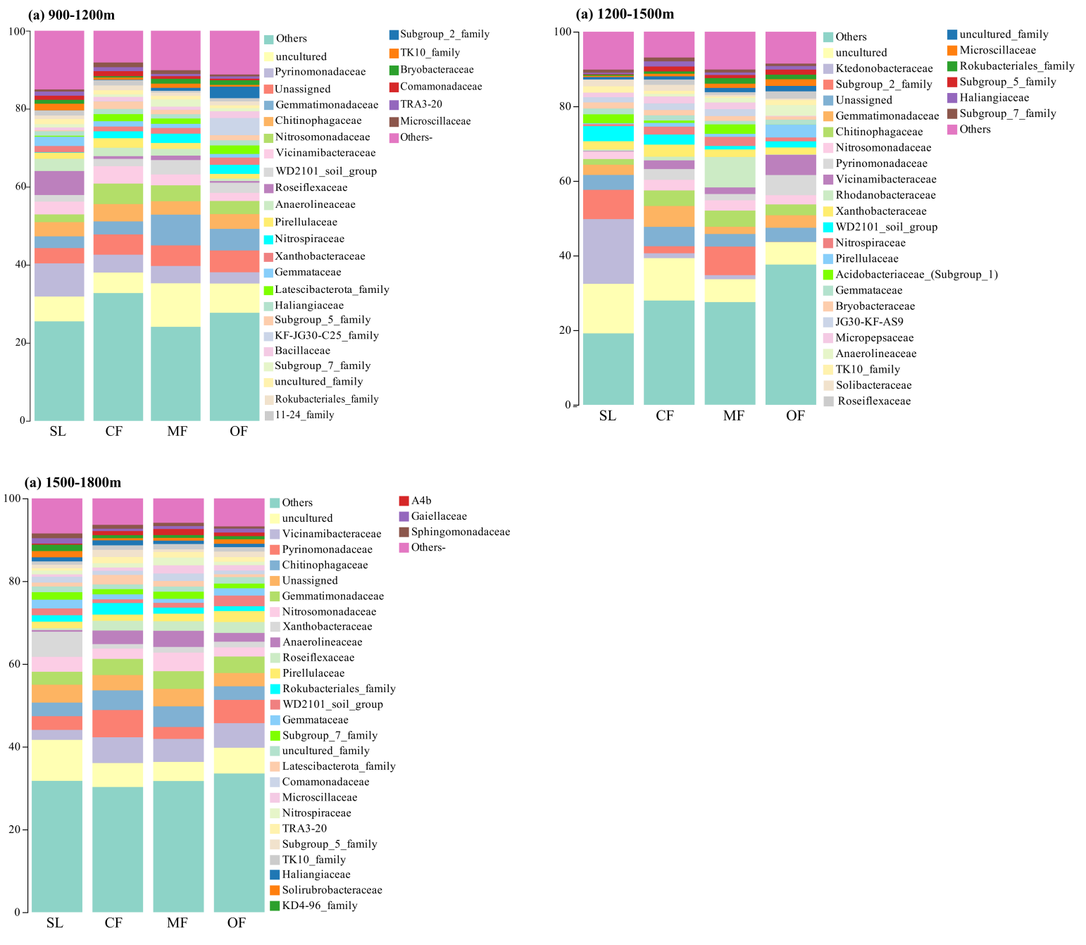
Figure S1 Effects of different land use types on soil bacterial families at different elevation. SL: shrublands; CF: coffee fields; MF: maize fields; OF: orange fields.
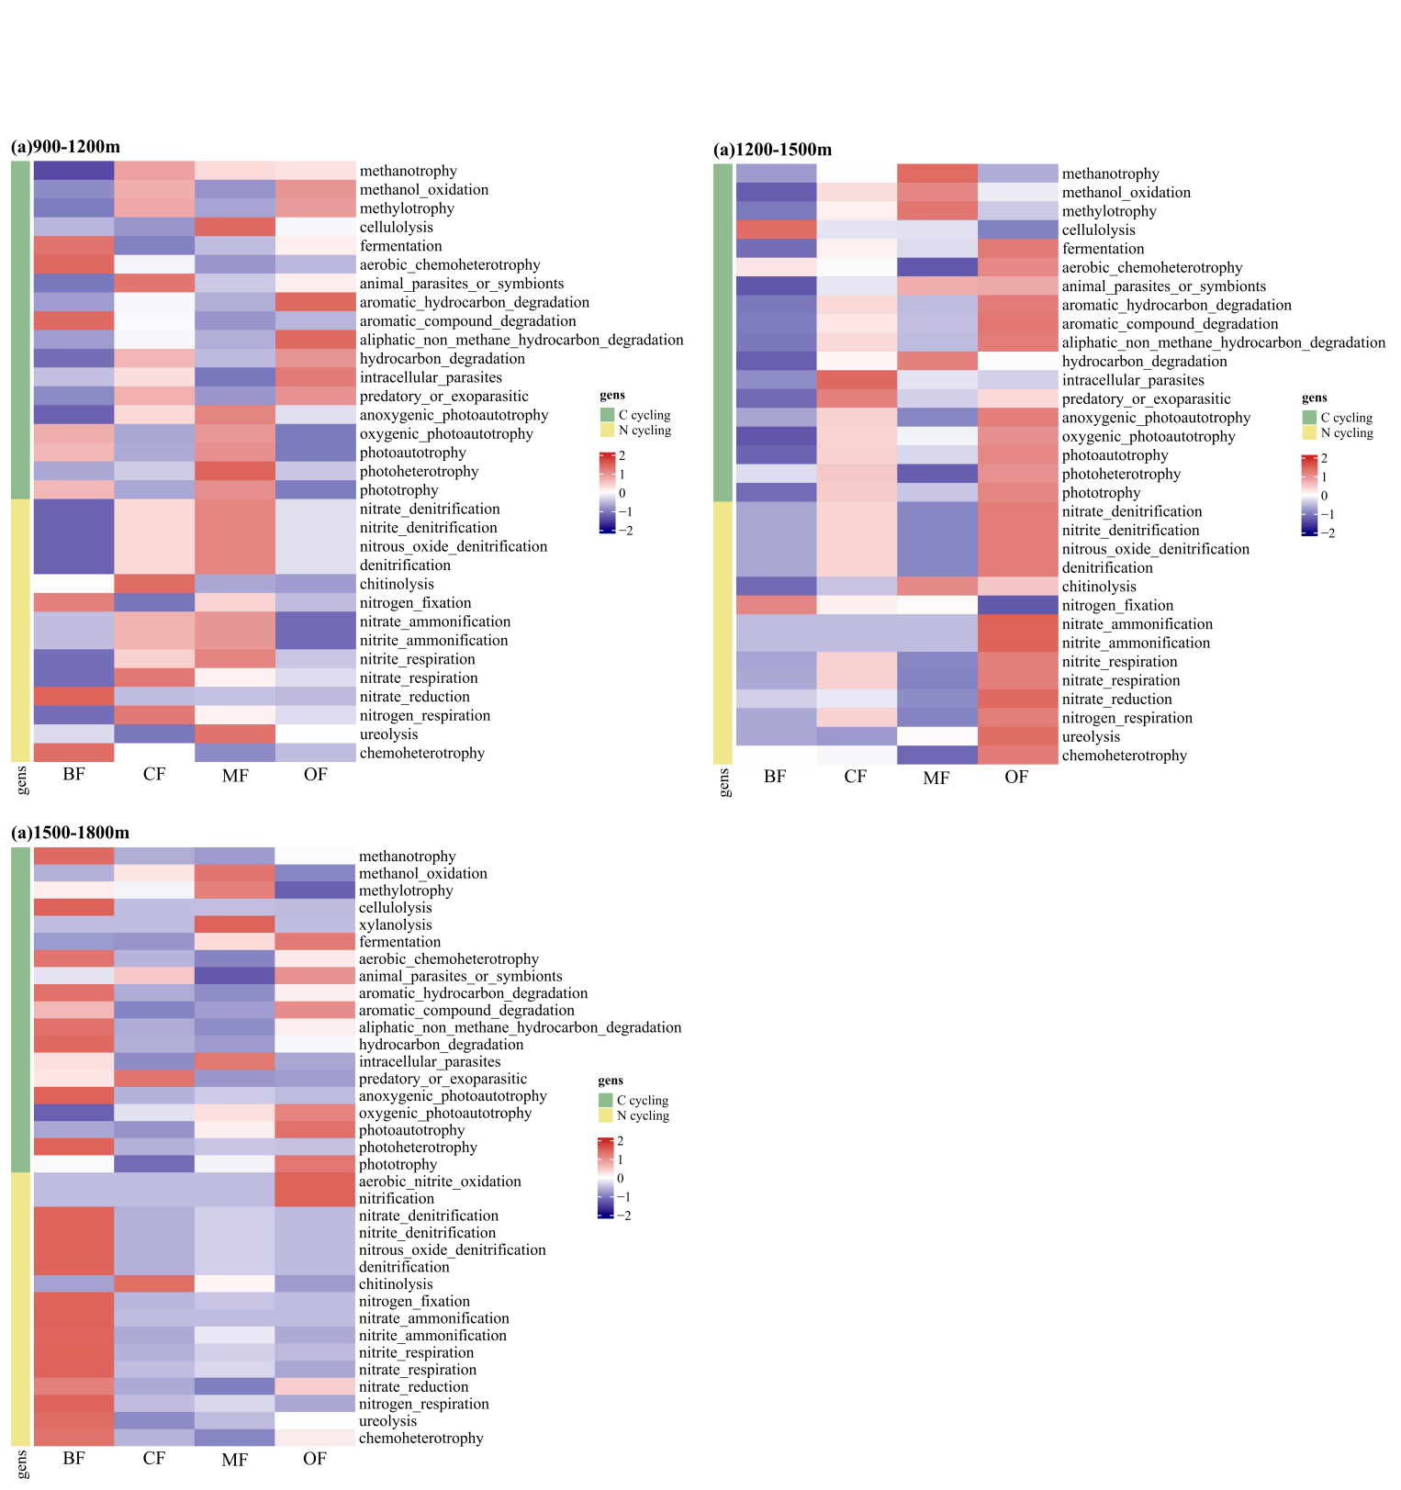
Figure S2 Composition of soil bacterial functional groups. SL: shrublands; CF: coffee fields; MF: maize fields; OF: orange fields.

