Supplementary materials
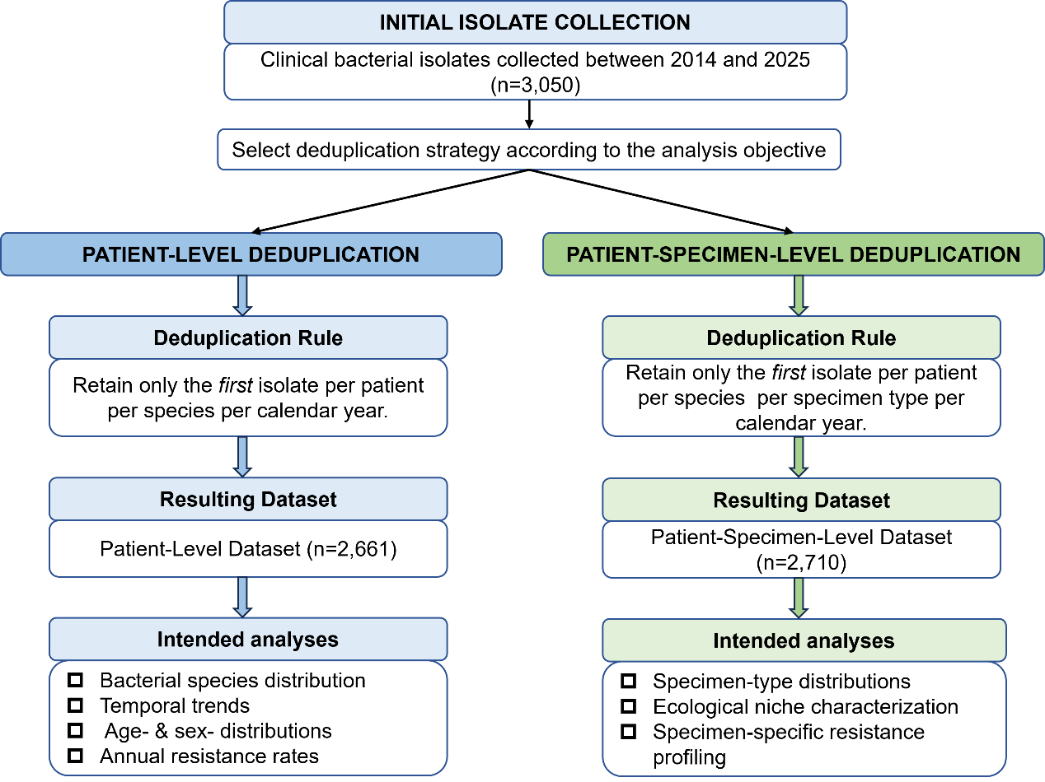
Figure S1. Flowchart of isolate selection and deduplication strategies.
Depending on the analysis objective, two predefined deduplication strategies were applied to the initial collection of 3,050 bacterial isolates. For analyses independent of specimen type (including bacterial species distribution, temporal trends, age- and sex-specific distributions, and annual antimicrobial resistance rates), only the first isolate of each bacterial species from each patient within a calendar year was retained, resulting in a patient-level dataset (n = 2,661). For specimen-specific analyses (including specimen-type distribution, ecological niche characterization, and specimen-specific antimicrobial resistance profiling), the first isolate of each bacterial species from each patient within each specimen type per calendar year was retained, resulting in a patient-specimen-level dataset (n = 2,710). Repeated isolates from recurrent infections within the same calendar year were excluded, while those occurring in different years were retained.

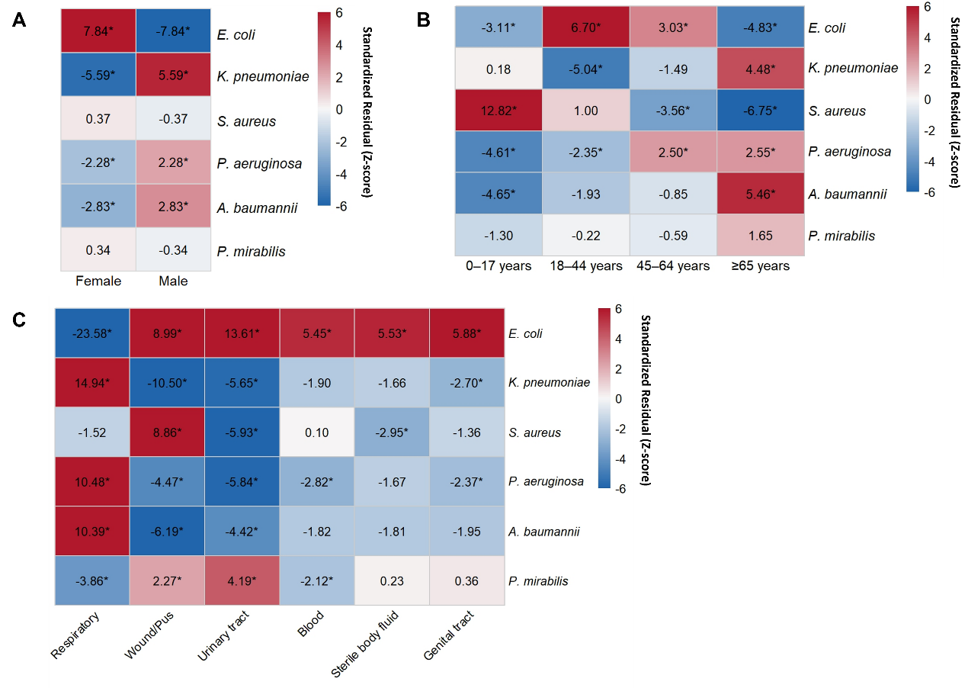
Figure S2. Standardized residuals derived from Pearson's chi-square test were used to identify bacterial species contributing to the overall associations across patient sex (A), age groups (B), and specimen types (C). Red indicates overrepresentation, whereas blue indicates underrepresentation relative to the expected counts under the null hypothesis of independence. Cells with standardized residuals greater than 1.96 or less than −1.96 (|Z| >1.96) were considered statistically significant and are marked with an asterisk (*).

Table S1. Temporal trends in the distribution of major bacterial species isolated between 2014 and 2025.
Species | Cochran–Armitage trend test (P_{trend}) | OR per year (95% CI) | Logistic regression (P_{year})
E. coli | 0.362 | 0.99 (0.97-1.01) | 0.362
K. pneumoniae | 0.026 | 1.03 (1.00-1.06) | 0.026
S. aureus | < 0.001 | 0.93 (0.89-0.96) | < 0.001
P. aeruginosa | < 0.001 | 1.10 (1.05-1.14) | < 0.001
A. baumannii | 0.376 | 1.02 (0.97-1.07) | 0.377
Note: ORs represent the change in odds associated with each one-year increase in calendar year, estimated using logistic regression. OR > 1 indicates an increasing temporal trend, whereas OR < 1 indicates a decreasing temporal trend.

Table S2. Temporal trends in the prevalence of major antimicrobial-resistant phenotypes between 2017 and 2025.
Resistance phenotype | Cochran–Armitage trend test (P_{trend}) | OR per year (95% CI) | Logistic regression (P_{year})
CRAB | 0.603 | 0.96 (0.83-1.12) | 0.603
CRE | 0.008 | 1.19 (1.05-1.37) | 0.009
MRSA | 0.098 | 0.88 (0.74-1.02) | 0.101
ESBL-EC | 0.524 | 0.98 (0.92-1.04) | 0.524
ESBL-KP | 0.262 | 1.04 (0.97-1.12) | 0.263
Note: ORs represent the change in odds associated with each one-year increase in calendar year, estimated using logistic regression. OR > 1 indicates an increasing temporal trend, whereas OR < 1 indicates a decreasing temporal trend. ESBL-EC, extended-spectrum β-lactamase-producing E. coli; ESBL-KP, extended-spectrum β-lactamase-producing K. pneumoniae.

Table S3. Antimicrobial resistance trends of E. coli across individual antibiotics (2017–2025).
Resistance rate  (E. coli) | 2017 | 2018 | 2019 | 2020 | 2021 | 2022 | 2023 | 2024 | 2025 | Total
Aminoglycosides
Amikacin | 3.9% | 3.0% | 6.9% | 9.1% | 11.1% | 7.3% | 15.4% | 5.6% | 4.3% | 6.9%
Gentamicin | 74.5% | 53.7% | 47.2% | 54.5% | 51.9% | 56.4% | 38.5% | 49.5% | 50.0% | 53.0%
β-Lactams (Penicillins)
Ampicillin | 86.3% | 86.6% | 84.7% | 84.8% | 82.5% | 92.7% | 96.2% | 87.2% | 91.3% | 87.2%
β-Lactams (Cephalosporins)
Cefotaxime | 60.8% | 61.0% | 50.0% | 47.0% | 42.5% | 58.2% | 73.1% | 53.8% | 48.6% | 53.1%
Ceftazidime | 51.0% | 32.8% | 47.8% | 44.4% | 37.5% | 45.5% | 69.2% | 46.2% | 44.3% | 44.6%
β-Lactams (Carbapenems)
Meropenem | 2.0% | 1.5% | 1.4% | 3.0% | 2.5% | 1.8% | 3.8% | 4.4% | 5.7% | 2.9%
Imipenem | 2.0% | 1.8% | 2.6% | 3.0% | 2.5% | 1.8% | 3.8% | 5.5% | 5.7% | 3.4%
β-Lactams (Monobactams)
Aztreonam | 45.1% | 44.8% | 32.9% | 30.3% | 32.1% | 40.0% | 57.7% | 50.5% | 38.6% | 40.2%
Fluoroquinolones
Ciprofloxacin | 72.5% | 67.9% | 35.9% | 62.1% | 56.8% | 66.7% | 65.4% | 64.8% | 64.3% | 62.3%
Levofloxacin | 76.5% | 53.7% | 38.6% | 57.6% | 48.1% | 63.0% | 65.4% | 60.4% | 61.4% | 56.9%
Folate Pathway Inhibitors
Trimethoprim-Sulfamethoxazole | 72.5% | 62.7% | 65.3% | 58.5% | 65.4% | 65.5% | 73.1% | 59.3% | 44.3% | 61.8%

Table S4. Antimicrobial resistance trends of K. pneumoniae across individual antibiotics (2017–2025).
Resistance rate  (K. pneumoniae) | 2017 | 2018 | 2019 | 2020 | 2021 | 2022 | 2023 | 2024 | 2025 | Total
Aminoglycosides
Amikacin | 4.8% | 7.3% | 3.0% | 3.0% | 9.0% | 2.6% | 8.7% | 11.5% | 2.4% | 5.5%
Gentamicin | 40.3% | 34.5% | 28.4% | 13.6% | 26.9% | 17.9% | 21.7% | 32.8% | 22.9% | 27.0%
β-Lactams (Cephalosporins)
Cefotaxime | 45.2% | 50.9% | 28.9% | 22.7% | 17.9% | 33.3% | 30.4% | 41.0% | 34.9% | 33.9%
Ceftazidime | 30.6% | 24.1% | 28.1% | 15.2% | 16.4% | 28.2% | 30.4% | 34.4% | 30.1% | 26.0%
β-Lactams (Carbapenems)
Meropenem | 1.6% | 3.6% | 0.0% | 4.5% | 0.0% | 2.6% | 4.3% | 8.2% | 3.6% | 3.1%
Imipenem | 1.6% | 4.2% | 0.0% | 4.5% | 0.0% | 2.6% | 8.7% | 8.2% | 3.6% | 3.5%
β-Lactams (Monobactams)
Aztreonam | 41.9% | 30.9% | 21.5% | 16.7% | 14.9% | 31.6% | 39.1% | 32.8% | 26.5% | 27.1%
Fluoroquinolones
Ciprofloxacin | 40.3% | 46.8% | 20.0% | 15.2% | 34.3% | 36.8% | 47.8% | 45.9% | 32.5% | 34.5%
Levofloxacin | 43.5% | 23.6% | 18.5% | 12.1% | 23.9% | 26.3% | 34.8% | 41.0% | 32.5% | 28.1%
Folate Pathway Inhibitors
Trimethoprim-Sulfamethoxazole | 61.3% | 50.9% | 39.4% | 38.1% | 43.3% | 38.5% | 39.1% | 42.6% | 32.5% | 42.8%

Table S5. Proportions of antimicrobial-resistant isolates among the corresponding bacterial species stratified by patient age group.
 | MRSA | ESBL-KP | ESBL-EC | CRE | CRPA | CRAB
0-17 years | 15.4% (8/52) | 29.1% (16/55) | 52.5% (31/59) | 2.8%  (3/108) | 0.0%  (0/11) | 0.0%  (0/3)
18-44 years | 35.5% (11/31) | 17.2% (5/29) | 49.4% (41/83) | 1.8%  (2/109) | 13.3%  (2/15) | 71.4%  (5/7)
45-64 years | 20.8% (11/53) | 24.7% (37/150) | 49.3% (99/201) | 4.2%  (14/333) | 17.6%  (13/74) | 73.7%  (28/38)
≥ 65 years | 20.4% (11/54) | 28.7% (77/268) | 64.6% (133/206) | 3.4%  (16/465) | 16.8%  (17/101) | 69.3%  (61/88)
Note: Data are presented as resistance proportion (%), with the number of resistant isolates divided by the total number of isolates of the corresponding bacterial species shown in parentheses (n/N). ESBL-EC, extended-spectrum β-lactamase-producing E. coli; ESBL-KP, extended-spectrum β-lactamase-producing K. pneumoniae.

Table S6. Proportions of antimicrobial-resistant isolates among the corresponding bacterial species stratified by specimen type.
 | MRSA | ESBL-KP | ESBL-EC | CRE | CRPA | CRAB
Respiratory tract | 18.2%  (12/66) | 34.2%  (125/366) | 58.8%  (57/97) | 4.7%  (21/445) | 18.2%  (31/170) | 71.5%  (93/130)
Wound/pus | 21.4%  (22/103) | 36.6%  (15/41) | 54.4%  (86/158) | 2.1%  (4/195) | 13.6%  (3/22) | 75.0%  (3/4)
Urinary tract | 50.0%  (2/4) | 52.4%  (22/42) | 58.0%  (102/176) | 2.8%  (6/212) | 0.0%  (0/2) | 33.3%  (1/3)
Blood | 27.3%  (3/11) | 32.0%  (8/25) | 57.1%  (28/49) | 1.5%  (1/66) | 0.0%  (0/4) | 66.7%  (2/3)
Sterile body fluids | 16.7%  (1/6) | 29.4%  (10/34) | 45.8%  (33/72) | 4.8%  (5/105) | 0.0%  (0/9) | 80.0%  (4/5)
Note: Data are presented as resistance proportion (%), with the number of resistant isolates divided by the total number of isolates of the corresponding bacterial species shown in parentheses (n/N). ESBL-EC, extended-spectrum β-lactamase-producing E. coli; ESBL-KP, extended-spectrum β-lactamase-producing K. pneumoniae.

