Supplementary table captions
Table S1 Composition and nutrient levels of experimental diets (DM basis)
Items | Fattening stages
Items | I | II | III | IV | V~IX
Items | 0~30 d | 31~60 d | 61~90 d | 91~120 d | 121~270 d
Ingredients (%)
Corn silage | 45.00 | 40.00 | 30.00 | 25.00 | 20.00
Whole cottonseed | 0.00 | 0.00 | 0.00 | 0.00 | 10.78
Flattened corn | 14.84 | 10.00 | 8.00 | 5.00 | 10.00
Corn | 25.17 | 41.36 | 51.06 | 59.93 | 54.36
Soybean meal | 8.21 | 3.20 | 0.00 | 2.00 | 0.00
Rapeseed meal | 0.00 | 0.54 | 5.17 | 3.57 | 0.00
Cottonseed meal | 0.00 | 2.00 | 2.00 | 1.00 | 1.00
Pea protein powder | 3.49 | 0.00 | 0.00 | 0.00 | 0.00
Fatty acid calcium | 0.00 | 0.00 | 0.00 | 0.00 | 1.00
CaHPO₄ | 1.12 | 0.80 | 1.10 | 1.28 | 0.65
NaCl | 0.62 | 0.30 | 0.47 | 0.50 | 0.47
NaHCO₃ | 1.11 | 1.00 | 1.28 | 1.00 | 1.15
MgO | 0.00 | 0.19 | 0.28 | 0.16 | 0.13
Premix¹ | 0.44 | 0.61 | 0.64 | 0.56 | 0.46
Total | 100.00 | 100.00 | 100.00 | 100.00 | 100.00
Nutrition levels²
CP, % | 11.94 | 10.95 | 10.80 | 10.60 | 9.80
TDN, % | 72.10 | 76.54 | 77.51 | 78.74 | 80.52
NEm, MJ/kg | 7.44 | 7.97 | 8.14 | 8.31 | 8.53
NEg, MJ/kg | 4.92 | 5.31 | 5.47 | 5.61 | 5.80
Ca, % | 0.61 | 0.50 | 0.59 | 0.63 | 0.37
P, % | 0.31 | 0.33 | 0.36 | 0.35 | 0.34
Note: ¹ Contained the following per kg of premix: VA 4,000,000 IU, VD3 600,000 IU, VE 120,000 IU, Mn 3340 mg, Fe 4800 mg, Zn 12600 mg, Cu 3140 mg, Se 60 mg, I 90 mg, Co 22 mg, nicotinic acid 5970 mg, biotin 200 mg.
² CP (Crude protein), Ca (Calcium) and P (Phosphorus) were measured values according to AOAC (2005), while TDN (Total digestible nutrient), Nem (Net energy maintain) and Neg (Net energy gain) were calculated values according to NRC (2016).
Table S2 Primer information for used qPCR
Gene name | Primer sequences (5'-3') | Length (bp) | Accession No.
APOC3 | F: GCTCGTTCAAGGGCAAGTTC | 102 | NM_001001175.2
APOC3 | R: AGGTGGACTTGGGGTACTGA | 102 | NM_001001175.2
LOC107133155 | F: GAGGCTGAAACGGATGCACT | 128 | XM_024975693.1
LOC107133155 | R: ATTCCATCCACGGCAGAGTT | 128 | XM_024975693.1
APAO5 | F: CTTCGACGACCTGTGGGAAG | 92 | NM_001083492.2
APAO5 | R: CGCGTGGACAAGTAGACACT | 92 | NM_001083492.2
CPT1B | F: CCAGCTCAGAGACAAATGCC | 111 | NM_001034349.2
CPT1B | R: ATCTCTCCAGCCCTTAGCCA | 111 | NM_001034349.2
SORBS1 | F: CGCCGAGTCCCAGAAAAACA | 113 | NM_001075169.2
SORBS1 | R: CAAATGCCACCACTCCTTGC | 113 | NM_001075169.2
APOA4 | F: TACAGTGAGCTGCCTGAGACC | 123 | NM_001037480.1
APOA4 | R: CTCAGGACCACAGCCTTCAGA | 123 | NM_001037480.1
FABP1 | F: CTTCTCCGGCAAGTACCAAGT | 126 | NM_175817.3
FABP1 | R: TTCTGCACGATTTCCGACAC | 126 | NM_175817.3
FADS2 | F: TGATGTTGTACACCTTTCGGTCAA | 86 | XM_024987160.1
FADS2 | R: GAAGGCGTCCTGGGACGAAG | 86 | XM_024987160.1
FABP7 | F: GGGTCTTTGGAATTGCAGTGG | 90 | NM_001078162.2
FABP7 | R: CTTGCTCTTTCCCCGTTTGC | 90 | NM_001078162.2
SAA2 | F: CCAACCACTTCAGACCTGCT | 109 | NM_001075260.2
SAA2 | R: CTCTCTAGGTCAGCGTCCCT | 109 | NM_001075260.2
LOC104968478 | F: GTCCAGTGGTGTTCTCCCAAAC | 124 | XM_024987427.1
LOC104968478 | R: GTGAAGAGCTTCATTGTGCTGA | 124 | XM_024987427.1
β-ACTIN | F: GCAGGAGTACGATGAGTCCG | 112 | NM_173979.3
β-ACTIN | R: CGTTTTCTGCGCAAGTTAGGT | 112 | NM_173979.3
Table S3 CAZy map annotated genes
Name | Bulls-Mean (%) | Bulls-Sd  (%) | Steers-Mean  (%) | Steers-Sd  (%) | P-value
GH92 | 1.337 | 0.2343 | 1.675 | 0.1939 | 0.04533
GH29 | 1.089 | 0.08344 | 1.231 | 0.09863 | 0.04533
CE12 | 0.6256 | 0.09229 | 0.5093 | 0.05553 | 0.04533
GH115 | 0.5978 | 0.09668 | 0.4921 | 0.05872 | 0.04533
CBM32 | 0.3631 | 0.09183 | 0.4502 | 0.09406 | 0.04533
PL11_1 | 0.2916 | 0.07182 | 0.1919 | 0.04179 | 0.02024
GT26 | 0.1977 | 0.01603 | 0.1589 | 0.01939 | 0.02024
CBM35 | 0.159 | 0.0532 | 0.1157 | 0.005286 | 0.03064
CBM66 | 0.1399 | 0.02412 | 0.1809 | 0.02576 | 0.03064
CBM56 | 0.1257 | 0.01955 | 0.1574 | 0.02193 | 0.03064
GH13_11 | 0.1221 | 0.02546 | 0.09634 | 0.01351 | 0.03064
GH154 | 0.1197 | 0.02216 | 0.09096 | 0.01126 | 0.03064
GH43_19 | 0.1193 | 0.01455 | 0.08754 | 0.01626 | 0.01307
GH30_5 | 0.09274 | 0.01941 | 0.06568 | 0.009106 | 0.03064
GH5_21 | 0.0684 | 0.01665 | 0.0501 | 0.0076 | 0.03064
GH30 | 0.06777 | 0.01965 | 0.04667 | 0.0149 | 0.04533
GH66 | 0.05689 | 0.01297 | 0.03801 | 0.006091 | 0.01307
GH98 | 0.0446 | 0.01669 | 0.02354 | 0.006446 | 0.005075
GH43_27 | 0.04374 | 0.01123 | 0.03021 | 0.004364 | 0.01307
GH126 | 0.02949 | 0.01504 | 0.0168 | 0.005577 | 0.04533
GT101 | 0.01983 | 0.00726 | 0.008165 | 0.003166 | 0.005075
GH43_11 | 0.01629 | 0.004835 | 0.01152 | 0.003323 | 0.04533
GT21 | 0.01557 | 0.006574 | 0.03976 | 0.02849 | 0.02024
GH159 | 0.01314 | 0.002529 | 0.019 | 0.003196 | 0.01307
PL10 | 0.005044 | 0.0009138 | 0.003501 | 0.0008427 | 0.03064
GH5_10 | 0.005031 | 0.005178 | 0.0008879 | 0.0007219 | 0.008239
PL14_3 | 0.002466 | 0.002259 | 0.0005635 | 0.0007413 | 0.04495
GH13_40 | 0.002381 | 0.001602 | 0.0006664 | 0.0004441 | 0.01307
CBM54 | 0.001792 | 0.0008519 | 0.00375 | 0.0008641 | 0.01307
PL16 | 0.0007607 | 0.0004915 | 0.000168 | 0.0001073 | 0.03064
PL1_5 | 0.00005663 | 0.0001387 | 0.0006357 | 0.0005665 | 0.02628
PL8_4 | 0 | 0 | 0.0004135 | 0.0005354 | 0.009622
PL18 | 0 | 0 | 0.0002003 | 0.000223 | 0.02844
Table S4 Correlation analysis between rumen differential metabolites and CMV
Metabolite | Class I | Type | Correlation
Leu-Tyr | Amino acid and Its metabolomics | up | 0.945969027
Ala-Val | Amino acid and Its metabolomics | up | 0.915922952
Leu-Leu-Leu | Amino acid and Its metabolomics | up | 0.864668495
Ser-Leu | Amino acid and Its metabolomics | up | 0.860649353
Ile-Arg | Amino acid and Its metabolomics | up | 0.854232026
Gly-Phe-Phe | Amino acid and Its metabolomics | up | 0.844870645
Val-Ala | Amino acid and Its metabolomics | up | 0.834646495
Ser-Phe | Amino acid and Its metabolomics | up | 0.830137437
Gly-Tyr | Amino acid and Its metabolomics | up | 0.82561331
Thr-Ile | Amino acid and Its metabolomics | up | 0.825052297
Phe-Ala-Leu | Amino acid and Its metabolomics | up | 0.817961993
Ile-Tyr | Amino acid and Its metabolomics | up | 0.813398672
Val-Leu | Amino acid and Its metabolomics | up | 0.793666706
Val-Met | Amino acid and Its metabolomics | up | 0.792405498
Thr-Leu | Amino acid and Its metabolomics | up | 0.784213419
Ile-Thr | Amino acid and Its metabolomics | up | 0.784209113
Val-Phe-Ala | Amino acid and Its metabolomics | up | 0.784097699
Val-Lys | Amino acid and Its metabolomics | up | 0.78043086
Leu-Thr | Amino acid and Its metabolomics | up | 0.777443611
Gly-Leu | Amino acid and Its metabolomics | up | 0.769269842
Ile-Trp | Amino acid and Its metabolomics | up | 0.76366268
Val-Ile | Amino acid and Its metabolomics | up | 0.758186868
Leu-Gly-Leu | Amino acid and Its metabolomics | up | 0.756748237
Leu-Trp | Amino acid and Its metabolomics | up | 0.756399739
Gly-Phe | Amino acid and Its metabolomics | up | 0.754367596
Thr-Val-Leu | Amino acid and Its metabolomics | up | 0.750551337
Gly-Ile | Amino acid and Its metabolomics | up | 0.74319906
Leu-Leu | Amino acid and Its metabolomics | up | 0.73627801
Ile-Ile | Amino acid and Its metabolomics | up | 0.731086592
Ile-Leu | Amino acid and Its metabolomics | up | 0.728651285
Tyr-Leu | Amino acid and Its metabolomics | up | 0.719008043
Ile-Val | Amino acid and Its metabolomics | up | 0.717419259
Thr-Phe | Amino acid and Its metabolomics | up | 0.71683051
Leu-Ile | Amino acid and Its metabolomics | up | 0.714056553
Val-Tyr | Amino acid and Its metabolomics | up | 0.705176505
LPE(0:0/20:3) | GP | up | 0.694881163
LPE(20:3/0:0) | GP | up | 0.694881163
LPC(0:0/20:3) | GP | up | 0.641327118
LPC(20:3/0:0) | GP | up | 0.641327118
Val-Val-Val | Amino acid and Its metabolomics | up | 0.631899718
LPE(15:0/0:0) | GP | down | -0.634346579
2-Aminophenol | Benzene and substituted derivatives | down | -0.63708014
LPC(0:0/20:1) | GP | down | -0.64757882
1-Methyl-hydantoin | Heterocyclic compounds | down | -0.700548212
Table S5 Correlation analysis between serum differential metabolites and CMV
Metabolite | Class I | Type | Correlation
Nα-Acetyl-L-glutamine | Amino acid and Its metabolomics | down | -0.677552294
2-Pyrrolidinone | Heterocyclic compounds | down | -0.596542913
DHA | FA | up | 0.626697642
FFA(22:6) | FA | up | 0.626697642
Glycerophospho-N-Arachidonoyl Ethanolamine | GP | up | 0.636089648
LPE(0:0/22:5) | GP | up | 0.65259258
LPE(22:5/0:0) | GP | up | 0.65259258
LPE(0:0/20:5) | GP | up | 0.674218204
LPE(20:5/0:0) | GP | up | 0.674218204
FFA(16:0) | FA | up | 0.691344208
LPC(0:0/22:4) | GP | up | 0.698588738
LPC(22:4/0:0) | GP | up | 0.698588738
N-Methyl-α-aminoisobutyric acid | Amino acid and Its metabolomics | up | 0.699602348
Farnesylacetone | Aldehyde,Ketones,Esters | up | 0.703813924
2-Methoxybenzoic Acid | Benzene and substituted derivatives | up | 0.716752188
PC(12:0/12:0) | GP | up | 0.721935297
PC(22:6(4Z,7Z,10Z,13Z,16Z,19Z)) | GP | up | 0.729639413
LPE(0:0/22:6) | GP | up | 0.730284334
LPE(22:6/0:0) | GP | up | 0.730284334
LPC(0:0/20:3) | GP | up | 0.75171116
LPC(20:3/0:0) | GP | up | 0.75171116
PC(16:0e/8-HEPE) | GP | up | 0.763262615
LPC(0:0/22:5) | GP | up | 0.768509052
7α,25-Dihydroxycholesterol | Hormones and hormone related compunds | up | 0.777547455
LPC(22:5/0:0) | GP | up | 0.785680365
Table S6 Correlation analysis between muscle differential metabolites and CMV
Metabolite | Class I | Type | Correlation
20-Hydroxy Prostaglandin F2α | FA | up | 0.803671394
(±)15-HETE | FA | up | 0.722402299
Ala-Val-Ala | Amino acid and Its metabolites | up | 0.667524063
N-Methyl-α-aminoisobutyric acid | Amino acid and Its metabolites | up | 0.657741241
5-HETrE | FA | up | 0.650968735
8(S)-HETrE | FA | up | 0.650968735
15(S)-HETrE | FA | up | 0.650968735
L-rhamnonic acid | Carbohydrates and Its metabolites | up | 0.642535746
Phenylacetyl-L-Glutamine | Amino acid and Its metabolites | up | 0.614836898
N-Methyl-L-Glutamate | Amino acid and Its metabolites | up | 0.610267779
2-Aminoadipic Acid | Organic acid And Its derivatives | up | 0.610267779
1-Methyl-hydantoin | Heterocyclic compounds | down | -0.600197589
Carnitine C13:1 | FA | down | -0.613513093
Cycloleucine | Amino acid and Its metabolites | down | -0.613637156
Hydroxypiperazic acid | Heterocyclic compounds | down | -0.615158917
Pyroglutamic acid | Amino acid and Its metabolites | down | -0.615270942
5-Oxoproline | Amino acid and Its metabolites | down | -0.620580834
D-piperidine acid | Organic acid And Its derivatives | down | -0.620580834
1,3-Diphenylguanidine | Alcohol and amines | down | -0.626236095
5-Methyluridine | Nucleotide And Its metabolites | down | -0.63766134
2-Methyl-1-Pyrroline | Heterocyclic compounds | down | -0.638066676
N-Cinnamylglycine | Organic acid And Its derivatives | down | -0.658120184
L-Glutamine | Amino acid and Its metabolites | down | -0.669592612
Val-Asp | Amino acid and Its metabolites | down | -0.700081917
Sucrose 6′-monophosphate | Carbohydrates and Its metabolites | down | -0.716186504
2-Pyrrolidinone | Heterocyclic compounds | down | -0.732762838

Supplementary figure captions
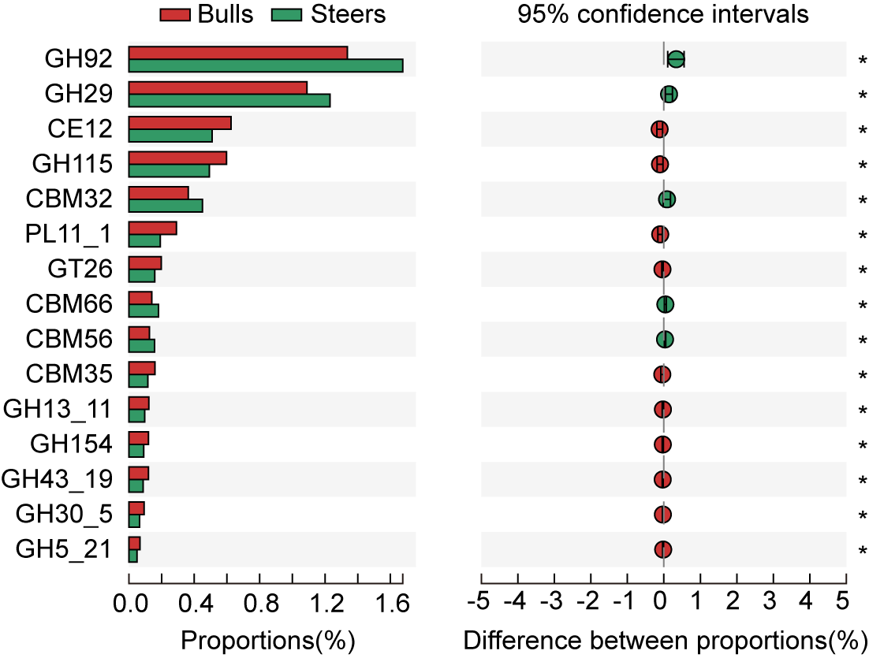
Fig S1 Differential CAZy functional profiles at the family-level in the rumen
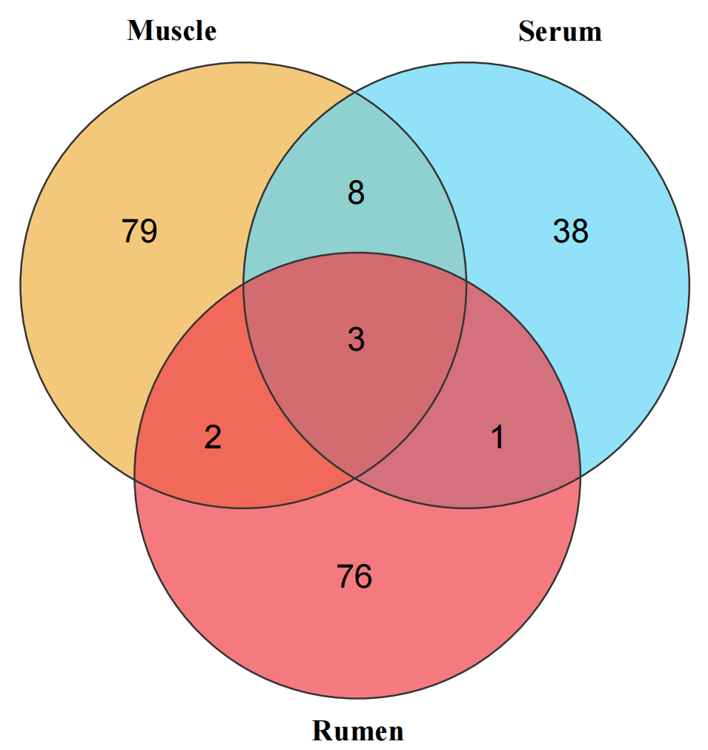
Fig S2 Venn diagram of muscle, serum, and rumen metabolites
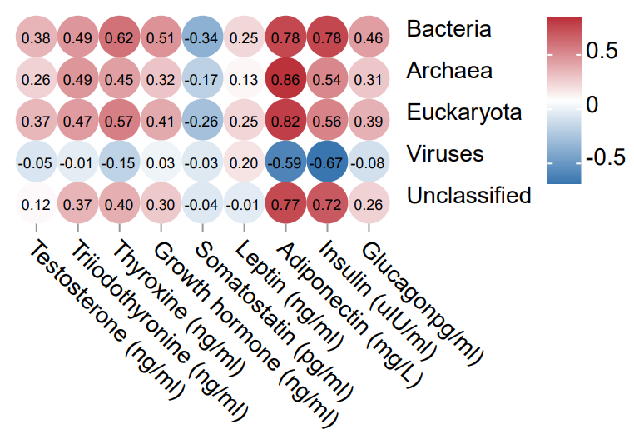
Fig S3 Correlation analysis between domain level microbial abundance and hormone concentration
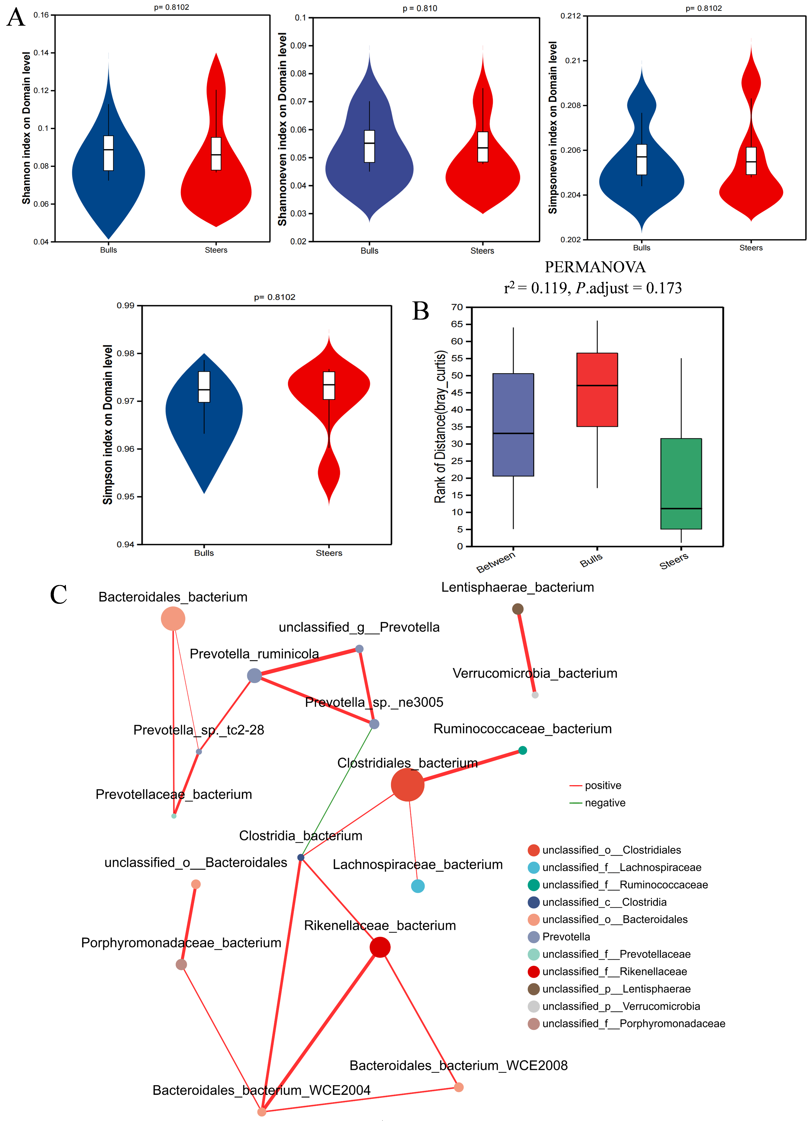
Fig S4 Rumen microbial diversity analysis (n = 6)
A. α diversity; B. β diversity statistical significance (PERMANOVA); C. The Network analyses of top20 rumen microorganisms at the species level.

