Annex-1
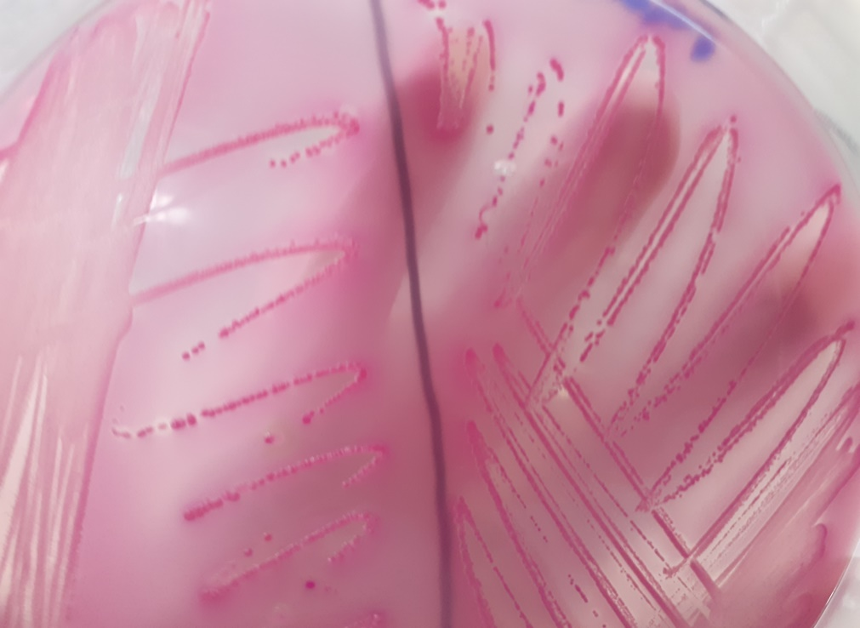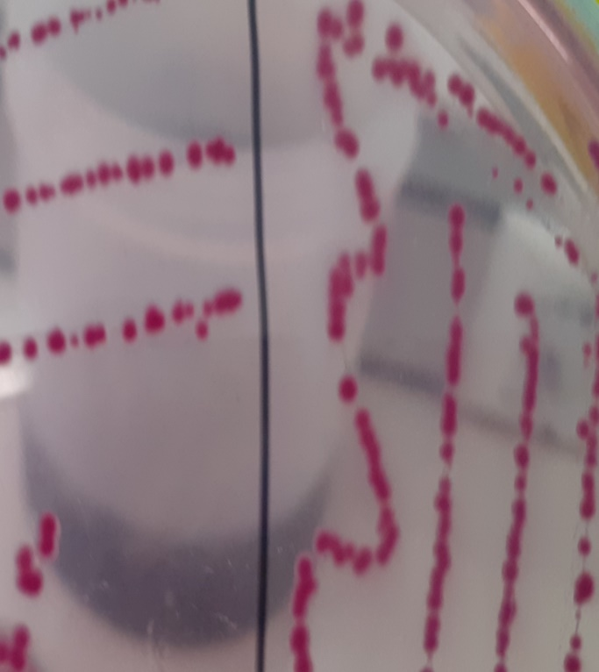

Figure 1: E.coli on MacConkey and SMAC agar (MacConkey left, SMAC right)
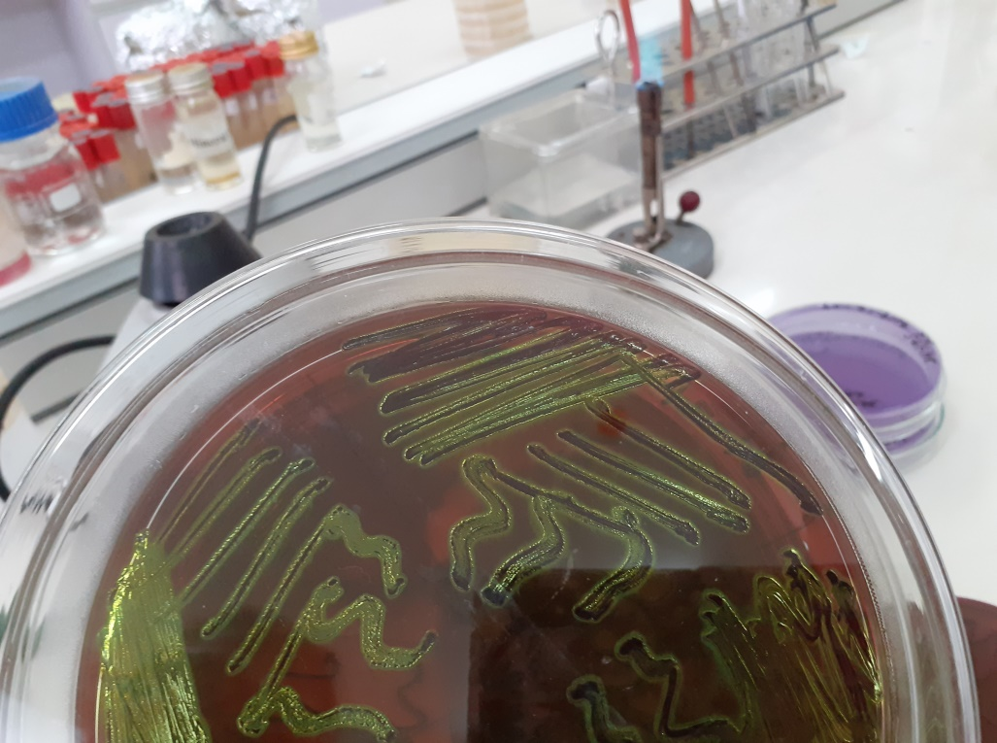
Figure 2: E.coli growth characteristics on EMB agar
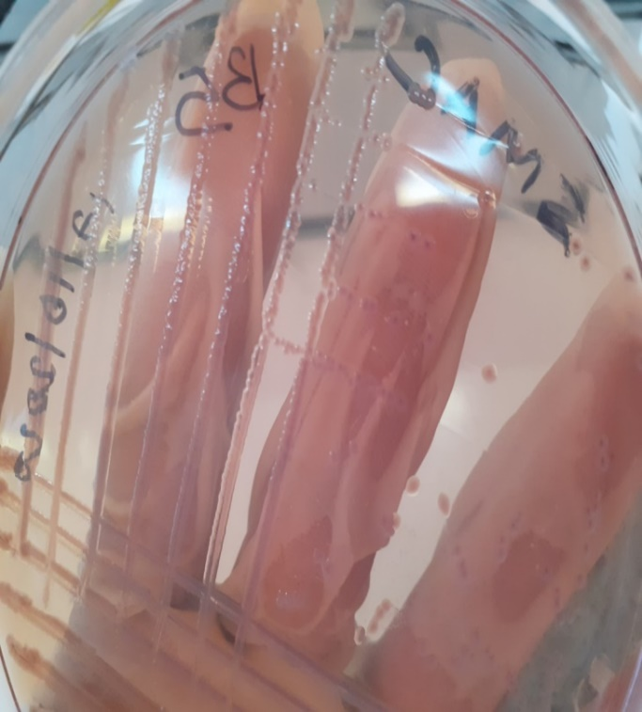
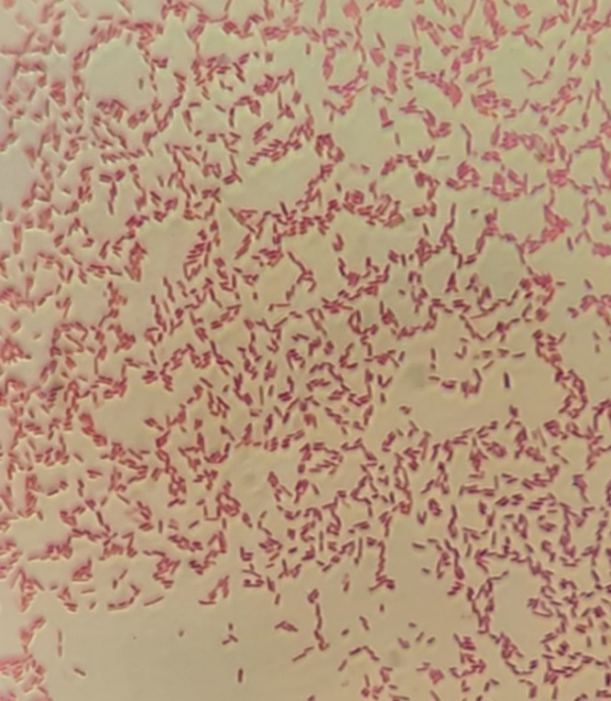
Figure 3: E.coli 0157:H7 on SMAC agar Figure 7: Gram stain for E.coli(pink, short rod)
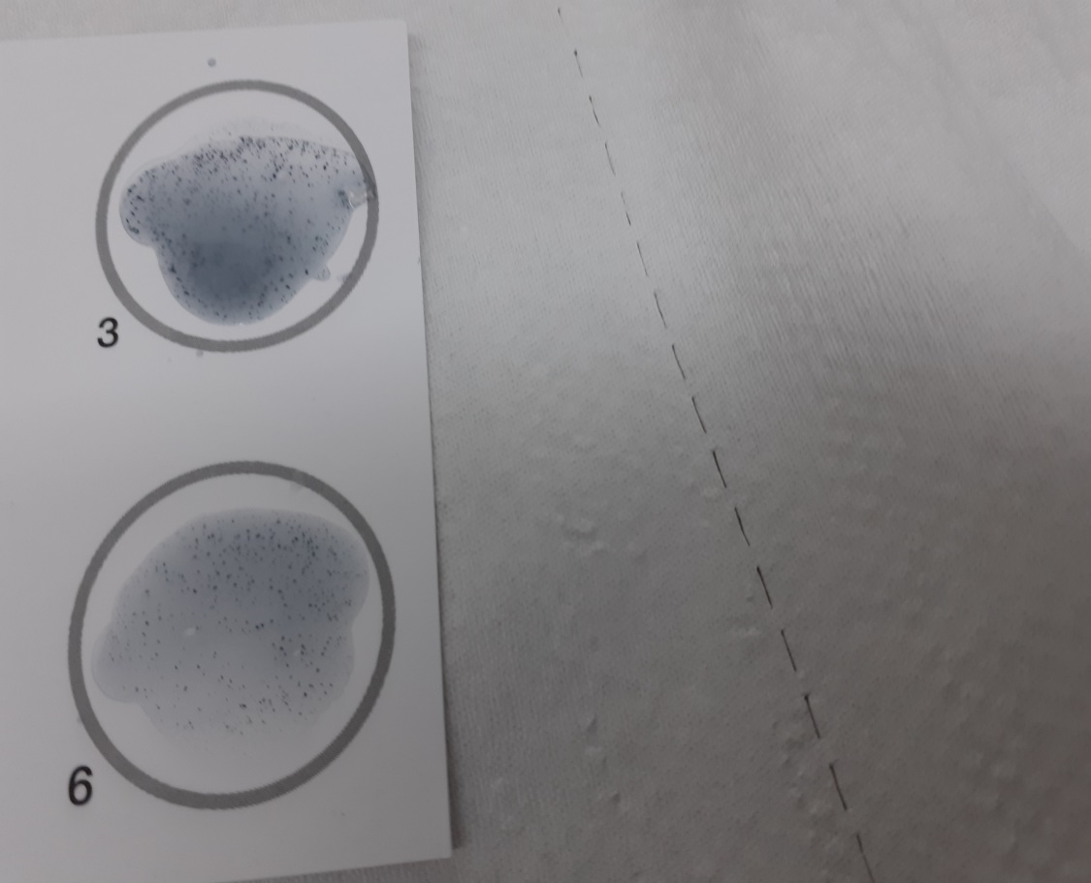

No. 3. Agglutination test for 0157 antigen

No. 6. Agglutination test for H7 antigen

Figure 4: Latex agglutination test for E.coli 0157 and H7 antigens
Annex-2
Annex 3: Questionnaire

Section I. Questionnaire for slaughter house workers to assess their knowledge and hygienic Practices at the Abattoir

Date________________________
Questionnaire code ______________________
Respondent Name: ______________ Sex ______________ Age _______________
Educational Status 1) Illiterate 2) Primary education 3) Secondary education 4) Informal education 5) Other (specify) ________________________________
Role at the abattoir? 1) Veterinarian /meat inspector 2) Butcher 3) Other (specify)
Duration of working in the abattoir ___________________
S. No | Question | Response | Skip to
1. | Do you have any awareness about food borne disease? | 1. Yes [ ] 2. No [ ]  If No skip | /______/
2. | What could be the possible ways that people could acquire food borne disease? | 1. Through contaminated food  2. Through canned food  3. Through contaminated water  4. If other, specify | /______/
3. | Do you have any awareness about carcass contamination? | 1. Yes [ ] 2. No [ ]  If No skip | /______/
4. | If Yes, What do you think is the cause for cattle carcass contamination? | 1. Dirty working area  2. Dirty utensils  3.Workers dirty hands and clothing  4. Cattle hide during flaying  5. Faeces due to accidental GIT puncture  6. Dirty(contaminated water)  7. If other, specify
 | Do you think carcass contamination could bring serious health problem to consumers? | 1. Yes [ ] 2. No [ ]
6. | Do you always take caution to avoid carcass contamination? | 1. Yes [ ] 2. No [ ] | /______/
7. | Do you wash your hands and the carcass after evisceration? | 1. Yes [ ] 2. No [ ]
8. | Do you regularly wash your working cloth and boots? | 1. Yes [ ] 2. No [ ]
9. | If yes, how frequently you wash your working cloth and boots? | 1. Every day  2. Once per week  3. Twice a week | /______/
10. | What is the source of water for use in the abattoir? | City supplied [ ] borehole [ ] rain collected water [ ] River [ ] others (specify)_____________ | /______/
11. | Did you take any work related medical tests to work at the abattoir? | 1. Yes [ ] 2. No [ ] | /______/
12. | Do you regularly take work related medical checkups? | 1. Yes [ ] 2. No [ ]
13. | Have you ever engaged in any work related training? | 1. Yes [ ] 2. No [ ]

Section II. Practices (slaughter house observation checklist).
Hand washing before touching the carcass? | 1. Yes [ ] 2. No [ ]
How washed? | 1. Running water [ ] 2. Bucket [ ]
All knives are completely clean and free from contamination | 1. Yes [ ] 2. No [ ]
Method of carcass dressing? | 1. Hanging [ ] 2. On the floor [ ] 3. Mixed [ ]
Carcass and GIT content kept separately | 1. Yes [ ] 2. No [ ]
Finger nails short and clean | 1. Yes [ ] 2. No [ ]
Eating while working | 1. Yes [ ] 2. No [ ]
Strict separation between clean and dirty areas | 1. Yes [ ] 2. No [ ]
Clothes free from faecal contamination | 1. Yes [ ] 2. No [ ]
Latrine available? | 1. Yes [ ] 2. No [ ]
Latrine has adequate water supply and soap for hand washing? | 1. Yes [ ] 2. No [ ]
Veterinary inspectors present to examine and pass carcass for consumption | 1. Yes [ ] 2. No [ ]
Use vehicle to deliver carcass to butcher houses | 1. Yes [ ] 2. No [ ]

Section III. Questionnaire for meat handlers on hygienic practices at retail shops
Date________________________
Questionnaire code ______________________
Respondent Name: _____________ Sex_______________ Age _________________
Educational Status 1) Illiterate 2) Primary education 3) Secondary education 4) Informal education 5) Other (specify) ________________________________

S. No | Question | Response
1. | After being received from the abattoir/after slaughter, will the meat be put directly at the display cabinet in the butcher shop?
2. | Do the meat left open or covered? | 1. Open 2. Covered
3. | If covered, what is the material that you use for covering? | 1. Plastic 2. Leaf 3. Other
4. | Is there regular cleaning of the butcher house, display cabinet and hooks? | 1. Yes [ ] 2. No [ ]
5. | If yes, what do you use for cleaning? | 1. Only water 2. Water and soap
6. | Do you regularly wash your working gown and head cover? | 1. Yes [ ] 2. No [ ]
7. | If Yes, how often? | A. Daily B. Once a week C. Twice a week
8. | Do you collect money while working? | 1. Yes [ ] 2. No [ ]
9. | Do you always wash your hands with soap before touching meat? | 1. Yes [ ] 2. No [ ]
10. | Do you regularly clean butcher house equipment’s and surfaces such as knife, axe and cutting board? | 1. Yes [ ] 2. No [ ]
11. | If Yes how frequently? | A. Once per day in the morning  B. Twice per day, in the morning and afternoon  C. Three times a day, in the morning, afternoon and evening  D. Other(specify)
12. | What do you use for cleaning of the equipment’s and surfaces in the butcher house? | 1. Water only 2. Water and soap
13. | What is the source of the water that you use in the butcher house? | A. City supplied B. Borehole C. Rain collected water  D. Others (specify)
14. | Do you have a refrigerator for storage of the meat that has not been sold for the day? | 1. Yes [ ] 2. No [ ]
15. | Do you protect the meat from flies? | 1. Yes [ ] 2. No [ ]
16. | If Yes, what method do you use for protection? | 1. Leaf 2. Thorough cleaning 3. Smoking
17. | What material do you use for wrapping of meat during sale? | A.Newspaper B.Plastic C.Other(specify)
18. | Do you make sure that the wrapping material you use is clean enough? | 1. Yes [ ] 2. No [ ]
19. | Do you use the same equipment for handing meat and offal? | 1. Yes [ ] 2. No [ ]
20. | Have you ever received training on food borne disease? | 1. Yes [ ] 2. No [ ]
21. | Have you ever received training on hygienic handling of meat? | 1. Yes [ ] 2. No [ ]
22. | Did you take medical test before being employed at the butchery house? | 1. Yes [ ] 2. No [ ]
23. | Do you regularly take medical checkups? | 1. Yes [ ] 2. No [ ]
24. | If Yes, how frequently? | A.Once/year B. Every 6 month  C. Every 3 month

Section IV. Questionnaire designed for diarrheic patients.
Date _____________________ Questionnaire code___________________
1. Age____________________
2. Sex ____________________
3. Address ________________
4. Did you eat raw meat for the last one week? 1. Yes [ ] 2. No [ ]
5. If No, what other food did you consume for the last one week?
A. Raw vegetable B. Raw milk C. Other (specify)
6. If yes, from where you got it?
A. Butcheries of Sebeta town B. backyard slaughter C. Other (specify)
7. What type of meat is it?
A. Beef B. Mutton C. Chevon D. Other (specify)
8. Duration of onset of diarrhea? A. A day before B. 2 days before C. 3 days before D. Other (specify)
9. Do you have an additional symptom? 1. Yes [ ] 2. No [ ]
10. If yes state the symptom? ____________________________________________________
Assessment of other possible risk factors
1. Do you have cattle? 1. Yes [ ] 2. No [ ]
2. If Yes, Do you manage their barn and did you have any contact with their faeces recently?
2. Did you have direct contact with a person with diarrhea for the last one week? Yes [ ] 2. No [ ]
3. If your answer is Yes, state how?_________________________________________________

New refrences
Bosilevac, J. M., Katz, T. S., Arthur, T. M., Kalchayanand, N., & Wheeler, T. L. (2024). Proportions and Serogroups of Enterohemorrhagic Shiga Toxin-producing Escherichia coli in Feces of Fed and Cull Beef and Cull Dairy Cattle at Harvest. Journal of Food Protection, 100273. https://doi.org/10.1016/j.jfp.2024.100273
Reis, J. O. dos, Teixeira, L. A. C., Neto, A. da C., Castro, V. S., & Figueiredo, E. E. de S. (2024). Listeria monocytogenes in beef: A hidden risk. Research in Microbiology, 104215. https://doi.org/10.1016/j.resmic.2024.104215
Liuzzo, G., Riu, R., Merialdi, G., Bardasi, L., Galletti, G., Carra, E., Rosmini, R., Giacometti, F., Pizzamiglio, V., & Serraino, A. (2011). Indicator and pathogenic microorganisms contamination of hide of cattle presented to for slaughter and contamination of the resultant carcasses. Italian Journal of Food Safety, 1, 121. https://doi.org/10.4081/IJFS.2011.1S.121
Tarekegn AA, Mitiku BA, Alemu YF. Escherichia coli O157: H7 beef carcass contamination and its antibiotic resistance in Awi Zone, Northwest Ethiopia. Food Science & Nutrition. 2023 Oct;11(10):6140-50
Kiranmayi, Ch. B., Krishnaiah, N., & Mallika, E. N. (2010). Escherichia coli O157:H7 - An Emerging Pathogen in foods of Animal Origin. Veterinary World, 3(8), 382–389. https://doi.org/10.5455/VETWORLD.2010.382-389.
Smith, J. R., Jones, A. B., & Williams, C. D. (2020). Quantitative risk assessment of Escherichia coli O157:H7 in contaminated raw beef products and consumer exposure. International Journal of Food Microbiology, 315, 108421. [DOI: 10.1016/j.ijfoodmicro.2020.108421]
Centers for Disease Control and Prevention. (2021). National Outbreak Reporting System (NORS) Dashboard. U.S. Department of Health and Human Services. Retrieved from [Insert actual CDC NORS dashboard URL here, e.g., https://wwwn.cdc.gov/norsdashboard/]
Bell, R. L., & Chapman, P. A. (2016). Escherichia coli O157:H7 in beef production and processing: A review of sources, prevention, and control. Food Control, 65, 1–13. DOI: 10.1016/j.foodcont.2016.03.012
Greer, G. G., Gill, C. O., & Yost, L. L. (2007). Microbiological conditions of beef carcasses entering a commercial abattoir. Journal of Food Protection, 70(8), 1888–1894. DOI: 10.4315/0362-028X-70.8.1888.
Matos, V. de S. R., Gomes, A. P. P., Santos, V. A. dos, Freitas, F., & Silva, I. de M. M. da. (n.d.). Perfil Sanitário Da Carne Bovina in Natura Comercializada Em Supermercados. https://doi.org/10.53393/rial.2012.71.32411
Little. The microbiological examination of butchery products and butchers’ premises in the United Kingdom. Journal of Applied Microbiology. 1998 Jul 1;85(1):177-86.
Kago JM. Assessment of beef carcass contamination with escherichia coli 0157: h7 post slaughter in Kenya (Doctoral dissertation, University of Nairobi).
Velebit, B., Lakicevic, B., Semenova, A., Revutskaya, N. M., Yushina, Yu. K., & Nasonova, V. V. (2021). Factors influencingmicrobial transmission in a meat processing plant. 6(2), 183–190. https://doi.org/10.21323/2414-438X-2021-6-2-183-190
Davies J, Davies D. Origins and evolution of antibiotic resistance. Microbiology and molecular biology reviews. 2010 Sep;74(3):417-33.
Goossens H, Ferech M, Vander Stichele R, Elseviers M. Outpatient antibiotic use in Europe and association with resistance: a cross-national database study. The Lancet. 2005 Feb 12;365(9459):579-87.

