Table S1 climate and soil characteristics for each site
 | AQ | GQ | HY | JX | TA
Annual precipitation (mm) | 858.7 | 724.5 | 895.1 | 1127.3 | 1035.3
Annual average temperature (℃) | 13.3 | 13.9 | 13.5 | 14 | 14.5
Altitude(m) | 76 | 42 | 15 | 49 | 35
pH | 7.2 | 7.6 | 7.5 | 7.3 | 7.3
EC(μs· cm⁻¹) | 95.6 | 260.3 | 56.7 | 60.2 | 83.9
Total nitrogen(g·kg⁻¹) | 1.02 | 0.98 | 1.06 | 1.15 | 1.13
Total phosphate(g·kg⁻¹) | 0.756 | 0.657 | 0.812 | 0.766 | 0.781
Total potassium(g·kg⁻¹) | 16.6 | 18.7 | 15.9 | 17.1 | 16.2

Table S2 PCR details
 | experiment details
PCR mixtures | The PCR mixtures contained 4 μL of 5x TransStartFastPfu buffer, 2 μL of 2.5 mM dNTPs, 0.8 μL of each primer (5 μM each), 0.4 μL of TransStartFastPfu DNA Polymerase, 10 ng template DNA, adding ddH₂O to a final volume of 20 μL. All reactions were performed in triplicate.
PCR cycling conditions | PCR cycling conditions included an initial denaturation at 95°C for 3 min, 27 cycles of denaturing at 95°C for 30 s, annealing at 55°C for 30 s, and extension at 72°C for 45 s, followed by a single extension at 72°C for 10 min and a continued hold at 4°C.
Data processing | (1) bases with quality scores < 20 were trimmed using a 10-bp sliding window; reads shorter than 50 bp or containing ambiguous N bases were discarded; (2) paired-end sequences were merged with a minimum overlap of 10 bp; (3) the mismatch rate within overlapping regions was capped at 0.2, and non-compliant merged sequences were eliminated. Cleaned sequences were subsequently clustered into operational taxonomic units (OTUs) at a 97% similarity threshold using UPARSE v11, during which chimeric sequences and chloroplast-derived OTUs were removed. Taxonomic classification of representative OTU sequences was performed using the RDP Classifier v2.2 against the 16S rRNA database with a confidence cutoff of 0.7.  The total number of sequences retained after filtering was 1,426,423. To eliminate biases introduced by uneven sequencing depth for subsequent alpha and beta diversity analyses, all samples were rarefied to a uniform depth of 34,513 sequences.

Table S3 Diversity index based on genus
 | sobs | simpson | ace | chao | coverage
AQ_X792 | 613±34.2bc | 0.018±0.0014bc | 689±34.3bc | 695±17.9b | 0.997±0.0001a
GQ_X792 | 616±17.9bc | 0.016±0.0024bc | 684±14.4bc | 684±11.6b | 0.997±0.0001a
GQ_H32 | 639±16.4b | 0.016±0.0033bc | 724±23.3ab | 729±38.3ab | 0.997±0.0003a
HY_H32 | 582±30.7c | 0.019±0.0017bc | 657±28.2c | 671±20.8b | 0.997±0.0003a
HY_X792 | 622±48.0bc | 0.018±0.0039bc | 691±63.2bc | 692±64.4b | 0.997±0.0004a
JX_X792 | 687±28.1a | 0.015±0.0018c | 765±47.3a | 775±64.9a | 0.997±0.0005a
JX_H32 | 625±15.6bc | 0.020±0.0027ab | 702±10.4bc | 707±6.3b | 0.997±0.0001a
TA_X792 | 615±9.5bc | 0.023±0.003a | 686±18.6bc | 688±16.6b | 0.997±0.0003a
TA_H32 | 651±19.6ab | 0.018±0.0012bc | 725±31.6ab | 733±39.0ab | 0.997±0.0004a
p value | 0.012 | 0.036 | 0.048 | 0.075 | 0.731
Data represent mean ± standard deviation (SD) of three biological replicates. Different lowercase letters within a column indicate significant differences (P < 0.05).

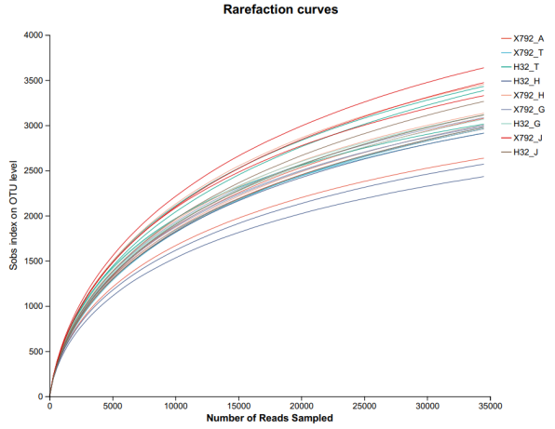
Fig S1 Rarefaction curves

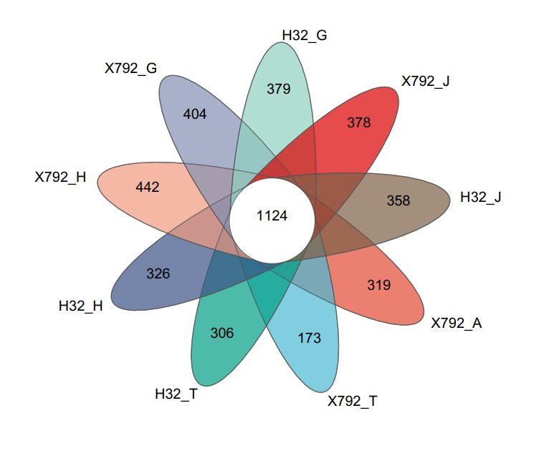
Fig S2 Venn

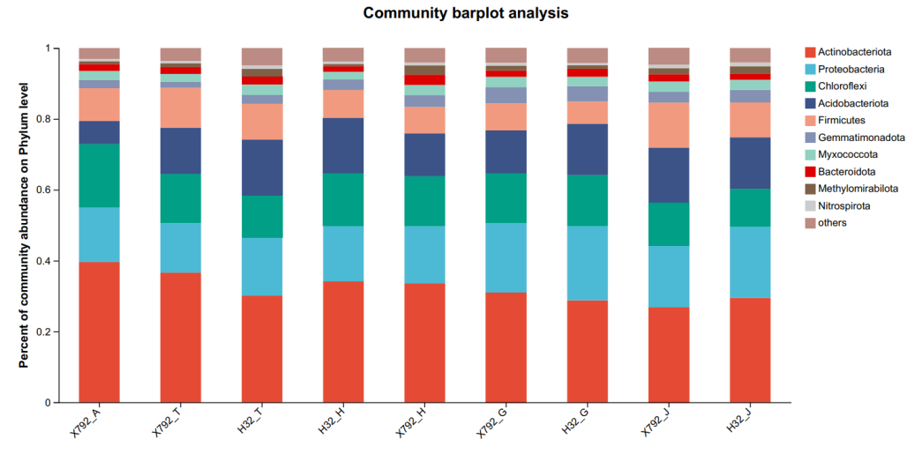
Fig S3 Bar on phylum level
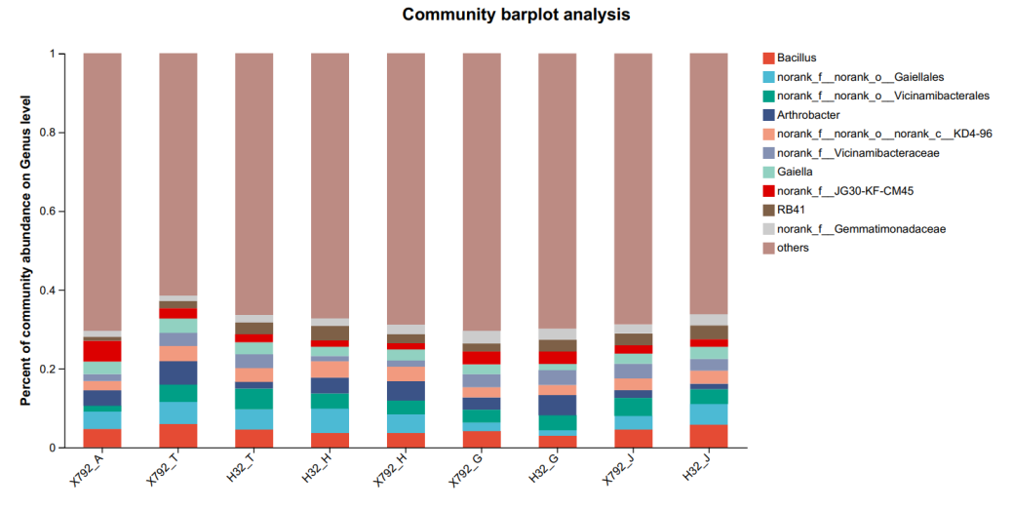
Fig S4 Bar on genus level
Table S4 Dominant genera (%)
 | AQ_X792 | GQ_X792 | GQ_H32 | HY_H32 | HY_X792 | JX_X792 | JX_H32 | TA_X792 | TA_H32
Bacillus | 4.67±1.1 | 4.11±1.84 | 2.95±0.82 | 3.66±0.63 | 3.76±1.24 | 4.5±0.66 | 5.87±3.22 | 6.08±2 | 4.55±1.13
norank_f__norank_o__Gaiellales | 4.43±1.25 | 2.19±0.4 | 1.46±0.5 | 6.17±0.74 | 4.77±2.33 | 3.46±0.88 | 5.12±1.83 | 5.44±0.92 | 5.08±0.66
norank_f__norank_o__Vicinamibacterales | 1.44±1.13 | 3.27±2.64 | 3.72±0.81 | 3.86±1.84 | 3.35±0.47 | 4.59±0.67 | 3.77±1.79 | 4.47±1.26 | 5.29±1.66
Arthrobacter | 3.94±1.93 | 3.11±1.11 | 5.15±3.92 | 4.02±1.25 | 4.93±1.86 | 1.97±0.36 | 1.39±0.75 | 5.86±3.77 | 1.82±0.58
norank_f__JG30-KF-CM45 | 5.28±0.53 | 3.28±1.04 | 3.28±0.74 | 1.66±0.36 | 1.56±0.42 | 2.15±0.41 | 1.92±0.63 | 2.62±0.79 | 2.06±0.51
Table S5 PERMANOVA analysis
Characteristics | SumsOfSqs | MeanSqs | F_Model | R2 | p value
Varieties | 0.15135 | 0.15135 | 2.51948 | 0.04799 | 0.019
Regions | 1.74098 | 0.43524 | 7.24527 | 0.55201 | 0.001
Residuals | 1.26153 | 0.06007 | 0 | 0.4 | 0
Total | 3.15386 | 0 | 0 | 1 | 0

Tabe S6 Zi-Pi analysis
 | X792 | H32 | HY | GQ | TA | JX | AQ
Module hubs |  |  |  | unclassified_c__Actinobacteria | Microbacterium
Connectors | Rubrobacter | RB41 | Rubrobacter | unclassified_f__Comamonadaceae | norank_f__Roseiflexaceae | norank_f__Roseiflexaceae | Microbacterium
 | norank_f__Xanthobacteraceae | Bradyrhizobium | norank_f__Anaerolineaceae | Pedomicrobium | norank_f__norank_o__norank_c__Subgroup_11 | norank_f__norank_o__Azospirillales
 | norank_f__Sandaracinaceae | Asanoa | Tumebacillus | norank_f__Gemmatimonadaceae | norank_f__A4b | norank_f__Anaerolineaceae
 | norank_f__norank_o__Rokubacteriales |  | unclassified_o__Acidobacteriales | Catellatospora |  | Nitrospira
 | norank_f__norank_o__norank_c__JG30-KF-CM66 |  | norank_f__norank_o__norank_c__JG30-KF-CM66 |  |  | Arthrobacter
 | norank_f__norank_o__Microtrichales |  | norank_f__norank_o__0319-6G20
 | norank_f__norank_o__IMCC26256 |  | unclassified_f__Gemmatimonadaceae
 | norank_f__AKYG1722 |  | Mycobacterium
 | Iamia |  | Candidatus_Solibacter
 | Haliangium

Table S7 Nodes
Top 50 | Node numbers | Edge numbers | Node average degree | Positive edges | Negative edges
H32 | 49 | 210 | 8.57 | 104 | 106
X792 | 50 | 271 | 10.84 | 138 | 133
Table S8 Two-factor variance analysis of variety × habitat
 |  | Interaction | Habitat | Variety
EC | Contribution rate (%) | 3.66 | 74.66 | 0.44
EC | Significance | ns | **** | ns
pH | Contribution rate (%) | 8.15 | 68.20 | 9.60
pH | Significance | ns | **** | **
K | Contribution rate (%) | 40.18 | 46.45 | 10.42
K | Significance | **** | **** | ****
Na | Contribution rate (%) | 12.04 | 86.61 | 0.28
Na | Significance | **** | **** | ns
NH⁴⁺-N | Contribution rate (%) | 6.52 | 89.51 | 0.08
NH⁴⁺-N | Significance | ** | **** | ns
NO³⁻-N | Contribution rate (%) | 44.12 | 13.78 | 15.92
NO³⁻-N | Significance | ** | ns | **
PO₄³⁻-P | Contribution rate (%) | 43.80 | 40.71 | 9.69
PO₄³⁻-P | Significance | **** | **** | ****
OC | Contribution rate (%) | 0.53 | 75.03 | 0.04
OC | Significance | ns | **** | ns
Ca_S | Contribution rate (%) | 0.25 | 98.29 | 0.03
Ca_S | Significance | ns | **** | ns
Ca_l | Contribution rate (%) | 5.17 | 82.28 | 0.00
Ca_l | Significance | ns | **** | ns
TP | Contribution rate (%) | 66.48 | 11.62 | 7.48
TP | Significance | **** | * | *
Crude protein | Contribution rate (%) | 27.29 | 14.55 | 0.77
Crude protein | Significance | ns | ns | ns
Crude fat | Contribution rate (%) | 6.71 | 79.30 | 0.12
Crude fat | Significance | ns | **** | ns
Crude fiber | Contribution rate (%) | 7.75 | 66.25 | 1.48
Crude fiber | Significance | ns | **** | ns
Crude ash | Contribution rate (%) | 1.45 | 77.85 | 2.29
Crude ash | Significance | ns | **** | ns
Crude polysaccharide | Contribution rate (%) | 48.83 | 7.19 | 21.23
Crude polysaccharide | Significance | *** | ns | **
Lignin | Contribution rate (%) | 0.55 | 92.77 | 0.68
Lignin | Significance | ns | **** | ns
Cellulose | Contribution rate (%) | 6.07 | 65.16 | 1.85
Cellulose | Significance | ns | *** | ns
Hemicellulose | Contribution rate (%) | 13.19 | 54.90 | 0.02
Hemicellulose | Significance | ns | *** | ns
sobs | Contribution rate (%) | 42.65 | 26.10 | 5.88
sobs | Significance | ** | ** | ns
shannon | Contribution rate (%) | 53.79 | 18.68 | 2.36
shannon | Significance | *** | * | ns
coverage | Contribution rate (%) | 19.03 | 33.88 | 2.64
coverage | Significance | ns | * | ns

