Additional File 2: Large-scale genome analysis of Listeria monocytogenes from Austrian food producers reveals differences in accessory genome dynamics and phage integration in persistent genomes
Lauren V. Alteio, Julia Steger, Felix Spiegel, Martin Wagner, Werner Ruppitsch, Ariane Pietzka, Kathrin Rychli

Table S1. Sensitivity analysis to assess the influence of short contigs (< 500 bp) on Panaroo results.
 | Panaroo results without filtering | Panaroo results post-filtering
Core genes (99% <= strains <= 100%) | 2775 | 2776
Soft core genes (95% <= strains < 99%) | 20 | 17
Shell genes 15% <= strains < 95%) | 12 | 12
Cloud genes (0% <= strains < 15%) | 4 | 1
Total genes (0% <= strains <= 100%) | 2811 | 2806

Table S2. R-Script used to categorize isolate genomes as persistent and non-persistent based on Company, ST, cgMLST, number of repeated isolates and SNP differences across the whole genome.
#Iterate through each unique company, ST and CT type
```{r}
# Initialize an empty list to store results
results_list <- list()

#Make an empty list to store the errors
error_log <- list()

# Define parent directory for all companies
parent_dir <- “//Genome_Analysis/SNP_Classification/"

# List all company directories
company_dirs <- list.dirs(parent_dir, recursive = FALSE)

# Find intersection between metadata assemblies and SNP matrix isolates
isolate_ids <- intersect(subset_metadata$Assembly, rownames(snp_matrix))

# Loop over each company directory
for (company_dir in company_dirs) {
# Extract company name from directory path
company <- basename(company_dir)

# List all SNP matrix and tree files in the directory
snp_files <- list.files(company_dir, pattern = "snp_distance_matrix_preserved.*\\.tsv$", full.names = TRUE)

# Process each SNP file
for (snp_file in snp_files) {
tryCatch({
# Extract ST and CT identifiers from file name
st_id <- str_extract(snp_file, "ST\\d+") %>% str_remove("ST")
ct_id <- str_extract(snp_file, "CT\\d+") %>% str_remove("CT")

# Subset metadata for the current ST, CT, and company
subset_metadata <- metadata %>%
filter(ST == st_id, CT == ct_id, Company_Code == company)

# Skip if no metadata for this combination
if (nrow(subset_metadata) == 0) {
warning(paste("No matching metadata found for ST:", st_id, "CT:", ct_id, "Company:", company))
next
}

# Load the SNP distance matrix
#snp_matrix <- read_tsv(snp_file, show_col_types = FALSE)
snp_matrix <- read.delim(snp_file, row.names = 1, check.names = FALSE)

# Subset SNP matrix to isolates in the metadata subset
#isolate_ids <- subset_metadata$Assembly
# Find intersection between metadata assemblies and SNP matrix isolate IDs
isolate_ids <- intersect(subset_metadata$Assembly, colnames(snp_matrix))

# Skip if no common isolates
if (length(isolate_ids) == 0) {
warning(paste("No overlap between SNP matrix and metadata for ST:", st_id, "CT:", ct_id, "Company:", company))
next
}

filtered_snp_matrix <- snp_matrix[isolate_ids, isolate_ids, drop = FALSE]

# Skip if filtered SNP matrix is empty
if (nrow(filtered_snp_matrix) == 0 || ncol(filtered_snp_matrix) == 0) {
warning(paste("Filtered SNP matrix is empty for ST:", st_id, "CT:", ct_id, "Company:", company))
next
}

# Perform clustering based on SNP distances (≤ 10 SNPs)
snp_clusters <- hclust(as.dist(filtered_snp_matrix)) # Hierarchical clustering
cluster_groups <- cutree(snp_clusters, h = 10) # Define clusters with ≤ 10 SNPs

# Assign clusters back to the subset metadata
subset_metadata <- subset_metadata %>%
mutate(Cluster = cluster_groups[match(Assembly, names(cluster_groups))])

persistent_clusters <- subset_metadata %>%
group_by(Cluster) %>%
mutate(distinct_years = n_distinct(Year_Isolated)) %>%
filter(distinct_years >= 3) %>% # At least 3 distinct calendar years
summarize(Isolates = list(Assembly), .groups = "drop")

# Annotate Persistence
subset_metadata <- subset_metadata %>%
mutate(Persistence = ifelse(Assembly %in% unlist(persistent_clusters$Isolates),
"Persistent", "Non-Persistent"))

# Save Results for the Current Subset
results_list[[paste0(company, "_ST", st_id, "_CT", ct_id)]] <- subset_metadata
}, error = function(e) {
# Log errors and print them
error_log[[paste0(company, "_ST", st_id, "_CT", ct_id)]] <- e$message
cat("Error in file processing for Company:", company, "ST:", st_id, "CT:", ct_id, "\n")
cat("Error message:", e$message, "\n")
})
}
}

# Check the error log after the loop
if (length(error_log) > 0) {
cat("The following datasets caused errors:\n")
print(names(error_log))
}

```

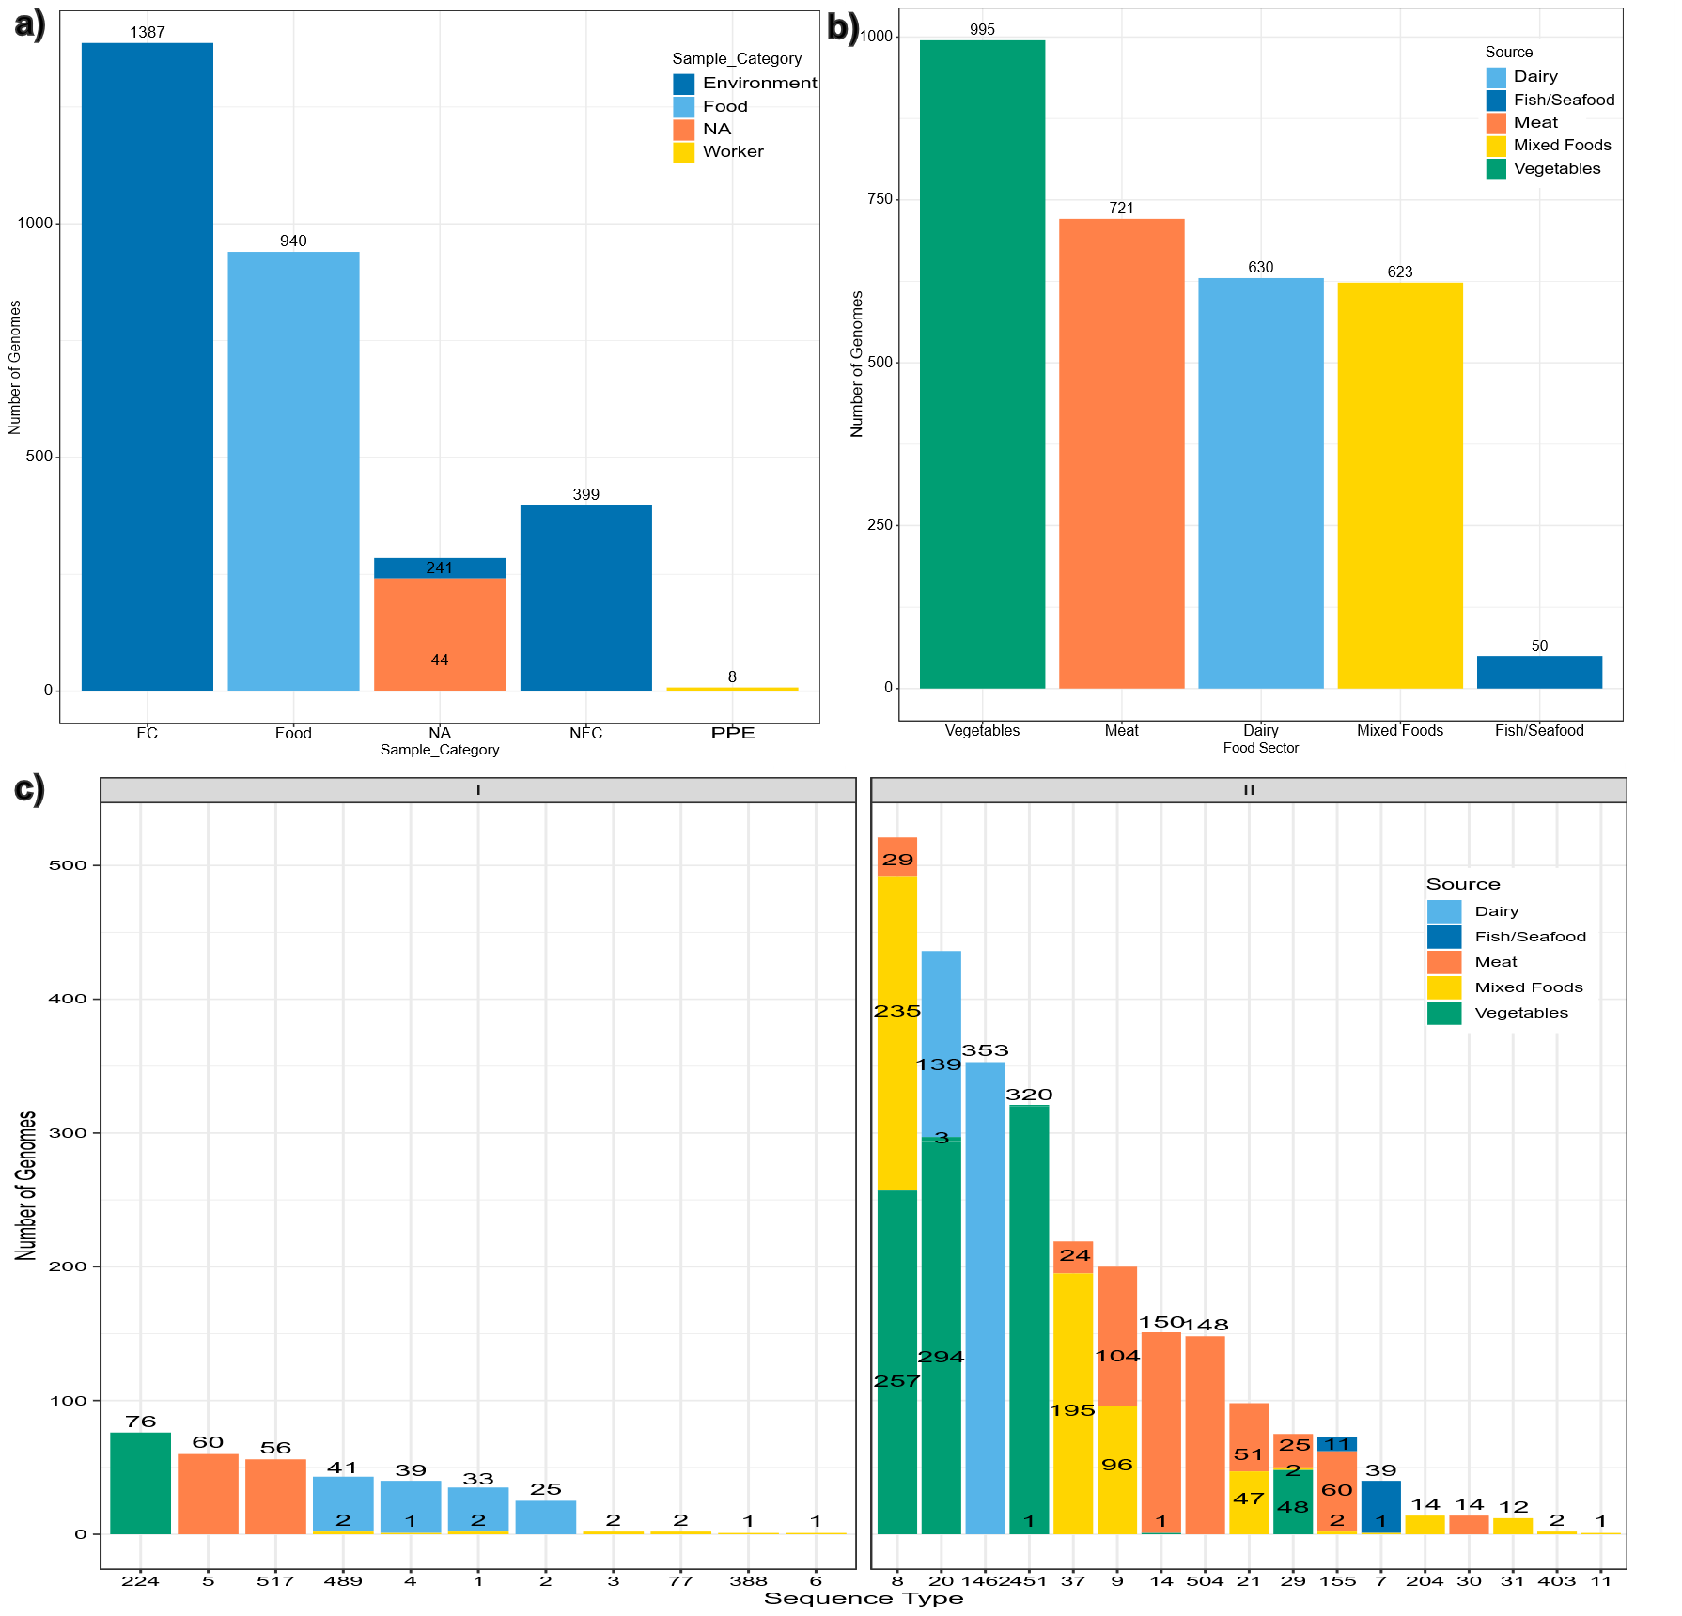
Figure S1. Overview of isolate genomes analyzed in this study. (a) Sample category and surface type for all food- and environmental-associated isolate genomes. “FC” refers to “Food Contact”, “NA” to “Not Applicable” where no source attribution was connected to the isolate, “NFC” refers to “Non-Food Contact”, and “PPE” refers to “Personal Protective Equipment”. (b) Sample food sector and sample category for all food- and environmental-associated isolate genomes. (c) Number of isolates from each sequence type for all food and environmental isolate genomes. Color indicates the sample food sector.

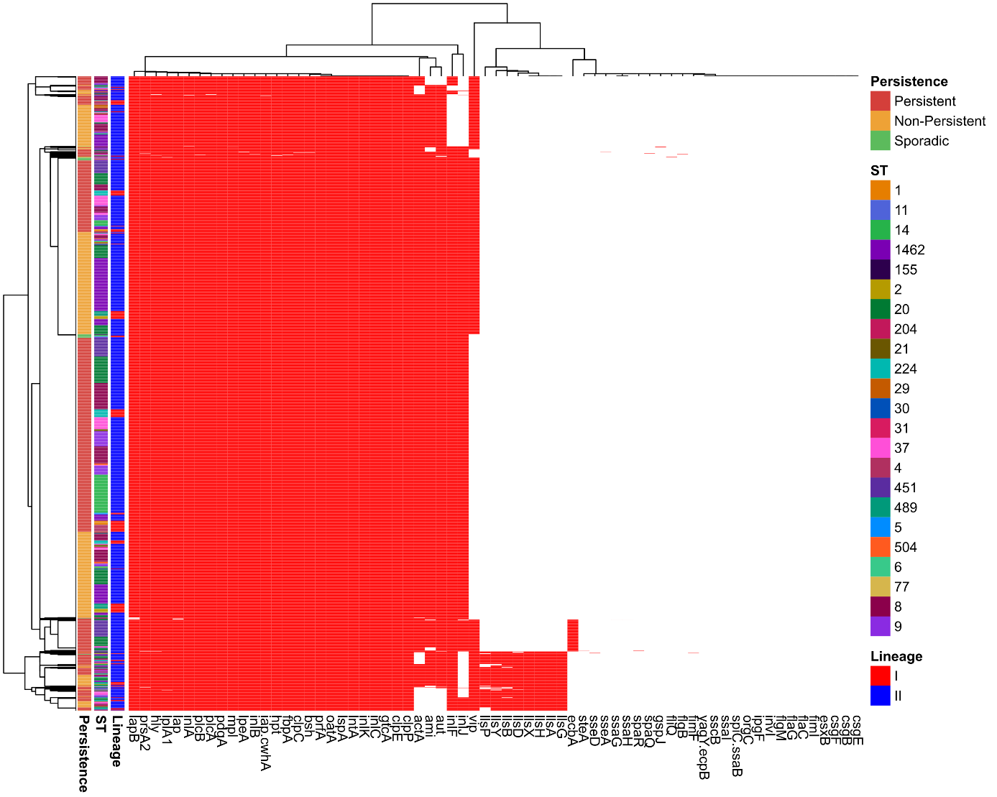
Figure S2. Overview of virulence-associated genes across environmental isolates. Virulence associated genes screened using ABRicate against the VFDB database. Hierarchical clustering is grouped by lineage (I or II), ST, and Persistence classification (persistent, non-persistent, sporadic).

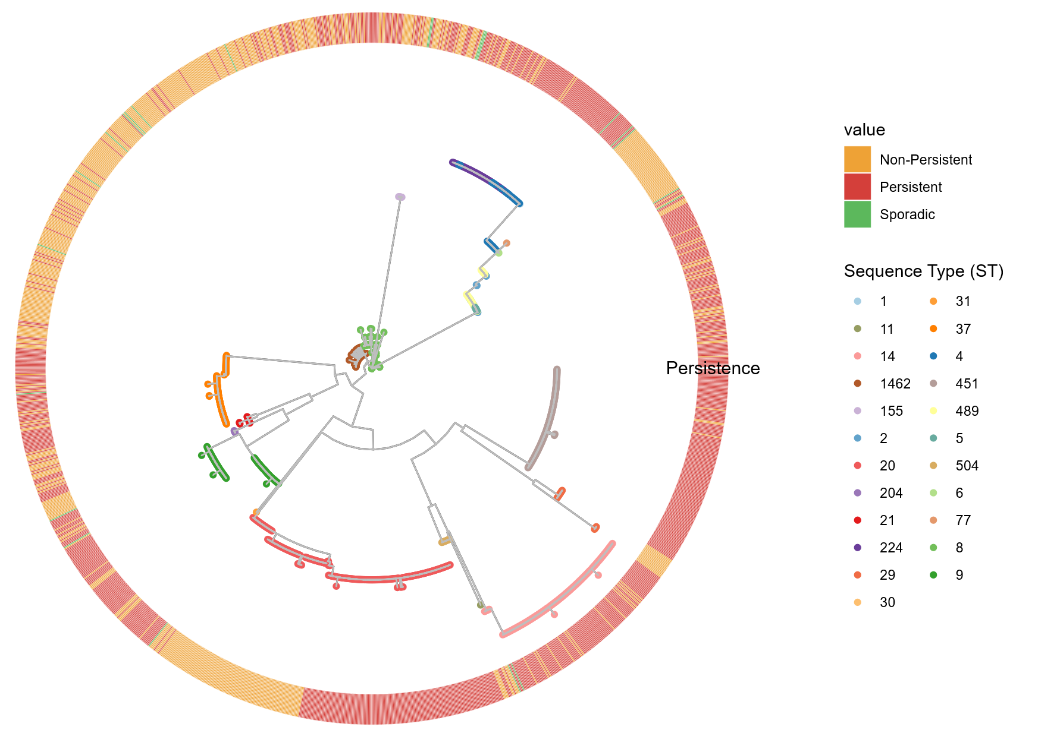

Figure S3. Phylogenetic tree based on whole genome SNP distance for all isolates from the food processing environment and worker personal protective equipment (PPE). Isolate STs are depicted at each node. Persistence classification for each isolate is shown in the heatmap bar around the tree. The tree is rooted with internal reference MRL-18-01751.

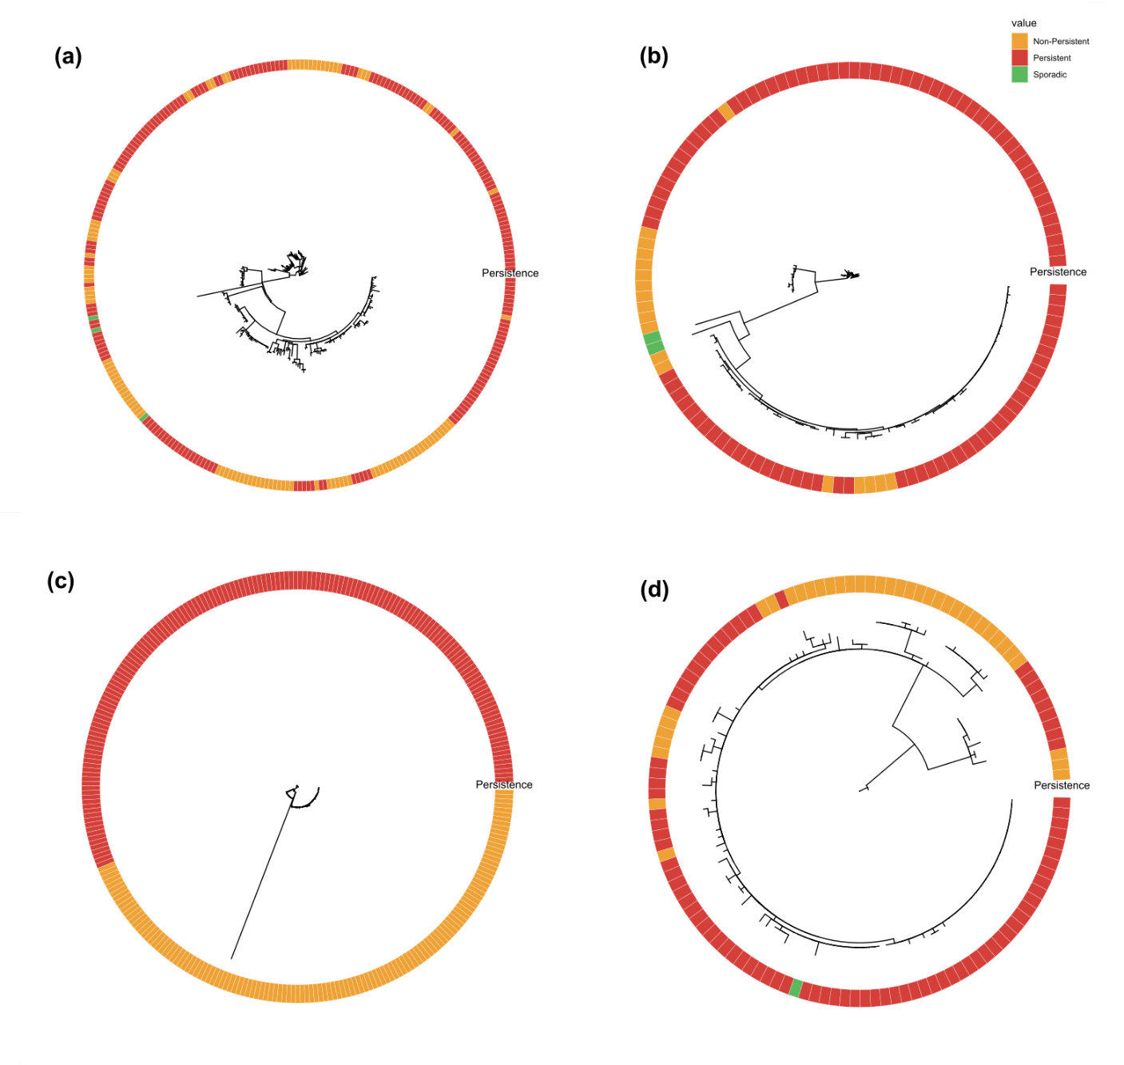
Figure S4. Phylogenetic trees based on whole genome SNP distance environment and worker PPE-derived isolates from (a) ST8, (b) ST9, (c) ST20, and (d) ST37. Persistence status for each of the isolates is shown in the colored heatmap around the tree. Trees are rooted with internal references including MRL-18-02061 for ST8, MRL-19-01240 for ST9, MRL-18-01750 for ST20, and MRL-18-01570 for ST37.

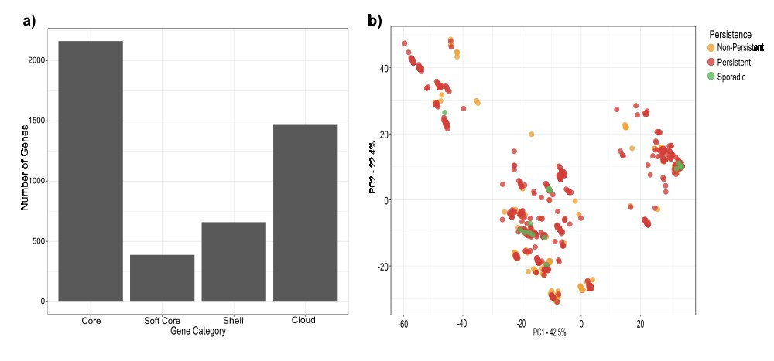
Figure S5. Pangenome analysis and Principal component analysis (PCA) of all environmental L. monocytogenes genomes. (a) Number of genes comprising the core and accessory genome of all environmental isolate genomes (n=1,699) including genes classified as “Cloud”, “Hard Core”, “Shell” and “Soft Core”. (b) PCA cluster analysis of all environmental isolate genomes.

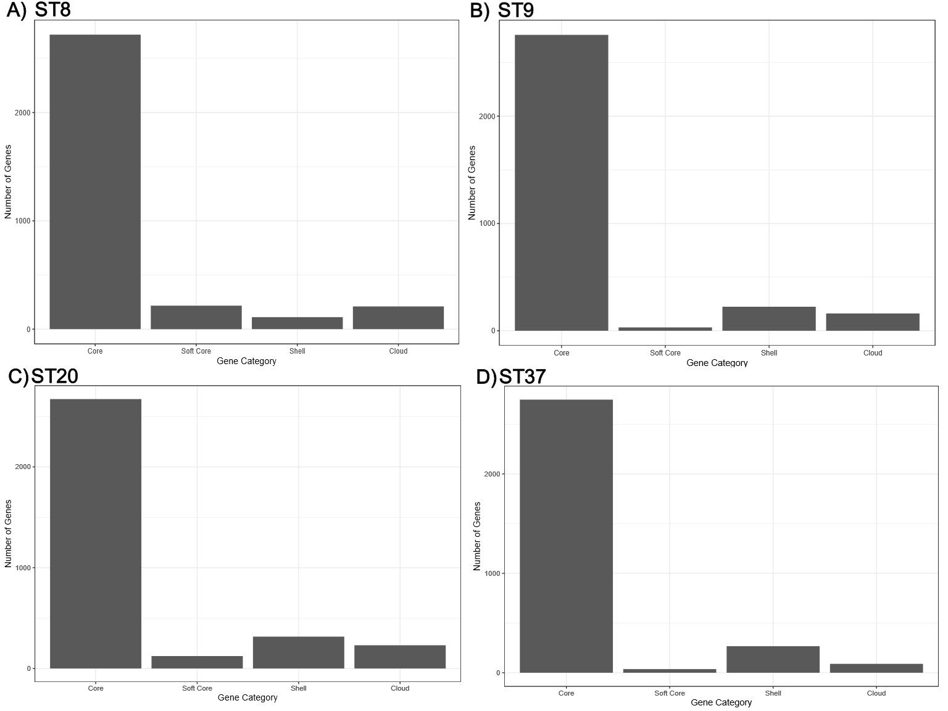 Figure S6. Number of genes in the “Core”, “Soft Core”, “Shell” and “Cloud” categories based on pangenome analysis with Panaroo. Pangenome results are shown for A) ST8, B) ST9, C) ST20, and D) ST37.

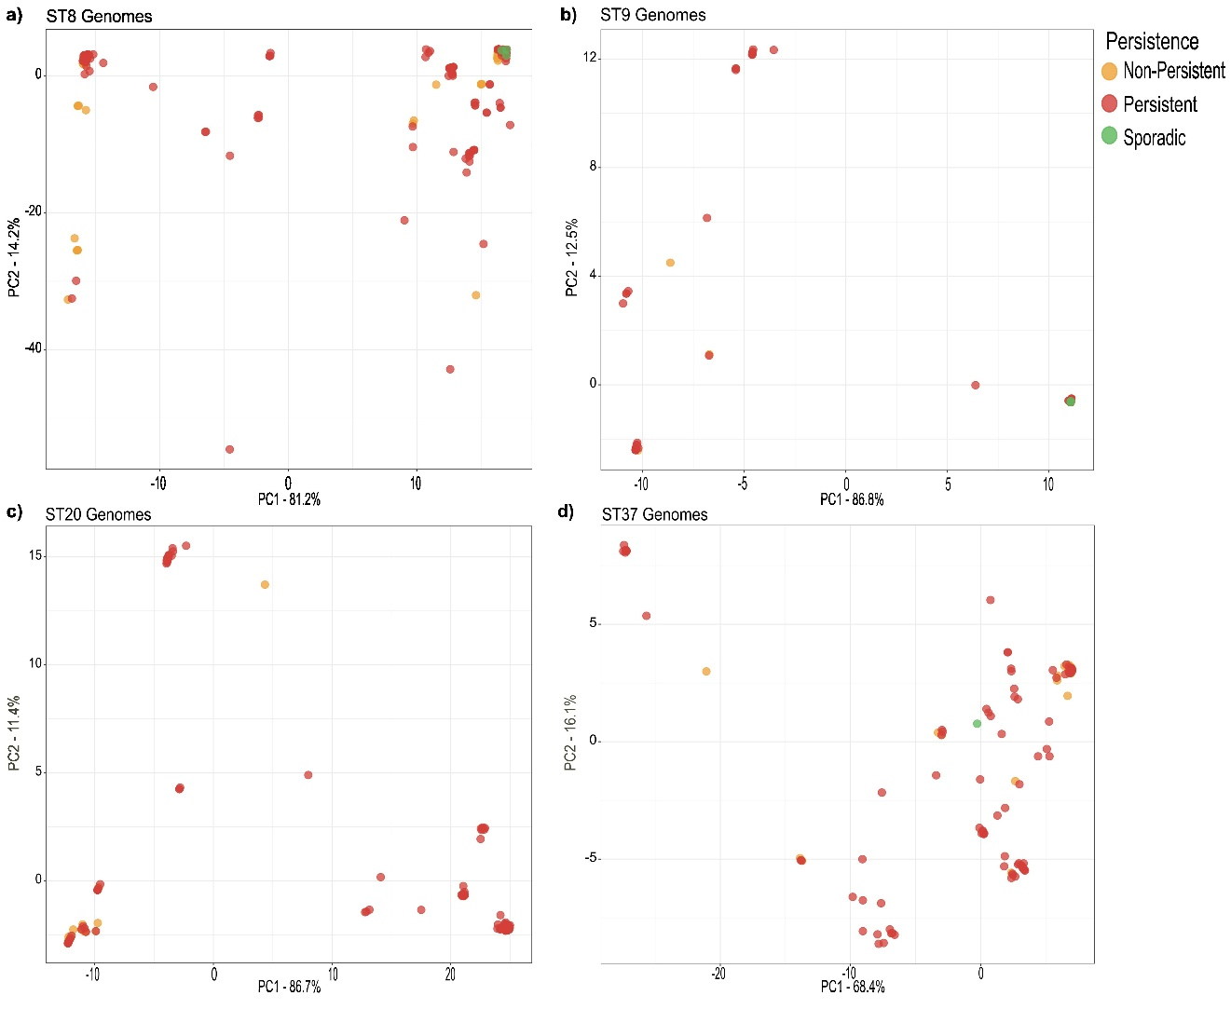
Figure S7. Principal component analysis of gene presence and absence within sequence types. PCA cluster analysis of (a) ST8 isolate genomes (n=316), (b) ST9 isolate genomes (n=122), (c) ST20 isolate genomes (n=287), and (d) ST37 isolate genomes (n=125) colored by persistence (red), non-persistence (orange), and sporadic/non-persistent (green).

Table S3. All Environmental Genome PERMANOVA results
 | Df | SumofSqs | R2 | F | Pr(>F) | Signif.
ST | 1 | 15410 | 0.00534 | 9.7827 | 0.001 | ***
CT | 1 | 4989 | 0.00173 | 3.1675 | 0.014 | *
Persistence | 2 | 80979 | 0.02807 | 25.7041 | 0.001 | ***
Source | 3 | 35618 | 0.01235 | 7.5373 | 0.001 | ***
Year Isolated | 1 | 1924 | 0.00067 | 1.2212 | 0.279
# Contigs | 1 | 1248 | 0.00043 | 0.7921 | 0.467
Total Length | 1 | 9502 | 0.00329 | 6.0324 | 0.002 | **
N50 | 1 | 1062 | 0.00037 | 0.6740 | 0.596
Residual | 1687 | 2657382 | 0.92113
Total | 1698 | 2884902 | 1.00000
Signif. codes: 0 ‘***’ 0.001 ‘**’ 0.01 ‘*’ 0.05 ‘.’ 0.1 ‘ ’ 1

Table S4. ST8 PERMANOVA Results
 | Df | SumofSqs | R2 | F | Pr(>F) | Signif.
CT | 1 | 222 | 0.00223 | 0.8295 | 0.401
Persistence | 2 | 10873 | 0.10923 | 20.3595 | 0.001 | ***
Source | 2 | 1160 | 0.01166 | 2.1724 | 0.069 | .
Year Isolated | 1 | 871 | 0.00875 | 3.2612 | 0.016 | *
# Contigs | 1 | 24 | 0.00024 | 0.0902 | 0.145
Total Length | 1 | 56 | 0.00056 | 0.2079 | 0.121
N50 | 1 | 167 | 0.00168 | 0.6247 | 0.111
Residual | 306 | 81711 | 0.82088
Total | 315 | 99540 | 1.00000
Signif. codes: 0 ‘***’ 0.001 ‘**’ 0.01 ‘*’ 0.05 ‘.’ 0.1 ‘ ’ 1

Table S5. ST9 PERMANOVA Results
 | Df | SumofSqs | R2 | F | Pr(>F) | Signif.
CT | 1 | 3.2 | 0.00022 | 0.0272 | 0.949
Persistence | 2 | 205.4 | 0.01391 | 0.8755 | 0.485
Source | 1 | 379.5 | 0.02571 | 3.2357 | 0.071 | .
Year Isolated | 1 | 176.8 | 0.01198 | 1.5073 | 0.201
# Contigs | 1 | 38.3 | 0.00260 | 0.3268 | 0.617
Total Length | 1 | 1.4 | 0.00010 | 0.0123 | 0.981
N50 | 1 | 95.1 | 0.00644 | 0.8105 | 0.424
Residual | 113 | 13254.2 | 0.89786
Total | 121 | 14762.0 | 1.00000
Signif. codes: 0 ‘***’ 0.001 ‘**’ 0.01 ‘*’ 0.05 ‘.’ 0.1 ‘ ’ 1

Table S6. ST20 PERMANOVA Results
 | Df | SumofSqs | R2 | F | Pr(>F) | Signif.
CT | 1 | 76 | 0.00093 | 0.5514 | 0.496
Persistence | 1 | 628 | 0.00765 | 4.5519 | 0.001 | ***
Source | 2 | 160 | 0.00195 | 0.5790 | 0.657
Year Isolated | 1 | 10378 | 0.12643 | 75.2545 | 0.001 | ***
# Contigs | 1 | 641 | 0.00781 | 4.6473 | 0.023 | *
Total Length | 1 | 8 | 0.00010 | 0.0600 | 0.936
N50 | 1 | 132 | 0.00160 | 0.9537 | 0.359
Residual | 278 | 38338 | 0.46706
Total | 286 | 82082 | 1.00000
Signif. codes: 0 ‘***’ 0.001 ‘**’ 0.01 ‘*’ 0.05 ‘.’ 0.1 ‘ ’ 1

Table S7. ST37 PERMANOVA Results
 | Df | SumofSqs | R2 | F | Pr(>F) | Signif.
CT | 1 | 106.6 | 0.00699 | 0.9679 | 0.327
Persistence | 2 | 793.0 | 0.05199 | 3.6007 | 0.032 | *
Source | 1 | 740.1 | 0.04853 | 6.7214 | 0.006 | **
Year Isolated | 1 | 82.5 | 0.00541 | 0.7488 | 0.454
# Contigs | 1 | 17.0 | 0.00112 | 0.1547 | 0.929
Total Length | 1 | 95.0 | 0.00623 | 0.8628 | 0.392
N50 | 1 | 76.6 | 0.00502 | 0.6955 | 0.437
Residual | 115 | 12663.0 | 0.83025
Total | 123 | 15252.0 | 1.00000
Signif. codes: 0 ‘***’ 0.001 ‘**’ 0.01 ‘*’ 0.05 ‘.’ 0.1 ‘ ’

