Supplementary Figure 3. Alignment of transposon-associated plasmid regions and antimicrobial resistance genes.
Nucleotide sequence alignments of the identified transposon-associated plasmid regions with their corresponding reference sequences. The aligned regions demonstrate the genomic context of the identified mobile genetic elements and their associated antimicrobial resistance determinants. The mph(E), msr(E), and bla_{OXA-48} genes are highlighted in red, illustrating its position within the analyzed transposon-associated region.
Plasmid
IncFIB(pNDM Mar)-IncHI1(pNDM MAR)-IncR
Transposon
TnPMLUA4

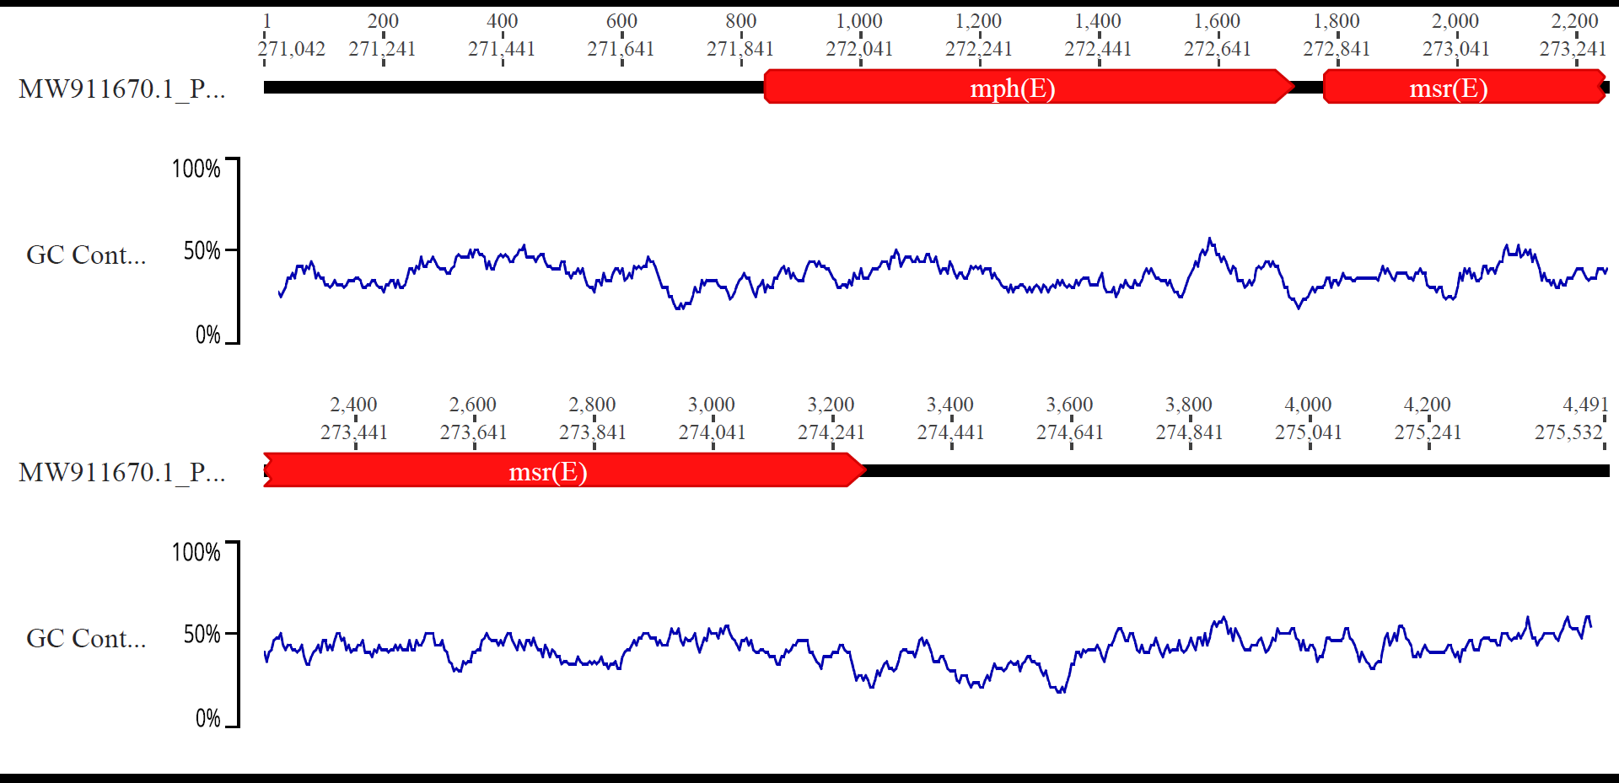

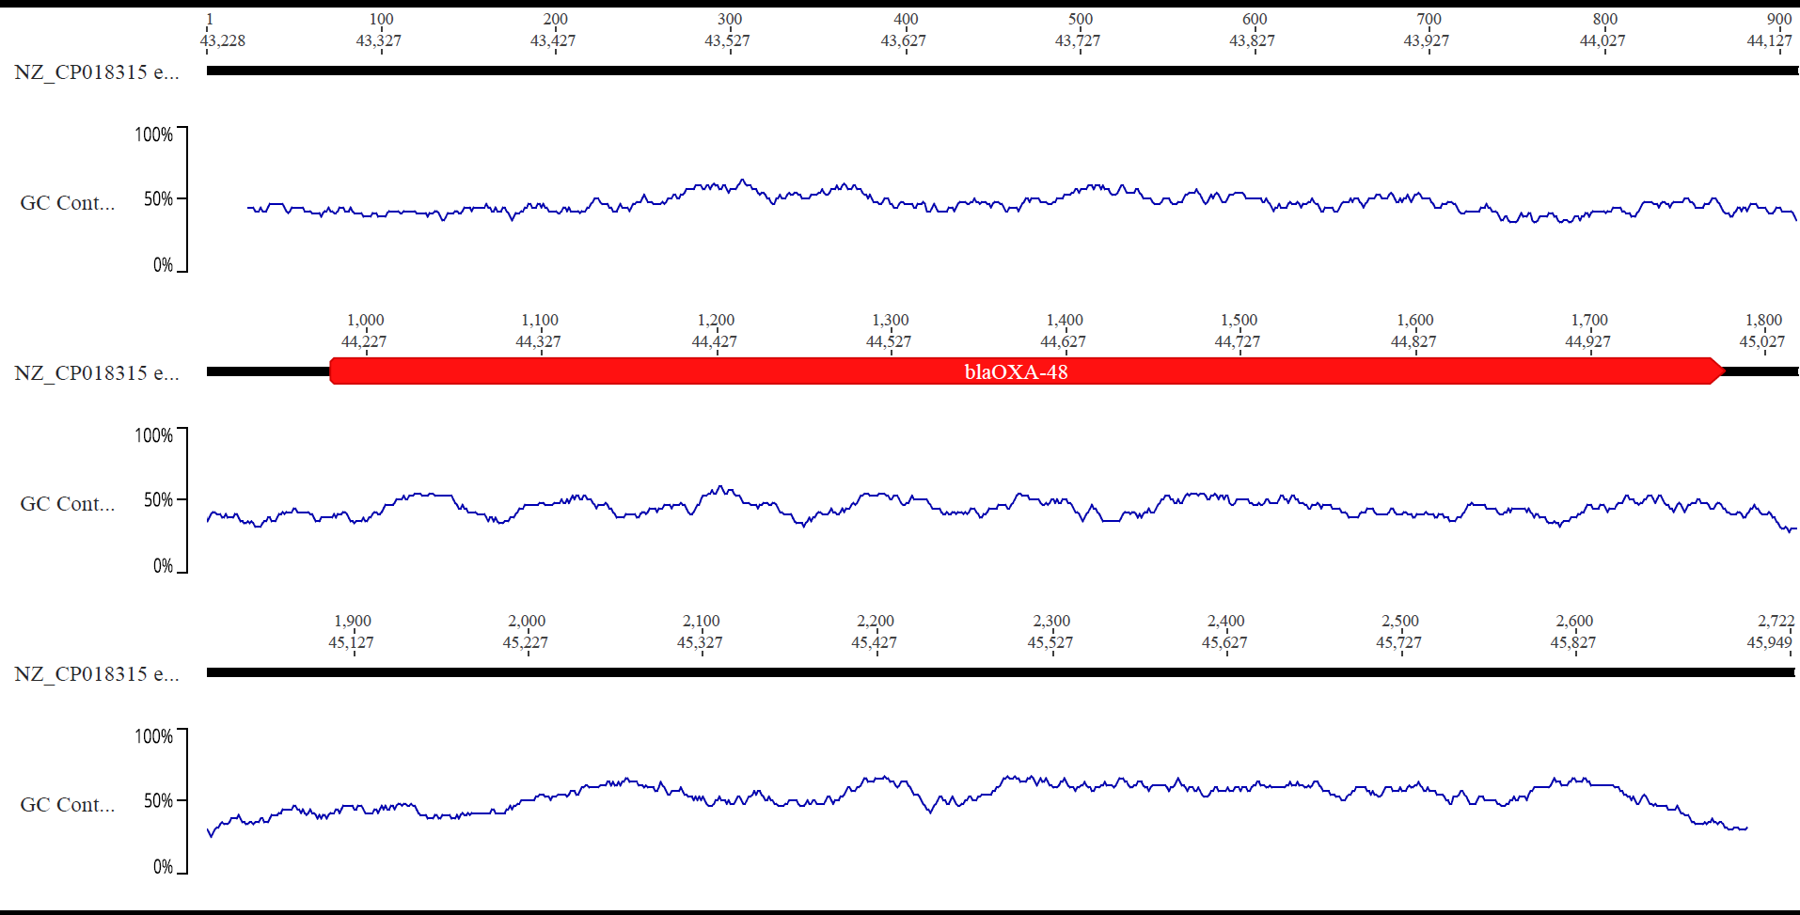

Plasmid
IncL
Transposon
Tn2696-HE617182

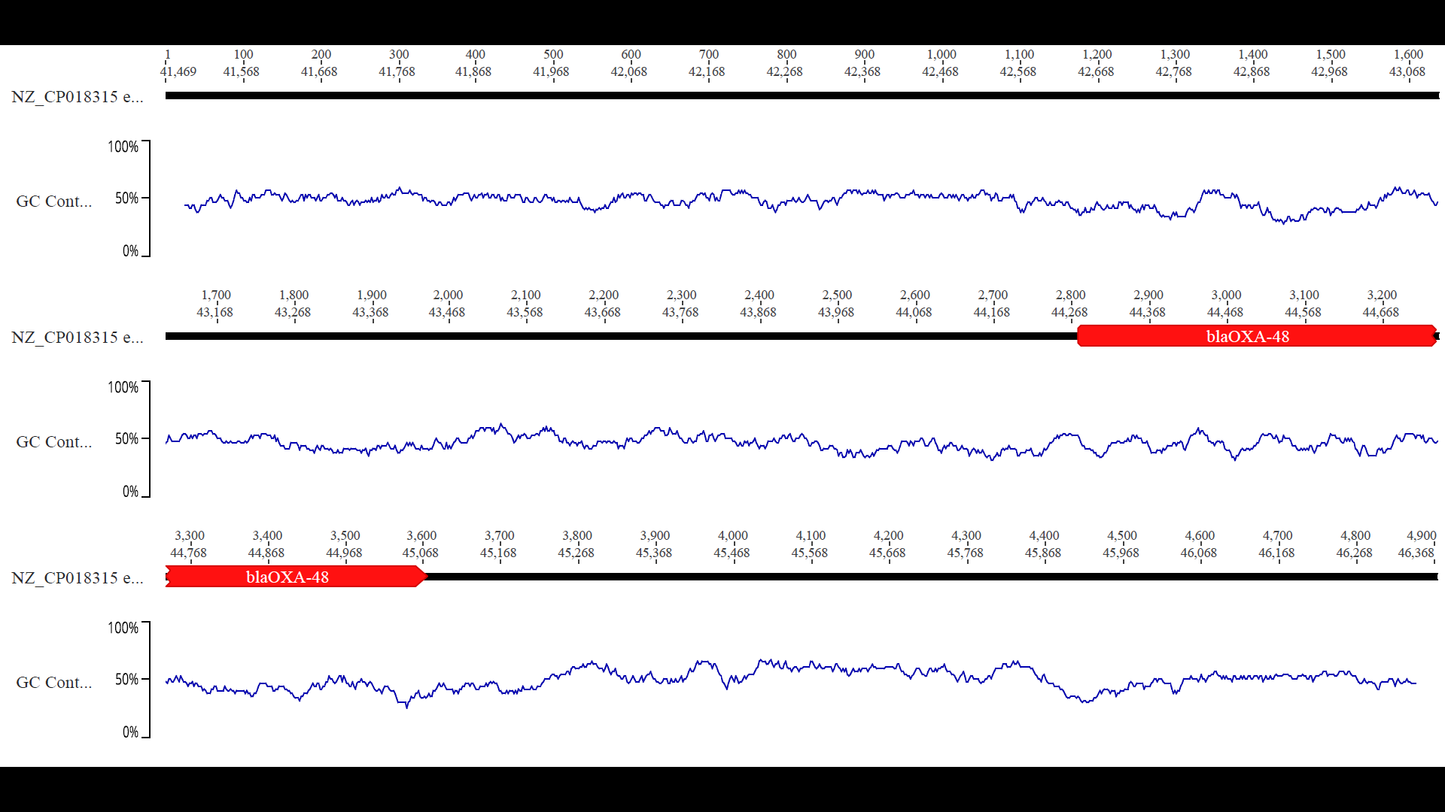

Plasmid
IncL
Transposon
Tn1999.1-CP019080

