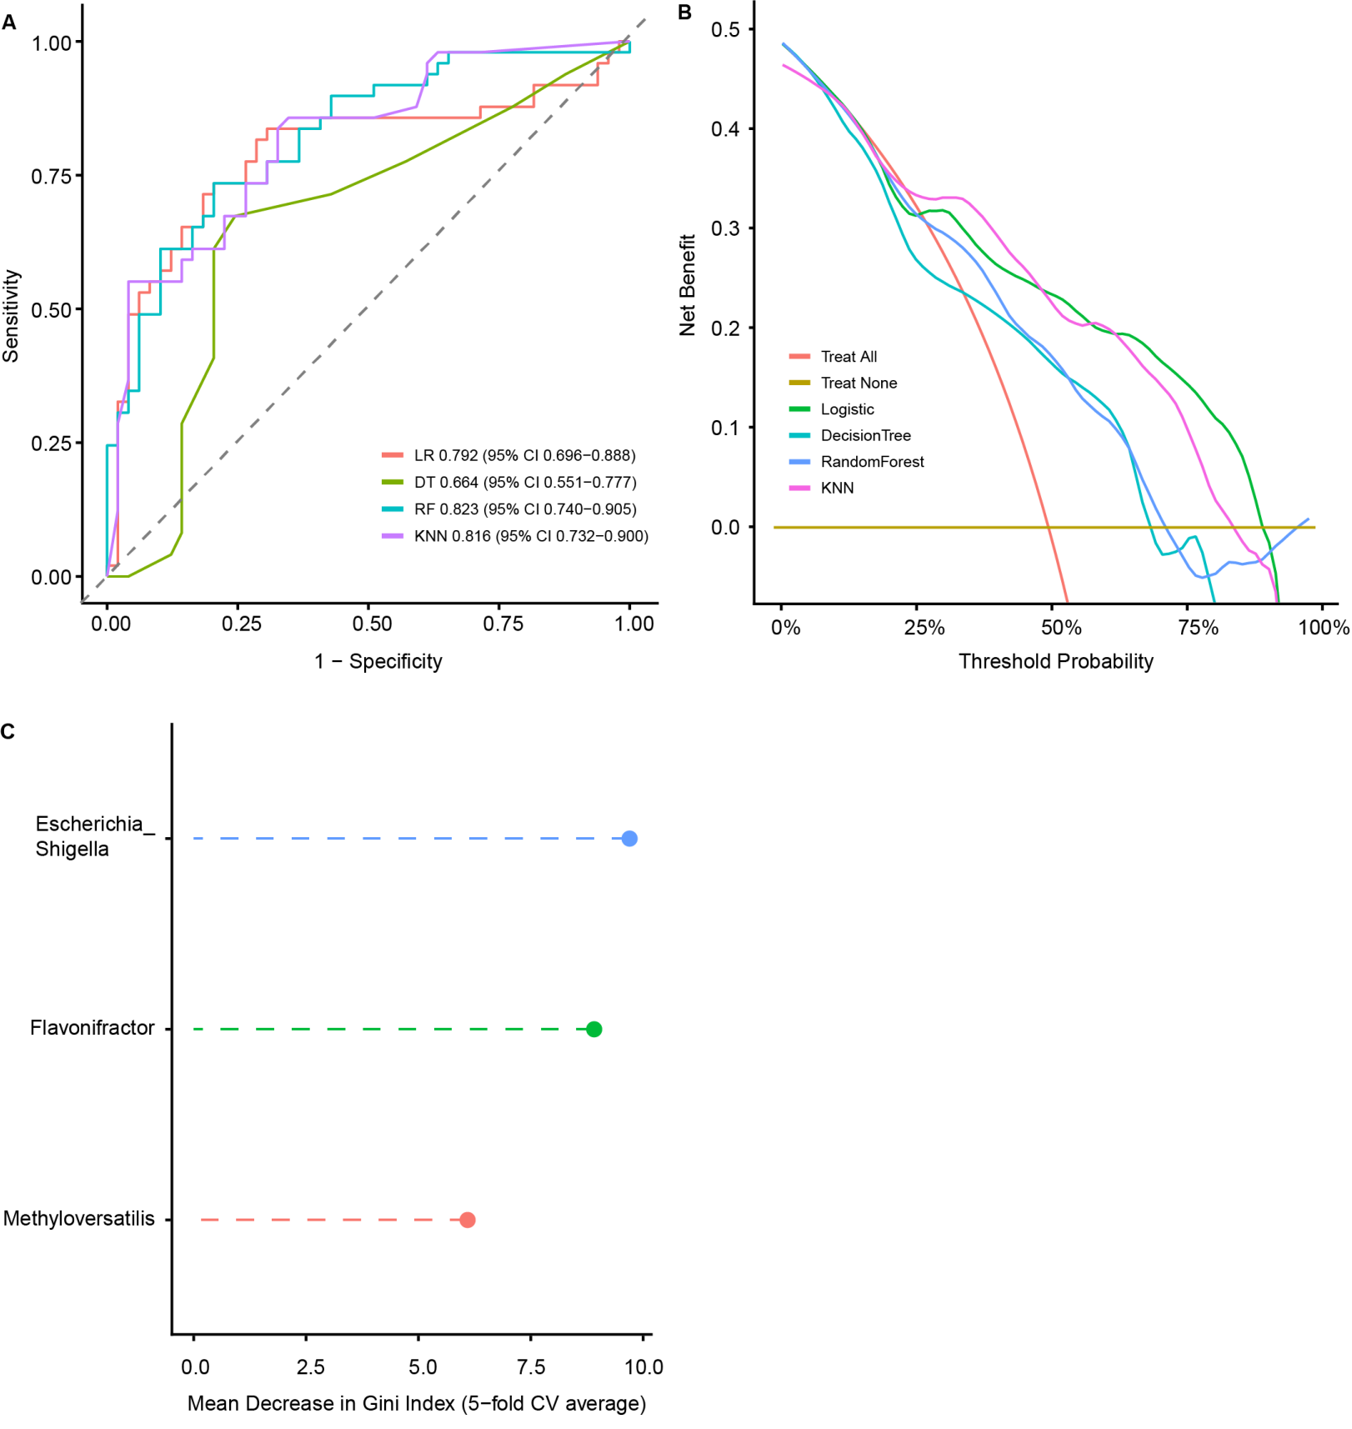
Figure S6. Disease classifiers using gut microbiota and serum/faecal metabolite data. A: ROC curve comparing the diagnostic performance of Logistic Regression (LR), Decision Tree (DT), Random Forest (RF), and K-Nearest Neighbor (KNN) models for JIA. The AUC and corresponding 95% confidence intervals (CIs) for each model are indicated in the figure. B: Decision curve analysis (DCA) evaluating the net clinical benefit of each model across different threshold probabilities. The horizontal axis represents the threshold probability, and the vertical axis represents the net benefit. C: Variable importance ranking of the Random Forest model based on the mean decrease in Gini index from 5-fold cross-validation, reflecting the predictive contribution of each genus.

