Supplementary Material for:

Kitchen-scale connectivity dominates bacterial and fungal communities across sink surfaces
Sherlynette Pérez Castro, Ugonna Chinwe Morikwe, Megan S Hill, Megan EJ Lott, Emma E Dempsey, Claudia Gunsch, Rachel T Noble, Kristen D Landreville, Liesl Jeffers-Francis

Table of contents

Table S1. Bacterial taxa targeted in this study. Target taxa were selected a priori using the CDC Opportunistic Pathogens of Premise Plumbing guidance as the primary framework and refined to include taxa reported in residential drinking water and additional opportunistic pathogens relevant to built environments and antimicrobial resistance based on the published literature. References supporting inclusion of each taxon are provided

Table S2. Fungal taxa targeted in this study. Taxa were selected based on indicator species commonly used in indoor environmental microbiology, including those from the Environmental Relative Moldiness Index (ERMI) framework and related literature on water-damaged and background indoor fungi.

Table S3. Primer and probe sequences and thermal cycling conditions used in the triplex droplet digital PCR (ddPCR) assay targeting OXA-48, KPC, and vanA antimicrobial resistance genes. Listed are probe and primer sequences (5′–3′), fluorophore labels for probes, annealing temperatures, and annealing times used during amplification.

Table S4. Taxonomic assignment summary for full-length bacterial 16S rRNA gene and fungal ITS amplicon sequencing. The table reports the number and percentage of amplicon sequence variants (ASVs) and sequencing reads classified at each taxonomic rank, from kingdom to species.

Table S5. Household IDs grouped by county and ZIP code. Distribution of de-identified households sampled in Durham and Guilford counties, with homes organized by ZIP code to illustrate the geographic structure used in community analyses.

Figure S1. Non-metric multidimensional scaling (NMDS) ordinations based on Bray-Curtis dissimilarities for bacterial (left) and fungal (right) communities from residential kitchen surface samples. Points represent individual samples. Color denotes county (green = Guilford; blue = Durham), with lighter to darker shades indicating countertop (CT), drain hole (DH), and faucet spout (FS) samples, respectively. Surface types are additionally distinguished by shape (circles = CT; squares = DH; triangles = FS). Ellipses represent 95% confidence intervals for each surface type. Stress values and PERMANOVA P values for surface type and county are shown within each panel.

Figure S2. Pairwise Spearman rank correlations of bacterial rank-abundance profiles across kitchen surface types. Heatmap shows Spearman’s correlation coefficients (ρ) comparing taxa rank-abundance patterns among countertops (CT), drain holes (DH), and faucet spouts (FS).

Table S1. Bacterial taxa targeted in this study. Target taxa were selected a priori using the CDC Opportunistic Pathogens of Premise Plumbing guidance as the primary framework and refined to include taxa reported in residential drinking water and additional opportunistic pathogens relevant to built environments and antimicrobial resistance based on the published literature. References supporting inclusion of each taxon are provided.

n | Taxon | reference
1 | Acinetobacter baumannii | https://link.springer.com/article/10.1007/s00203-021-02503-3
2 | Acinetobacter junii | https://www.sciencedirect.com/science/article/pii/S0043135423013623
3 | Aeromonas salmonicida | https://www.sciencedirect.com/science/article/pii/S0048969721047252
4 | Bacillus cereus | https://pubmed.ncbi.nlm.nih.gov/31896482/
5 | Burkholderia cepacia | https://pmc.ncbi.nlm.nih.gov/articles/pmid/25803794/
6 | Campylobacter jejuni | https://pmc.ncbi.nlm.nih.gov/articles/pmid/31234440/
7 | Citrobacter freundii | https://onlinelibrary.wiley.com/doi/10.1155/2022/2850165
8 | Citrobacter koseri | https://link.springer.com/article/10.1007/s00203-021-02503-3
9 | Enterobacter aerogenes | https://pmc.ncbi.nlm.nih.gov/articles/pmid/36170198/
10 | Enterobacter asburiae | https://pmc.ncbi.nlm.nih.gov/articles/pmid/35862664/
11 | Enterococcus faecalis | https://onlinelibrary.wiley.com/doi/10.1155/2022/2850165
12 | Enterococcus faecium | https://enviromicro-journals.onlinelibrary.wiley.com/doi/abs/10.1111/lam.12474
13 | Enterococcus hirae | https://pubmed.ncbi.nlm.nih.gov/31896482/
14 | Escherichia coli | https://pmc.ncbi.nlm.nih.gov/articles/PMC9566567/
15 | Klebsiella pneumoniae | https://www.ajicjournal.org/article/S0196-6553(17)30691-0/abstract
16 | Legionella pneumophila | https://pubmed.ncbi.nlm.nih.gov/27959883/
17 | Mycobacterium gordonae | https://pmc.ncbi.nlm.nih.gov/articles/pmid/25803794/
18 | Mycobacterium kansasii | https://pmc.ncbi.nlm.nih.gov/articles/PMC7145143/
19 | Proteus vulgaris | https://onlinelibrary.wiley.com/doi/10.1155/2022/2850165
20 | Providencia alcalifaciens | https://www.sciencedirect.com/science/article/pii/S0043135423001240
21 | Pseudomonas aeruginosa | https://pmc.ncbi.nlm.nih.gov/articles/PMC9566567/
22 | Pseudomonas alcaligenes | https://www.sciencedirect.com/science/article/pii/S0043135423013623
23 | Pseudomonas fluorescens | https://pubmed.ncbi.nlm.nih.gov/22521167/
24 | Pseudomonas putida | https://pubmed.ncbi.nlm.nih.gov/22521167/
25 | Pseudomonas stutzeri | https://pubmed.ncbi.nlm.nih.gov/22521167/
26 | Ralstonia pickettii | https://pmc.ncbi.nlm.nih.gov/articles/pmid/25803794/
27 | Salmonella enterica | https://bmcinfectdis.biomedcentral.com/articles/10.1186/s12879-018-2957-4
28 | Serratia marcescens | https://link.springer.com/article/10.1007/s00203-021-02503-3
29 | Shigella sonnei | https://www.sciencedirect.com/science/article/pii/S1876034119301455
30 | Staphylococcus aureus | https://pmc.ncbi.nlm.nih.gov/articles/pmid/31148965/
31 | Stenotrophomonas maltophilia | https://www.sciencedirect.com/science/article/pii/S0048969718323398
32 | Vibrio cholerae | https://pmc.ncbi.nlm.nih.gov/articles/PMC9547466/

Table S2. Fungal taxa targeted in this study. Taxa were selected based on indicator species commonly used in indoor environmental microbiology, including those from the Environmental Relative Moldiness Index (ERMI) framework and related literature on water-damaged and background indoor fungi.

n | Taxon
1 | Alternaria alternata
2 | Aspergillus amstelodami
3 | Aspergillus flavus
4 | Aspergillus fumigatus
5 | Aspergillus ochraceus
6 | Aspergillus penicillioides
7 | Aspergillus restrictus
8 | Aspergillus sclerotiorum
9 | Aspergillus unguis
10 | Aspergillus ustus
11 | Aspergillus versicolor
12 | Aureobasidium pullulans
13 | Chaetomium globosum
14 | Cladosporium cladosporioides
15 | Cladosporium herbarum
16 | Cladosporium sphaerospermum
17 | Epicoccum nigrum
18 | Microascus brevicaulis
19 | Paecilomyces variotii
20 | Penicillium brevicompactum
21 | Penicillium camembertii
22 | Penicillium commune
23 | Penicillium corylophilum
24 | Penicillium crustosum
25 | Penicillium echinulatum
26 | Penicillium purpurogenum
27 | Penicillium rubens
28 | Penicillium solitum
29 | Penicillium spinulosum
30 | Penicillium variabile
31 | Rhizopus stolonifer
32 | Sarocladium strictum
33 | Stachybotrys chartarum
34 | Trichoderma viride
35 | Wallemia sebi

Table S3. Primer and probe sequences, thermal cycling conditions, and synthetic positive control information used in the triplex droplet digital PCR (ddPCR) assay targeting OXA-48, KPC, and vanA antimicrobial resistance genes. Synthetic double-stranded DNA fragments (gBlocks, Integrated DNA Technologies) were designed from the indicated GenBank accession numbers and used as positive controls to confirm successful ddPCR assay amplification.

Target | Positive control (GenBank) | Oligo Type | Sequence (5′–3′) | Annealing (°C) | Time (min)
blaOXA-48 | AY236073.2 | Probe (ROX) | TTACCCGCATCTACC | 55 | 1
blaOXA-48 | AY236073.2 | FWD | ACGGGCGGAACCAAGCAT | 55 | 1
blaOXA-48 | AY236073.2 | REV | GCGATCAAGCTATTGGGAATTT | 55 | 1
blaKPC | CP128077.1 | Probe (FAM) | TGATAACGCCGCCGCCAATTGT | 55–60 | 1
blaKPC | CP128077.1 | FWD | GGCCGCCGTGCAATAC | 55–60 | 1
blaKPC | CP128077.1 | REV | GCCGCCCAACTCCTTCA | 55–60 | 1
vanA | OR298096.1 | Probe (HEX) | CAACTAACGCGGCACTGTTTCCCAAT | 55–60 | 1
vanA | OR298096.1 | FWD | CTGTGAGGTCGGTTGTGCCG | 55–60 | 1
vanA | OR298096.1 | REV | TTTGGTCCACCTCGCCA | 55–60 | 1

Table S4. Taxonomic assignment summary for full-length bacterial 16S rRNA gene and fungal ITS amplicon sequencing. The table reports the number and percentage of amplicon sequence variants (ASVs) and sequencing reads classified at each taxonomic rank, from kingdom to species.

Marker | Rank | Classified ASVs | % ASVs  Classified | Classified Reads | % Reads  Classified
Bacteria  16S rRNA | Kingdom | 5,104 | 100 | 10,580,279 | 100
Bacteria  16S rRNA | Phylum | 5,103 | 100 | 10,580,197 | 100
Bacteria  16S rRNA | Class | 5,101 | 99.9 | 10,580,180 | 100
Bacteria  16S rRNA | Order | 5,077 | 99.5 | 10,575,855 | 100
Bacteria  16S rRNA | Family | 4,956 | 97.1 | 10,525,104 | 99.5
Bacteria  16S rRNA | Genus | 4,638 | 90.9 | 10,448,686 | 98.8
Bacteria  16S rRNA | Species | 457 | 9 | 3,195,221 | 30.2
Fungi  ITS | Kingdom | 6,376 | 100 | 34,736,382 | 100
Fungi  ITS | Phylum | 5,546 | 87 | 34,089,773 | 98.1
Fungi  ITS | Class | 5,370 | 84.2 | 33,993,042 | 97.9
Fungi  ITS | Order | 5,274 | 82.7 | 33,960,218 | 97.8
Fungi  ITS | Family | 5,266 | 82.6 | 33,959,742 | 97.8
Fungi  ITS | Genus | 5,229 | 82 | 33,958,758 | 97.8
Fungi  ITS | Species | 4,085 | 64.1 | 30,667,980 | 88.3

Table S5. Household IDs grouped by county and ZIP code. Distribution of de-identified households sampled in Durham and Guilford counties, with homes organized by ZIP code to illustrate the geographic structure used in community analyses.

County | ZIP Code | Household IDs
Guilford | 27403 | G1
Guilford | 27401 | G2, G3, G4
Guilford | 27406 | G5, G6, G7, G9, G10, G12
Guilford | 27455 | G8
Guilford | 27265 | G11
Guilford | 27410 | G13, G14, G15, G17, G19
Guilford | 27407 | G16, G18
Durham | 27707 | D1, D2, D3, D4, D10, D12, D15, D20
Durham | 27704 | D5, D14, D22
Durham | 27701 | D6
Durham | 27703 | D7, D8, D9
Durham | 27705 | D11, D13, D16, D17, D19, D21
Durham | 27713 | D18

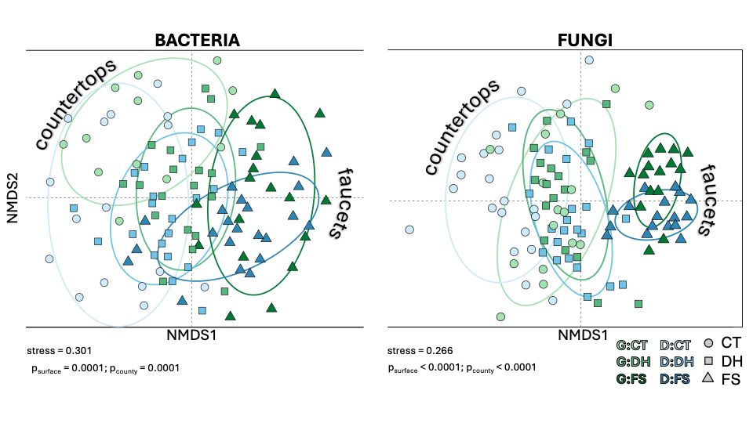
Figure S1. Non-metric multidimensional scaling (NMDS) ordinations based on Bray-Curtis dissimilarities for bacterial (left) and fungal (right) communities from residential kitchen surface samples. Points represent individual samples. Color denotes county (green = Guilford; blue = Durham), with lighter to darker shades indicating countertop (CT), drain hole (DH), and faucet spout (FS) samples, respectively. Surface types are additionally distinguished by shape (circles = CT; squares = DH; triangles = FS). Ellipses represent 95% confidence intervals for each surface type. Stress values and PERMANOVA P values for surface type and county are shown within each panel.

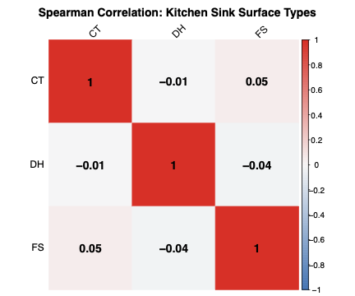

Figure S2. Pairwise Spearman rank correlations of bacterial rank-abundance profiles across kitchen surface types. Heatmap shows Spearman’s correlation coefficients (ρ) comparing taxa rank-abundance patterns among countertops (CT), drain holes (DH), and faucet spouts (FS).

