Unraveling Biochar’s Role: Dosage-dependent Impacts on Continuous-cropping Soil Microbiome and Metabolites
Shaohua Ge^{1,2}, Jun Meng¹, Dong Chang³, Yang E^{1*}, Junyi Gao^{4*}
¹ National Biochar Institute of Shenyang Agricultural University, Shenyang, Liaoning, 110866, PR China
² Henan University of Science and Technology, Luoyang, Henan, 471000, PR China
³Pingdingshan Tobacco Company of Henan Province, Pingdingshan, Henan, 467000, PR China
⁴ Bijie Tobacco Company of Guizhou Province, Bijie, Guizhou, 551700, PR China
*Correspondence: eyang@syau.edu.cn (Yang E), 289174143@qq.com (Junyi Gao)
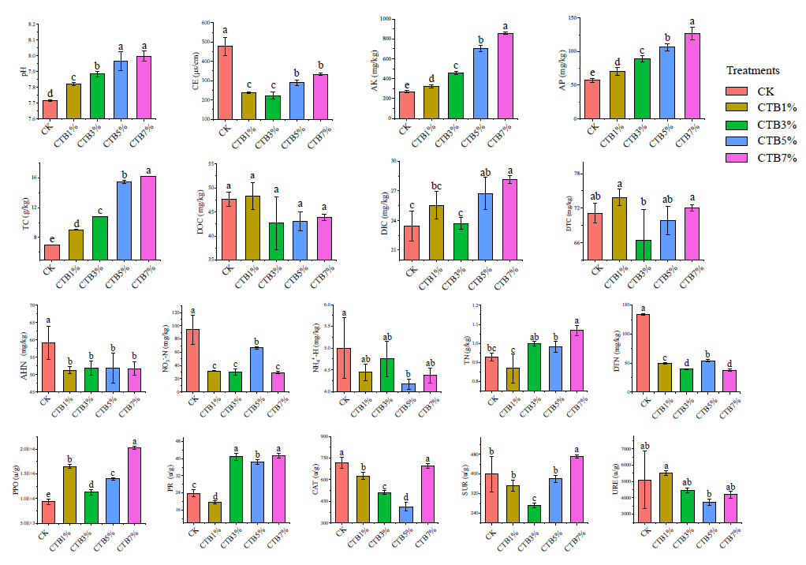
Fig.S1 the distribution of soil properties in contents from soils as affected by biochar addition. The error bars indicate the standard deviation (n=3), the lower-case letters indicate significant different groups via ANOVA followed by Duncan multiple-range test (p < 0.05). The indexes of soil contain basic properties (pH value, conductivity electrical, available potassium, and available phosphorus), carbon (total carbon, dissolved organic carbon, dissolved inorganic carbon, and dissolved total carbon), nitrogen (alkali-hydrolyzable nitrogen, nitrate nitrogen, ammonium, total nitrogen, and dissolved total nitrogen), and enzyme activities (polyphenol oxidase, protease, catalase, sucrase, and urease).

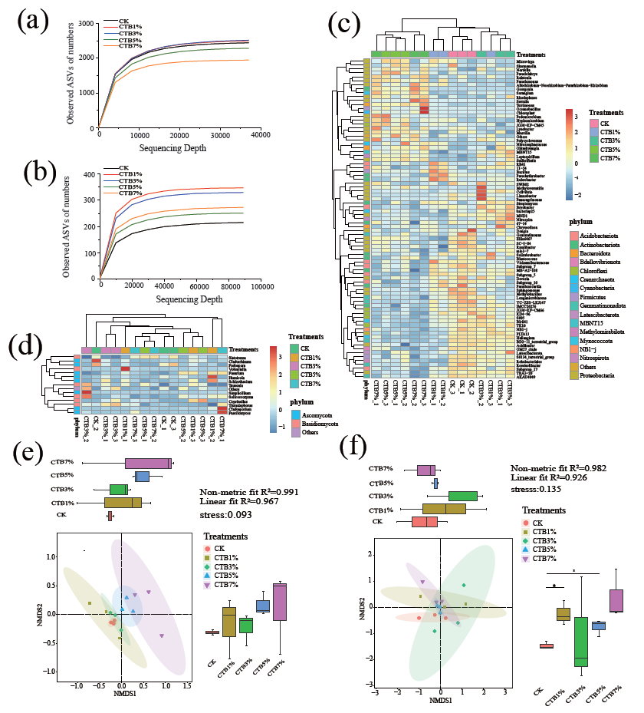
Fig.S2 (a) The rarefaction curves of bacteria (16SrRNA genes); (b) the rarefaction curves of fungus (ITS genes); the horizontal axis represented the number of sequences, and the vertical axis represented the number of observed species. (c) The heatmap analysis of the bacterial genera; (d) the heatmap analysis of the fungal genera; the absolute abundance of genera expression across rows in the heatmap according to the z-score, and the Others contain the genus relative abundance less than 0.2%, the treatments were clustered using Bray-Curtis dissimilarities while the Average clustering of the taxa of genera. (e) NMDS showed the structure of soil bacterial community based on Bray-Curtis; (f) differences in soil fungal community composition using NMDS; 95% confidence ellipses were shown around the sample treatments.

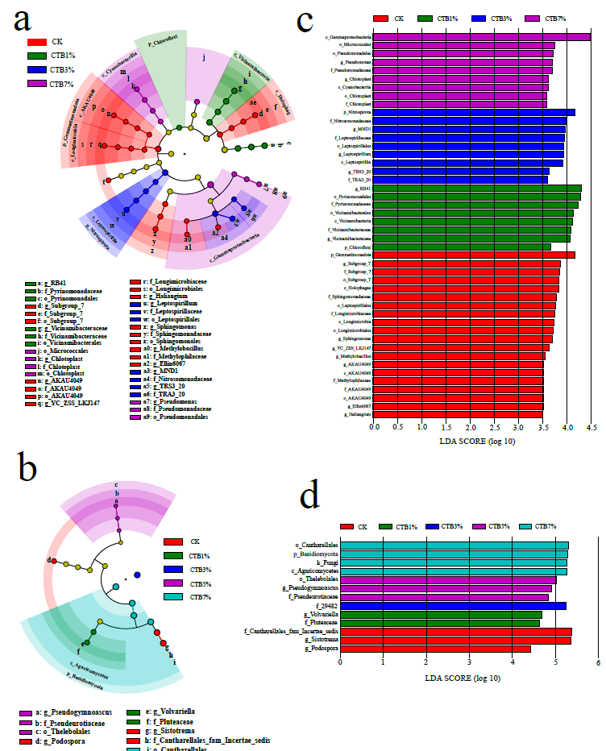
Fig.S3 Responses of bacterial community and fungal community in the biochar soils by LEfSe analysis (LDA > 3.5). (a) Circular cladogram of significant biomarker of bacterial species. (b) Circular cladogram of significant biomarker of fungal species. Circles showed the subsequence from phylum to genus with an outer, and different colors showed the species in each treatment, yellow denoted non-significant. (c) The chart showing the LDA scores of bacterial taxa. (d) The chart showing the LDA scores of fungal taxa.
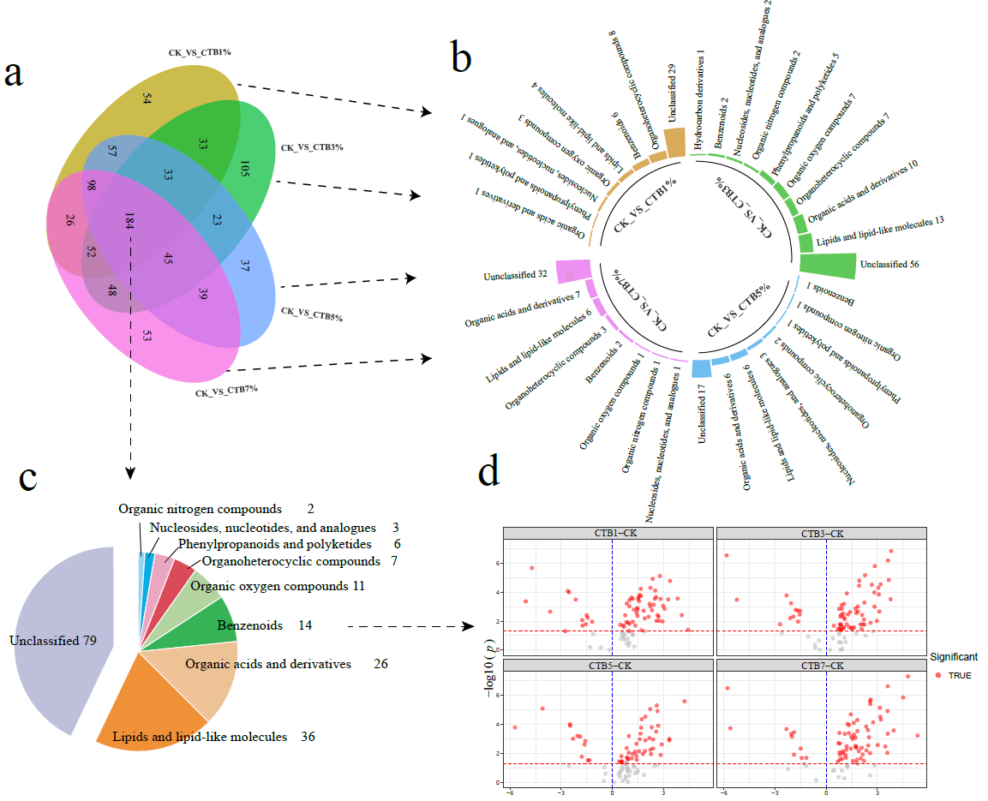
Fig.S4 The different metabolites shown between biochar treatments and control. (a) Venn diagram for different metabolites from the four treatments vs. control. (b) The classified metabolites for the specific metabolites. (c) The classified metabolites for the mutual metabolites from the four groups. (d) Volcano plots depicting different metabolites among four treatments vs. control following the common metabolites annotation (adjusted p-value < 0.05, fold change > 2).

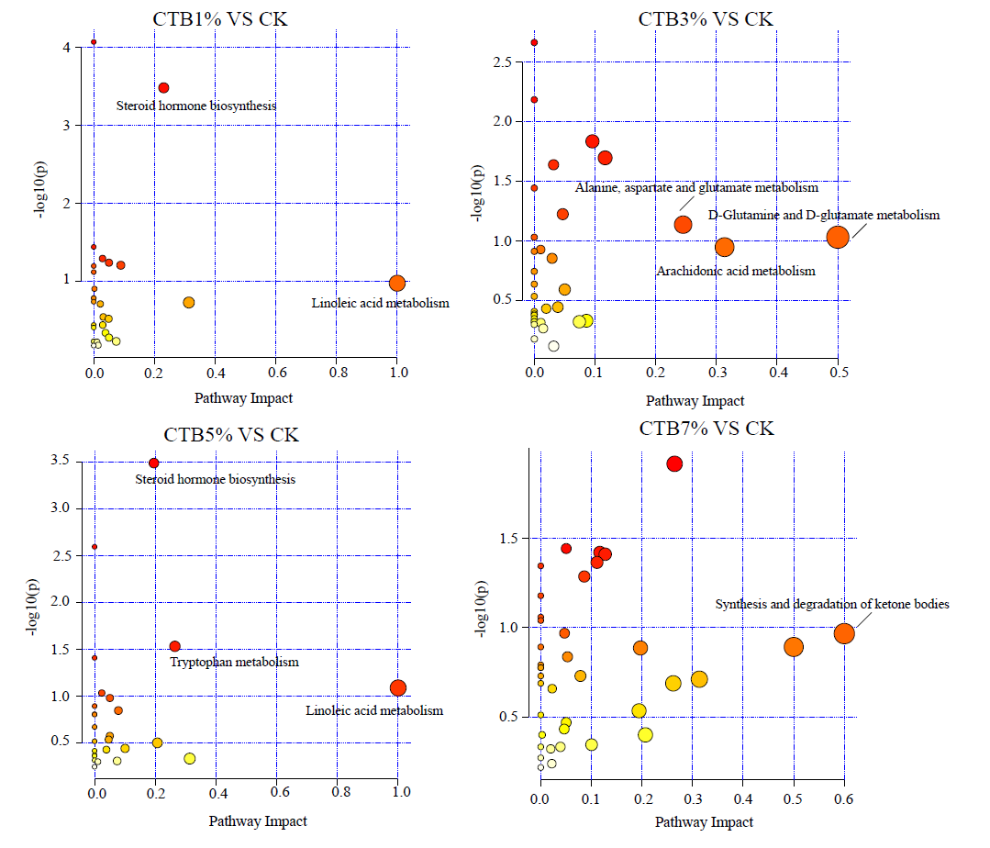
Fig.S5 the enriched metabolomic pathways in the soil were analyzed based on the KEGG database between the dosage of biochar with control treatments

