Additional file
A
33.2kDa

Full unedited gel for Figure3C, the red-marked lanes correspond in sequence to the Hla levels of the Newman strain in Figure3C under control, 1/4MIC, 1/8MIC, 1/16MIC EDHB treated conditions. Blotting was performed using the rabbit anti-Hla antibody (Sigma, 1:2000 dilution) and horseradish peroxidase (HRP)-conjugated goat anti-rabbit IgG (Biosharp, 1:2000 dilution).

B
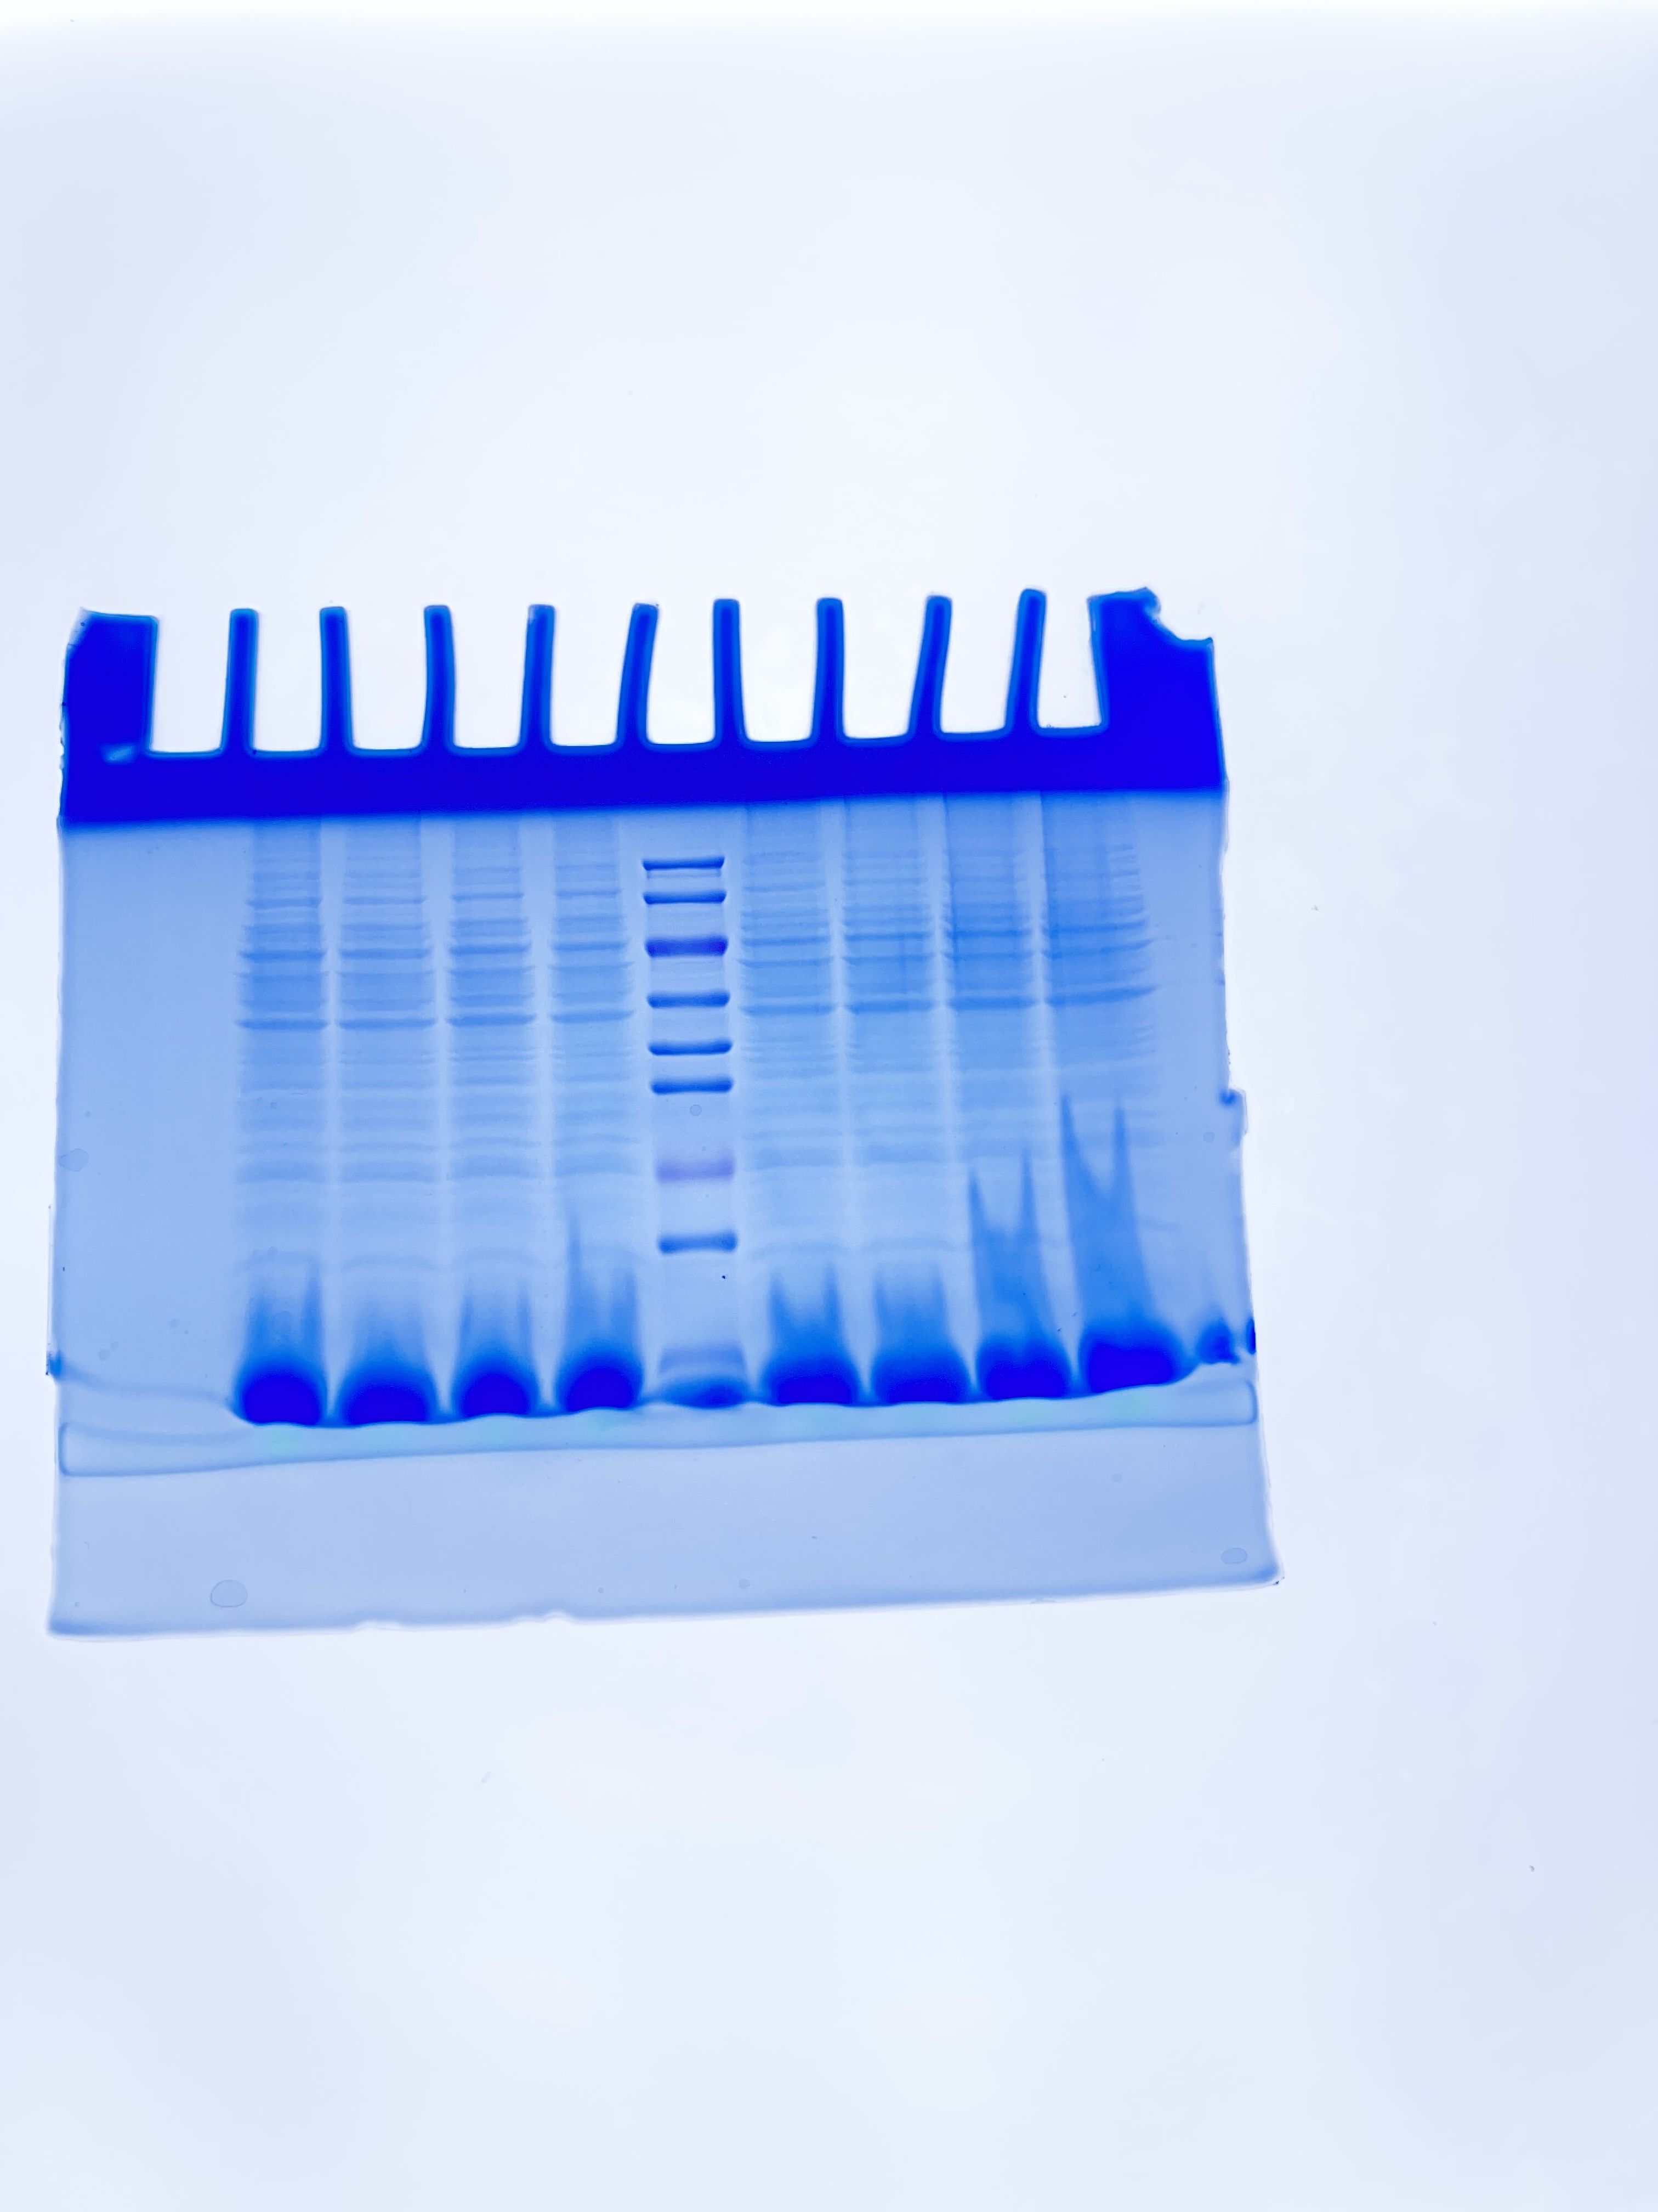
Full unedited gel for Figure3C, Coomassie blue staining of total protein from S. aureus Newman culture supernatants under control, 1/4 MIC, 1/8 MIC, and 1/16 MIC EDHB-treated conditions, serving as a loading control.

C

34
Marker Newman 1/4 1/8 1/16
Intracellular Hla levels in S. aureus Newman. Bacterial cell lysates were prepared under the indicated conditions and analyzed by Western blot using rabbit anti-Hla antibody. Coomassie blue staining of total protein served as a loading control. Intracellular Hla was barely detectable in all samples, and no accumulation was observed upon EDHB treatment.

D
33.2kDa

Full unedited gel for Figure4C, the red-marked lanes correspond to the Hla levels of the following strains and treatments: Newman (control), Newman (1/4 MIC), NewmanΔsaeR (control), NewmanΔsaeR (1/4 MIC) , Newman:saeR (control) and Newman:saeR (1/4MIC) in sequence. Blotting was performed using the rabbit anti-Hla antibody (Sigma, 1:2000 dilution) and horseradish peroxidase (HRP)-conjugated goat anti-rabbit IgG (Biosharp, 1:2000 dilution).

