The dispirotripiperazine compound PDSTP impairs Pseudomonas aeruginosa and Burkholderia cenocepacia adhesion to lung epithelial cells through a novel mechanism of action
Gabriele Trespidi¹, Sara Costa¹, Andrea Bonacorsi¹, Mauro Giuseppe Spatafora¹, Marco Peviani¹, Olga Riabova², Maria Rosalia Pasca^{1,3}, Vadim Makarov², Silvia Buroni¹*.

¹Department of Biology and Biotechnology "Lazzaro Spallanzani", University of Pavia, Pavia, Italy
²Research Center of Biotechnology RAS, Moscow, Russia
³Fondazione IRCCS Policlinico San Matteo, Pavia, Italy

*Correspondence: silvia.buroni@unipv.it

Supplementary material
Methods
Cytotoxicity assay
To assess PDSTP cytotoxicity on A549 cells, the 3- [4,5- dimethylthiazol-2-yl]-2,5-diphenyl tetrazolium bromide (MTT) assay was used. Cells were seeded in 96-well tissue culture plates at a density of 4x10⁴ cells/well and cultured in antibiotic-free DMEM for 24 h to reach confluence. Subsequently, cultures were incubated for 3 h at 37°C with 5% CO₂ in the presence of increasing concentrations of PDSTP, using vehicle-treated cells as the control. Following incubation, the culture medium was removed, and the wells were washed with 100 µL of PBS prior to adding 0.5 mg/mL MTT (Merk) in PBS. The plate was incubated for an additional 2 h under the same conditions to allow formation of formazan. Formazan crystals were dissolved in DMSO, and absorbance was measured at 560 nm using a GloMax Discover microplate reader (Promega). Cell viability was presented as a percentage relative to vehicle-treated control cells.
Figures

Fig. S1 Absorbance spectrum of a 20 µg/mL PDSTP solution in 20 mM TrisHCl (pH: 7.4), 150 mM NaCl.

Fig. S2 A549 cell viability, determined by MTT assay, after 3 h of incubation with increasing concentrations of PDSTP. Results are expressed as mean ± SD from n = 3 independent biological replicates.
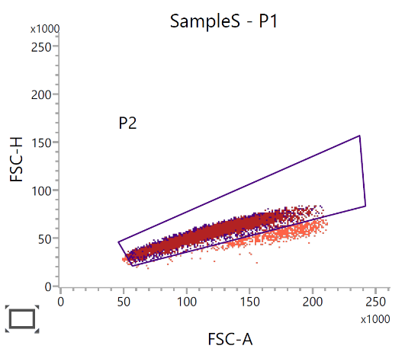
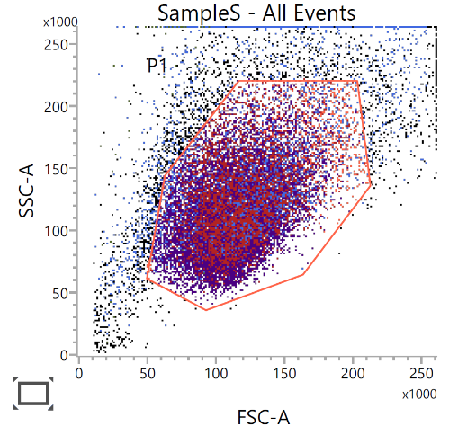
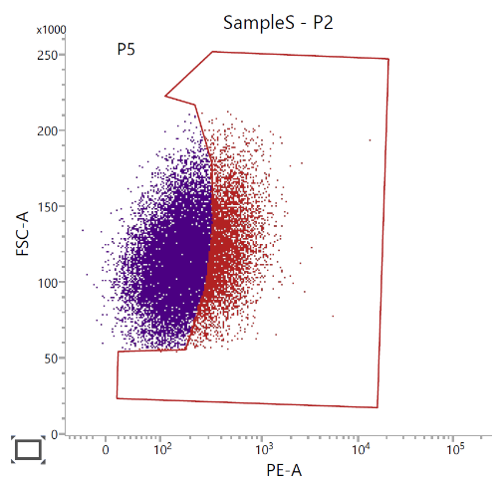
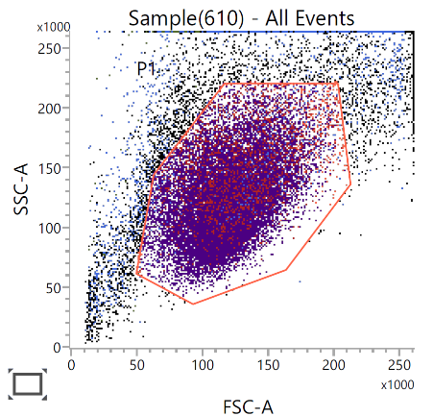
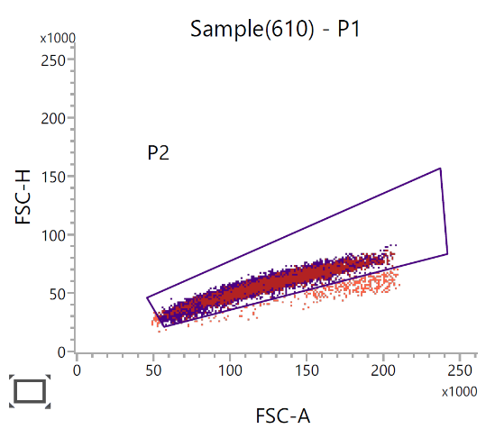
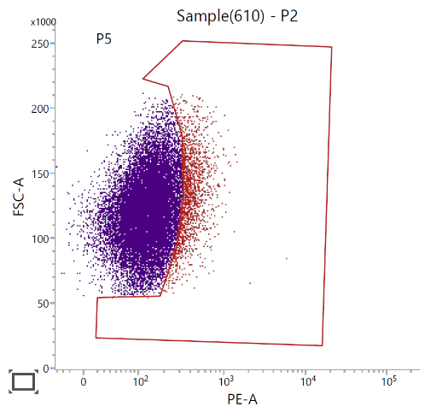
A1
B1
A2
A3
B2+
B3+

*

Fig. S3 Representative flow cytometric profile and hierarchical gating of SampleS (referred to as A549-scrLV in the main text) and Sample(610) (referred to as A549-B3GAT3KD in the main text). Dot plots showing all events with debris exclusion via region P1 (A1 and B1). Single-event discrimination on the P1-gated cells excludes multiplets within region P2 (A2 and B2). PE-A analysis of the P2 singlet population with the complex polygonal gate P5 (set using the secondary antibody only control) selecting events with high PE-A intensity (A3 and B3).

Table S1 Flow cytometric quantitative summary of cell populations. Event counts, gate percentages (% Parent, % Grandparent, % Total), scatter values (FSC-A, SSC-A), and fluorescence intensity metrics (PE-A Mean and Median) are presented for SampleS and Sample(610).
Name | Events | % Parent | % Grandparent | % Total | FSC-A Mean | SSC-A Mean | PE-A Mean | PE-A Median
SampleS:P1 | 21.915 | 87.08 | *** | 87.08 | 117.456 | 114.911 | 251 | 192
SampleS:P2 | 21.071 | 96.15 | 83.73 | 83.73 | 115.413 | 112.767 | 245 | 189
SampleS:P5 | 5.296 | 25.13 | 24.17 | 21.04 | 121.357 | 127.481 | 494 | 427
Sample(610):P1 | 21.816 | 81.28 | *** | 81.28 | 121.976 | 124.397 | 170 | 141
Sample(610):P2 | 21.404 | 98.11 | 79.75 | 79.75 | 121.189 | 123.570 | 166 | 140
Sample(610):P5 | 1.901 | 8.88 | 8.71 | 7.08 | 131.899 | 149.583 | 431 | 386

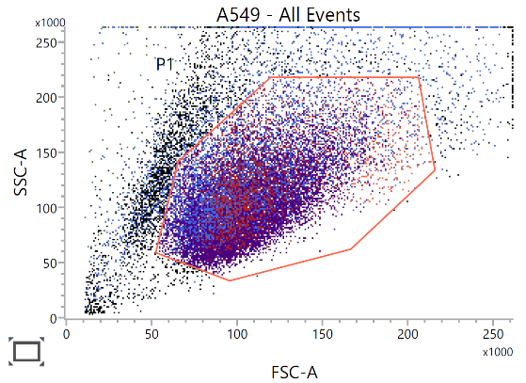
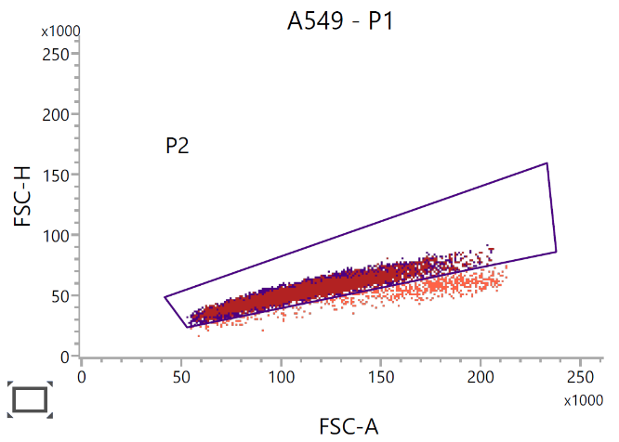
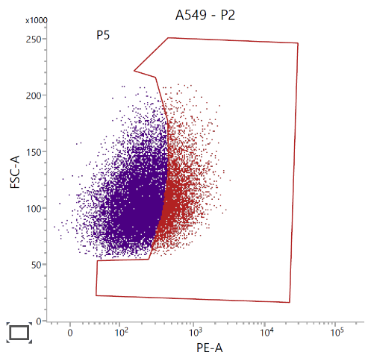
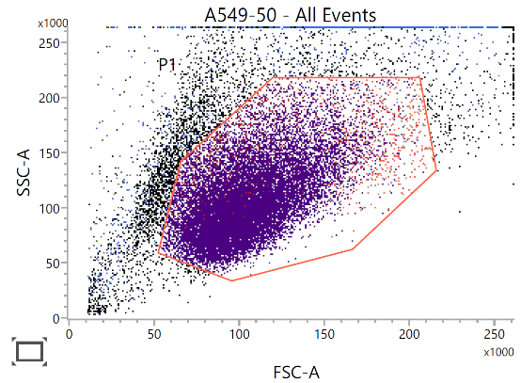
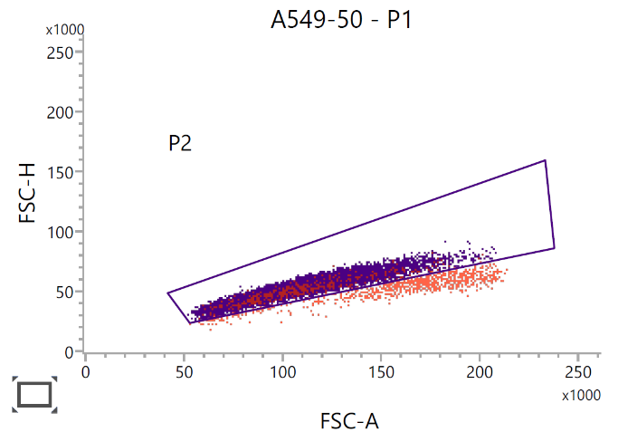
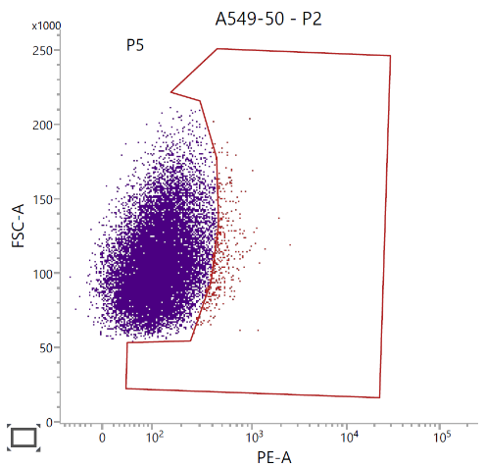
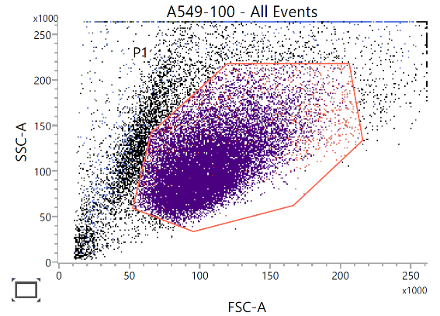
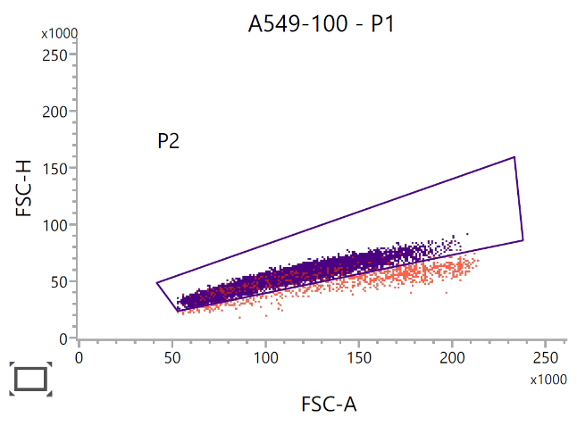
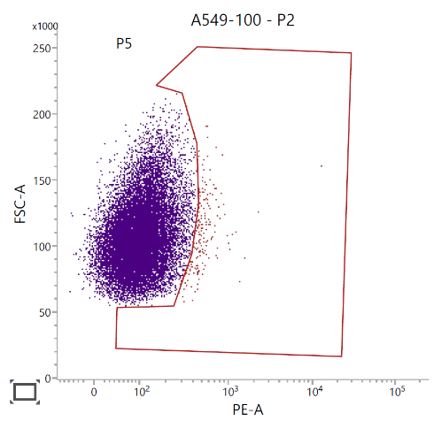
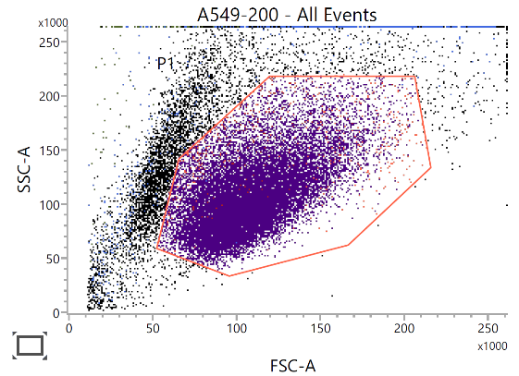
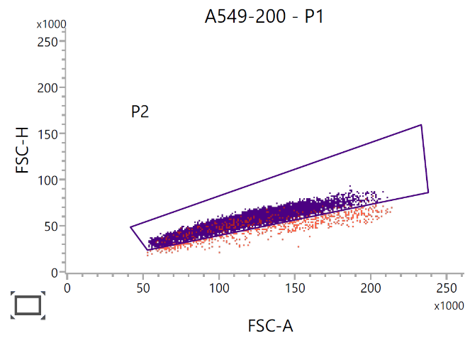
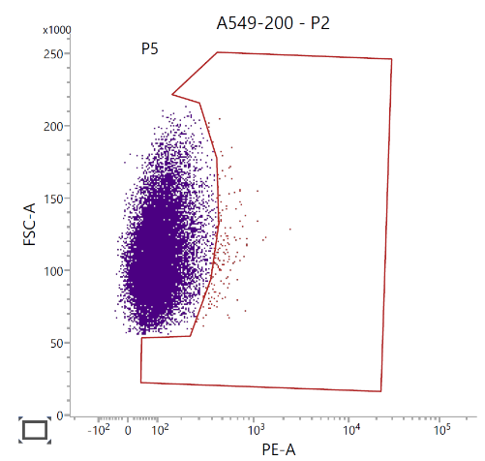
A1
B1
C1
D1
A2
A3
B2
B3
C2
C3
D2
D3

Fig. S4 Representative flow cytometric profile and hierarchical gating of untreated and 50, 100, and 200 mU heparinase III treated A549 cells. Dot plots showing all events with debris exclusion via region P1 (A1, B1, C1, and D1). Single-event discrimination on the P1-gated cells excludes multiplets within region P2 (A2, B2, C2, and D2). PE-A analysis of the P2 singlet population with the complex polygonal gate P5 (set using the secondary antibody only control) selecting events with high PE-A intensity (A3, B3, C3, and D3).

Table S2 Flow cytometric quantitative summary of cell populations. Event counts, gate percentages (% Parent, % Grandparent, % Total), scatter values (FSC-A, SSC-A), and fluorescence intensity metrics (PE-A Mean and Median) are presented for samples A549, A549-50, A549-100, A549-200.
Name | Events | % Parent | % Grandparent | % Total | FSC-A Mean | SSC-A Mean | PE-A Mean | PE-A Median
A549:P1 | 20.260 | 81.54 | *** | 81.54 | 107.824 | 106.233 | 309 | 234
A549:P2 | 19.495 | 96.22 | 78.46 | 78.46 | 105.884 | 104.448 | 306 | 232
A549:P5 | 4.606 | 23.63 | 22.73 | 18.54 | 109.585 | 123.842 | 653 | 560
A549-50:P1 | 20.287 | 82.26 | *** | 82.26 | 107.557 | 107.037 | 144 | 122
A549-50:P2 | 19.471 | 95.98 | 78.95 | 78.95 | 105.337 | 105.114 | 140 | 119
A549-50:P5 | 390 | 2.00 | 1.92 | 1.58 | 111.993 | 159.503 | 532 | 485
A549-100:P1 | 20.232 | 77.97 | *** | 77.97 | 107.735 | 107.181 | 125 | 107
A549-100:P2 | 19.435 | 96.06 | 74.89 | 74.89 | 105.911 | 105.401 | 121 | 105
A549-100:P5 | 220 | 1.13 | 1.09 | 0.85 | 110.238 | 158.932 | 597 | 487
A549-200:P1 | 19.988 | 77.50 | *** | 77.50 | 110.197 | 108.136 | 121 | 103
A549-200:P2 | 19.382 | 96.97 | 75.15 | 75.15 | 109.454 | 107.041 | 115 | 102
A549-200:P5 | 187 | 0.96 | 0.94 | 0.73 | 112.796 | 160.245 | 537 | 484

B
A

Fig. S5 Adhesion to untreated (A) or heparinase III-treated (B) A549 cell monolayers of B. cenocepacia J2315 in the presence of 50 and 200 µg/mL PDSTP. Results are expressed as mean ± SD from n = 3 independent biological replicates. Statistically significant differences are indicated (One-way ANOVA test; ns, not significant; **, p < 0.01).

