Fermentation by Bacillus siamensis BSJ-2 degrades Cruciferin to improve bioactive peptides and essential amino acids in rapeseed meal
Fangfei Yun^{1,2#}, Tianqi Xia^{1,3#}, Kunling Teng¹*, Tianwei Wang¹, Siyue Wang^{1,2}, Sijie Jin^{1,2}, Jie Zhang¹, Jin Zhong^{1,2}*
¹ State Key Laboratory of Microbial Diversity and Innovative Utilization, Institute of Microbiology, Chinese Academy of Sciences, Beijing 100101, China
² School of Life Science, University of Chinese Academy of Sciences, Beijing 100039, China
³ School of Life Science, Dezhou University, Dezhou 253023, Shandong Province, China

*Correspondence:
Jin Zhong (email: zhongj@im.ac.cn) and Kunling Teng (email: tengkl@im.ac.cn)
# These authors contributed equally to this work.

Supplementary Table S1 Peptides with significant differences between BSJ and CK group
Peptide | Accessions | Protein name
RAMPNTLMFRPADGNETAGAY | A0A078HWK8 | transketolase
SFKEAMKMGVE | A0A078H5M7 | phosphopyruvate hydratase
SVMRGLPLEVISN | A0A078G0Q2 | 11S globulin
VFKRTERNFFTV | A0A078HF73 | BnaC03g41590D protein
SLTDIVIEINRVPKKKA | A0A078FN18 | (rape) hypothetical protein
RYDEIIKEVSSY | A0A078G8C9 | BnaC08g43440D protein
NARLGPMLNDLARAR | A0A078HIJ4 | (rape) hypothetical protein
NVVLTGRKIIGATNPAASEPGT | A0A078F7Y5 | Nucleoside diphosphate kinase
SIPQGFSVVKRATSEQF | A0A078JJC3 | 11S globulin
NHNADVAVDF | A0A078J5J3 | thioglucosidase

Supplementary Figure S1

Figure S1 Number and strength mapping result and visualization of peptides derived from Cruciferin. (A) Number and strength mapping result and visualization of peptides derived from Cruciferin protein A0A078G0Q2. (B) Number and strength mapping result and visualization of peptides derived from Cruciferin protein A0A078HL31.

Supplementary Figure S2
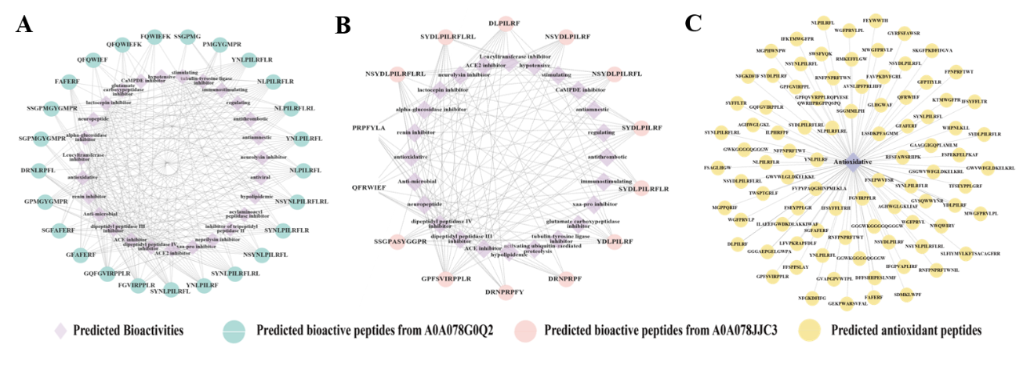
Figure S2. Bioactive peptides derived from Cruciferin and the antioxidant peptides in fermented rapeseed meal. (A) Active peptides produced by Cruciferin A0A078G0Q2 and function analysis. (B) Active peptides produced by Cruciferin A0A078JJC3 and function analysis. (C) All of the predicted antioxidant peptides in rapeseed meal.

Supplementary Figure S3
Figure S3 Content comparison of amino acids in fermented rapeseed meal. Content of alanin (A), arginine (B), asparagine (C), aspartate (D), cysteine (E), glutamate (F), glutamine (G), glycine (H), histidine (I), leucine (J), lysine (K), phenylalanine (L), proline (M), serine (N), threonine (O), tryptophan (P), tyrosine (Q) in fermented rapeseed meal. FR: unfermented group; CK: sterile water fermented group; BSJ: B. siamensis BSJ-2 fermented group.

