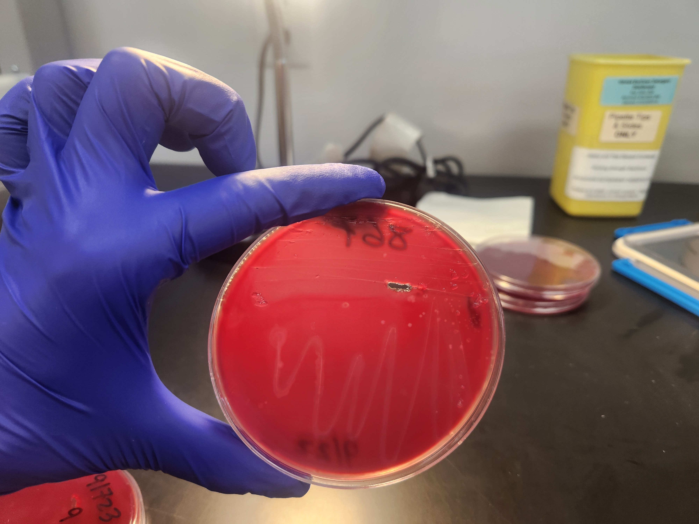
Fig S1. Hemolytic phenotype of Brachyspira burroughii isolate M_B38_867.
Colony morphology of isolate M_B38_867 following subculture on tryptic soy agar supplemented with 5% bovine blood. Colonies exhibit a weakly β-hemolytic phenotype and are ring negative, in contrast to the strong hemolysis and ring phenomenon characteristic of B. hyodysenteriae reference strains.

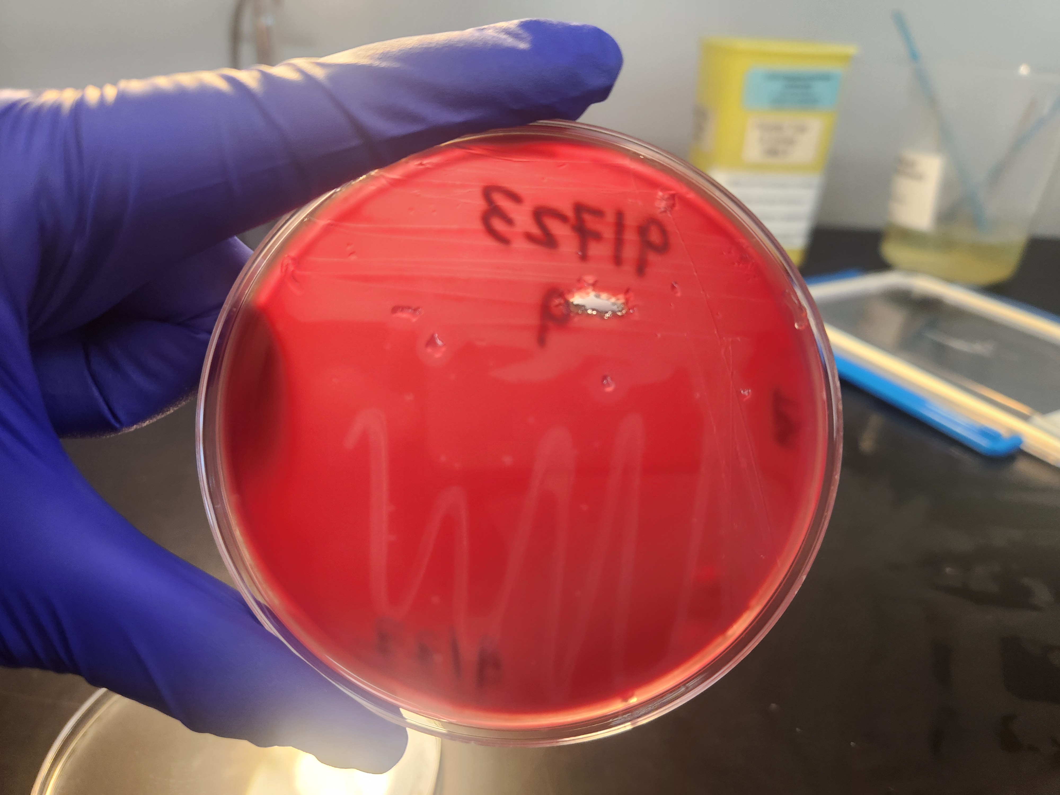

Fig S2. Hemolytic phenotype of Brachyspira burroughii isolate M_B35_793b.
Colony morphology of isolate M_B35_793b following subculture on tryptic soy agar supplemented with 5% bovine blood. Colonies exhibit a weakly β-hemolytic phenotype and are ring negative, consistent with the phenotype observed for isolate M_B38_867.

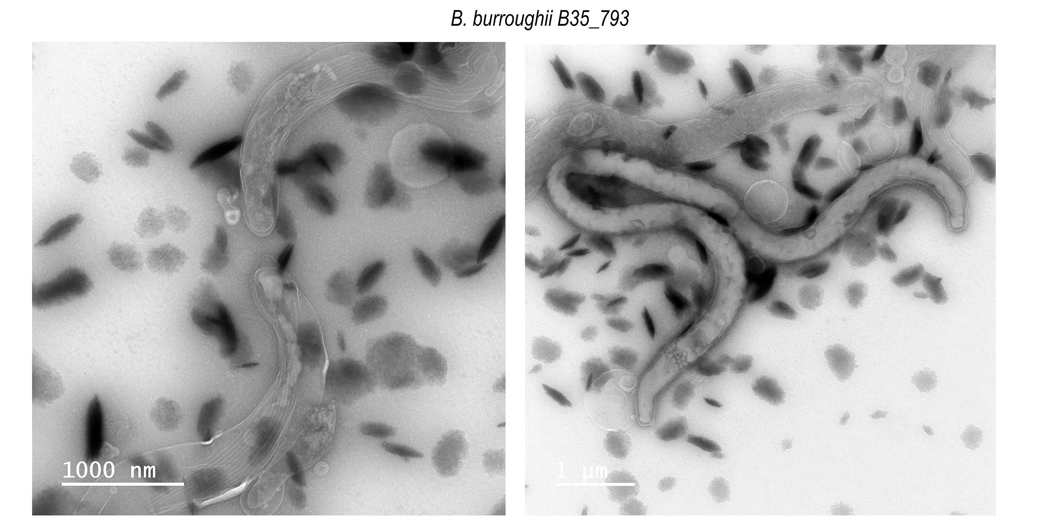
Fig S3. Transmission electron microscopy of Brachyspira burroughii isolate M_B35_793b showing spiral morphology and bundles of periplasmic flagella beneath the outer membrane. The isolate contains approximately 8–11 periplasmic flagella per cell. Scale bars = 1 µm.

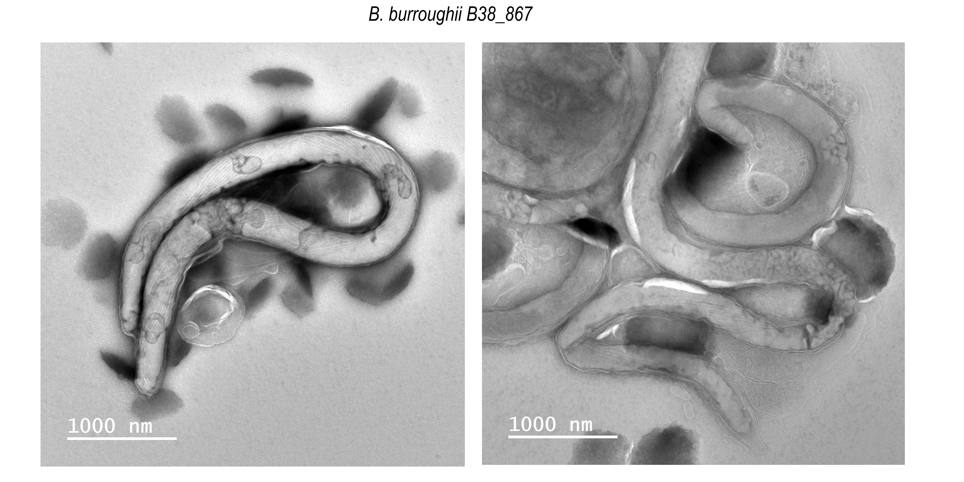
Fig S4. Transmission electron microscopy of Brachyspira burroughii isolate M_B38_867 showing spiral morphology and bundles of periplasmic flagella beneath the outer membrane. The isolate contains approximately 8–11 periplasmic flagella per cell. Scale bars = 1 µm.

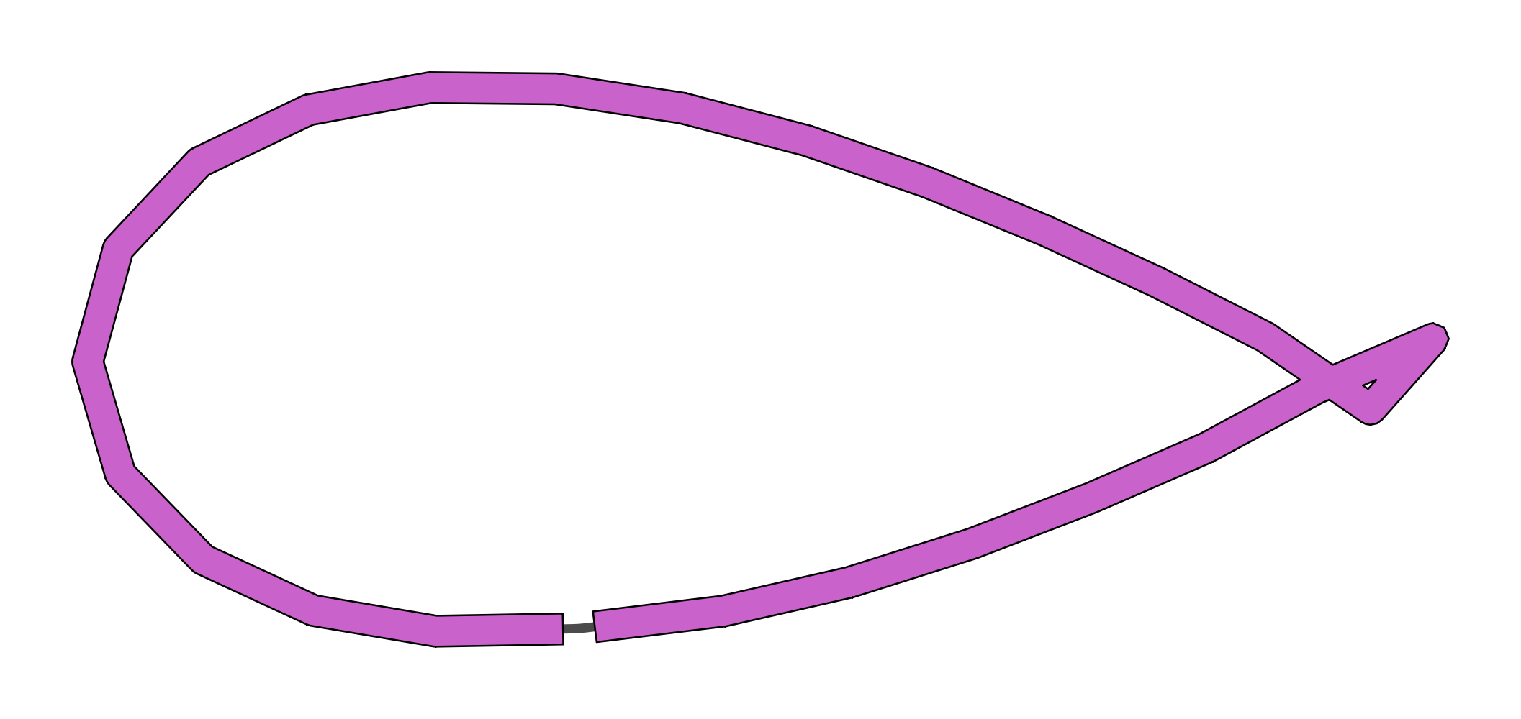
Fig S5. Bandage assembly graph of B. burroughii isolate B38_867 showing the assembled circular chromosome and absence of additional assembled replicons.

Fig S6. Bandage assembly graph of B. burroughii isolate B35_793 showing the assembled circular chromosome and absence of additional assembled replicons.

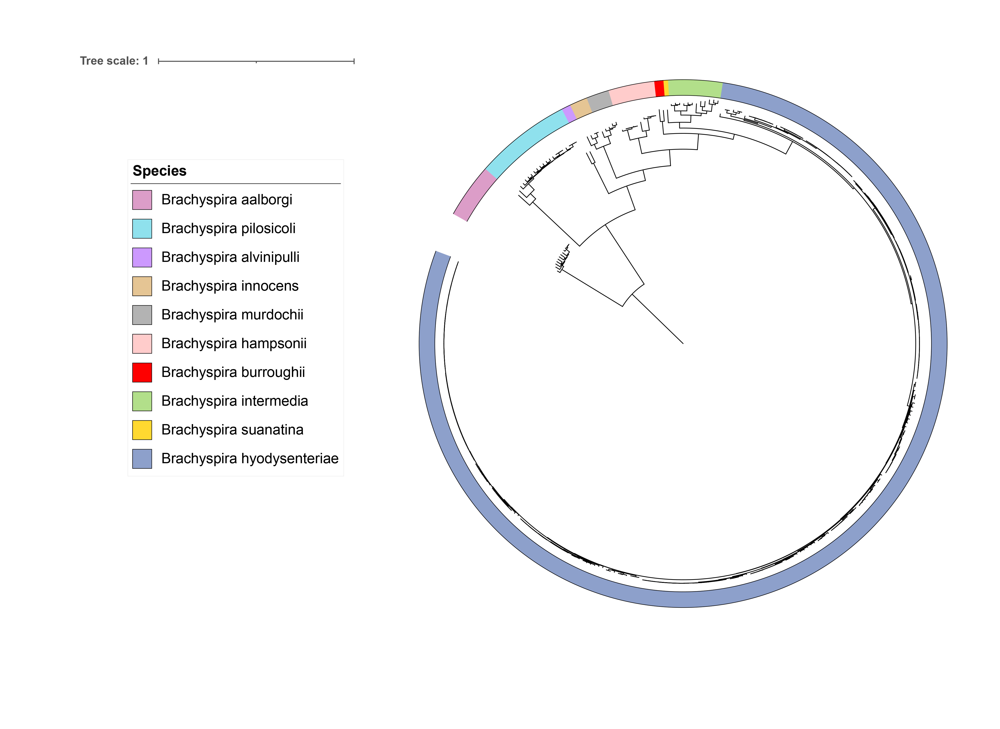
Fig S7. Core-genome SNP-based maximum-likelihood phylogenetic tree of 350 Brachyspira genomes, representing the full dataset used in this study. Species are indicated by branch colors as shown in the legend.

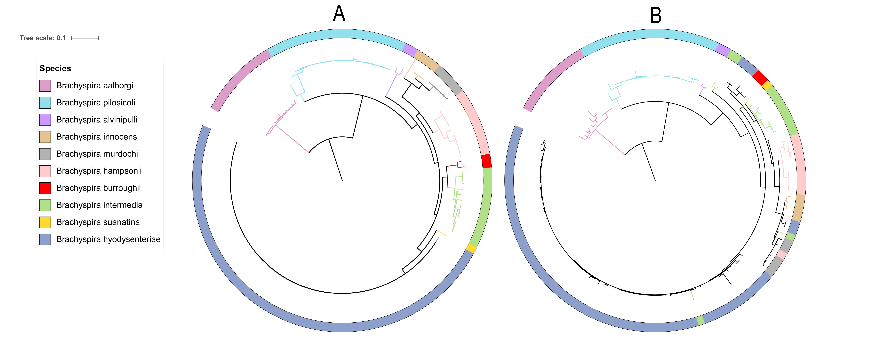
Fig S8. Single-gene phylogenetic trees of the complete dataset of 350 Brachyspira genomes. (A) Tree constructed from nox gene sequences. (B) Tree constructed from 23S rRNA gene sequences. Branch colors correspond to species assignments as indicated in the legend. The trees were midpoint rooted for visualization purposes.

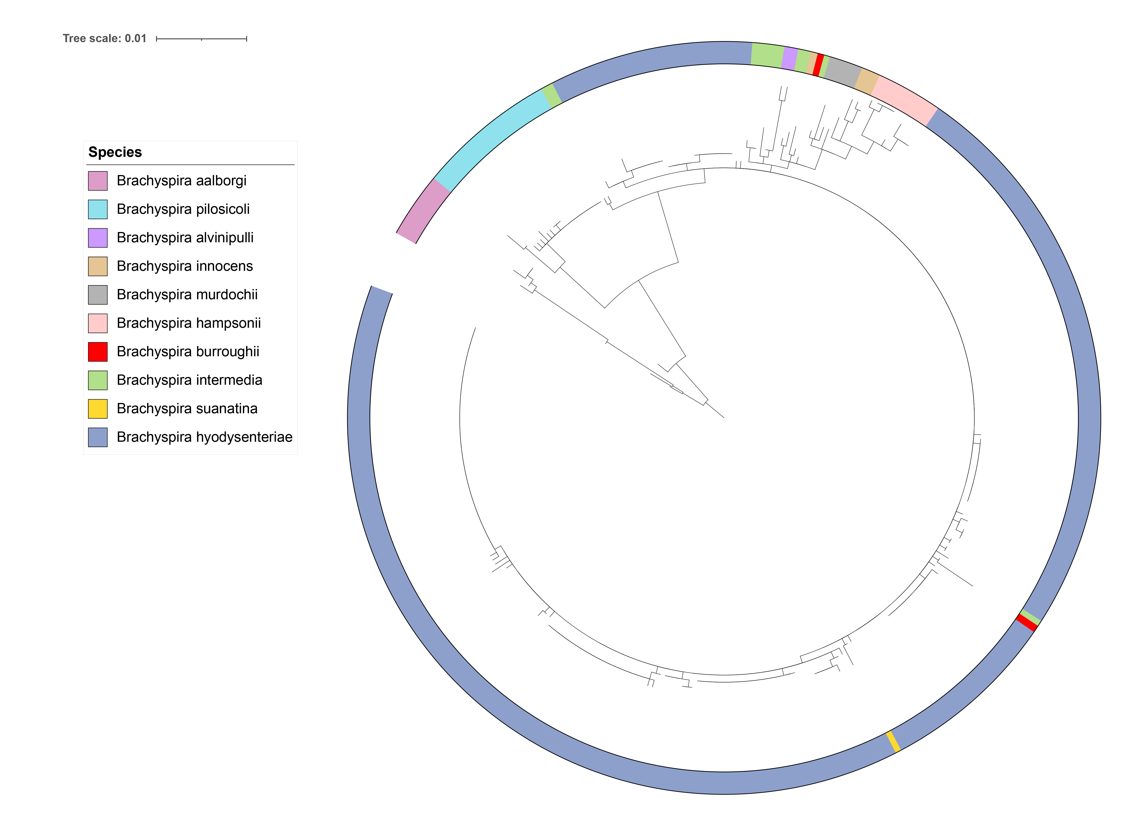
Fig S9. 16S rRNA gene–based phylogenetic tree of Brachyspira species, showing limited resolution among closely related taxa. Several recognized species are not clearly separated, and the two B. burroughii isolates do not form a distinct clade, consistent with the limited discriminatory power of the 16S rRNA gene for species-level resolution within the genus.

