Table S1. Information about purity and integrity of the RNA samples.
Item | Sample Name | OD260/280  ≥1.5 | OD260/230  ≥1 | Total  Amount | RIN  ≥7 | Small RNA fraction |  | QC Result  ( Pass or Fail)
1 | Normal 1 | 1.88 | 2.15 | 47.78 | 7.6 |  | N | Pass
2 | Normal 2 | 1.88 | 1.98 | 32.00 | 7.6 |  | N | Pass
3 | Normal 3 | 1.88 | 1.95 | 40.61 | 7.2 |  | N | Pass
4 | Treatment 1 | 1.88 | 2.00 | 42.51 | 8.1 |  | N | Pass
5 | Treatment 2 | 1.89 | 2.08 | 38.93 | 8.1 |  | N | Pass
6 | Treatment 3 | 1.88 | 2.12 | 35.48 | 7.9 |  | N | Pass
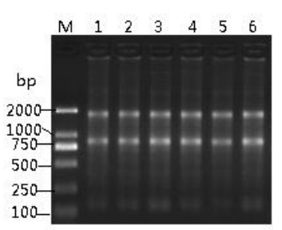
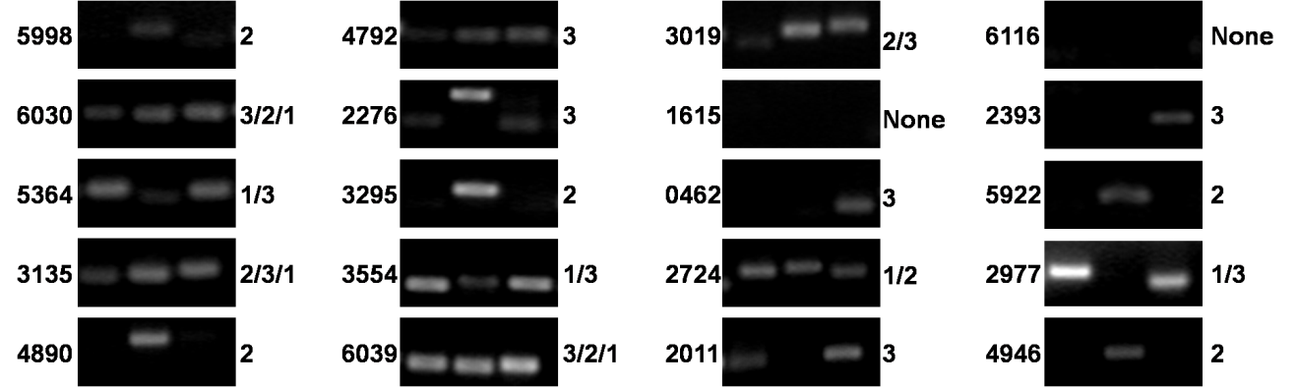
Figure S1.Information of DNA contamination

FigureS2 Results of 20 candidate lncRNAs primers.

Table S2 Summary of lncRNAs randomly selected from the microarry result. Red means the increased lncRNAs after FF transection, while the black means the decreased lncRNAs.
ID | Ratio | transcription_ID
RB_p_rnol003019 | 7.022697359 | ENSRNOT00000037631
RB_p_rnol002977 | 2.765922921 | ENSRNOT00000035283
RB_p_rnol002393 | 3.167740533 | ENSRNOT00000036611
RB_p_rnol002724 | 2.071017274 | ENSRNOT00000038344
RB_p_rnol003135 | 2.117569787 | ENSRNOT00000073813
RB_p_rnol005364 | 2.553447248 | ENSRNOT00000052065
RB_p_rnol006030 | 2.155873896 | ENSRNOT00000071854
RB_p_rnol005998 | 3.268128917 | ENSRNOT00000075272
RB_p_rnol005922 | 2.833333333 | Mouse_homology_transcript(2929):NR_033620
RB_p_rnol004890 | 2.091362811 | ENSRNOT00000009721
RB_p_rnol003295 | 3.556863803 | Mouse_homology_transcript(2772):NR_030673
RB_p_rnol003554 | 2.211021154 | ENSRNOT00000027501
RB_p_rnol004792 | 2.036483021 | ENSRNOT00000047322
RB_p_rnol006039 | 2.321195652 | XR_147166.1
RB_p_rnol000462 | 2.317794486 | Mouse_homology_transcript(1316):NR_033745
RB_p_rnol006116 | 2.126764706 | Mouse_homology_transcript(274):NR_045744
RB_p_rnol001615 | 2.087113518 | Mouse_homology_transcript(1584):NR_102387
RB_p_rnol002011 | 2.227689741 | Mouse_homology_transcript(3150):NR_045507
RB_p_rnol002276 | 2.174579985 | Mouse_homology_transcript(1441):NR_046002
RB_p_rnol004946 | 2.007826768 | Mouse_homology_transcript(1191):NR_028126

