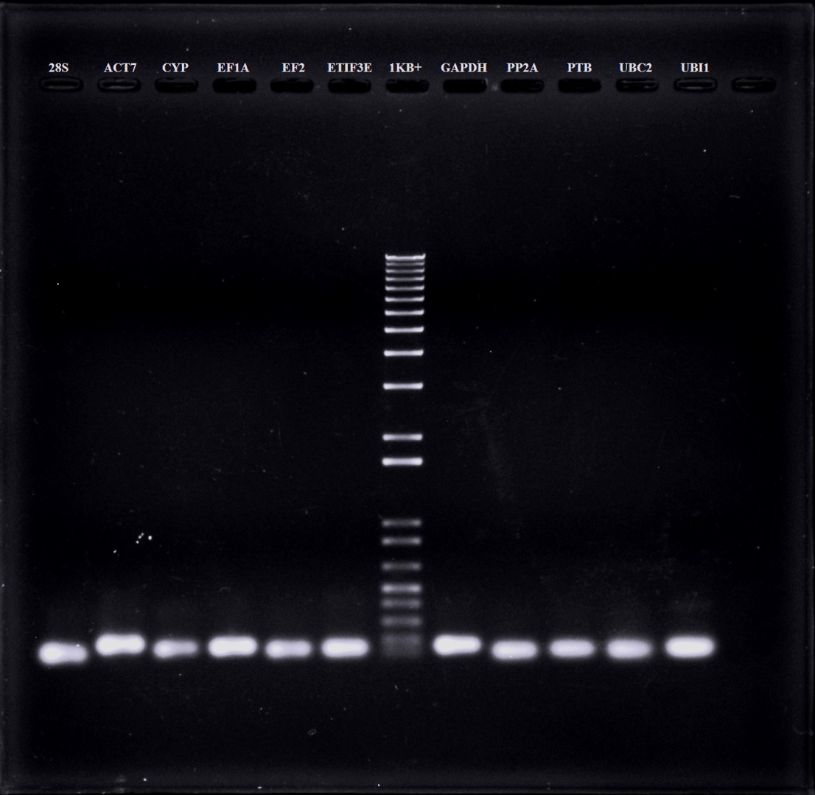

Figure S1. Specificity of primers. Agarose gel electrophoresis showing amplification specificity of the candidate housekeeping genes.

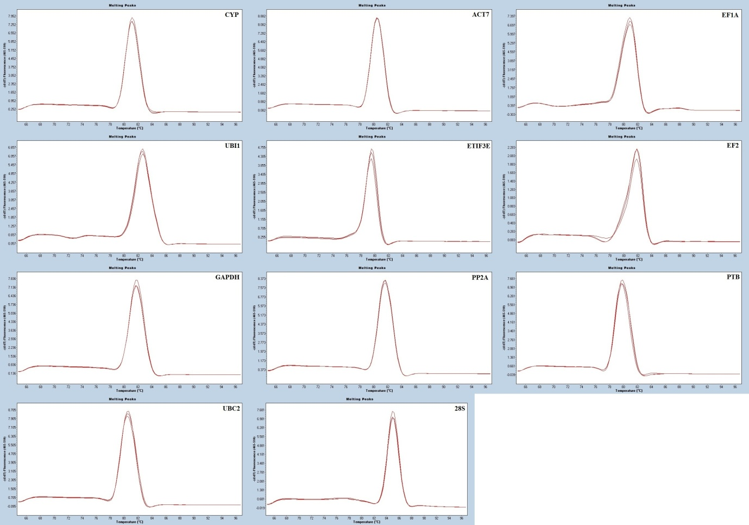
Figure S2. Specificity of qRT-PCR amplification. Dissociation curves of the 11 candidate housekeeping genes.with single peak after qRT-PCR reactions.

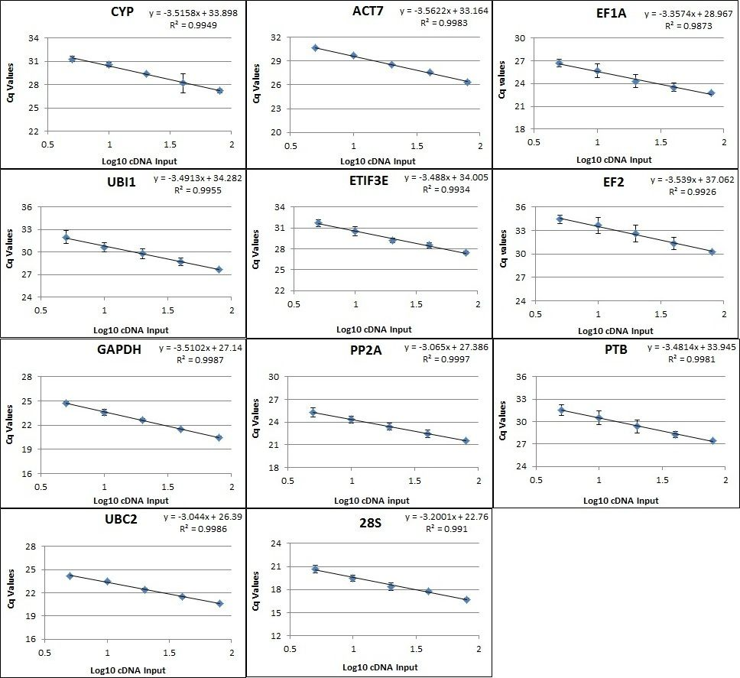
Figure S3. Primer efficiency. Standard curves obtained from real-time PCR for the 11 candidate housekeeping genes. The x-axis represents the copies of cDNA and y-axis represents the cycle threshold.

