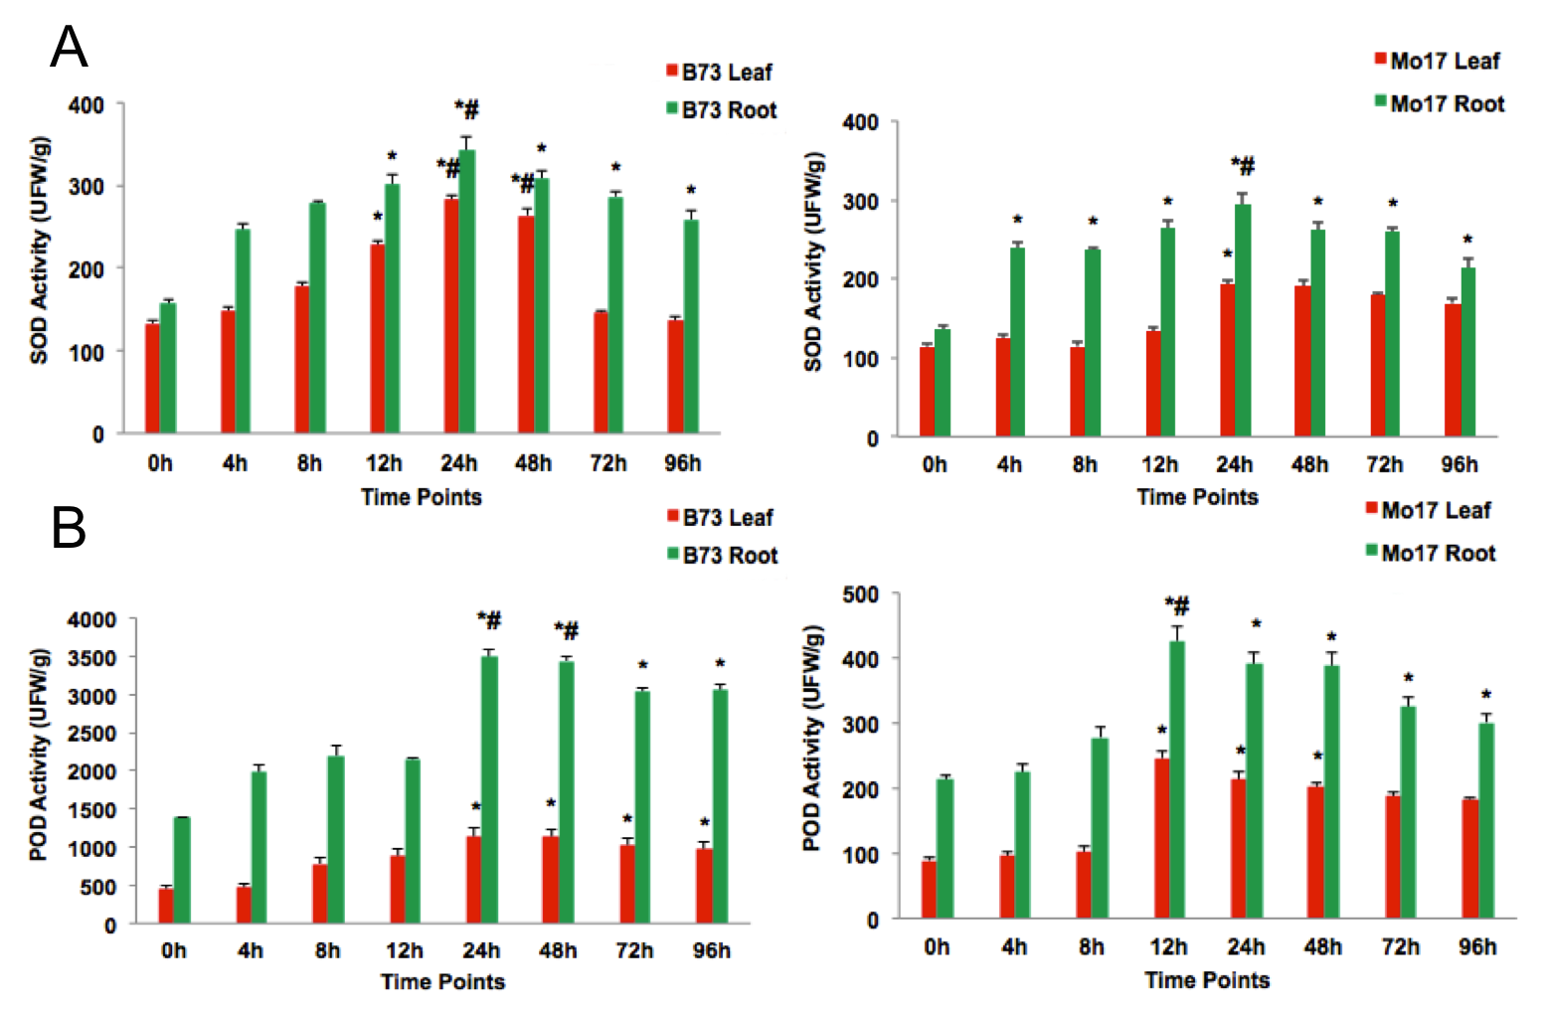
Figure S1 Effect of Cd stress on SOD and POD enzyme activities in B73 and Mo17.
The graphs (A) and (B) depicted the average change of superoxide dismutase (SOD) activities and contents of peroxidase (POD) in maize inbred line B73 and Mo17 leaf and roots respectively. The data are presented as the mean number per section ± SEM. *p<0.05 experimental vs. 0 h; #p<0.05 root vs. leaf.

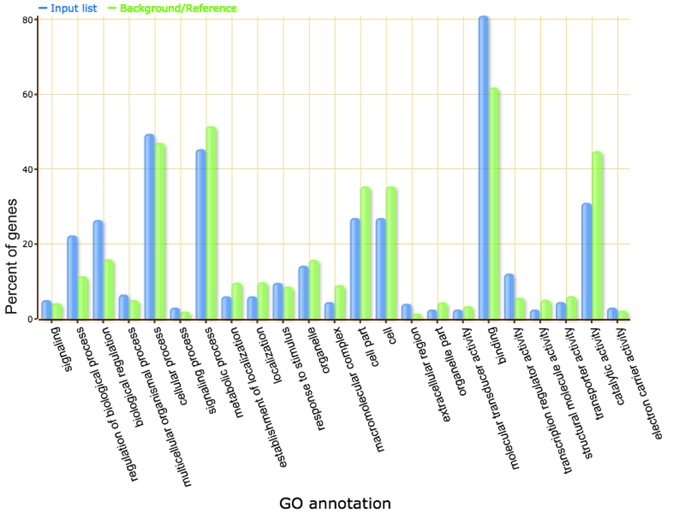
Figure S2 GO annotation of target genes of the candidate miRNAs. The Y -axis is the percentage of targeted genes mapped by the term, and represents the abundance of the GO term. The X -axis is the definition of GO terms

