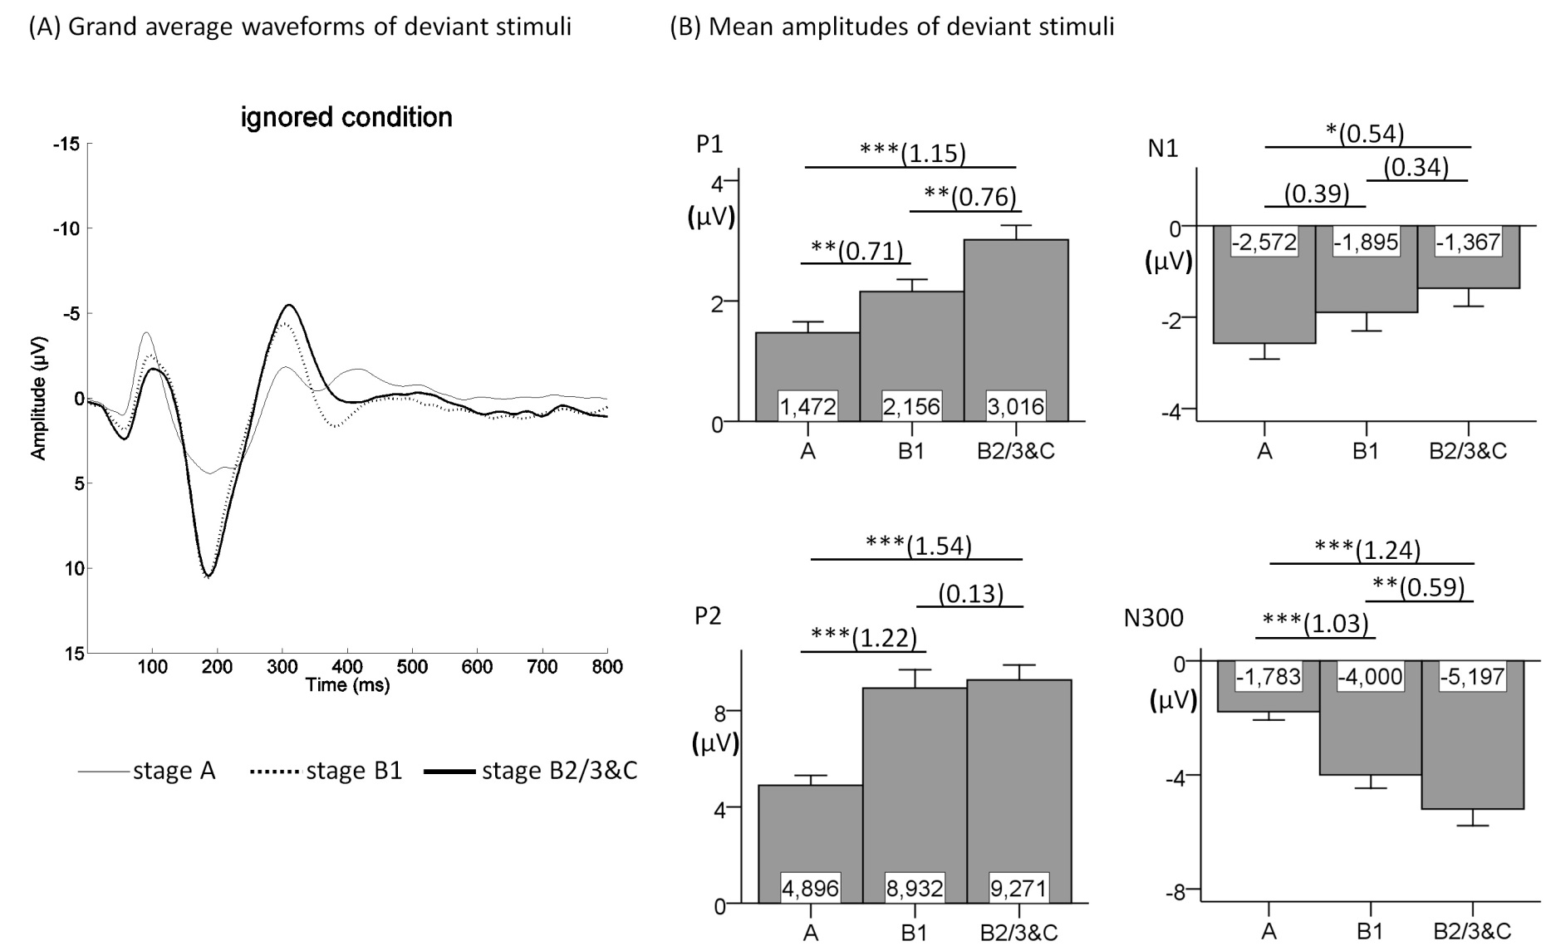
Figure S1. Grand average waveforms (A) and mean amplitudes (B) for deviant components in the ignored condition.
The deviant P1, N1, P2 and N300 are presented at Cz electrode in EEG-vigilance stages A, B1 and B2/3&C (N = 33). The main effects of EEG-vigilance stages on the deviant P1 [F_{(2,60)} = 27.632, p < .001, η_{p}² = 0.479], N1 [F_{(1.666,49.992)} = 6.457, p < .01, η_{p}² = 0.177], P2 [F_{(2,60)} = 42.459, p < .001, η_{p}² = 0.586] and N300 [F_{(2,60)} = 34.122, p < .001, η_{p}² = 0.532] were significant. The significant results of multiple comparisons are marked with asterisk (* p < .05; ** p < .01; *** p < .001; each p-value is Bonferroni corrected). The corresponding effect sizes for Cohen’s dz are presented in parentheses. Neither grand average waveform nor mean amplitude for the MMN [F_{(2,60)} = .126, p = .882, η_{p}² = 0.004] is represented since no effect was found.
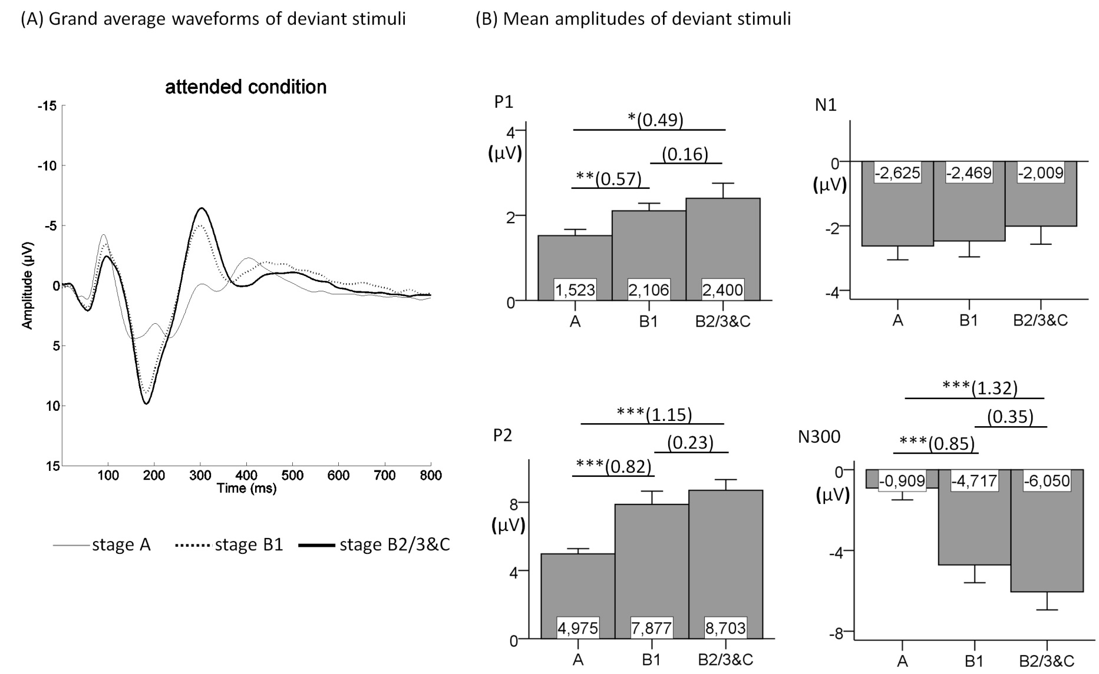
Figure S2. Grand average waveforms (A) and mean amplitudes (B) for deviant components in the attended condition.
The deviant P1, N1, P2 and N300 are presented at Cz electrode in EEG-vigilance stages A, B1 and B2/3&C (N = 29). Deviant P1 [F_{(1.475,41.291)} = 4.483, p < .05, η_{p}² = 0.138], P2 [F_{(2,56)} = 21.613, p < .001, η_{p}² = 0.436] and N300 [F_{(2,56)} = 24.853, p < .001, η_{p}² = 0.470] differed significantly between EEG-vigilance stages. The significant results of multiple comparisons are marked with asterisk (* p < .05; ** p < .01; *** p < .001; each p-value is Bonferroni corrected). The corresponding effect sizes for Cohen’s dz are presented in parentheses. No multiple comparisons were run for deviant N1 [F_{(2,56)} = 2.102, p = .132, η_{p}² = 0.070] since no effect was found. Neither grand average waveform nor mean amplitude for the P3 [F_{(2,56)} = 1.416, p = .251, η_{p}² = 0.048] is represented since no effect was found.

