Supplementary data regarding biodistribution, cell survival, functional responses, and cytotoxicity studies
Section 1. Biodistribution study
Supplementary Table 1. Bioavailability of SA-10 in mouse ocular tissues.
Anterior Segment | Cornea | Iris | Lens
1 h | 800.3 ng/mg | 677.5 ng/mg | 73.0 ng/mg
8 h | 211.9 ng/mg | 1025.8 ng/mg | 85.6 ng/mg
24 h | 20.9 ng/mg | 874.9 ng/mg | 79.2 ng/mg
Posterior Segment | Choroid | Retina | Optic Nerve
1 h | 302.2 ng/mg | 247.4 ng/mg | 418.3 ng/mg
8 h | 210.5 ng/mg | 206.5 ng/mg | 683.4 ng/mg
24 h | 294.9 ng/mg | 140.2 ng/mg | 676.6 ng/mg

Section 2. Functional responses of RGCs and their axons post-I/R injury
Supplementary Table 2. PERG and PVEP post-I/R injury. (n=14-18 mice/sex/group)
Sex | Sham | I/R + Blank NP (1% w/v) |  | I/R + SA-10-NP (1% w/v)
 | PERG Amplitude (µV)
Females | 29.19 $±$ 1.35 | 8.64 $±$ 1.27 |  | 18.30 $±$ 2.76
Males | 24.76 $±$ 1.67 |  | 16.85 $±$ 2.87 | 19.07 $±$ 2.36
Combined | 26.77 $±$ 1.15 |  | 12.61 $±$ 1.68 | 18.75 $±$ 1.77
 | PERG Latency (mS)
Females | 86.47 $±$ 1.41 |  | 131.4 $±$ 5.91 | 112.67 $±$ 5.95
Males | 74.61 $±$ 0.96 |  | 101.67 $±$ 6.28 | 84.92 $±$ 2.86
Combined | 80 $±$ 1.32 |  | 116.53 $±$ 5.06 | 104.53 $±$ 4.42
 | PVEP Amplitude (µV)
Females | 35.73 $±$ 1.43 |  | 17.57 $±$ 2.44 | 29.43 $±$ 2.98
Males | 31.88 $±$ 2.07 |  | 30.04 $±$ 2.7 | 25.88 $±$ 2.61
Combined | 33.63 $±$ 1.33 |  | 23.39 $±$ 2.12 | 27.55 $±$ 1.96
 | PVEP Latency (mS)
Females | 93.8 $±$ 1.24 | 131.34 $±$ 2.69 |  | 119.4 $±$ 4.89
Males | 84.25 $±$ 1.14 | 111.21 $±$ 5.85 |  | 101.65 $±$ 5.1
Combined | 88.59 $±$ 1.18 | 121.95 $±$ 3.56 |  | 109.97 $±$ 3.84

Section 3. Mid-peripheral retina RGC count post I/R injury
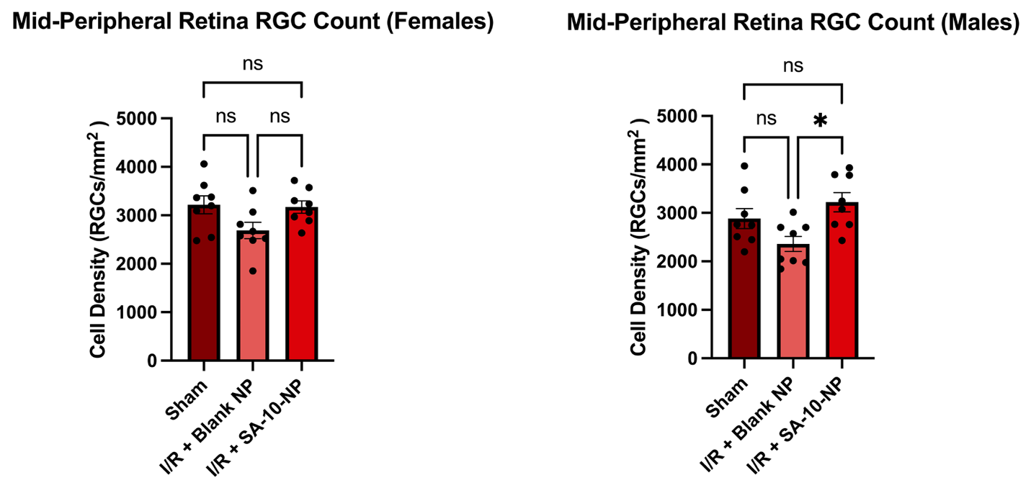
Supplementary Figure 1. Survival of RGCs following I/R injury at the mid-peripheral retina. A significant increase in RBPMS⁺ RGCs was observed in the male mice with SA-10-NP treatment compared to the blank NP (n=8 mice/group/sex). Statistical analysis was performed using a one-way ANOVA followed by Tukey’s test. *p≤0.05.

Section 4. Cytotoxicity study in primary human optic nerve head astrocytes (ONHAs)

Methods:

Primary human optic nerve head astrocytes (ONHAs) isolation and culture
Optic nerve head astrocytes (ONHAs) were derived from normal human donor eyes (n=3 biological replicates) and characterized based on the expression of glial fibrillary acid protein (GFAP) and neural cell adhesion molecule as previously described (1). ONHAs were maintained with astrocyte basal media supplemented with 5% fetal bovine serum, 1% astrocyte growth supplement, and 1% penicillin/streptomycin solution (ScienCell, Carlsbad, CA) in a humidified 37°C/5% CO₂ incubator. Once near confluency, ONHAs were trypsinized and seeded onto 24-well plates at 500 μL per well and allowed to grow to confluence. Afterwards, ONHAs were serum-deprived for 24 h prior to the cytotoxicity experiments.

Cytotoxicity evaluation of SA-10-NP in primary human ONHAs
After the culturing period, the culture medium was replaced with the appropriate treatment (Table 1) for 24 hours under the same culture condition described previously. LIVE/DEAD™ Cell Imaging Kit (488/570) (#R37601, Invitrogen) was used to determine cell viability following the manufacturer’s instructions. ONHAs treated with cold 75% ethanol and incubated for 15 minutes were used as a positive control for dead cells. The fluorescence was measured using the Cytation 5 microplate reader and quantified using ImageJ/Fiji.

Supplementary Table 3. Treatment groups for cytotoxicity study in ONHAs.
Group | Treatment
1 | ONHAs + vehicle (DPBS)
2 | ONHAs + SA-10-NP (1% w/v, 100 µM)
3 | ONHAs + free SA-10 [100 µM]
4 | ONHAs + free SA-2 [100 µM]

Results:

PLGA NP exhibited no cytotoxicity to primary human ONHAs
Primary human ONHAs were incubated with different treatment groups (vehicle, SA-10-NP, SA-10, SA-2; 100 μM) for 24 h and stained with the LIVE/DEAD™ assay to evaluate any potential cytotoxic effects of the NP formulation and free SA compounds (n=3 biological replicates). Alive cells were stained with Calcein AM, while dead cells were stained with a dimeric cyanine nucleic acid dye. At 24 h, compared to the dead cell control. In all treatment groups, there was a significantly reduced number of dead cells, as quantified by integrated density measurements (Supplementary Figure 2).

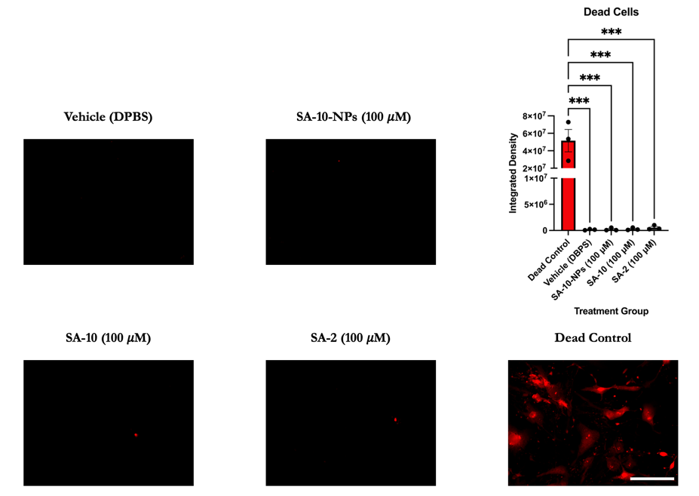
Supplementary Figure 2. Cytotoxicity assay on primary human ONHAs. Staining with a dimeric cyanine nucleic acid dye showed a significantly lower number of death cells compared to the dead cell control (n=3 biological replicates), evaluated with one-way ANOVA and Tukey’s multiple comparisons test. Scale bar: 100 μM. ***p<0.001.

References

1. Lopez NN, Clark AF, Tovar-Vidales T. Isolation and characterization of human optic nerve head astrocytes and lamina cribrosa cells. Exp Eye Res. 2020;197:108103.

