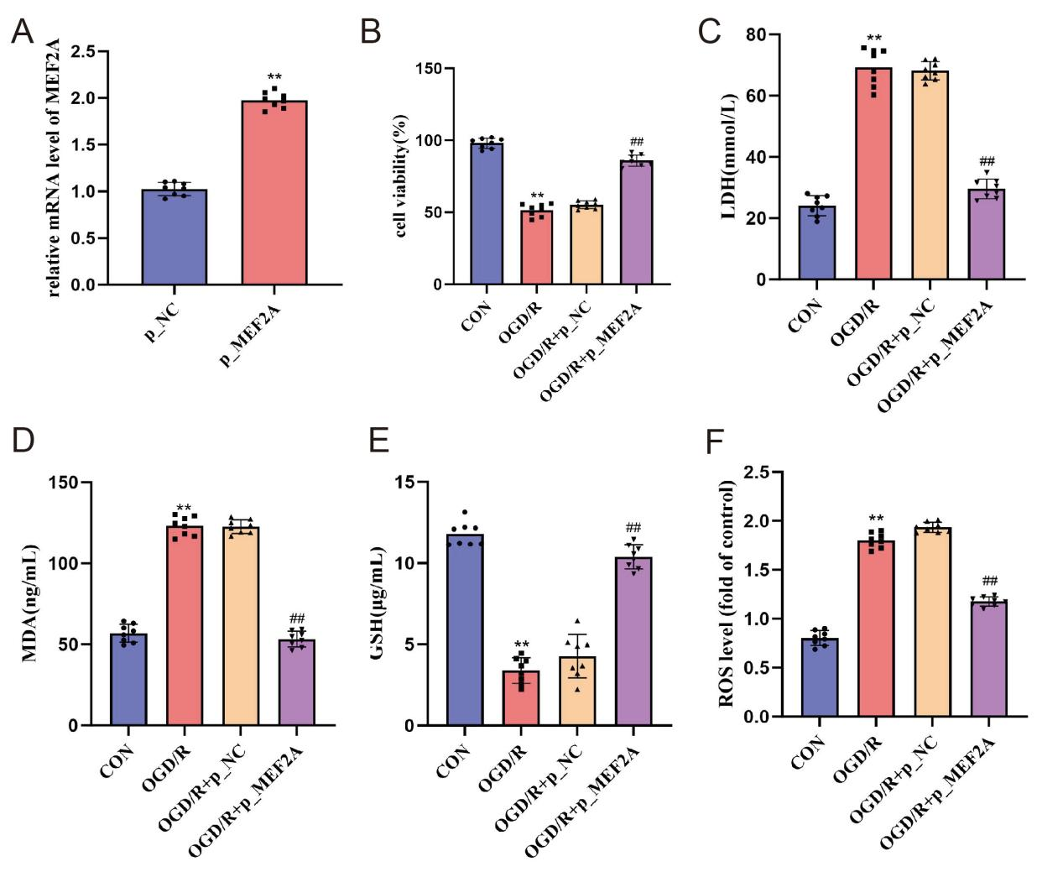
Supplementary Figure 1: Effects of up-regulated MEF2A expression on OGD/R-induced PC12 cells. A. RT-qPCR shows MEF2A mRNA was upregulated in p_MEF2A vs p_NC (P<0.01). B. CCK-8 assay shows OGD/R reduced cell viability vs CON (P<0.01), with p_MEF2A overexpression restoring it vs p_NC (P<0.01). C. LDH assay shows OGD/R elevated LDH vs CON (P<0.01), with p_MEF2A overexpression reducing LDH vs p_NC (P<0.01). D. MDA level increased in OGD/R vs CON (P<0.01), attenuated by p_MEF2A overexpression (P<0.01). E. GSH level decreased in OGD/R vs CON (P<0.001), restored by p_MEF2A overexpression vs p_NC (P<0.01). F. ROS level increased in OGD/R vs CON (P<0.01), reduced by p_MEF2A overexpression vs p_NC (P<0.01).

