Table S1
Identification of endophytes MOTUs based on NCBI BLAST of 28S, ITS rDNA, EF-1α or β-tubulin sequences.

MOTU number | Isolate  number | DNA region | Blast best match : Genbank accession number and ID | Class  Order
MOTU 1 | 9B (LCP5974) | EF-1α | >gi|149798252|gb|EF453149.1| Gibberella intermedia strain NRRL 43666 (Fusarium proliferatum) | Sordariomycetes  Hyprocreales
MOTU 2 | 82D1 | ITS | >gi|262476602|gb|GQ505743.1| Fusarium scirpi strain NRRL 36478 | Sordariomycetes  Hypocreales
MOTU 3 | 28 | EF-1α | >gi|306412978|gb|HM347120.1| Fusarium oxysporum strain NRRL 26360 | Sordariomycetes  Hypocreales
MOTU 4 | 29A (LCP5979) | ITS | >gi|316980277|emb|FN706553.1| Acremonium implicatum MUCL 1412 | Sordariomycetes  Hypocreales
MOTU 5 | 3C1B (LCP5984) | 28S | >gi|523713894|gb|KC157757.1| Purpureocillium lilacinum strain M4076 | Sordariomycetes  Hypocreales
MOTU 6 | 55E (LCP5980) | ITS | >gi|215490348|gb|FJ441623.1| Phomopsis phyllanthicola strain msy55 | Sordariomycetes  Diaporthales
MOTU 7 | 5 (LCP5978) | ITS | >gi|283856804|gb|GU066686.1| Diaporthe phaseolorum isolate 123AC/T (Phomopsis sp) | Sordariomycetes  Diaporthales
MOTU 8 | 61B (LCP5982) | ITS | >gi|44893890|gb|AY541610.1| Nemania bipapillata strain CL8 | Sordariomycetes  Xylariales
MOTU 9 | 9B | ITS | >gi|387773616|gb|JQ846066.1| Xylaria sp. 5485 | Sordariomycetes  Xylariales
MOTU 10 | 61F (LCP5983)  55A (LCP6051) | ITS | >gi|21310048|gb|AF377292.1| Pestalotiopsis microspora strain CBS364.54 | Sordariomycetes  Xylariales
MOTU 11 | 69D (LCP5988) | ITS | >gi|169135011|gb|EU482214.1| Colletotrichum gloeosporioides ICMP 17323 | Sordariomycetes  Glomerellaceae
MOTU 12 | 39 | ITS | >gi|82799468|gb|DQ286216.1| Colletotrichum sp. | Sordariomycetes  Glomerellaceae
MOTU 13 | S101Z1 (LCP5987)  42a,b,c | ITS | >gi|317383391|gb|HQ631070.1| Nigrospora sp. TMS-2011 voucher SC9d1p7-1 | Sordariomycetes  Trichosphaeriales
MOTU 14 | 69H (LCP5985)  S104Z1 | ITS | >gi|383842765|gb|JQ316443.1| Fungal endophyte isolate EL-10 Australia | Sordariomycetes  Trichosphaeriales
MOTU 15 | S104Z1 Bis | 28S | >gi|290889519|gb|GU390656.1| Delitschia chaetomioides strain SMH 3253.2 | Dothideomycetes  Pleosporales
MOTU 16 | 25 (LCP6048)  61d,e,g, S104Z1ter | ITS | >gi|34328662|gb|AY236935.1| Botryosphaeria ribis isolate CMW7772 | Dothideomycetes  Botryosphaeriales
MOTU 17 | 51B (LCP5998) | ITS | >gi|330369659|gb|JF261465.1| Guignardia mangiferae strain CPC18848 (CBS128856 T) | Dothideomycetes  Botryosphaeriales
MOTU 18 | 33B (LCP5989) | ITS | >gi|262386897|gb|GQ852747.1| Mycosphaerella marksii strain CPC:13273 | Dothideomycetes  Capnodiales
MOTU 19 | 8B2 (LCP6049) | ITS | >gi|310769695|gb|GU944569.1| Penicillium citrinum strain CBS 13945 | Eurotiomycetes  Eurotiales
MOTU 20 | S102Z1 (LCP6050) | β-tub | >gi|110743536|dbj|AB248059.1| Aspergillus fumigatus strain: IAM 13869 | Eurotiomycetes  Eurotiales
MOTU 21 | 74A (LCP5981) | ITS | >gi|22023786|gb|AF485074.1| Sarcosomataceous endophyte E99297 strain E99297 | Pezizomycetes  Pezizales
MOTU 22 | 51A (LCP5976) | 28S | >gi|353703687|gb|HQ848487.1| Perenniporia nanlingensis voucher Cui 7589 | Agaricomycetes  Polyporales
MOTU 23 | 3C1A (LCP5977) | ITS | >gi|15147895|gb|AF254932.1| Cunninghamella blakesleana strain CBS 133.27 | Zygomycetes  Mucorales

Table S2
Statistical validations on SIMCA-P for the PLS-DA model generated. The P-value from the CV-ANOVA is shown and tests the significance of the PLS-DA model.
MVDA method | R²Y | Q²Y | P CV-ANOVA
PLS-DA | 1.00 | 0.99 | 1.41 x 10⁻⁴

.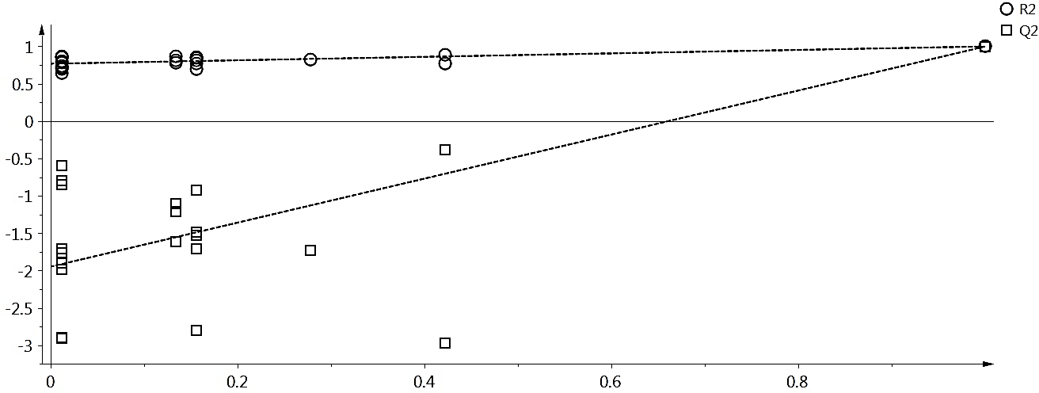
Fig.S1. Response of permutation test. Correlation of Y-permutated vs. Y-original permutation test of the partial least squares discriminant analysis (PLS-DA) model of results obtained from ¹H NMR spectral data of the pod based media on which fungi were cultured and scaled to Pareto distribution. The number of permutations used was 20 and the number of components was 20. The R2 value was 0.999 and the Q2 value was 0.976.

