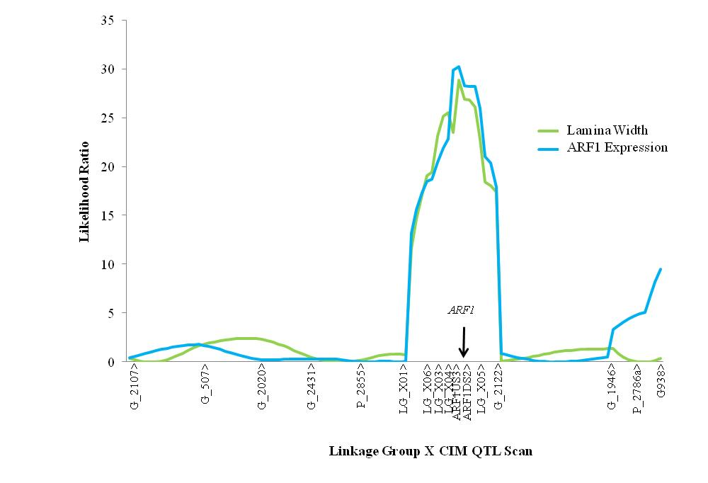

Additional file 2. Fine-scale mapping of the major lamina shape QTL on LG X in the segregating pedigree. Framework SSR loci were genotyped in 396 progeny (“G_” and “P_” loci) while additional SSR underlying the QTL were genotyped in 96 recombinant progeny. Recombinants were identified by maternally inherited marker genotypes at locus P_2855 and G_2122.

