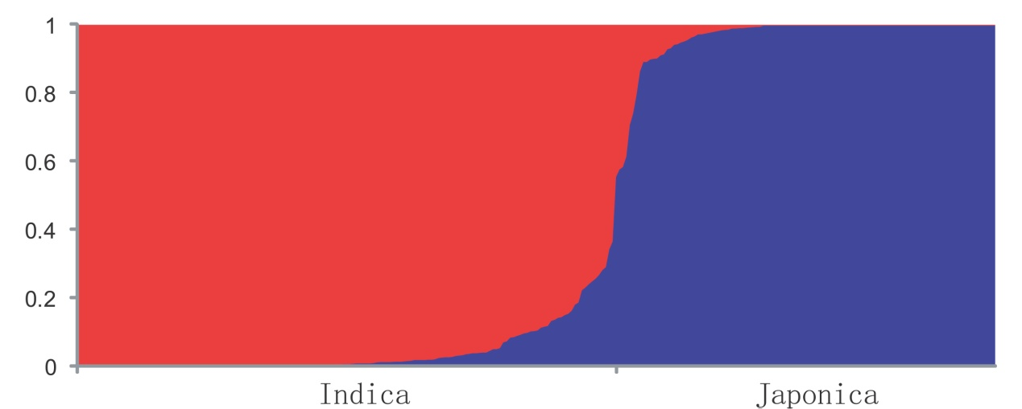

Figure S1 Two subpopulations defined by STRUCTURE

