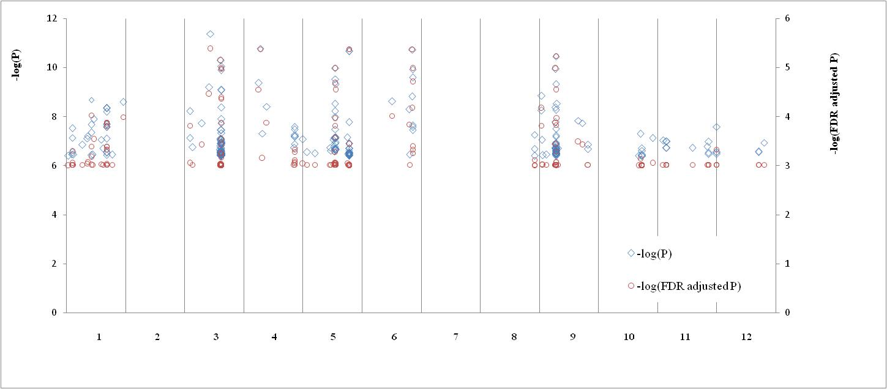
Chromosome
A
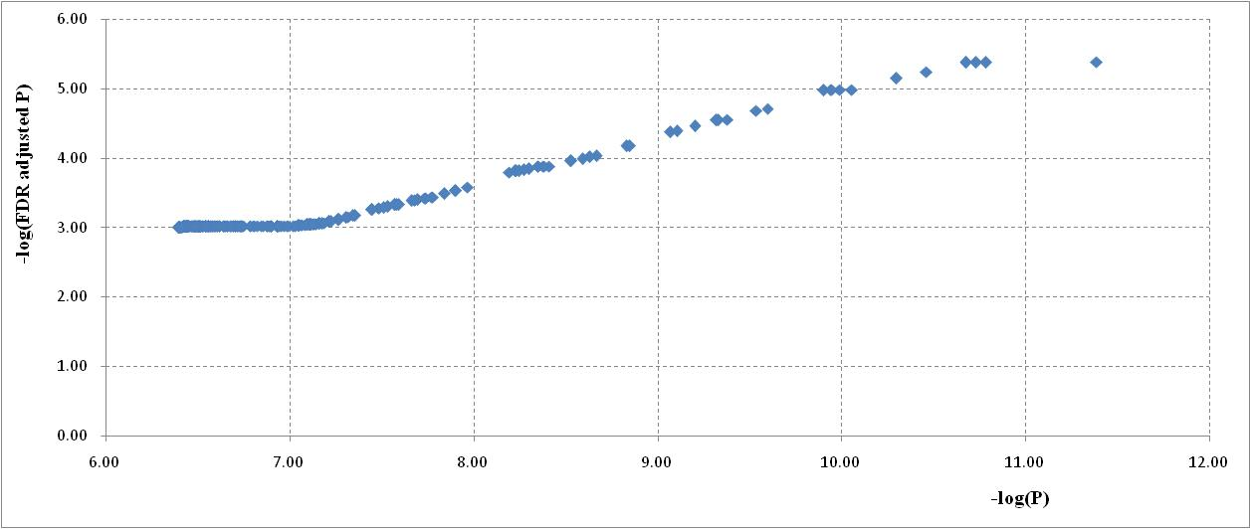
B

Figure S2. Distribution of –log(P) and –log(FDR adjusted P) values of SNPs with –log(FDR adjusted P)≥3.0 (A) and the parallel changes of both parameters estimated in GWAS of MLw
The positions of SNPs were presented in relative values against the lengths of each chromosome. So the abscissa axis did not show the real lengths of chromosomes.

